Summer route patch 2.1

* After starting the game and doing the first events of the game where you get bullied by tricia you go to summer.(Find her using the app you got from the Devil) 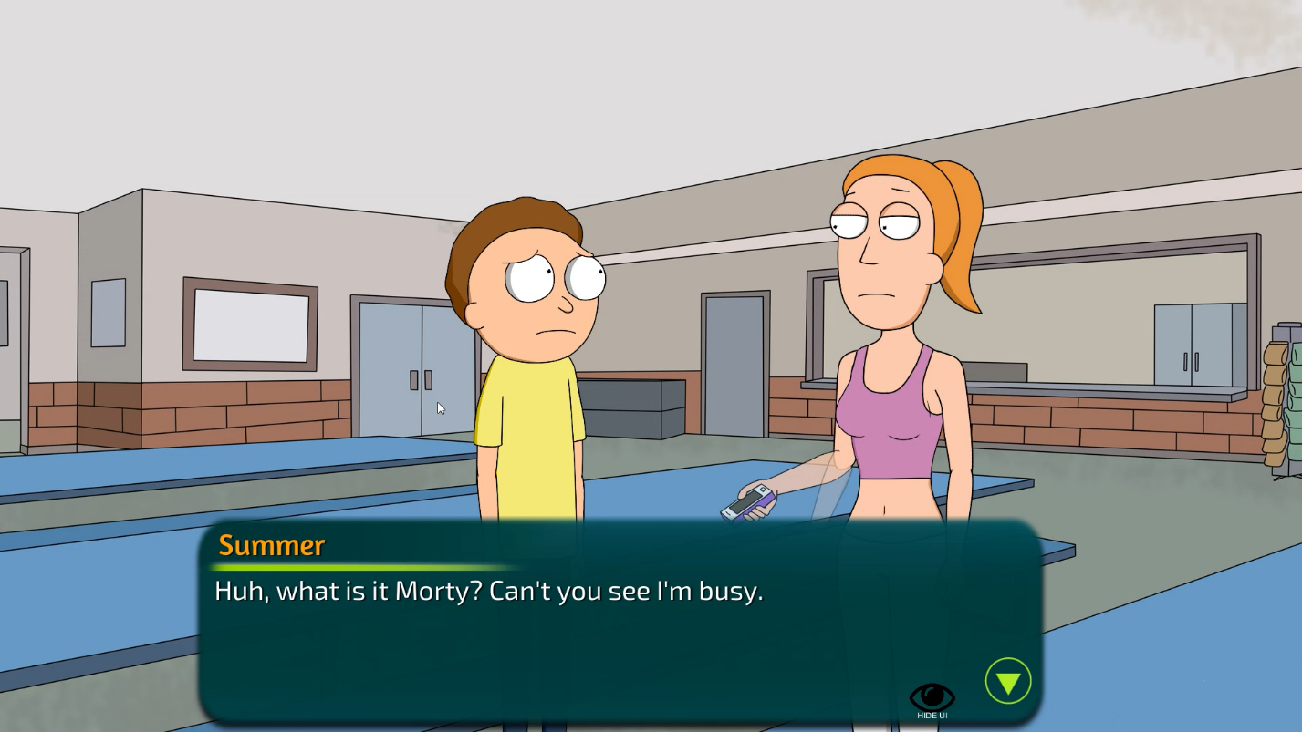
* For the next event you have to continue the missions with Tricia. After the bathroom scene Summer will talk to you.
* After showing the video of Tricia you have to ask her about Jessica. This will activate the mission to sneak into her room and search her phone
* At midnight you have to go to summer’s room. She is sleeping you have to click on her. Then click on her phone – Its locked. Click her diary on the shelf to get the password. After that click on her phone again. 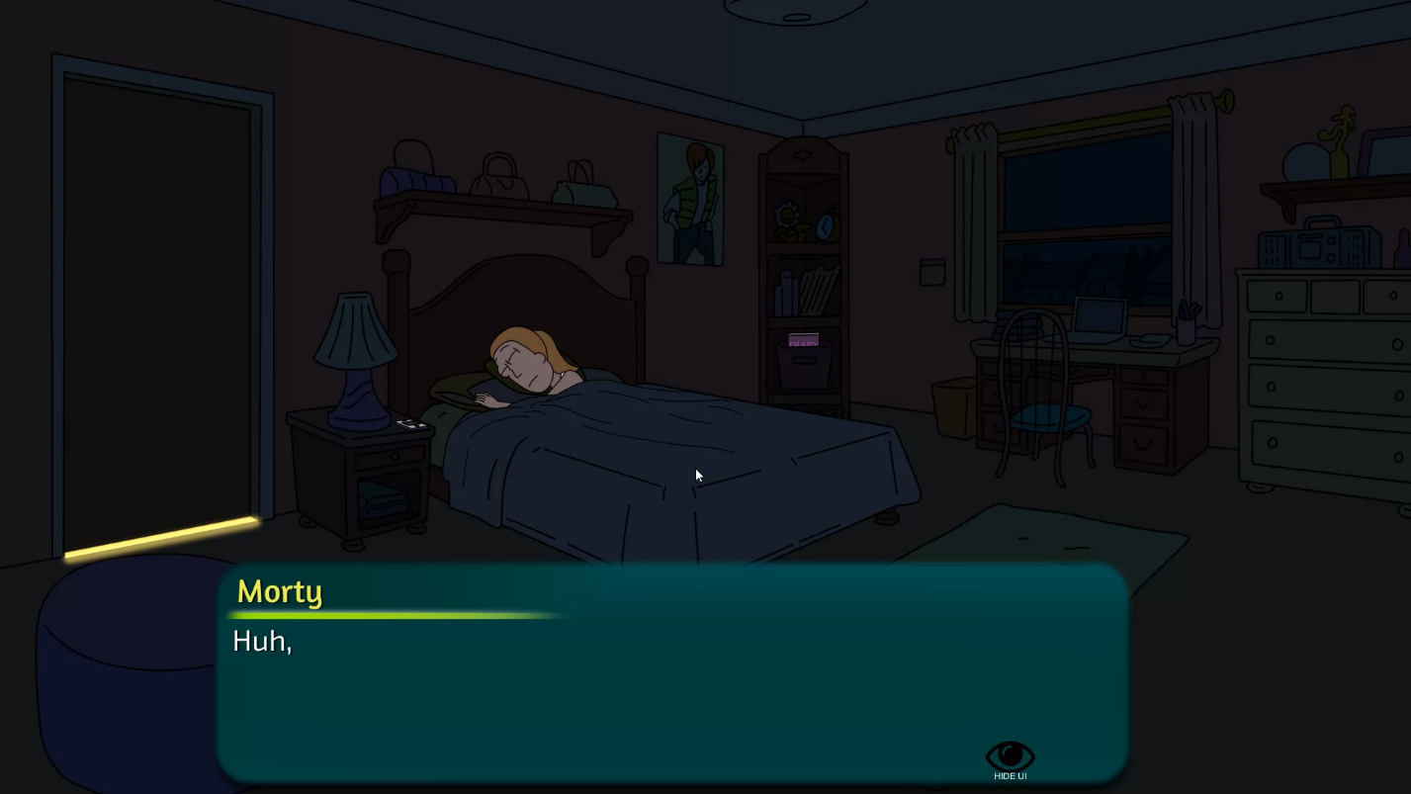
* On the next day go to school and talk to Tricia. After that the next mission is to ask for advice for Jessica. Go to Summer
* After finding crying Summer she will ask you to make Tricia give you a blowjob.
* After going to the church and receiving the blowjob go to your house and talk to Summer.
* After trying to practice with a banana Summer fails to do it properly so you have to go buy her a dildo. To do that you have to ask Rick for money. Then go to the mall and buy one. 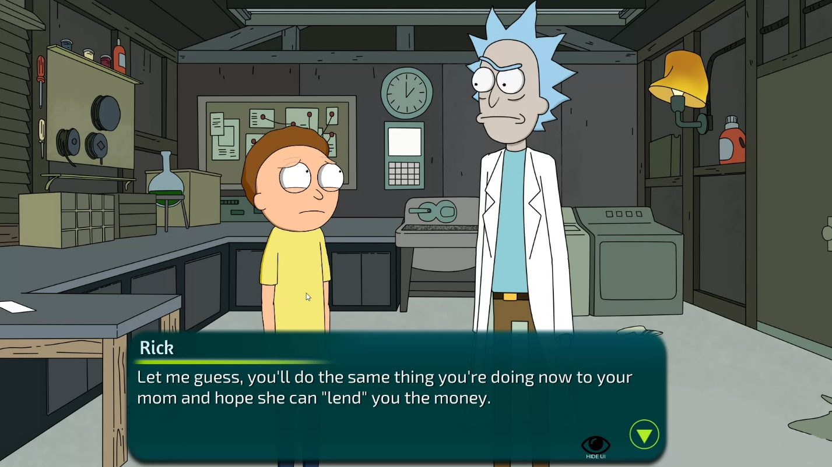
* Find her and give it to her
* On the next day go to her room.
* After that find her on the next day and talk to her about practice.
* And then AGAIN find her and talk to her about practice.
* On the next day she has talked with Rick and got another idea for practice
* And then AGAIN find her and talk to her about practice
* AND AGAIN
* After that find her and return the favor.
* After the cinema find her and talk to her about Ethan
* On the next day after the zoopark talk to her.