**MHA 113**

The new world was… a somewhat dirty iron hallway, metal lanterns keeping it well lit and pipes running along the tops of the slightly sooty walls. The air carried a mix of scents, predominately the cloying scent of coal-smoke undercut by the sharper smell of sea-water, and, from the slight shifting of the ground, that meant…

*We were on Prince Zuko’s ship.*

*… probably.*

But was the Fire Nation the bad guys I remembered them being, or were they the *good* guys in this alternate universe, the evil Water Tribes having engaged in a century of naval conquest, the Avatar being Zuko’s and Azula’s only hope to stop the Dark Tide of Conquest from drowning the land?

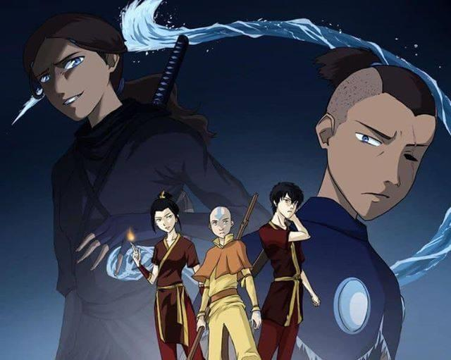

*Well, not going to find out waiting here,* I thought, looking to Mina. “Fire Nation ship,” I explained. “Stay non-lethal until we can figure out who the players are.”

“I, yeah?” the girl replied, confused. “You… *right*. I’m there for ya, Sparky!” she promised.

Now it was *my* turn to be confused, “Uh, good?”

Focusing on the *now*, I picked a direction, and started walking, glancing back to make sure Mina was following me, turning the corner and practically running into two stereotypical Fire Nation soldiers, skull-mask and all.

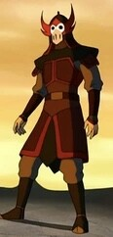

“Oh, hi?” I greeted them. “Take us to your leader?”

For a long moment the pair stared at us, before one dropped into a combat stance, while the other yelled *“INTRUDERS!!!”*

“I mean, *technically,*” I agreed, “but-”

Which is when the first soldier moved to strike, and, yeah, *that was enough politeness.*

Darting forward, I pulled on my main Quirk, and *shocked the shit out of him,* as he started to move, flames just beginning to swirl around his fist, only to suddenly dissipate as he lost control of his body.

As I did so, I found I had to *actively* hold myself back, the flow *wanting* to ravage my target until nothing but twitching, *burned* ***meat*** remained, but, with a force of *will*, I kept its touch light on the metal-clad soldier, who, with a scream, more of surprise than pain, dropped to the ground, still twitching even after I stopped.

Turning to the other, having had to concentrate solely on the first, Mina had already taken the man down, bonds of low-level acid holding him in place, as he started to yell again, *“Bend-aaaaahhh!”*

Shocking him too, careful to modulate my flow to avoid hitting Mina, he slumped, smoking slightly.

For a moment, I worried I’d gone too far, but, as Mina pulled away her Quirk’s expression, though she stared at the fluid, as if it was confusing her, I put a hand over the man’s mask, and… *yes,* he was still breathing.

*Good.*

However, from the calls that were now echoing through the ship, *they knew we were here,* and they were *not happy about this fact.*

“Sparky?” my partner questioned, unsure.

“We go up, I’ll have a chat with the man in charge, and if need be I’ll open a portal and we’ll out,” I told her, the woman nodding, both of us taking off down the ship’s corridor, up a set of stairs, and coming across three more Fire Nation soldiers, these ones wielding swords.

Turning my hand to lightning, I grabbed the lead one’s slashing weapon, shocking him through it, twisting around him about to lash out with my other limb, pushing number two to the side, into the wall, and tazing him as well, Mina dashing past me on a thin layer of acid to catch the third’s blade with a gel-clad hand, copying me, the substance packed tight enough to stop the edge of his blade before it got close to her skin, and, with a rolling throw, she slammed him into the floor, the man winded but struggling, only to be shocked into unconsciousness by me a moment later, the self-imposed non-lethal limit getting easier to work with the more I did this.

With a nod to my partner, we kept going, up another set of stairs, and, around the corner, I could see natural daylight spilling in.

Turning, I called upon **Creation**, pulling on my reserves to spew Containment Foam from my fingertip, painting the top of the hallway, letting it expand again and again as I went back and forth, using what felt like half my reserve to completely block off the passage, leaving only one way to go. “Stay here for a moment,” I commanded. “I can kind of pass, but…”

The heteromorphic girl winced, “Yeah, I kinda guessed. Knock ‘em dead, Sparky!”

“Hopefully things won’t go *that* bad,” I quipped, turning back towards the doorway, and pausing as a wave of *tiredness* hit, a feeling of **strain** tugging at every part of me, body and soul, but I pushed through it, and, moving at a jog, emerged into the morning light, blue reflected at me from every direction as the ship made its way between towering icebergs, and-

[*Ohfuck!*](https://www.youtube.com/watch?v=TVxuAJinu3I)

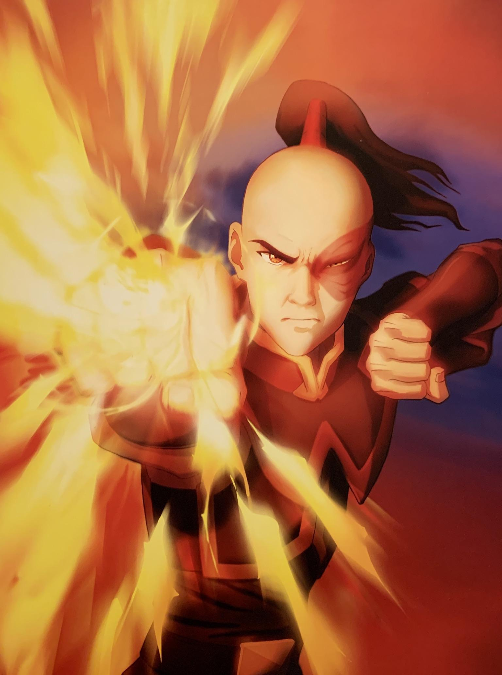

A *blast* of fire came roaring for my head, and I threw myself into a roll, coming up as Zuko, who looked older in real life than I expected, and *damn* did that scar look bad, fired a few more fireballs, which were fast, but *I’d dealt with worse*. Spinning about, I Created a thermal glove for my left hand, batting the last attack away with my now white-covered limb, the substance in a state of partial-extrusion and thus armoring me tightly.

“*Who are you!?”* the scarred young man demanded, still in a ready stance, while General Iroh, his uncle and minder, sat off to the side, at a low table covered in tiles, along with a steaming tea pot and cup, the elderly Master Firebender looking at me with the slightest of frowns.

“Denki,” I smiled, not taking the attempted burning seriously, as I kind of expected it. “Denki Kaminari. And are you...” I paused, trying to figure out which address would confirm my suspicions faster. Given we were *clearly* at one of the poles, and this was a Fire Nation ship, things seemed close to canon, but this was an **AU,** so something was clearly going to be *off.* “Zuko, son of Ursa?” I settled on.

Iroh’s expression twitched slightly, though he was still unreadable, while Zuko just glared at me. “That’s *Prince* Zuko!” the exiled royal snapped. “And *what are you doing on my ship!?”*

“Would you believe I’m on vacation?” I shot back with a smirk, the young man’s expression telling me that *no, no he didn’t,* as he launched another fireball at my head.

Dodging it, the Firebender charged me, leaping up into the air, getting *impressive* distance, the young man flipping in a somersault, and, with one leg extended, he fired off a *wave* of flame that was a little harder to dodge, but not too bad, Shoto able to pump out *far* fucking more, well, *firepower*, though there was something about the fire he created that seemed… *off.*

Or, it could be the fact that I now was a Firebender *myself* that added an extra dimension to everything flame-related.

Either way, he landed, and went on the offensive through martial arts alone, and the boy was both *fast* and *good.* Better than me, but, after sparring with the likes of *All Might*, I could deal with a superior opponent while holding my own, and while he was *absolutely* in shocking range, I was *also* learning a good deal from him through **Martial Talent**, and didn’t want to use that Trump Card unless I *had to.*

Zuko shifted his stance and lunged for me, but I fell back, coming in with a palm strike of my own, my greater than human strength taking him back even as he crossed his arms to block the blow, which sent him skidding several feet across the iron deck.

“So, can we go back to talking, or…” I questioned.

“What, so you can lie some *more?* No, I’ll *beat* the answers out of you!” the teen growled, clenching his hands and jerking them downwards, making twin daggers of flame jut from the bottoms of his fists.

Iroh, meanwhile, cleared his throat, “*Perhaps* we should-”

But the Prince didn’t let him talk, charging me once again instead with a *roar* of anger, going for fast slashes, as I started to soak up *this* set of techniques instead, the young man not realizing he’d made this fight *several times easier* for me, as, by limiting his attack options, he became *much* simpler to predict.

Slash after slash came my way, until, with a spin, he went for a kick that was just a *touch* too telegraphed, letting me counter with one of my own that slammed into *his* chest first, and sent him spinning backwards.

Having seen him fight, I concentrated, closing both of my hands as well, and with a jerk, tried to form twin daggers of my own, only for the fire to uselessly billow down and away.

“You’re a Firebender!?” Zuko demanded.

“Among other things,” I shrugged, glancing at my fists. *Was it the flame-resistant covering? No, then the* ***other*** *hand should’ve been fine*. “Huh, harder than it looks. Keep going, I want another look at it.”

A look of *rage* twisted across the young man’s features, as he screamed, *“Gaaah!”* and charged me once again, dismissing his daggers, which… did make this harder. Now with *naked* aggression, Zuko opened with a fireball, which I parried with my protected hand, but the projectile itself was a feint for him to come at with me another strike, one I barely was able to dodge, as well as the next two.

Strike four, a sweeping kick, saw me dancing back again, only for it to ignite mid-swing, sending a *wave* of fire to chase me, forcing me to leap high, Zuko streaming a *deluge* of flame at me, instead of a compressed fireball, both of us breathing hard at this point. With a spin, and a bit of extruded Acid to try and protect my body, which *itself* caused a painful burning sensation that had *nothing* to do with the strength of the fluid, I was ready to weather the firestorm.

Regardless, as the flames passed me by, *I* was left to come down, ready to strike-

*Bam-****Snap!***

As I was sent flying *backwards*, I learned four things in short order.

One, Firebenders apparently had *super strength* in this AU.

Two, my ribs could still be broken by that level of power.

Three, Zuko had, somehow, expected me to weather that attack and come out swinging.

And, *worst of all*, Four, when pressed, I *reflexively pulled on* ***One-for-All***.

I bit back a *scream* of pain as my entire body spasmed, still flying away, twenty feet in the air, my **Defenses** ringing as I was forced through the ***agony*** back *into* the fight, reflexively turning my feet to lightning and slamming them down *into* the metal of the deck, anchoring myself and reeling myself down *hard*, staggering as I tried to regain my balance.

“Ready to take me *seriously* now?” Zuko demanded, starting to stalk towards me.

Working my cramping muscles, my good humor *gone*, I spat blood off to the side. “You know what, *fine.* Let’s do things *your way.*”

Pulling on my main Quirk, electricity *surged* within me, and, taking a step forward, a *tight* control over my **Elecrification**, the energy *roare-*

*Fuckhe’sfast!*

In an instant, Iroh was *there,* right in front of me, expression *furious,* as he grabbed my hand, turned, pointed to a nearby glacier, a hundred feet away, and everything I was pumping out was yanked from my control and the stream of energy was *fired* towards it.

Reaching out about thirty feet, just a bit past the edge of the ship.

Then Twenty feet away.

Ten.

Five.

Three.

One.

I finished pulling back on my Quirk, as the old man, whose grip was like iron, stared at his own extended hand, two fingers pointed towards the unmolested iceberg, anger replaced with confusion.

Looking to me, the elderly Firebender commented, “I… expected more.”

“What?” I shot back, offended. “I wasn’t going to *kill* him! Just shock him a little to get him to stop trying to kill *me!”*

“… Even small amounts of a storm’s fury can do far more damage than one would think,” Iroh pointed out.

“Yes, which is why I *control* it pretty carefully,” I informed him, turning my hand to lightning to slip it out of his grasp. “So, are we gonna go back to talking or-”

“*Uncle! Step away from the assassin!”* Zuko demanded.

Turning his back to me, Iroh stated, “I think if the visiting Spirit wished you harm, Prince Zuko, he would have done so already.”

The look of exasperation on the teen’s face was quite amusing. “There’s *no such thing as Spirits, Uncle!”* the young firebender argued.

*Spirits?* I thought, but, *technically.* Turning my arm to lightning, I waved to the scarred prince, greeting him with a cheery, “Yo!”

The shocked expression on the teen’s face made the older man, glance back, see my electric limb, blink, and add, “*Indeed*. As I was saying, perhaps we should be *greeting* this Spirit, instead of attacking him? And perhaps, greeting his companion?”

Zuko glanced back the way I’d come, grit his teeth, and then slumped, abandoning his balanced stance and standing fully, waving defeatedly, “Fine, *whatever!”*

*“Hey, Mina, fighting’s over!”* I called out, and, as she poked her pink head out of the doorway, and, glancing over, the Prince took a step back, *clearly* unnerved, but the young man glanced over, and, seeing Iroh just looked *pleased*, merely shook his head in disgust.

Mina, meanwhile, *gasped*, and came skating over to me, and yelled, *“Sparky! You’re hurt!”*

“I’ll heal, and most of it was my own fault,” I reassured her, the girl dashing over to get close and check my injuries. “Reached beyond my grasp, like I did before. Only less, so with less, you know…”

*“Almost dying!?”* she demanded, creating a bit of acid to wipe my face off, revealing I’d bled from the corners of my eyes as well. Again. *Whups.*

“Yeah, *way* less of that,” I tried to joke, but it fell flat as she looked at me worriedly. “And better to figure out my reflexes in a spar than a real fight,” I stated.

Nodding, Iroh agreed sagaciously, “It is better to bleed a little in safety, than to lose it all on the field of battle. Onto more *pleasant* matters, I must say, I have not met a Spirit quite so beautifully striking in appearance before, young lady. I am General Iroh, of the Fire Nation, and you would be?”

“Oh, I’m Mina Ashido!” the girl smiled. “And I’m *this* big lug’s partner! But, uh, Spirit?”

“Are you saying that we *don’t* come from another world, with strange ways and stranger abilities?” I questioned wryly.

Blinking black-and-gold eyes, my lover tapped a finger to her chin. “Huh, I guess we are. That’s, like, so *weird!”*

“What about my life *isn’t,*” I countered with a smirk.

Rolling her eyes, she smacked me on the shoulder, and glanced over, stiffening as she spotted Zuko. “Oh, *Honey*, what happened to *you?”*

The Prince bristled, and I held up a hand, asking Iroh, “Ozai, right?” At the older man’s nod, I told my lover, “I’ll explain later. It’s… complicated.”

The heroine struggled with that, before finally nodding, but shooting me a look that promised we *would* be talking about this, but she was willing to let it go for now.

The old Firebender standing beside us cleared his throat. “If I may be bold as to ask, Ms. Ashido, what brought the two of you two our humble vessel?”

“Oh, we’re, like, on vacation, and stuff!” she smiled. “Some, uh…” she glanced my way. “Some *stuff* happened, so we decided to take a trip! Not sure why we’re *here*, though.”

“The portal we use takes us to interesting places,” I explained. “The Exiled Fire Prince’s Ship, as he tries to track down the Avatar, seems to be one of them.”

From the lack of reaction from either of them about that announcement, I was *probably* correct in that assumption, though the general’s *observable* expression meant little, given who he was. “Ah, while I appreciate the compliment, I must say our journey has not been what one would call,” the old man paused for effect, “*eventful.*”

I started to respond, when I felt something *shift* in the air, below the surface of the world, *outside* it, and I felt myself smile, as this, too, was what I expected to happen.

“That’s the thing, Iroh,” I told him, as, behind me, a beam of blue light pierced the sky, coming from over the horizon, and extending up to the stars themselves, creating coronas of light, a harsh monotone aurora borealis that cast everything in cool luminescence. “*It’s about to be.*”

Slipping my phone out of my pocket, I created a portal on the deck of the ship, and addressed the exiled prince. “Zuko, you’ve been looking for the Avatar? That’s where he is. Just be warned… all is likely not what it seems. Now if you’ll excuse us, I think it’s best we go, and we leave you to your work.”

The scarred teen was gazing at the light with surprise, and an undisguised hope that looked… odd on his features, his scarred eye set in permanent squinting glare, before he looked to me. “This, this is *your* doing?”

“Nope, just right time, right place,” I informed him cheerfully. “Mina?”

“See you guys later!” my girlfriend wished, sliding over to the portal.

Iroh gave her a half bow, “It was most interesting to meet you. Both of you. And I look forward to doing so when we have more time to talk.”

“Oh, like, *totally!”* she agreed, glancing my way, and, when I waved her through, she nodded, and stepped through the portal, causing the older man’s eyes to widen slightly.

On my end, I finished the Creation of my ‘glove’, discarding it, and took a moment to Create a glass vial containing the neutralizing agent for the Containment Foam, unable to visualize a spray-bottle top, so I just sealed it with wax instead. Handing it to Iroh, he accepted it gently, and at his inquisitive look I informed him, “This will get rid of the obstruction I created, to make sure we weren’t interrupted.”

“I *had* wondered,” the ‘Dragon of the West’ noted, nodding slightly. For a moment, the Dragon of the West hesitated, before, glancing at his nephew, the teen still staring at the slowly fading skybeam, the old man questioned, quietly, “You think he can do it?”

“I *know* he can, but capturing the Avatar is merely *step one,”* I replied, getting a grudging nod from the Fire Lord’s brother. “See you later.”

“Indeed,” was Iroh’s only response, as I passed through the portal myself.

Exiting the other side, Mina was waiting for me, and I relaxed, only to almost *collapse*, as *waves* of [***soul-deep fatigue***](https://www.youtube.com/watch?v=u-hJ3plAUuk) slammed into me, and would’ve forced me to my knees if my lover hadn’t caught me.

*“Sparky!”* she shouted, able to hold me up, and, after a moment, just taking me off my feet completely in a princess carry, her Acid providing extra lift and support. “Are you okay? You said you were fine!”

“I, I am,” I replied, even as my vision swam, slurring my words a little as I added, “Not physical. Something else. Sorry.”

The woman supporting me sighed, “Oh, *Sparky,* that’s, it’s not *your fault*. I, I thought you were better.”

I laughed weakly, “That’s the thing, I, I *am,* I just… I burned through my reserves a little. I can put on a performance, sure, *after*…” I chuckled, then winced, the feeling of ***strain*** even worse. “Hey, Mina, guess what?”

“What?” she asked, with a little trepidation, skating up the stairs and bringing us to our house proper, carefully putting me down on a couch, maneuvering me so my head was in her lap, clearly wanting to do *something,* but unsure of what *to* do.

*“I’m like All Might now,”* I mused, having long told her about the man’s mustering of his limited resources.

“S-Sparky, you said he was burning *out,*” she stated worriedly. “Are… Are you?”

I shook my head, feeling a little nauseous as I did so. “N-no. I don’t think so. I’m just… *exhausted,* in every sense of the word. Do, do you mind if I just lie here?”

While her own smile, as she looked down at me, was a little fragile, the woman I loved reassured me, “Of *course* it’s fine. We can stay like this as long as you want.”

I closed my eyes, and felt as she ran her fingers through my hair, relaxing, hoping I’d done the right thing.

But either way, *I was with Mina*, so it was going to be alright.

Music

*Ohfuck! -* Agni Kai - Avatar: The Last Airbender Soundtrack

*Soul-deep fatigue - Boku No Hero Academia [Original Soundtrack] - "Mu kosei no kunō" (Mukosei Anguish)*