BEACH-I THE ROCK
CH4: SHINING LIGHT
BY CHALDEACHANGE
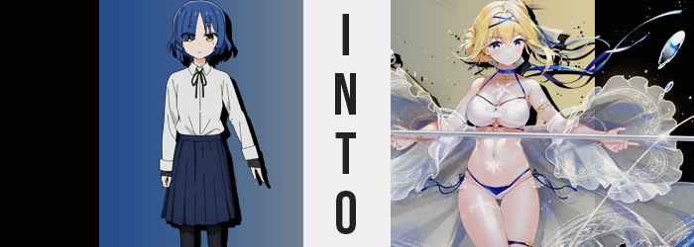

Ryo Yamada was sitting on the toilet.

Don’t get the wrong idea! She wasn’t going to the bathroom even if she was tucked away in a bathroom stall at the beachside convenience store. The girl had been smart enough to empty her bladder before she had come to the beach with the rest of Kessoku Band. No, her reason for sitting in the bathroom was far more selfish. Not that anyone would be shocked to hear that Ryo of all people might be selfish when the opportunity arose.

She was just avoiding going back to the beach too soon. While she considered herself to be one of Bocchi’s close friends, with her own personality the way it was she didn’t exactly consider herself to be particularly compatible with her pink-haired kouhai when she was going through one of her episodes. Something that was inevitably going to happen when you tried to get her to wear a swimsuit in public. It didn’t matter how secluded the part of the beach might be.

Bocchi would always be Bocchi-ing.

“Another five minutes should be enough time. I’m sure Kita is dealing with it just fine.” Ryo was playing a game on her phone and smirking to herself as she gave herself this time limit. She still had to buy the snacks they needed for the picnic but Nijika had gone off ahead. There wasn’t anyone to get on her case about putting it off. Once plus she left the bathroom? She could waste even more time doing the shopping. It was the perfect diabolical plan!

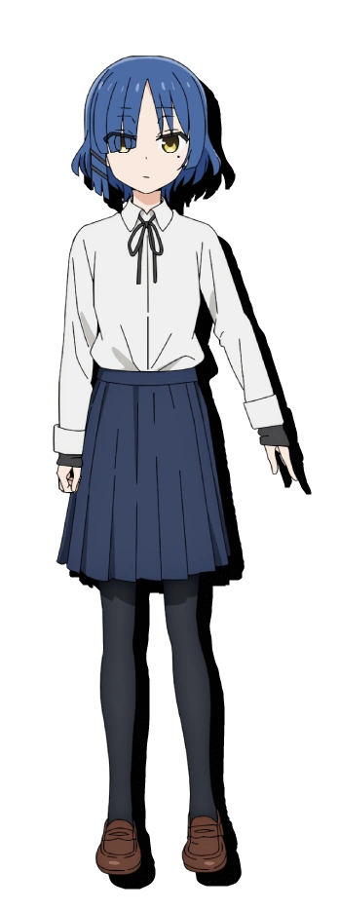
Enjoying the peace and quiet, she jumped a little as the bathroom door flew open and a noisy woman came into the bathroom. “Sorry! Sorry! I didn’t mean to drop the whole udon bowl on the floor!” Ryo couldn’t see her, but it was a woman seemingly yelling out the door as the tap ran. She was probably washing her hands or, since this was beachside, maybe she’d spilled something on her skin while wearing a swimsuit.

Wait, udon? Did the food section of this convenience store sell that? Huh. Thinking she might have to look into that after she left the stall, she returned her attention to the game on her phone once more while waiting for the woman to leave. She did eventually, but before that happened? Ryo couldn’t be sure but she felt like maybe she’d seen a flash of rainbow light shoot underneath the stall? Eh, that was probably nothing.

Once the coast was clear the girl finally stood off of the lowered toilet seat and placed her phone back in her uniform skirt pocket. Why had Nijika insisted they all come in their uniforms again? Something about helping Bocchi fit in better since she wore her jersey everywhere? Nonetheless, she reached for the latch of the stall door – only to pause. “Huh?”

Was something up with her fingernails?

Ryo was left staring at the hand that she had reached out, squinting with a growing expression of abject horror as she took in the sight of those nails. In fact, she raised her other hand to see if they looked the same. They did. She was a girl who kept her fingernails trimmed short, but they were now several inches long, manicured, and painted a royal blue color. This was to say nothing of her toenails, which now appeared the same, and the callouses she’d earned on her digits as a musician had all but softened away.

“WHAT THE HELL!?” This was enough to prompt an outburst even from the ever calm bassist, though unfortunately it wasn’t overheard by anyone in the adjoined convenience store. She stumbled back in the backroom stall, bumping into the toilet before correcting her posture… or at least she thought she had for a moment. Yet she soon fell towards the stall door, catching herself on it before faceplanting.

What had been the cause? It was like she had become heavier in the torso area all… of a… sudden…? Her gaze slowly traveled downwards while still holding herself against the door, settling on her uniform blouse which was… protruding far more prominently than it had been prior to her little fall. “You gotta be kidding me!” She was heavier, but it was all focused on her chest. Her bosom had swelled abundantly, untucking her blouse from her skirt as F-cup tits ultimately dislodged even the strap of her bra.

Ryo’s brain short-circuited in that moment. From shock? Certainly, but something in her memories had hitched. Why was she surprised about the size of her breasts? Have they not always been this large? Ever since I was thirteen? This question was communicated by her own brain in a tone that felt far too proper considering how overtly casual the girl typically was.

The hitch didn’t immediately sort itself out, and so her body continued to change without the recognition she’d been giving it thus far. Her waistline and tummy broadened for one, swelling thicker but not chubbier. She was simply gaining a broader frame that flowed naturally into hips that swung farther out in kind. You could hear her tights tearing beneath her skirt from the suddenness of this growth…

Although that tearing sound only continued from the combined efforts of her thighs and ass. Her upper legs were making great use of the excess space between them now that her legs had widened. Thighs were bloating stupendously, it not taking long at all for the nylon of her tights to tear as pink flesh poked its way out bit by bit. Before long her thighs met each other between her legs even with widened hips, and her tights were only still bound by the odd strand here and there that pressed into her flesh.

Behind these thighs? Her ass had been swelling, bubbling in girth as cheeks likewise grew rounder. They frayed the tights in their own way while her panties were wedged into her deepening ass crack. With the waistband of those panties frayed, it was clear that her lower half was far too wide for her underwear now – her body was much too mature for the childish uniform she was wearing now.

Fortunately for Ryo, she wouldn’t be burdened by those clothes any longer. The stall filled with a flash of golden, almost holy light, and when it cleared? She was wearing a blue and white bikini bottom, a white bikini top that held her ample bosom, and a blue choker around her neck with open, white, detached sleeves.

“What was I…?” It seemed the flash of light had begun to stir the young woman from her stupor (for her body was hardly that of a teenaged girl anymore). From the neck of up she still looked like Ryo, but both her voice and the way she was speaking as she corrected her posture? It all made her sound like a completely different person. A different person who didn’t know what was going on.

Which was fine. Her yellow eyes glazed over with a purer blue, the structure of those eyes slowly losing their Japanese traits in favor of something more Western. They were rounder in shape, bigger in size, and her lashes were notably longer. Yet what became of her gaze was a small part of her continuously changing face. It structurally became much prettier with slenderer bones and more pronounced lips.

Until all that was really left of her previous self was her hair, but even that was fleeting. “Hmm…” She raised a delicate hand to her chin, lost in thought. Had she been holed up in this bathroom stall for some reason? Of course she paid no mind to the vague sight of blue bangs lightening in color towards a blonde. Her hair was consumed by the color and then lengthened, though much of it was tied up by blue ribbons with one wrapping itself around her left thigh.
“To think that I’ve put off my task for so long… I should hurry to procure the necessary nourishment posthaste!” There was already something elegant and refined about Jeanne D’Arc’s appearance, the way that she spoke with duty certainly contributed to a perceived demeanor that was similar to the historical Frenchwoman that she had been named after. Of course she wasn’t the Jeanne D’Arc from history, her life had long ended (though Musashi seemed to insist that she was still about elsewhere).

Instead she was a Ship Girl that hailed from across the sea. She could maneuver atop the water like a fleet ship with ease if she so wished, though she hadn’t come to the beach with friends that spanned time and space to merely cruise atop of it. She had picked out a swimsuit so that she could swim with the others later. But before that? They had to get all of their things in order.

“Come to think of it, hadn’t it been Miss Musashi’s idea to have a picnic? Yet she was eating udon…” Stepping out of the stall while speaking to herself, it was clear that Jeanne’s memories of the past five minutes were at least somewhat consistent. Her life’s story was completely different now and she couldn’t recall being Ryo, but some of Ryo’s experiences had carried over. “Ah well, she has a voracious appetite. It’s strange that Miss Healer is always enabling her, however…” Probably because the Healer had a thing for Musashi.

Not that Jeanne was well versed in love. She hadn’t even noticed Tharja being interested in her that way. But how could they be compatible? They were practically light and dark, even if she did find Tharja to be a beautiful woman. Shrugging off the stiffness from resting in the cramped stall, she finally set out for the convenience store proper.

“I wonder how much food I should purchase?”

Considering Musashi’s attitude, surely a lot?

