Forces – Formula Sheet:
Newton’s 1st Law: | An object at rest will remain at rest and an object in motion will continue in motion unless acted on by a net external force.
Newton’s 2nd Law: | $$F_{net}=ma$$
Newton’s 3rd Law: | For every action force, there’s an equal and opposite reaction force.  $$F_{AB}={-F}_{BA}$$
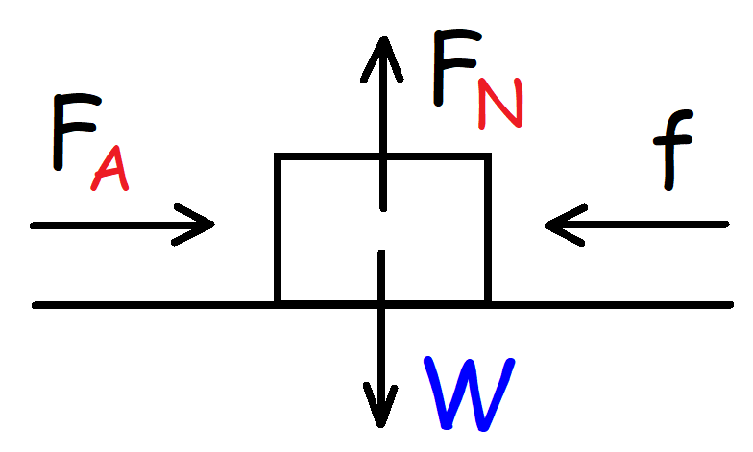 | Weight Force:  $$W=mg$$  Normal Force:  $$F_{N}=mg$$  Net Force:  $$F_{net}=\sum{F_{x}}=F_{A}-f$$  $$F_{net}=\sum{F_{y}}=F_{N}-W$$  Kinetic Friction:  $$f_{k}=u_{k}F_{N}$$  Static Friction:  $$f_{s}≤u_{s}F_{N}$$
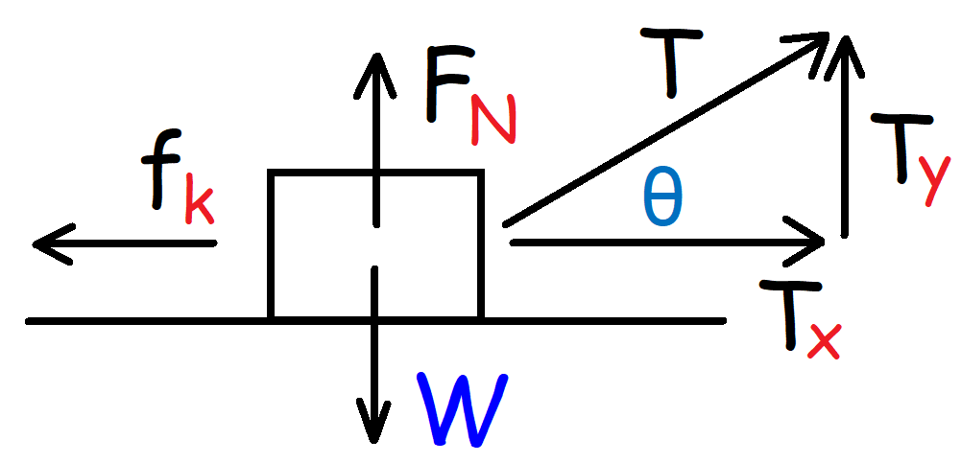 | Net Force:  $$F_{net}=\sum{F_{x}}=T_{x}-f_{k}$$  $$F_{net}=\sum{F_{y}}=F_{N}+T_{Y}-W$$  Normal Force:  $$F_{N}=mg-T_{y}$$  Tension Force:  $$T=\sqrt{{T_{x}}^{2}+{T_{y}}^{2}}$$  $$T_{x}=T\cos{θ} T_{y}=T\sin{θ}$$

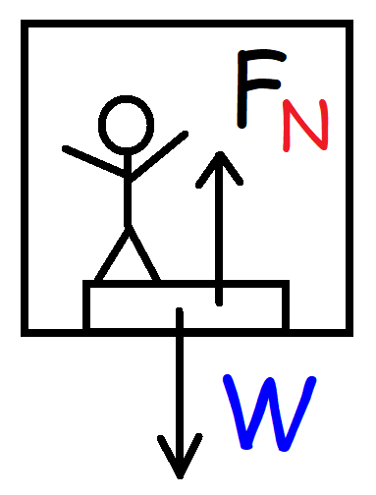 | The Elevator Problem:  $$\sum{F_{y}}=F_{N}-W$$  $$ma_{y}=F_{N}-mg$$  Normal Force:  $$F_{N}=m\left(a_{y}+g\right)$$  $$g=+9.8 m/s^{2}$$
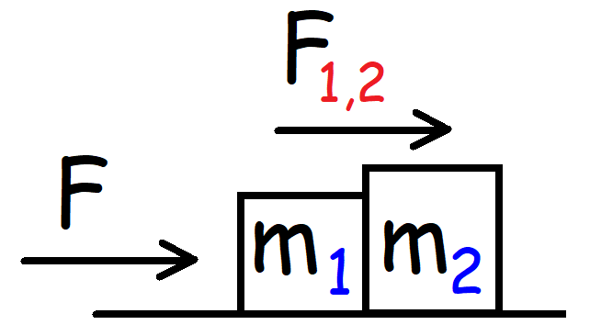 | Contact Force: (Without Friction)  $$F_{1, 2}=\frac{m_{2}}{m_{T}}F$$  $$a=\frac{F}{m_{T}} m_{T}=m_{1}+m_{2}$$
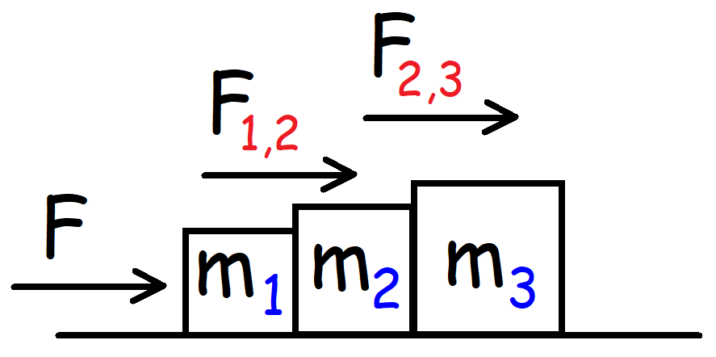 | Contact Force: (Without Friction)  $$a=\frac{F}{m_{T}} m_{T}=m_{1}+m_{2}+m_{3}$$  $$F_{1,2}=\frac{m_{2}+m_{3}}{m_{T}}F F_{2,3}=\frac{m_{3}}{m_{T}}F$$
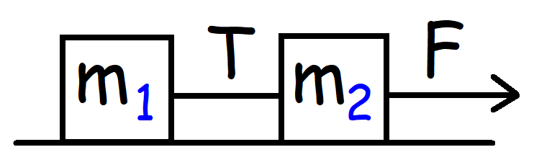 | Tension Force:  $$T=\frac{m_{1}}{m_{T}}F a=\frac{F}{m_{T}} m_{T}=m_{1}+m_{2}$$
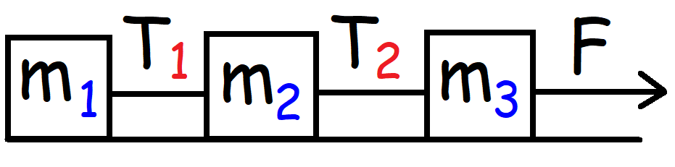 | Tension Force:  $$T_{1}=\frac{m_{1}}{m_{T}}F T_{2}=\frac{m_{1}+m_{2}}{m_{T}}F$$
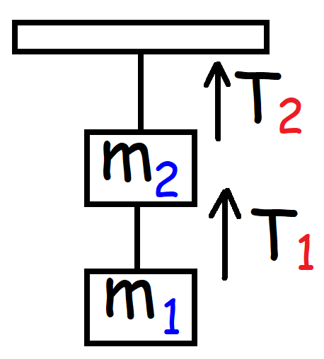 | Tension Force:  $$T_{1}=m_{1}g T_{2}=\left(m_{1}+m_{2}\right)g$$
Note: For examples with friction, see my physics video playlist at www.Video-Tutor.net

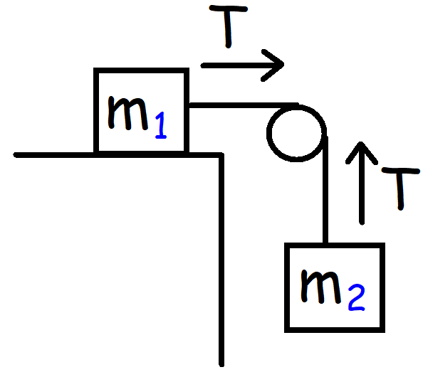 | Acceleration:  $$a= \frac{m_{2}}{m_{T}}g m_{T}=m_{1}+m_{2}$$  Tension Force:  $$T=m_{1}a_{x} T=m_{2}(a_{y}+g)$$  $$a=\left|a_{x}\right|=\left|a_{y}\right| g=+9.8 m/s^{2}$$  Note: $a_{y}=- since m_{2} is falling and a_{x}=+for m_{1}.$
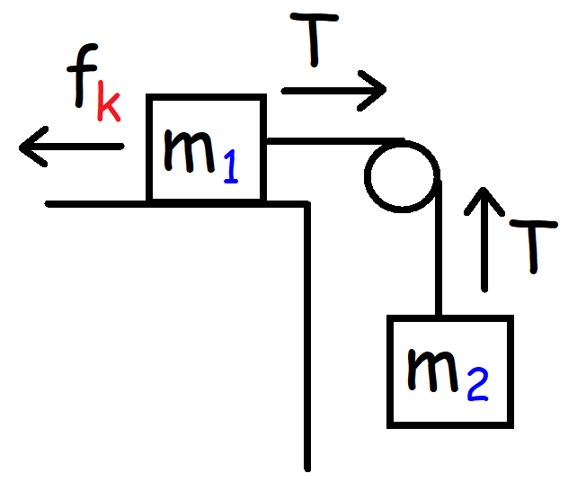 | Acceleration:  $$a=\frac{m_{2}-u_{k}m_{1}}{m_{T}}g m_{T}=m_{1}+m_{2}$$  Tension Force:  $$T=m_{1}\left(a_{x}+u_{k}g\right) T=m_{2}\left(a_{y}+g\right)$$  $$a=\left|a_{x}\right|=\left|a_{y}\right| g=+9.8 m/s^{2} a_{y}=- a_{x}=+$$
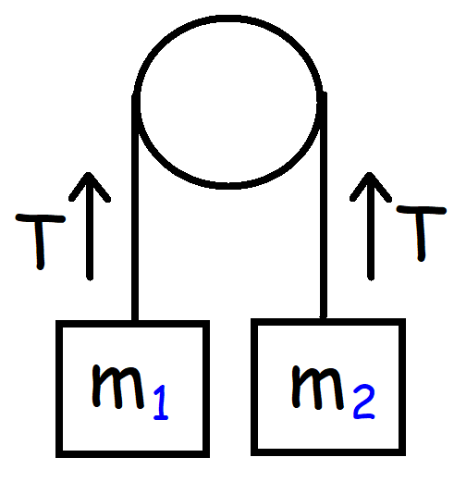  $$a_{y}=+for m_{1} since it^{'}s going up.$$  $$a_{y}=- for m_{2} since it^{'}s going down.$$ | Acceleration: (If m₂ > m₁)  $$a=\frac{m_{2}-m_{1}}{m_{T}}g m_{T}=m_{1}+m_{2}$$  Tension Force:  $$T=m_{1}\left(a_{y}+g\right) T=m_{2}(a_{y}+g)$$  $$a=\left|a_{y}\right| g=+9.8 m/s^{2}$$
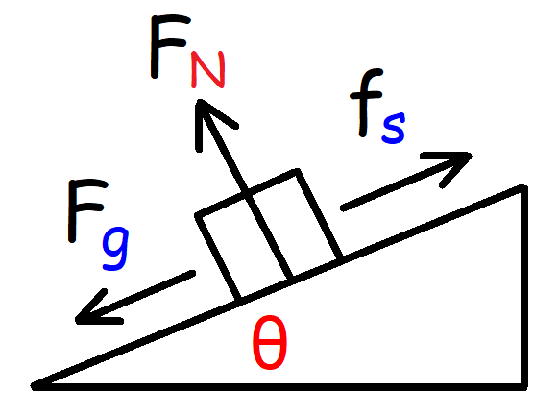 | Minimum Angle Needed for the Box to Begin Sliding:  $$θ=\tan^{-1}(u_{s})$$  $$f_{s}≤u_{s}F_{N}$$  $$F_{g}=mg\sin{θ} F_{N}=mg\cos{θ}$$

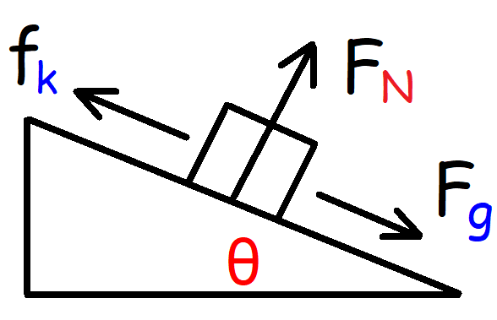 | Acceleration: (Without Friction)  $$a=g\sin{θ}$$  Acceleration: (With Friction)  $$a_{x}=g\sin{θ}-u_{k}g\cos{θ}$$  $$\sum{F_{x}}=F_{g}-f_{k}$$  $$F_{g}=mg\sin{θ} F_{N}=mg\cos{θ} f_{k}=u_{k}F_{N}$$
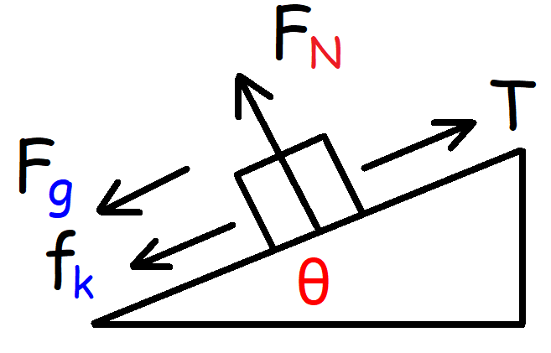 | Net Force:  $$\sum{F_{x}=} T-f_{k}-F_{g}$$  $$ma_{x}=T-u_{k}mg\cos{θ}-mg\sin{θ}$$  Note: $f_{k}$ will always point opposite to the direction of motion.
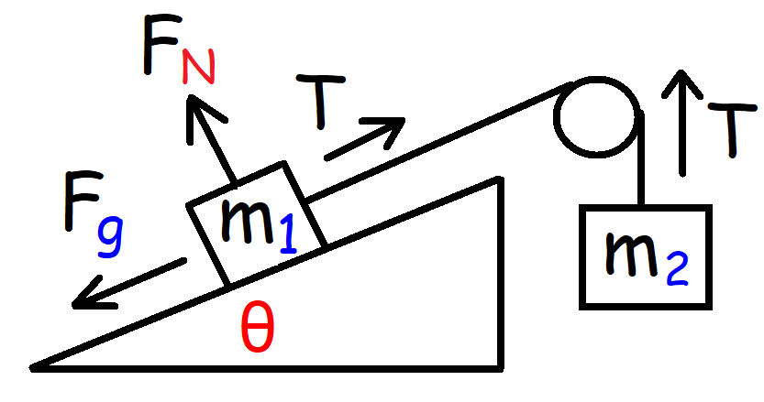  $$m_{2}g>m_{1}g\sin{θ}$$ | $$If m_{2}g>m_{1}g\sin{θ}, the system will move to the right.$$  Acceleration: (Without Friction) $a=\left|a_{x}\right|=|a_{y}|$  $$a=\frac{\sum{F_{x}}}{m_{T}}=\frac{m_{2}-m_{1}\sin{θ}}{m_{T}}g a=+$$  Tension: (Without Friction) $a_{x}=+ and a_{y}=-$  $$T=m_{1}\left(a_{x}+g\sin{θ}\right) T= m_{2}\left(a_{y}+g\right)$$
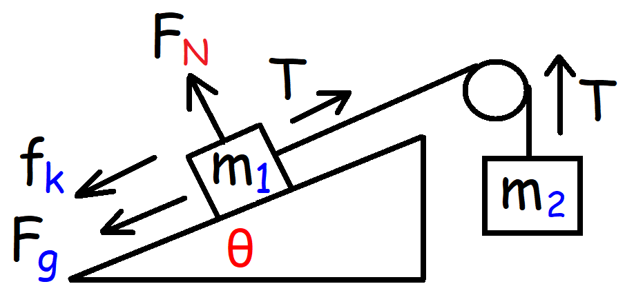  $$m_{2}g>m_{1}g\sin{θ}$$ | Acceleration: (With Friction) $a=\left|a_{x}\right|=|a_{y}|$  $$a=\frac{\sum{F_{x}}}{m_{T}}=\frac{m_{2}-m_{1}\sin{θ}- u_{k}m_{1}\cos{θ}}{m_{T}}g$$  Tension: (With Friction) $a_{x}=+ and a_{y}=-$  $$T=m_{1}\left(a_{x}+g\sin{θ}+u_{k} g\cos{θ}\right) T= m_{2}(a_{y}+g)$$

$$m_{2}g<m_{1}g\sin{θ}$$ | $If m_{2}g<m_{1}g\sin{θ}, the system will move to the left.$ (a = -)  Acceleration: (Without Friction) $a=\left|a_{x}\right|=|a_{y}|$  $$a=\frac{\sum{F_{x}}}{m_{T}}=\frac{m_{2}-m_{1}\sin{θ}}{m_{T}}g a=-$$  Tension: (Without Friction) $a_{x}=- and a_{y}=+$  $$T=m_{1}\left(a_{x}+g\sin{θ}\right) T= m_{2}\left(a_{y}+g\right)$$
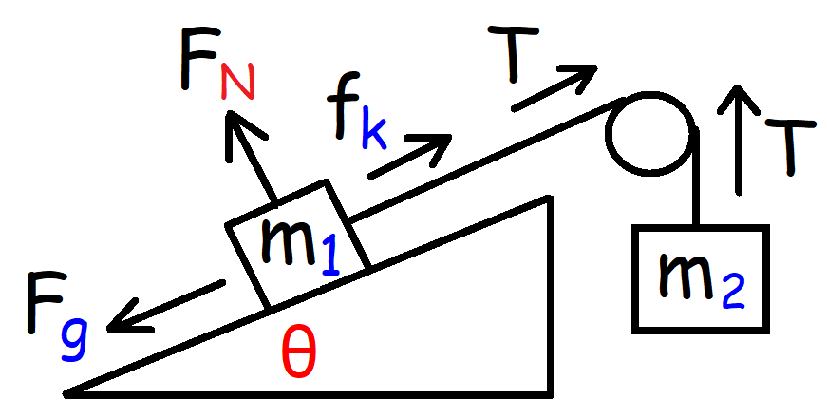  $$m_{2}g<m_{1}g\sin{θ}$$ | Acceleration: (With Friction) $a=\left|a_{x}\right|=|a_{y}|$  $$a=\frac{\sum{F_{x}}}{m_{T}}=\frac{m_{2}-m_{1}\sin{θ}+ u_{k}m_{1}\cos{θ}}{m_{T}}g a=-$$  Tension: (With Friction) $a_{x}=- and a_{y}=+$  $$T=m_{1}\left(a_{x}+g\sin{θ}-u_{k} g\cos{θ}\right) T= m_{2}\left(a_{y}+g\right)$$

