BRITISH TACTICS
COMMISSION STORY
BY CHALDEACHANGE
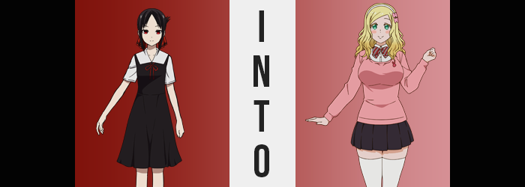

It seemed as if it was becoming more and more common to see Kaguya Shinomiya making that face.

No, not the cute and potentially ‘in love’ face that Chika believed she had caught the student council’s vice president making. The vice president in question was always extremely adamant that she wasn’t making a face like that whenever the topic came up. That was the kind of face that she reserved for her bedroom where no one else could see her gushing over a certain someone. The face that Kaguya had been making a lot lately? It was one of overbearing frustration. She was bottling up her feelings in the worst possible way.

Because love was war.

“Grr! He didn’t notice again! Is he dense!? Surely my charms should be enough to win over a troglodyte such as him! He should be bowing to and pledging his loyalty to me already!” It was after another long day of classes and the Shinomiya daughter had returned to the room in her family’s manor that belonged to her. The moment she finally had some peace and quiet alone? She practically slammed her face into the bed and began to shout a number of nonsensical statements like these into her pillow.

A frustrated Shinomiya was not a cute Shinomiya. But such was the fate of a wealthy and powerful girl in a school of her own peers. Everything had an element of power to it and love was no exception. Especially when the object of her affection was Miyuki Shirogane, son of the powerful Shirogane family and the student council president at Shuchi’in Academy.

Every proverbial dance with that man was a dangerous battle. Kaguya wanted Shirogane to look at her like a woman worthy of dating, but simultaneously she did not want to budge on her principles and end up in a situation where he could laud himself over her. Were these problems that could be solved with a simple conversation? Probably. But this was the world of the rich! Who really knew how their minds worked? It was all the more humorous that Miyuki harbored feelings for Kaguya in return, however. Neither of them had realized the other’s affections just yet.

But another day had brought about another failure. There were days where she felt like she had gotten one up over him but that day was not one of those days. “Do I need to change up my strategy? He does pay a lot of attention to Fujiwara, but I’ve never really gotten the feeling that she’s his type… Should I act cuter?” The very thought churned a knot in her stomach. She was not going to act cuter, that would just make her appear weaker!

KNOCK, KNOCK, KNOCK!
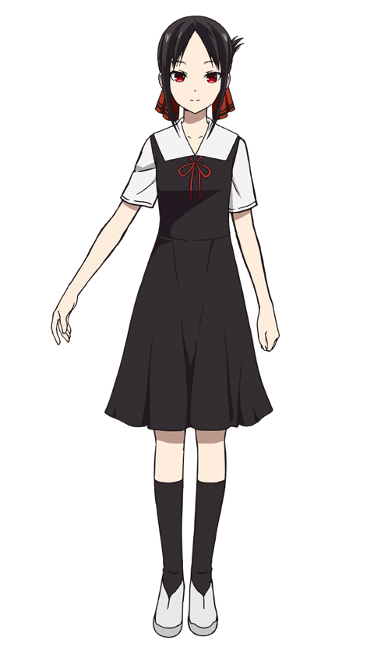
A knocking rang at her bedroom door, prompting the teenager to immediately jump up into a sitting position on her bed. She couldn’t allow anyone in the household to see her acting like that! “C-Come in!” In most circumstances this invitation was enough for the person on the other side of the door to come in and talk to her about whatever they had needed her ear for. “I said you could come in!” But moments passed with no effort on anyone’s part to open up the door.

Kaguya blinked and pushed herself off her lavish bed before moving to open the door herself. It was a little weird, but it would only be polite to make sure nothing had happened to the person on the other side, right? What if the one knocking had been in the middle of a medical emergency! The girl didn’t know what to expect when she finally opened the large barrier between her room and the hall, but what she found? It wasn’t really something she had been expecting.

“A hairband?” Sometimes packages were left for her by her door, but if she was home from school then they were usually delivered directly. But there it was, a white hairband with a pink bow on it sitting on the floor directly in front of her door. “Was it here when I got home and I didn’t see it? Or maybe the person who knocked on the door dropped it?” Certain that she couldn’t just leave it on the ground she picked it up and brought it into her room, closing the door behind her. “It’s a cute bow though. A cute… bow?”

Repeating that statement aloud, it almost seemed as if Kaguya had stumbled upon some sort of realization. She had. “I shouldn’t act cuter, but what if I dressed a little cuter?” Like with a cute headband? It was almost like fate itself had brought the accessory she was clenching in her hands to her! And well… that belief was definitely true in a sense. Fate certainly wanted her to succeed, but perhaps not in the way that she was assuming.

Shinomiya moved quickly over to the mirror in her bedroom and got to work fastening the hairband atop her head. It didn’t take long to do at all, and before long it was sitting in place. “Hm… I guess this color combination doesn’t really go with the rest of my appearance though…” Should she buy one in red and black? At the very least that color scheme would better match her hair? The girl turned away from the mirror for a moment to contemplate that. “Or perhaps my color scheme is giving me some sort of disadvantage? Does he think I look too gloomy?”

That idea pissed her off a little.

Had Kaguya bothered to turn back to look at the mirror in that moment, mind you? She would probably have immediately taken off the headband she had worn on a whim. Not because it clashed with the rest of her appearance, which she was correct to think that it was, but because of how it was affecting her hair. Which was needless to say something that no hair accessory should have done under any circumstance.

And yet? The black hair directly beneath the headband wasn’t… so black anymore. Instead it exhibited a light and golden sheen that wasn’t a hair color any Japanese woman could pull off naturally – at least without having mixed heritage. At first this blonde only just barely peeked out from underneath the accessory, but before long it spread, sinking into nearby hairs and then into the hairs nearby to those, and so on. It caught like a wildfire in a forest and in that comparison her head of hair was the forest.

But the teen didn’t notice and continued to step away from the mirror with the clip still working its magic. Color aside, these blonde hairs became wavier in the back and sides, but the clip she wore in her hair’s rear kept much of it bound up so that she didn’t notice yet even though it had grown a couple of inches longer. Her parted bangs were even parted no longer, instead swept to the left. While this all ended up being a series of changes that were simple for Kaguya to remain ignorant to, however?

“WHAT!?” The next set? Not so much. Kaguya couldn’t even have hoped to stifle the scream that jumped from her lips as a surge of weight prompted her body to stumble forward. It had been so sudden that it had completely taken her off guard, and for a brief few seconds she couldn’t comprehend what had both lurched her torso forward while simultaneously bringing her bra and top to feel much too tight. But by the time she had struggled against the pull to stand upright once more? It was incredibly obvious.

The girl was left gawking at her chest. “H-H-H-H-How is this possible!?” The weight, the discomfort; it had all stemmed from her bosom which had grown – no, continued to grow – into a much larger size than she recalled. Being small chested wasn’t exactly something that the teen had liked, but she was expecting that perhaps they would one day grow in naturally. This wasn’t how she had expected it to ever happen, and she especially hadn’t anticipated that it would come on so quickly. “How much bigger are they? Twice…? No, they’re getting larger!?”

A loud SNAP signaled the strap of Kaguya’s bra snapping while weight continued to pool with its cups, seeing her breasts swell fuller and fuller. Forget D-cups. They had to be at least E or Fs by the time their growth had culminated and her back muscles had adjusted to contain them. Her uniform dress had been hoisted up by their new sizes, which almost rivaled her own head in size! “But… Isn’t that silly of me!? They’ve been this big for… N-N-No they haven’t!” Something deep down wanted her to acknowledge those changes as… not changes at all. They want her to accept them as the norm? But her chest used to be so… so… She couldn’t remember how big they had been before!?

Making matters even more concerning for her, the sensation of clothing not fitting the way it should have became more widespread than just around her chest. Beneath her uniform’s skirt? She felt the urge to pick at a wedgie that was deepening further and further even despite the fact that she wasn’t moving, thus making it impossible for one to develop at all without her underwear somehow shrinking.

…Or the body that the underwear covered growing larger. Such was the truth of the matter, and while still struggling a little to manage the weight and shape of her new breasts, she craned her back so that she could have a look at her rump. “Eeeeh?” Kaguya’s voice cracked as she cried out this time, but the shock that had been so obvious before had certainly waned significantly. Regardless of how she reacted it had definitely been worth a reaction. Her ass now protruded nearly four inches farther out behind her, widened cheeks forcing her hips to momentarily dislodge and rejoin with a sharp POP! “Wah!?”

In a way it was probably for the best that her hips had widened because if they had remained at their original gait then it would have been impossible for her thighs to then grow as they did. Her slender body was rapidly being compromised in every possible facet, and the sponginess that applied itself to her upper legs was certainly part of that. They became so thick that they rubbed up against each other while she stood up straight, whereas the excess? It pulled her tummy a little wider and added just the slightest bit of a pleasant roundness to her gut.

“I don’t understand! My body is so different, but is it really different? Um… Wasn’t it kind of always like this? But even then…” Kaguya herself sounded torn on the matter. Changes to her memories suggested she’d always been that curvy. And not just curvy, but tall as well. Roughly four extra inches saw her short body sprout up, ultimately rendering her frame as something that almost betrayed what was considered the ‘standard’ for a teenaged, Japanese girl.

But there was a reason for that, and her blonde hair was the biggest clue as to why.

Her nose wriggled for a second as the girl felt a sneeze coming on but that sneeze never came. It had actually been a side effect of her nose changing shape, nostrils thinning by the length growing ever so slightly. Her lips took on a thinner but poutier shape between cheeks that thinned in chape above a narrowed jawline. It was Kaguya’s eyes that made the shift the plainest though, as crimson irises was washed over with a bright blue, and eyelids widened and curved so that her eyes were bigger, brighter, and pointedly Caucasian. Just in time for her memories to reflect this shift so that Kaguya believed herself to be a girl of British descent.

She blinked rapidly numerous times, her mind glazing over briefly. “I… Hm! Was I confused about something?” The teen asked in a higher pitch. Despite being British, her Japanese was just as fluent as anyone else who had grown up in Japan. And keeping in line with that? A magical change washed over her uniform, transforming it into a pink cardigan overtop a white dress shirt. A black, pleated skirt concealed pink lingerie and white thigh highs gripped her plush thighs so that they lipped over the hem. Throw in pink loafers, a striped bow, and an absence of her rear hairclip that allowed wavy, blonde locks to fall to her shoulders and…

Her new look, and her new life, were both complete!
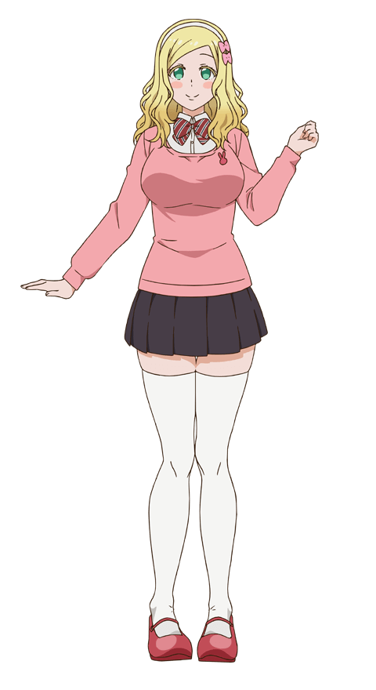
“Ohhh~? What was I doing again!?” Carol Olston seemed to be confused. But admittedly? That wasn’t very out of character for her. This British girl was a bonafide airhead. Her Japanese was good and when it came to her studies? She was surprisingly intelligent. But when it came to her personality? When it came to how she acted? She could be clumsy both socially and physically, and she definitely had a bad habit of having memory lapses where she forgot what she was doing.

So it was easy enough to write this off as just another one of those episodes. First she had to piece together why she was in this room. It was a big and fancy bedroom, but Carol was used to living a lavish lifestyle herself. She had once given a friend three gold bars for their birthday, after all! That certainly wasn’t the sort of gift that a middle class individual could afford.

But then it struck her. Memories that had been created were now slowly settling into place. “Right~! This is the Shinomiya manor! I’m here on with an exchange student program!” She hadn’t met the ‘Kaguya’ girl that was supposed to live in this bedroom, but that was fine! She had been taking good care of the room in the original owner’s absence!

This meant that she had just got home from school, right? “It was nice of them to let me wear the uniform from my school!” That was why her clothes had changed, even though it wasn’t a matter of the school being ‘nice’ or not. It was simply Shuchi’in’s policy that prestigious exchange students be allowed to wear the clothing that they were most comfortable in.

“Ah!” Carol had a realization and bopped her right fist down into her left palm. “I wanted to figure out which accessory to wear tomorrow, right!?” If one thing hadn’t changed about the girl it was this. A boy had caught Carol’s attention at school. The student council president. Miyuki Shirogane. The boy that Kaguya had a crush on. But funnily enough? Despite being incredibly attractive, Shirogane didn’t really have any interest in Carol. The girl was actually in a worse place than before she had been transformed.

But hey, love is a game, right?

“If I play hard enough I can definitely win!”

