MEDICALLY GOTH
FIRST PERSON STORY
BY CHALDEACHANGE
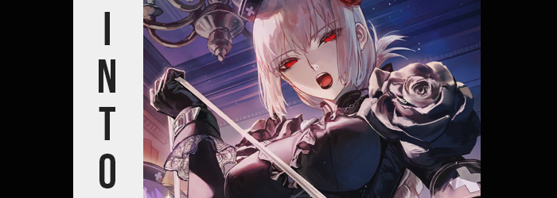

Who couldn’t relate to living from paycheck to paycheck?

Even if you were better off these days, unless you were born into wealth it was beyond likely that you would experience a period in your life where you could only really afford food, amenities, and perhaps the odd little treat for yourself. But living was living no matter how you sliced it, and sometimes just getting by was enough.

In my case? I’d just barely managed to choke out enough extra money to take a little trip with some friends. It wasn’t anywhere too far, just a seaside villa a couple of towns away from where I lived. We’d be staying in a small and fancy mansion for a couple of nights. Tasting the life of luxury albeit briefly. Not that we planned on doing anything particularly fancy.

“Hey, do you think if we roll for Servants while we’re there we’ll have a higher chance of rolling an SSR?” Such was one of the ideas that had been floated in the early planning days, referencing our shared love of Fate / Grand Order. Everyone had laughed it off at the time and it hadn’t been mentioned since, but everyone had brought their FGO machines, nonetheless, whether they were phones, tablets, or otherwise. We hadn’t even known if the villa had Wi-Fi!

As it turned out? It did. One of my friends was quick to ask after we had checked in, and before long we had all gone our separate ways to her own rooms to drop off our things. “This place really is fancy. It’s got like a Victorian look to it…” While located in America, there was something very European about the building’s design and the antiquated furniture inside. But there were still modern amenities in each room like televisions, outlets, and the like.

My own room was pretty big. It had a nice, fluffy bed and a deceptive chandelier hoisted above. Deceptive because it was definitely electronic, not that I really minded. I tossed my bag into the corner of the room with the intention of packing my swimsuit and things later, but since there was public internet I quickly took out my tablet and booted up Fate / Grand Order. “Time to test that theory… Probably to prove it wrong though.” There was no way in my mind that at least one other of my friends wasn’t doing the same thing at the exact same moment.

Round and round the light went as the did with every summoning. Being a JP player who’d been playing for a long time, it was almost impossible for me to ever roll new Servants these days – but I still liked that little bit of hope that I had right before it was taken away. When the gold sparks went off I knew it was a Craft Essence. There had been no loading hiccup which meant it wasn’t a new card.

“Huh?” But even so, the Craft Essence itself left me vaguely bewildered. The art featured a gothed up Florence Nightingale and Medea Lily. I recognized the card, but it had been run in a recent event. As a lottery prize. There was no way it should have been in the pool for rolling? Then again it also shouldn’t have resonated with an antiquated first aid kit beneath the bed I’d been assigned, causing both it and my tablet to glow a crimson red. “What the—!?”

The light was piercing; not only in brightness but because I felt this light pass through my body. It hadn’t hurt or anything like that, and upon checking myself immediately after the glow I didn’t seem to be in any immediate danger. But there was a lingering tingling sensation. Something close to a numbness and yet it wasn’t particularly strong. All I could really think in the moment was about how weird that had been.

Of course, I hadn’t noticed that my irises had changed in color towards a very vivid red.

Mind you it wasn’t just my eyes that had seen a stark color change since the flash of light. Slowly but surely my skin tone lightened towards a much chalkier tone – the change seemingly having waited until after I’d checked for damages to take effect. In a similar vein all of the hairs on my body had lightened towards a strawberry blonde that was a touch pinker than it was blonde. It was like someone had given me a Player 2 color swap.

“That was… odd. I wonder if there’s anything unsanitary about strange flashes of red light?” The fact that wondering if light was unsanitary, much less that I hardly ever concerned myself with worries like that, went right over my own head. Instead I was wondering why it felt so hard to talk all of a sudden. It was almost like my lips were sticking together? The concern crossed my mind momentarily before I moved on, just as the concern did about my eyes feeling heavy.

Both of those concerns were rooted in changes, however. Not only had my lips inflated so that they were thick and round, but the stickiness came from black lipstick that had been spread across them. As a man I had never worn lipstick before, but I also hadn’t worn mascara. Mascara that made my lashes longer and heavier, yet… My red eyes were also rounder and fuller in their shapes now, with strawberry blonde eyelashes trimmed thin.

My face had become wholly feminine, thinned dramatically to better sport these more effeminate, Caucasian features including a shrunken nose. There was no denying I was beautiful, but there was something about my gaze that appeared off. Almost vacant in a strange way. “What was I…?” I felt out of it now too. Like I had been flashbanged or something to that effect. I didn’t feel as if I was in my right mind.

Which distracted me as my changes worsened. My body was growing notably lighter now, excess pound seemingly drained away into naught. My waistline grew trim beneath a shirt that seemed baggier and baggier as the seconds ticked by, and effectively? My frame was rendered fairly androgynous by design. My shoulders were somewhat shorter across than they had been, but my hips remained untouched for the time being (which kept my pants up). If it could even be seen a positive then at least my slenderer body now better matched my pretty, thin face.

“This room is filthy…” I spoke in the sultry albeit subdued voice of a woman. To be honest this comment basically jumped from my lips without a reason for doing so. I hadn’t seen the room as anything but luxurious since stepping inside, and it looked immaculate. But something twitched in the depths of my soul. Just looking clean isn’t enough. It needed to be disinfected.

I swayed from side to side. Thinking was difficult, and as a side effect of my personality and memories slowly becoming compromised it almost seemed like I was rapidly passing in and out of consciousness. As I swayed though, my hair grew out. Strawberry blond locks cascaded just past my shoulders while lengthened bangs framed my face. Midst it all, my shrunken ears still poked out from behind stray strands. It all contributed to the increasingly androgynous appearance I was developing.

Until no doubts were left at all.

My destiny here wasn’t to be left androgynous. “Mmn—!?” A sharp tug between my legs saw to it that this was a certainty in a feeling that was equally parts confusing and arousing. The cause was clear, that my dick and balls had folded into the new slit and womb that had been entrenched within my loins, but I didn’t think much of the sex change itself as my mind fixated on the arousal. “No cumming here, that would make a mess.” Why did I care about that?

A sudden drop down to 5’5” saw my footing waver a bit, but I was still too out of it to register this as ‘wrong’ much like I didn’t doubt that I was, in fact, a woman. Which ultimately worked out for the forces that changed my body, for it seemed like all that was really left was to mold my body’s figure into something much more suitable. This included parting my hips wider as if an invisible force had grabbed and separated them – keeping my pants fastened.

Though my hips weren’t the only reason those pants didn’t slip. Before long a bloating had seen my thighs swell in shape and volume, the slack of my pants around my upper legs left little choice but to grip what had swelled into abundance keenly. On the other hand, in the rear the cheeks of my ass spilled over the waistline of those pants of mine, chalk-colored cheeks muffining without pause while affirming their new heart shape. If I was to take a step like this there was no doubt the front button of those pants would pop off and the excess weight would jiggle free.

Speaking of free, excess weight though? “Hm!?” My body stumbled forward suddenly. The reason escaped me personally but to anyone not being affected by the force that was transforming me, the cause was plain as could be. My once flat chest had inflated rapidly, a woman’s tits taking shape beneath my shirt that were likely DD’s in size with swollen nipples the size of quarters propping cloth up like a tent around them. They ached with need because they had only just formed and skin had tightly and sensitively been pulled around them, but I ignored their call to be touched.

Even if that call did intensify, but only because my ill-fitted outfit had begun to tighten around my body. Cloth darkened all about, some firming while my pants parted into a skirt with a nurse’s frilled apron above a par of black, stitched, thigh high, leather boots. Dark colors were the theme of this ensemble, with tights and black, lace panties hugging my ass and pussy snugly.

A matching, black nurse’s cap appeared atop a head where hair was pulled up into a bun, black and red roses in the corner of the cap itself. Hardly the only place where roses appeared, two black flowers that were larger than my new tits bloomed on either shoulder as tight sleeves were etched into a black dress that resembled a corset. Belts wrapped across my tight tummy; cleavage obscured by black nylon. Even gloves hid my daintier fingers. Aside from my face, not an iota of skin was left exposed.

But the dress’ design still appealed to fetishes and highlighted my sexy figure.

Did this make me big tiddy goth girlfriend material?

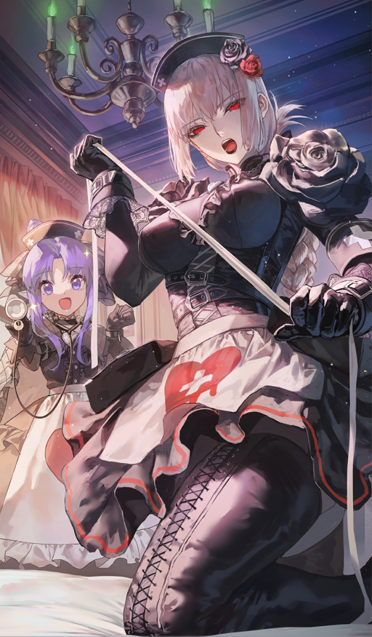
“Ngh… Everything around me needs to be disinfected.” I was no longer able to resist that odd itch in the back of my mind in any capacity. An itch that demanded everything around me be sterilized and clean. This room was old. There was dust. Who knew what kinds of infectants could be laying around? It was a good thing that despite how lewd my new outfit was upon my voluptuous woman’s body that it still covered from me to head to toe.

I knew that there was a first aid kit under the bed. My first aid kit. Much like my outfit it was pitch black and decorated with roses. A little fancy perhaps, but it was what the owner of this villa asked me to wear as his nurse, Florence Nightingale. How had a mere mortal managed to summon a Servant like me here? I couldn’t recall whatsoever, but at the very least that was what my memories suggested to me. It was the new reality that I had found myself in, and so I didn’t question the disinfectant wipes and spray that I pulled out of my kit and get to work on my room. Not a room I was renting, but the room that I was living in as part of my job.

But even as I cleaned up there was still a nagging feeling at the back of my head. Was this in fact what I was really supposed to be doing? I almost felt like I had come here to relax. “Relax? That word is hardly in my vocabulary.” What was more relaxing than working? Nothing. Which reminded me… “My help should be ready now as well. I’ll have to disinfect them too.”

Which of my past life’s friends had become the poor Medea Lily to my Florence Nightingale?

