BOTW: WITHOUT BLESSINGS
CHAPTER 5: TAUT AND TINY
BY CHALDEACHANGE
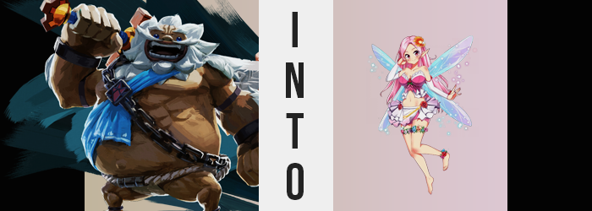

“Hrm? A forest?” The Champion of the Goron, Daruk, took no kindlier to the fact that he had suddenly been whisked away to a different part of Hyrule by that strange teleportation spell than his peers had been. It was of the utmost priority that he return to his people and the Divine Beast that he was meant to pilot, and before the influence of Calamity Ganon could cause too much damage.

While this was clearly the Kokiri Forest, the crimson light that bled down through the trees painted it all in a very ominous glow. The forest was completely still, with presumably most of its inhabitants having gone into hiding at first sign of the calamity. Not that the massive Goron could blame them for that. It was so still that there wasn’t even a breeze, which posed a potential problem for the massive man of stone.

Where did the forest’s exit exist?

There was no breeze. No determined path. No sound of water flowing. There was nothing but large trees as far as the eye could see, and not much of anything else when all was said and done. “Which direction should I go then? I guess I need to follow my gut, ahaha!” Despite how dire the situation obviously was, the Goron seemed to retain his high spirits at least. He had faith that things would work out. They had all worked so hard that it just couldn’t go poorly, and at the very least having a negative attitude about it wouldn’t help anyone.

It was fortunate that he was a Goron at times like these, admittedly. There weren’t many races that could just turn themselves into a ball and roll along. In fact, his people was the only one! All he had to do was compact himself and get rolling, and hopefully he could get out of the forest without knowing over too many trees. He didn’t really have faith that that would be the case though.
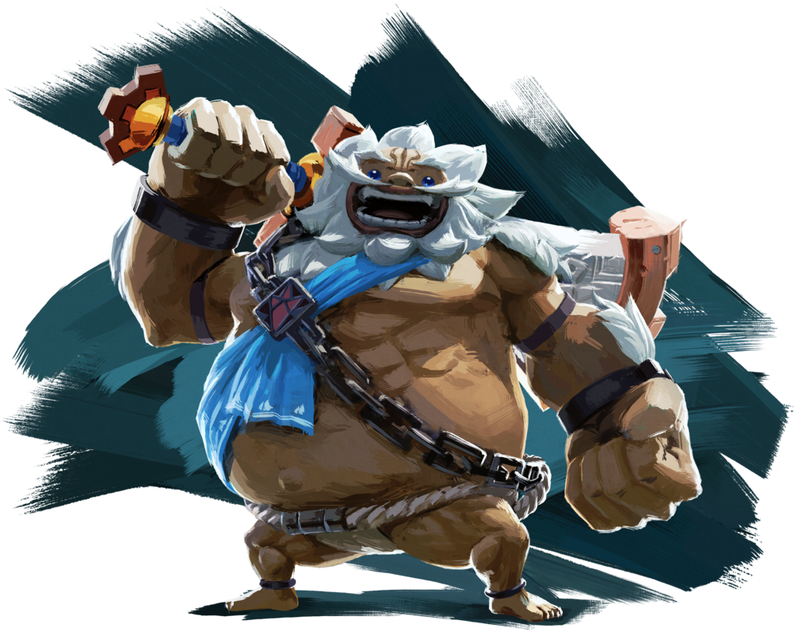
“Okay, let’s get rolling! Hyup!” The giant man jumped with the intention of triggering his transformation into a ball shape, but… it didn’t happen. Instead, his feet just landed back on the ground and the entire forest floor shook from the impact of his weight against the soil. “Erm… Let’s try that again! Hyup!” But the same thing occurred. It was an ability that was ingrained instinctively into every Goron, so he couldn’t possibly fathom what might lead to it failing several times.

The next he jumped, in what would be his final attempt, however? He found his fall to the ground took much, much longer than it most certainly should have considering his size and weight. “Huuuuh!?” In fact, it felt like he’d had a lot of air time, falling for what felt like almost twenty seconds as the world… was the forest growing bigger around him?

Unfortunately for the Goron, that wasn’t really the case at all so much as it was a matter of him becoming smaller. The red light filtering through the treetops had finally had an effect on him, and his once boulder-sized body shrunk down to little more than that of a small stone. By the time his feet landed on the ground? He was standing inside his own footprint as a fragment of what he had once been.

“How in the world? I’m little more than a pebble!” Stomp about as he might at this size, his footsteps no longer caused the earth to quake. Instead there was nothing as he jumped, his weight naturally decreased alongside his stature. But Daruk’s overall, consistent size was not the only thing that was being lost midst this predicament. A Goron wouldn’t exactly woo anyone regardless of how big or small he was overall, and so adjustments had to made to his great figure.

And so, his great mass, still consistent with his height up until this juncture, began to erode. Whether it was the thickness of his arms or the mass of his hands, it began with these appendages well dust seemed to become shaved from them. Thinner and thinner they became, the breeze taking the dust and spreading it elsewhere amongst the forest floor. “Guh!? What’s happening to my…!?” As much as the man tried to make a comment about it, he was otherwise rendered incapable of doing so because something clicked within that brought him to accept what was happening.

And that was true even as the sanding phenomenon soon plagued his torso, legs, and head as well. Like he was being rigorously smoothed down by a million hands holding sanding paper, his entire form was ultimately consumed by what seemed to be a storm of dust and sand – which in turn obscured his appearance and left the man coughing. After a few moments of this continuing the sand finally cleared, and yet what was revealed from within? That was certainly no Goron.

All of his stone form had been sanded away, leaving a figure made of soft flesh with thin limbs and a narrow torso. Even his great beard had been stolen away, and his face much more normal with bright blue eyes and long, pointed ears. Rather than a Goron, he looked much closer to a Hylian than anything. An extremely tiny Hylian. “What just… Why do I feel so weird!?” Even Daruk’s voice had changed, sounding quite feminine. Which perhaps wasn’t all that surprising, since the shaving had left him with nothing between her legs as well. Well, other than that slit, of course. And a bush of hair above it that was unusually pink.

That pink was quite to appear elsewhere. It found itself into the hair atop of head, for one. And that hair quickly spilled over her shoulder, falling down to her rear end as it was restyled into something soft, silky, and effeminate. As did the pink seep into her eyes, which lit up as lashes grew and the eyes themselves turned to a much greater, more pronounced size. Any ruggedness that her face possessed was very quickly sanded away as well, and before long Daruk’s features were undeniably womanly, plump and succulent lips and all.

“Ugh, why am I walking? I’m not supposed to walk!” Where were these words coming from? Not even the tiny woman herself seemed to know, but it didn’t stop her from blurting them out. Why would it be strange to walk? Needless to say, her body was quick to give her a reason or two – starting with its overall weight distribution.

After being slimmed down into a more humanoid form, Daruk had come off as looking like a rather thin man. That didn’t seem to totally be the case any longer, for some weight did weave itself into her figure. But it wasn’t around her belly, or anywhere unusual for her new sex, really. But that didn’t mean that it wasn’t at all inconvenient.

Growing a pair of tits as big as your head still amounted to some problems, after all. And that was exactly what happened, with her new nipples thickening before a mass beneath them brought flesh to jiggle and bounce with a growing intensity. More and more they flourished, and idly her hands began to tease them – hands that themselves were different, for fingers had become daintier and lined with long nails painted in pink.

“Ooh…” It felt pretty good to fondle herself, she realized, and it kept her distracted as the lower half of her body’s figure filled out at well. Hips widened first to accommodate what was to come, while bloating flesh made better use of that space. Thighs thickened and her rear end swelled taut, with skin pulled tightly around them so cheeks almost shone. In the end, her hourglass figure was undeniable.

Just as undeniable as the fact that she no longer needed to bother walking.

Why? Well, her pointed ears stretched out so that they were even longer than a Hylian’s, not that this was the cause. It was an emergence of four wings behind her, and the subconscious knowledge to use them that soon had her fluttering in the air as magic sparkled off of them, that led to that reality. Each wing was as beautiful as stained glass, but they were thin and shaped like a dragonfly’s.

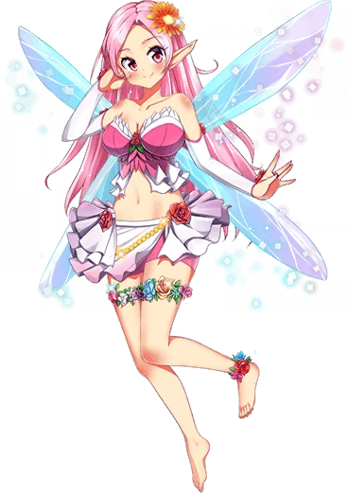
A far cry from the massive, muscular Goron that she had been before, a tiny fairy fluttered about midst the light of the crimson forest. “Oh my~ What’s going on, Mr. Calamity Ganon?” Singing as she spoke, the tiny woman cast her gaze towards the forest’s canopy. She felt some kind of special link with the darkness that had beset this land, because she wasn’t exactly one of the native fairies that lived in Hyrule.

With her big breasts and hourglass figure, it was clear that she was a fairy designed to entice others into tasting her sweet nectar, so to speak. She wasn’t meant to be bottled and exhausted to bring back someone on the cusp of death to life. Nancy was a different, seductive sort. But she was also a singer and a teacher, surprisingly.

“I guess this forest is my home, but where is everyone!?” Monster or not, a fairy was still a fairy. They were intrinsically linked to nature, whether they pledged themselves to Calamity Ganon or not. And that was why she was so confused. There was nothing wrong with Ganon, so why was everyone hiding?

“Maybe if I fuck their brains out, the other fairies will come?”

Well, she’ll certainly corrupt them that way.

