*Winner Takes All*

**"C'mon Daniel, if you're not careful-shit!"**

**"Should keep your eyes on the screen Max, you talk too much…"**

**"Shut your hole dude, we'll see who's talking when I have you eating out of my hand!"**

With the combined raucous of two controllers clacking furiously under the dexterous fingers of the gamers that held them, a small, dimly lit room was the.staging ground for the greatest battle the two nerds had unwittingly found themselves fighting with no clue whatsoever;

A battle to see who would keep their manhood, with the loser being forced to forfeit it in its entirety.

Because living in a world where flying cars, cybernetic augmentations and holographic tablets were real wasn't a rose tinted dreamscape like many in the past thought it would be; Rising cybercrime cases that had real world implications like never before because of how close the physical and digital realms had been brought together, terrible allocation of taxpayer funds due to government corruption, the gap between the rich and poor expanding at a ridiculous rate, record high environmental pollution, etcetera etcetera.

Ever the thrill lover, Max had been the one to suggest that they install something that would, in his own words, spice things up when the time came for their weekly gaming sessions together. When asked if it was a mod by the more tech savvy and concerned Daniel, the hard headed Max had simply laughed it off, plugging a strange chip into the console before he could say a word.

And with the two already connected via neural link thanks to the added effort by developers to combat piracy, the effects of the chip were instantly made clear when both young men received a blinding flash of installation messages and error codes popping up in their vision, ending off with a peculiar heart shaped symbol radiating salacious intent appearing over their pupils, remaining dormant for now.

**"Buddy of mine snagged this cool thing off the net, apparently only works when plugged into a game that's got local PVP in it!"**

**"And did you even think to ask him why this thing works the way it does? For all we know it could be hacking our home network…MY home!\***

**"Chillax dude, the guy just said it stuff those connected to the console full of those preem grade medical nanobots, and until the game's over, they'll be right at home and we can't leave without a penalty…you chicken?"**

**"Max…do you even understand the words that just came out of your own mouth? Besides…y'know? Spicing up our weekend game time?"**

A genuine shrug of the shoulder and an unashamed smile was all Daniel needed to know that his dunderhead of a friend had probably accepted some shady black market product this other 'friend' of his had offered to him probably for safekeeping while he fled from the authorities and whatever gang was hot on his heels.

And with it plugged into the console and their fates sealed before he even had a chance to inspect the damn thing, it seemed if they wanted to leave intact then they'd have to go through with playing the game that the chip had created for them while avoiding whatever it was Max had mentioned would 'spice things up'.

Making a mental note to never let the dullard handle anything related to technology ever again while in his home, Daniel sighs before accepting the controller from Max, being retro style gamers, they preferred a physical handheld controller over the modern digitized versions that didn't feel good to use.

The moment their eyes fell on the screen, it was easy to see how the chip had modified the game software; turning their simple one time done configuration into a gauntlet style battle tournament mode, featuring a total of 5 rounds with the victor presumably decided by who won the most rounds.

**"Did he even tell you how this is supposed to work? Winner gets decided on who scored the most?"**

**"I dunno, I guess? That's how a competition's supposed to go right?"**

**"I swear to God Max this is the last time I'm letting you handle the console…"**

And after a decisively quick choice on which characters they felt most certain would bring them victory, the game would begin in earnest with both Daniel and Max feeling a raging excitement in their hearts alongside a cold chill, doing their damnedest by playing like they'd never played before, unwilling to be the guinea pig that would end up having to test the rules the chip played by.

But eventually, one would have to lose, and that someone would predictably be Max. Not used to being put under pressure and having a strong boasting streak, his carelessness would cost him the first round. Groaning in tune to the victory trumpets signaling Daniel's first win.

**"So? How're you feeling? Any…wait, your eyes…there's something strange going on with them!"**

**"W-What? What's happening?! You'd better not be pulling my leg dude?"**

**"I-I'm being serious here, its pink, there's some pink light coming from inside!"**

Sure enough, with the first loss, the dull heart in Max's eyes begins to glow an ominous shade of magenta pink, pulsing in tune to the panicking youth's body beginning to ripple and contort, sweating buckets as beads of salty liquid begin to drip and flow across smoothening skin while hard earned muscles begin to recede, vibrating like jelly until layers of soft, supple flesh adorned slender limbs and a tight torso beginning to show signs of bodacious curves that needed just a little more time to grown in with a thinned neckline supporting a shrinking cranium that had already lost most of its manly qualities by the time his singlet hangs loose over a tinier frame while baggy pants sag lower down his cinched in waistline, showing off smooth calves and fattened thighs in the process.

It didn't take long for Daniel to realize what the terms for losing were the moment Max's wild hairdo cleans itself up into smooth silken locks of pale silvery brown that made up a cute bob cut framing the beginnings of a girly visage. If it weren't for the flat chest and obvious but weakened member straining against his pants, Max would've been easily mistaken for a girl, blushing furiously while tracing daintier fingers over his transformed body, wincing when the sharpened nails finally graze against his sensitive nipple tenting the singlet that Max could already see taking on a more revealing quality to it as cutouts widen, straps thin and it's hem cutting down in height to reveal a tender belly sheared clean of ugly body hair, blushing at the sight of it.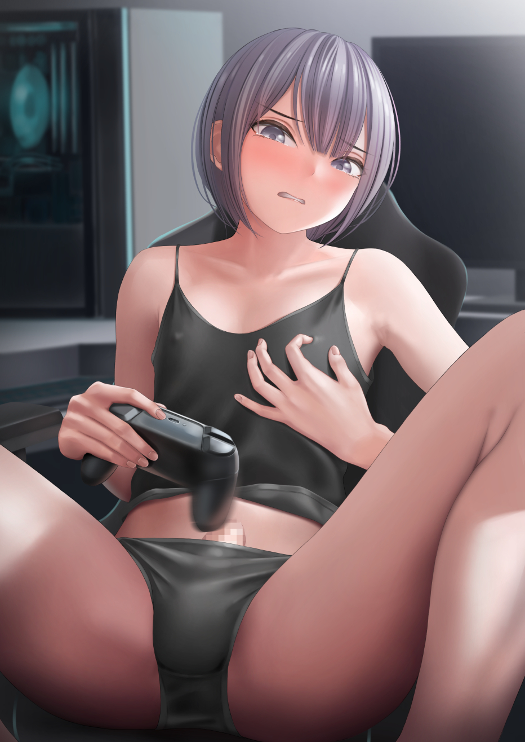

And judging by the equally flushed expression on Max's face while he dabs away the sweat coating his new form, the process must've been pleasant to say the least. But once he was done cleaning up, the look on his face was anything but pleasant.

**"T-Tell it to me straight man! What's…happened? Oh god, my voice…it's so…"**

**"Girly? Yeah…whoever loses…I think, becomes girlier…and I think the loser becomes the winner's…dream girl…"**

**"What makes you say that?"**

**"Because…you're starting to look like what I…y'know?"**

**"S-Shut up asshole! You'd better lose the next round you hear me?"**

**"How am I an asshole? And for the record, you were the one who started this whole thing!"**

Staying quiet with an angry pout on his face was more than enough of a signal for Daniel to quit pushing lest they end up fighting for real. Sighing as he picks up the controller once more, Daniel puts his mind into playing the game once more, beginning the 2nd round with a much more serious atmosphere lacking in friendly banter and jeers, both players razor focused on winning no matter the cost.

And for Max, foul play wasn't out of the question any longer once he had fully realized what was at stake here, rushing forward to disconnect Daniel's controller before he could even react.

But the moment his hands make contact with the wireless port, an electric shock sends Max flying backwards much to Daniel's shock that Max would stoop that low to snag a win, still not hesitating to rush over to help as the screen flickers with static before automatically giving the win to Daniel who was busy trying to help a stunned Max onto his feet before backing away once he felt the intense heat radiating from his friends transforming body, throwing his head back with a dazed expression just in time for it to finish tipping over the edge into womanhood as wide eyes narrow into effeminate slits framed by silky lashes while respectable lips fill just a little bit more into full cushions with skin so pristine it had a natural gloss to its pale pink coloration.

**"D-Dan…I don't…feel so-hngh?!"**

Doubling over while clutching hard against his navel, Daniel backs away to give his changing friend space, watching wide eyed as the rest of his body continues its transformation as hips snap outward into moderate handlebars while his roiling ass balloons into a firm derriere, convulsing in overwhelming pleasure as the ecstatic cry of a young lady bursts free from Max's lips, yelling out in pleasure before groaning as movement between his legs intensify before hitting climax, soiling his pants with a damp spot before the pent up rod begins to deflate, shrinking into a tiny nub of sensitive nerves that settles in comfortably around a moist pink blanket of flesh framing the fat lips of a virgin snatch, leaking a trail of fresh lubricant down trembling thighs at the paralyzing sensation of testicles sliding up her innards to take their place as active ovaries beside a heated baby chamber pumping her body full of female hormones and chemicals, triggering further changes in her body as she flops over onto her back, choking back a moan as her eyes make contact with a flustered Daniel frozen to the spot.

*'That…****delicious*** *idiot…looking at me with those…****cute eyes*** *of his! What am I even…thinking?!'*

Within her mind, Max was beginning to feel strange emotions fluttering within her whenever the thought or image of Daniel crossed her mind, blushing while choking back a cry, struggling to tear her eyes away from the nerdy young man staring at her with wide eyed duress. The childish anger she once felt for him begins to crack, breaking under the unfamiliar weight of love, wondering why Daniel looked so scared and what she could do to flip that grimace upside down instead of smacking him to vent her frustrations.

But another burst of energy surging forward and building in her chest as a roiling mass interrupting her thoughts, what little remains of Max's mental image struggles to keep ahold of itself as her chest begins to ripple with change, displaying a disturbing yet strangely arousing sight akin to invisible hands squeezing, pulling and kneading at his softened chest, encouraging firm fat and soft flesh to coagulate, fill and expand until two small B cup tits had fully grown over a flat chest, wasting no time in testing it's milk producing capabilities as wet spots on her singlet where her nipples were tenting the fabric begin to leak sweet nectar; mother's milk.

By the time it was over and the timer for the third match started its countdown, Max was no longer Max, leaving a dainty young girl where a rough hewn scraggy boy once sat. Lying in a pool of her own making while struggling to rise back up to her feet, weak arms reaching for her discarded controller lying by her feet with a frustrated click of her tongue. Clearly embarrassed and angry at her predicament.

If anything it served to dissuade any further thoughts on foul play from a fully feminized Max and a stunned Daniel, who only just seemed to snap out of his stupor as he takes a step forward.

**"Max…are you?"**

**“Just shaddup and play already you big dummy!"**

Even her voice has fully lost its grit and innocent naivete, sounding more like that of a tomboy who was genuinely mad…at her boyfriend.

*'Big dummy? He's never called me that before…and as far as insults go…he didn't even sound that mad! Is this thing affecting the mind too?'*

Although Daniel could clearly see some hint of longing beginning to burn within the sea blue eyes of his dream girlfriend taking shape from his friend's body, there were 3 more rounds left to win, Daniel was beginning to dread just how far these changes would go if he did end up winning all of them.

But that was something he didn't want to feel firsthand, and besides, Max had brought this upon herself in the first place for using obviously illegal black market tech. Body and mental alterations outside the law were up there as one of the most severe crimes to be branded with. Which only made Daniel more nervous after thinking about what to do once this was over. For now however, he had another game to win, muttering a silent apology in his mind and steeling himself to secure the last 3 wins.

*'I'm sorry Max…but you brought this on yourself…'*

**"Ah hah! I've won! Suck it Dan!"**

It was supposed to have been an easy win, a surefire victory now that his opponent had been distracted,

But Daniel's confidence had been deftly slapped aside after being dealt a crushing defeat by the same girl who not too long ago, had resorted to cheating because she knew she couldn't win. It was like he was playing against someone else entirely.

But she wasn't a girl back then, and she certainly didn't have the vocabulary and gaming expertise needed to one up her more experienced, intellectual friend. Because his wish for a dream girl had been granted, so too did it grant Max the tact and know how to do well in any game she played from now on.

***'A girl who could game just as well as she excelled in her studies.'*** That was the basis for Daniel's ideal. And now it would be his undoing.

**"Shit…I guess it's…oh wow…it's really hot..all of a sudden…"**

**"Mmhm~ Really makes you feel all hot and bothered doesn't it?"**

Dropping his controller, Daniel begins to convulse in his seat, trembling while struggling to disrobe himself to let some air in, only managing to shirk off his jacket before his limbs stiffened up, locked in place by the nanites he could feel beginning to work their magic like they had on Max, groaning in discomfort at the eerie sensation of his bones being cut down to size while his own flesh shifts around them, reallocating themselves into new positions while fresh biomass bubbles into existence, stunning Max with the sight of voluminous clouds of steam emanating from Daniel's body from the rapid formation of mass.

But the intense heat would also serve a useful purpose; heating the tips of Daniel's ginger toned hair that, unlike Max, he kept in a long unkempt mane that lended to his geeky nature. Rapidly curling them into silver tipped strands of stiff but lustrous locks of midnight black, gaining a healthy blossom to it from the roots as his scalp cleanses itself of dandruff, becoming a fitting match for the girlish face already taking shape beneath it as a lengthy fringe drapes itself over his left eye alongside a bevy of hair accessories that keep the new style in place.

With his body lacking in muscle and already bearing a somewhat androgynous appearance, the nanites coursing through Daniel's body seemed to pick up the pace, taking cues from the second phase of Max's transformation as the bulge in his neck recedes, changing the grating gasp of a young Caucasian male into the sonorous sigh of a young oriental lady that would most certainly make people think of questionable imagery if they heard it without proper context. Much like the fantasy Max was trying not to dwell too hard on as she fidgets nervously on the bed, rubbing her smooth thighs together while keeping her hands to herself.

**"Damn girl…you sound…LOOK…amazing~"**

**"Ssshut it…this…isn't what it loo-oahhn!"**

As the adorable slurring gives way to a throaty moan, Daniel's body convulses once more, consumed in mind numbing ecstasy that leaves petite feet twitching madly in the air thanks to his reduced stature, doing his damnedest to resist the burgeoning mass building behind his chest as his singlet ripples and contorts in disturbing fashion. But instead of a Chestburster, two melons one size bigger than Max's cute B's burst forth to fill the empty cups of a girly singlet with lace floral deco around the collar, dropping a head lower as an unstable strap slides down the rapidly feminising man's shapely shoulder, showing off a healthy amount of cleavage that sends Daniel into a fit of crazed lust, no doubt triggered by the soft fabric of his top rubbing taut against his highly sensitive nips, looking like angry red nubs by the time Max had found the will to walk over to help her friend, swallowing the ball of saliva in her throat while dabbing a towel over Daniel's far smoother skin, feeling a tinge of jealousy well up inside her as she adjusts the new girls top to fit her curvier proportions, watching with wide eyed curiosity as the erect pecker between her legs begins to shrink away inside loose fitting hot pants, but not before spraying a pathetic dribble of thick white cum that splashes between milky thighs before giving way to a healthy spray of slick fluids emanating from the sputtering folds no doubt already nestled between her long curvaceous legs by the time her pants billow out into a short pleated skirt that matched up well with her singlet.

And while she still held reservations against her strong lingering attachment for Daniel despite the sudden gender inversion, the fact that she now looked like the girl of her dreams with an expression of cocklust plastered over her face with literal hearts in her eyes was too big a force to ignore, feeling herself draw closer and closer to Daniel…

Unable to help herself, Max leans in to slide her tongue down Daniel's inviting lips, pushing past her weakened jaws to savor her sweet smelling saliva and breath. And all the second girl could do was groan in protest as the hearts in her eyes glimmer brightly in tune to the stimulation she was receiving, clenching dainty hands while kicking madly, struggling to free herself from Max's grip while the countdown for round 4 blares in the background.

Left with three seconds till the timer ended, Max finally parts from a fully transformed Daniel, both girls breathing heavily while staring entranced into each other's eyes with a bridge of saliva hanging between their pert lips as they each made their own efforts to recover; Max with her tongue cleaning up her mouth, Daniel adjusting her new thick rimmed glasses while frowning in confusion, looking like she was about to question Max on what she saw in her dream girl if she was myopic.

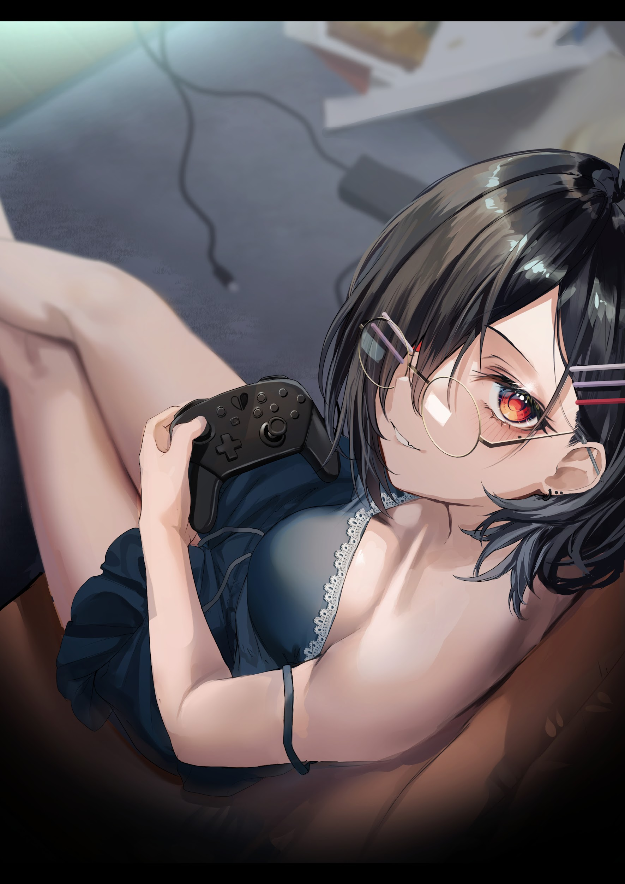

But with the game moving on with or without them, the two girls continue their banter while resuming the match, already showing clear signs of who the imminent victor would be as Daniel clicks her tongue in frustration, squinting at the screen while blushing furiously, clearly affected by whatever Max's desires had done to her.

**"D…Did you really…have to do that? Make me into this…slut?!"**

**"W-Why not? You made me your girl…and now you're mine…well about to be anyway. And you're no slut in my eyes girl~"**

**"Damn it…we'll see who gets the last laugh when I'm done with you!"**

**"Looking forward to it~"**

**"You damn horndog!"**

Despite the brave front Daniel was putting on, she knew she had no chance of winning as her shoulders slump in defeat while dropping her controller into her lap seconds before the game was even over, cradling her head in frustration as Max's mischievous cooing drifts into her ears alongside the tingle in her skull as the nanites begin their alterations once more, realigning synapses and firing them off within the intellectual's mind without her notice.

**"As much as I love what you've done to my head and all that? I like my girls a little more…on the ditzy side if you know what I mean. Sorry Dan!"**

**"The heck're you even sayin' sorry for…the hell's up with my voice?\***

**"Damn, you're already sounding absolutely adorable~"**

With the degradation in her vocabulary, Daniel's studious brain would soon see a fairly large IQ drop that puts her down to Max's level pre-change, struggling to recall algebraic formulae while losing dexterity in her fingers as the hand that once held the controller firmly in her grip begins to loosen, no longer able to recall the proper grip she used for fighting games and becoming more focused instead on makeup and fashion, things a girl her age would be interested in.

But before either of them could continue goading each other, a new jingle alerts them to a new development in the final match of the game, staring with gaping surprise at the announcement of a 3rd participant joining at the last minute.

**"T-That can't be! Shit s'pposed to be just two players ain't it?"**

**"You're asking me? You're the one who bought the game Dan!"**

**"Ahh let's just deal with this bozo! It's the last match and I totes don't wanna lose!"**

Scrambling for their controllers, the two rivals would soon find themselves staring at a 3rd character standing between them, ready to tag team the mysterious player to oblivion whose username was scrambled with static above a third healthbar improperly placed in the middle of the screen.

But no matter how coordinated they tried to be, the mystery player seemed to be leagues ahead of them in terms of skill and reaction timing. For every hit they landed, their foe.would return it trifold, countering before pushing the offensive once more. And with Daniel no longer being the expert gamer she once was, it was inevitable when she was singled out and focused on, with Max's attempts to save her being a futile mess that only serves to chip away at her own health bar from Daniel's panicked button mashing.

**"I need help here! This guy's beatin' me hard!"**

**"Just…stay still! You're hitting me!"**

Alas, both their efforts would end in failure as the third player sends Daniel's digital avatar careening off screen, ending the march as the timer hits zero before he could turn his attention to Max. Silencing the pair as the screen fills with bold text;

PLAYER DAN - ELIMINATED

Sharing one last glance with each other, the hearts in Daniel's eyes light up in time for the light of intelligence inside them to fade away, drooping lifelessly to the floor as Max rushes forward to catch hold of her friend, shocked to realize her curled head of black hair was already well on its way to becoming a long messy mane of chestnut brown by the time she lays her out on the couch, shaking her shoulders all while her impish figure continues to age, gaining expanded curves in all the right places as her innocent dress morphs into a more daring and adult getup complete with a loose orange top that shows off her right supple navel alongside a shredded set of jeans with plump flesh peering through the gaps.

**"No, no, no! This can't be! C'mon! Snap out of it Dan!"**

**"Hmm? My name isn't Dan silly, it's a lil close, but that doesn't sound like Delilah now does it?"**

By the time her spectacles melt away to allow for the splendor of the young minx's eyes to flourish without distraction, Max was already backing away, horrified at the sudden memory loss and change in personality as the now twenty something year old brunette unbuttons her jeans while giggling salaciously, showing no interest in the game anymore as she pushes herself up against the bedding while undressing herself before her former friend. Undoing the newly formed bra that easily slips free out of her skimpy top while sliding silken panties down long luscious legs free of their skin tight prison without a hint of embarrassment in her vapid eyes still aglow with that accursed heart burning brighter than ever. Leaving Max afraid and embarrassed at the sight of her changed friend beginning to masturbate without a care in the world.

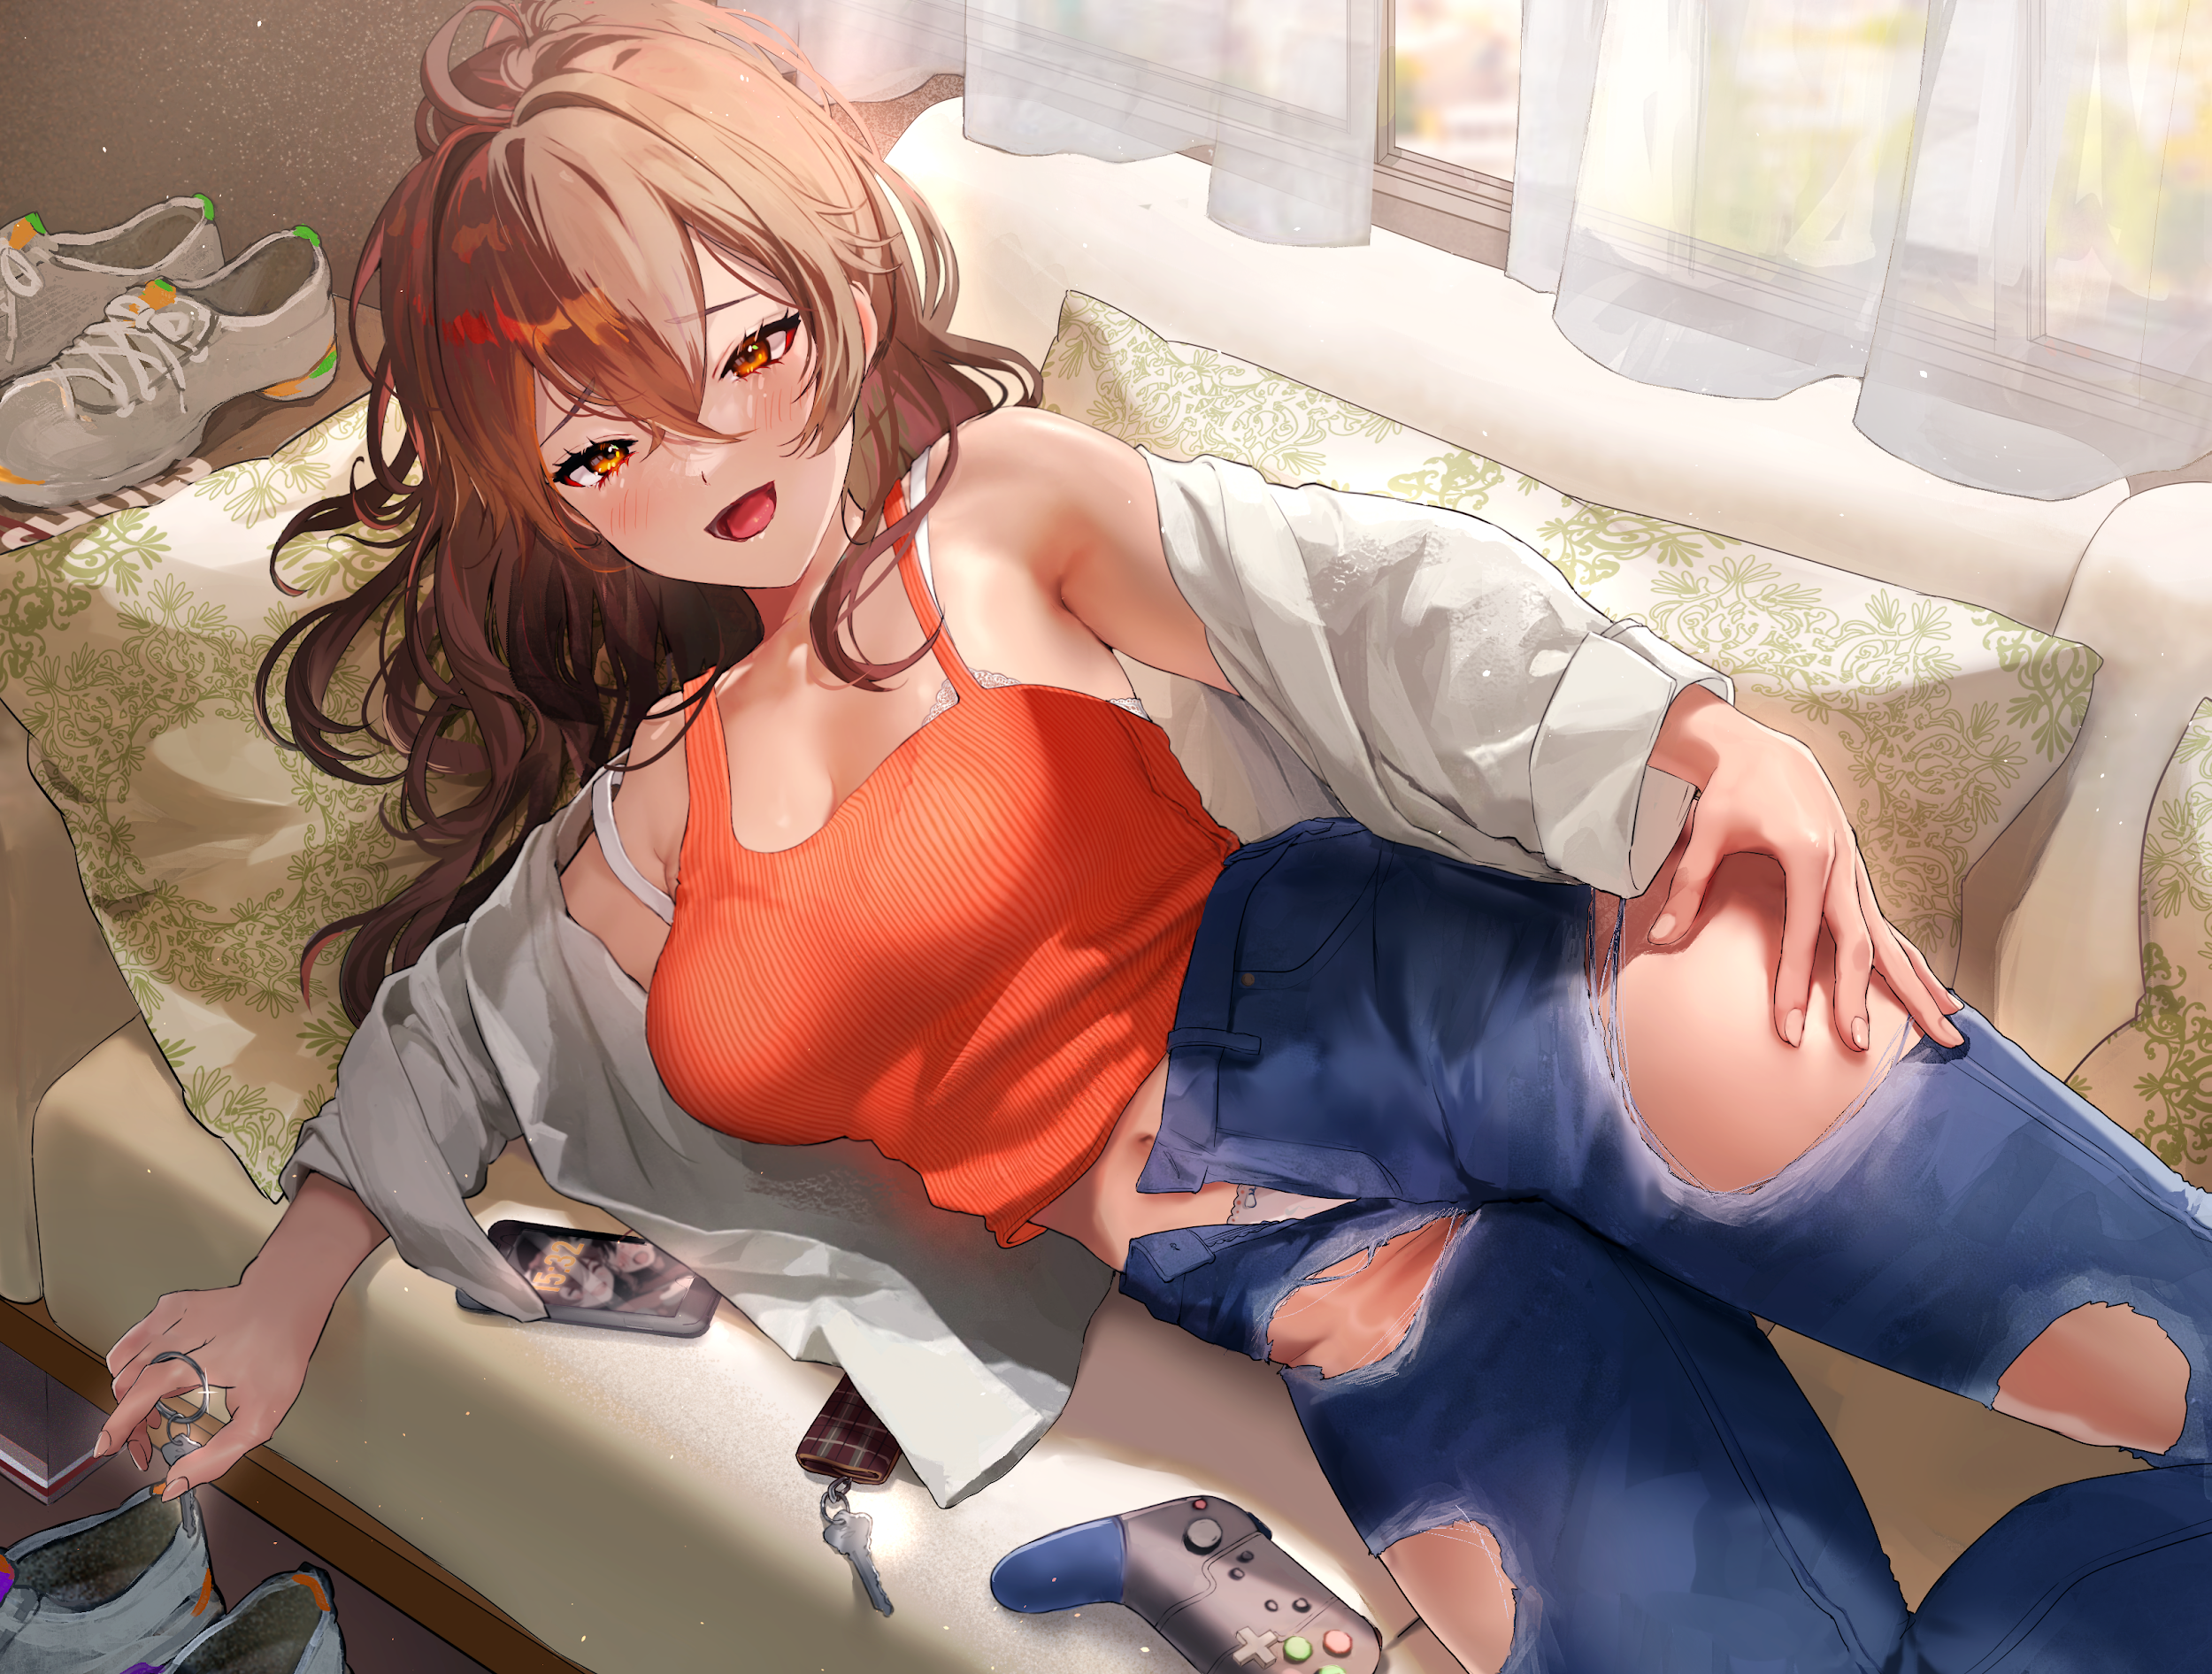

**"C'mon Dan! F-Fight it! This isn't you!"**

**"I have like, zero clue what you're going on about sister, but don't you think you have more important stuff to worry about? Like that game thingy of yours? You sure it's fine to lose like that?"**

Turning around in a panic, Max knew then that it was too late to even do anything as her body suddenly tenses up while her vision begins to blur, spinning on her heels before collapsing in a heap on the chair Daniel had been using before Delilah took her over. Blank eyes glimpsing the message of the victor of a sudden death match she had remained oblivious to in her panic to help her friend, feeling a final spurt of anger rise in her chest before her vision in tandem with her thoughts, are instantly silenced to the tune of pink embers lighting themselves into the shape of a heart for the final time within deep blue irises that were slowly being diluted with traces of mesmerizing magenta.

Regret derived from being foolish enough to accept that obviously shady deal, anger at the mysterious third player for stealing her girl and turning her into some unrecognizable slut, sadness at having missed her opportunity to turn it all around. All of it would fade away in the dark, discarded and forgotten without mercy.

PLAYER MAXIMILLION2000 - ELIMINATED

Feeling her body begin to shift beneath her clothes as subtle gasps and groans escape her lips, Max's emptied headcase begins to fill with new memories of a vastly different life from her old one, shifting to accommodate the sexy brunette currently moaning mindlessly beside her as her elder sister, filling in the gaps of a shared childhood and school life together. Everything, from work to play, they did together.

Until a sharp split occurred in highschool where, at some point or another, Delilah had stopped hanging out with her, preferring to spend her time hanging with the jocks and delinquents instead of studying with her. Thinking nothing of it, Melina had simply continued on her path towards being a computer engineer, honing her technological skills while Delilah mastered the use of her body, becoming a sexual savant while her baby sister made a name for herself as a master of computers.

But right before Melina graduated, the young girl, still oblivious to the adult world her sister seemed to bask in, had willingly accompanied her out on what was supposed to be a 'sisters outing'. Although she could barely recognize the ditzy bombshell from the Delilah of old, Melina saw no harm in spending time with her after realizing just how long they hadn't interacted with each other.

That was the day she had her first taste of the debauchery of her sister experienced on a daily basis, whether it was an aphrodisiac in the intoxicating drink she had sipped from or the atmosphere of the nightclub Delilah had dragged her into, Melina cared little for the reason she had ended up with a man's tongue stuffed firmly down her throat alongside his girthy member pulsing away inside her womb, drunkenly indulging in sex with a complete stranger who Delilah had claimed to be her boyfriend.

By the time night had come and gone however, Delilah's private outings would now be joined by Melina in her spare time. While her newfound libido wasn't as high-strung as her sister's, she always found a good dicking to be an excellent stress reliever, opening her doors for her Delilah and her new boyfriend, who had taken a liking to groping and using her while she worked on her computer, eventually accepting a gig on an adult streaming site for some earnings on the side.

But once said earnings spiraled into the thousands after her weekly streams of ***'Hardworking Gal Gets Pegged by Buff Boyfriend'*** had netted her a sizeable number of simps and twisted individuals who had a kink for the seemingly emotionless lovemaking Melina had become known for, said gig would become her full time job with thoughts of a life at college no longer of importance on the vapid girls mind.

While she still loved her games and anime as much as the next week, sex was now dominant priority within Melina's aching brain, no longer able to remember why she felt so distressed just moments ago, attributing it to a lack of stimulation as her used snatch pulses and contorts in need, flexing around a non existent dick as a new ensemble of clothes finish forming around her aged body. Stripped clean of any semblance of purity it might've held under Max's purview.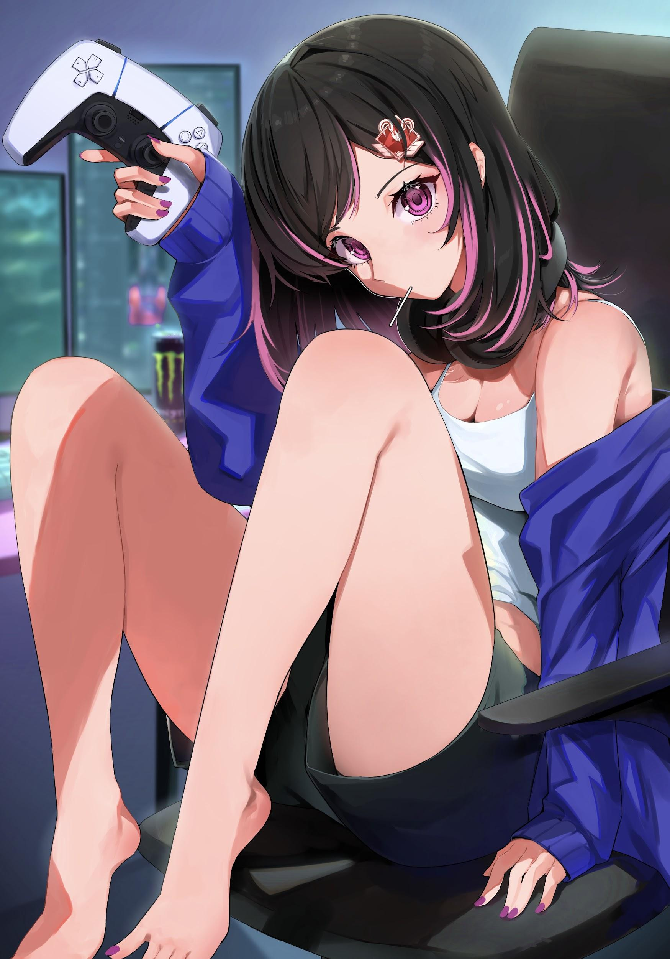

All that was left was a temptress hiding behind the mask of a geeky girl, as big of a slut as Delilah but with more control over her actions and a newfound loyalty to the stud they both shared.

With her new memories and personality slotted carefully into her tampered brain, Melina shakes her head, blinking slowly before her blurred vision settles on her big sis cleaning herself off on the sheets, recovering from a similar haze of newly altered memories going unnoticed as she shoots her a warm smile.

**"Hey baby gurl~ Slept well?"**

**"Mmm…feel like I haven't moved in ages…what're we…doing here? This isn't our home…"**

**"Now that you mention it…this really isn't our home at all…and what with those clothes? This some nerds cave? Yuck!"**

**"I mean…they've got a good setup going but this stuff? Totally last gen…"**

**"Speakin' of…how about we ditch this place and pay Dex a visit?"**

**"Sure, but I call dibs on round one, it's a Sunday and I'm due live in about an hour, Dex's got a banging workstation I could use."**

**"Eheh~ *'Banging'* workstation…"**

Slapping Delilah playfully on the shoulder, the two young women would simply leave the abandoned room behind without a second thought, leaving the foreign house they no longer held any familiarity with in what little clothes they had on their person, eager to return to the arms of the sudden victor who had intruded on their spicy weekend gaming session.

Spying the two sisters heading his way from the street camera, the man who had passed Max the chip in the first place relays the success of the experiment to his superiors before preparing himself for the arrival of Delilah and Melina…

*THE END*