MY SILLY LITTLE TASQUES
BIWEEKLY STORY #78
BY CHALDEACHANGE
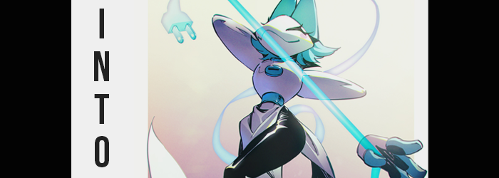

There was never a shortage of problems with modern technology, honestly.

Everything could be working perfectly fine one moment only to succumb to chaos the next. To some, these failings amounted to little more than minor inconveniences. To others? They based their livelihoods on proper, working technology – for them to break just would not do. Not to mention that tech that didn’t work properly could leave to a loss of life depending on what device malfunctions in the first place.

But this isn’t a tale of something so dire. Instead, this is the very unlikely, very unbelievable case of a simple computer error gone wrong. One that took place on a Windows PC. Because of course it did. Well, similar things would probably still happen on a Mac, so maybe I’m being a little harsh? Either way, my computer, being a computer, decided that it would one day start giving me errors.

“The Task Manager has stopped working again?” Sitting at the desk in my office first thing in the morning, I was understandably upset by the sight of a familiar error. It had been happening all day, and when I had work to do at that. The task manager was meant to be the beacon of hope that could help you resolve computer errors, not bring them about itself! Such a thing was essentially the betrayal of a computer owner! “I can’t afford a new computer. What are my options here…?”

Closing the Task Manager didn’t help. Rebooting the computer didn’t help. Could I do a clean install? But then I would lose literally everything that I had available on my computer, which was no good. My only other thought, no matter how futile, would be simply unplugging and plugging back in the tower. It probably wouldn’t amount to anything, but I was just desperate enough to give something strange like that a try.

It wasn’t a convenient thing to do. My desk was in a corner and my tower was in the back. That meant moving the desk out of the way and crawling on all fours. I wasn’t a small nor nimble guy, so it was the last thing I wanted to do. But I did, and without any fanfare I unplugged the power cord and waited thirty seconds. There certainly shouldn’t have been any ceremony once I plugged it back in, but…

“Uh…” Power sockets weren’t supposed to glow a bright blue, were they? Not that I was afforded much of an opportunity to dwell upon it; not before the strong feeling of suction claimed me. And I ceased to exist in the physical world any longer.

If any time had passed from that moment, I certainly didn’t have a clue. Instead I found myself standing in my bedwear upon a seemingly endless bridge of big, white cubes. There was no landscape as far as the eye could see, but off in the open distance, where someone might expect to find a sky? There was a big, anime image. One that was posted around the bridge four times. It wasn’t just any anime image though.

It was my computer’s wallpaper.

I blinked and shook my head from side to side. “I must be dreaming… Was there an electrical shock that knocked me out?” Really, that was the only thing that made sense. Because this was just far too unbelievable otherwise.

REBOOTING TASQUE MANAGER!

The sound of a loud, robotic voice booming almost had me jumping out of my skin! Where the hell was this? A dream about being inside of a computer or something? Of course, because I could only hear? I heard the phrase communicated as “REBOOTING TASK MANAGER”. I was left wondering if my computer issues had begun to influence my dreams of all things?

“AH—!?” Any belief that this was a dream was quickly dismissed by a sensation that ran through my entire body as the bridge cube beneath me suddenly began to glow a dark teal. It dissuaded my allusion that this was a dream because, well, it hurt like hell, like a static shock that welled up from inside of me and erupted from my flesh and bone – not that there was any visual indication of such a thing happening. My heart naturally raced, and my eyes quivered from the unwanted stimulation.

Just as quickly as it struck me, however, it came to an end. But my issues only progressed from there, in the form of a whirring sound that forced me to look around frantically. The cube below me – nay, the entire bridge – was still glowing, but it was what was coming that caught my attention. A similarly colored, translucent laser grid that was coming across the bridge. Was that bad? It was probably bad. “Should I run!?”

RUNNING IS DISORDERLY.

Even if I wanted to, where could I go? The bridge extended off almost into infinity in both directions, and there was nothing but a void below. My limited time trying to devise a plan eventually ended though, and the laser grid passed over and through my body. Bringing a new wave of tingles. “Why do I feel so… cold?” No. Was ‘cold’ even the right word? Everything felt less warm, but I wouldn’t exactly describe it as cold.

I looked around with confusion, and as I did, I remained oblivious to some unusual tells. Tells that told an impossible story: that my body was somehow changing in ways that were clearly robbing me of my humanity. The ‘chill’ I had felt hadn’t been all that unwarranted in the end, at least if you looked at my skin. Beginning with my face, patches of porcelain white spread across them. This change bled into my chest, stomach, and legs – and yet strangely even though it crawled into my feet as well, it did not touch my arms or hands. Which was a shame because the hands were where I would have immediately noticed.

It wasn’t simply a change in color that teased my porcelain flesh, on the other hand. Anything that became dyed white ultimately firmed up, ultimately looking just as solid as its color suggested. Despite being so hard though, I still had all of the flexibility needed to move, and that included my mouth and eyes. As a side effect though, all of my body hair had been effectively eliminated. “What was that scanner thing? It’s like I’m in some sort of strange digital world. Digimon? Is this like Digimon?”

If that had been the case, I might have been becoming one of the titular monsters. I wasn’t. But that also didn’t mean I would be remaining human much longer. Humans didn’t have skin so pale nor hard. Nor did they have bright blue hair, which was now a trend plaguing my short cut. Gone were the original colors in favor of this blue, a blue just a few shades lighter than the glow the blocky bridge was emanating. But so too did the length of my locks crawl, settling at a luscious shoulder length that was far longer than I would ever rightfully wear.

As for the hair around my groin, it all dissipated to leave white skin bare.

“Huh? Why am I smiling? There’s nothing good about this!” It was strange. Try as I might, my paled lips kept pulling up into a smirk. My hands were still the same color, and my hair had only grown in the back while not at all in the front, and so I remained oblivious even as the colors of my eyes changed. Now, when you consider the color of an eye normally, you would think of the iris. But it was everything – from irises, to pupils, to sclera – that ultimately shone a bright yellow. Even my lashes joined in on the occasion, lengthening in a very feminine manner.

STYLED SYMMETRICALLY, TO MAINTAIN ORDER.

Whether it was those glowing, yellow eyes, my blue hair, or my pale skin, I likely looked more like a clown than anything. And I didn’t even realize it! Those look was practically reinforced my a pair of pink blush stickers that seemed permanently fixated on my cheeks. “Whoa!?” I was taken by surprise as the laser scanner that had passed the first time returned from behind, and in doing so I noticed my voice. It was strangely high all of a sudden?

Butt that was the least of my concerns. A weight had been lifted from my body with its passing, and it was only when I looked straight down at myself that I noticed the cause. “My clothes are— WAIT!?” The fact that I was naked was shocking. The fact that my skin was so white was mind-blowing. Except my nipples and my dick, which were… why were they blue?

“This is… It’s like one of those stories I’ve been reading…” Not just stories, but art as well. Content where people are transformed – it was something of a guilty pleasure. But I never thought I would be experiencing it! As I stared down at myself though, something other than my skin color caught my attention. My stomach was always bulging out a little, but that bulge was regressing? And in tandem with that, it was my chest that began to bulge. “Uh…”

Even though my skin had firmed so much with the previous color change, my chest was looking rather soft. Nipples had grown plumper as the flesh beneath pushed forward. They were most certainly breasts, and yet the soft orbs seemed far too tender once they peaked at around what I assumed were D-cups. They almost looked like they were made of jello? “I have tits!?” Considering the pitch of my voice, it wasn’t all that surprising really.

Simultaneously, my bellybutton had evaporated along with my tummy fat. And boy had it evaporated. This ultimately led to a collapse of my waistline that left my gut so miniaturesque that you could probably wrap two hands around it fully. Proportionally it was just as strange as my gelatin breasts, and it made my hips look unusually wide. Er… was it actually just an illusion, though?

The size of my tits really got in the way of proper examination, and so despite my decision not to grope them, hands worked at trying to part them so that I could see down the middle. They were so sensitive in their overly abundant squishiness that I expected my rod to get stiff from the unfamiliar stimulation. That wasn’t exactly what happened though, as I realized after holding both breasts out to the sides somewhat uncomfortably.

“Oh gosh, my—!?” In my mind I had gone to swear, but ‘gosh’ had come out for some reason. Cuss words incite chaos, after all. My shock wasn’t censored though, at least regarding the sight of my dick’s tip disappearing into my loins where a growing void forced my legs to wriggle uncomfortably. I quickly dropped my tits, and they bounced up and down several times as a result, but that didn’t matter. A hand went directly between my legs out of concern, and before long a finger disappeared up between blue pussy lips. “It’s gone…!”

Not only that, but my previous question of whether my hips were actually widening or not had been answered in the process. They certainly had grown wider, several inches that left a gaping absence between my legs as I weighed pushing my finger even farther into my pussy. I ultimately stopped and withdrew my hand, but even as I did so it felt as if the hand in question was being suffocated.

Because the porcelain thighs around that hand had been swelling, thickening, bloating – ultimately rendering my hand’s escape more perilous as both thighs met in the middle of this gap. It was a phenomenon replicated in my dumper too, the cheeks of my ass swelling into a perfect, round, bubbling shape that was tighter than my chest was.

“I’m a woman…” I sounded a little dejected, but that wasn’t quite it. That wasn’t a bad thing in any capacity, and it was a little exciting to think about? But I was still in shock, and the fact that my body’s colors, and the strange design of my chest, were among things that left me confused. I’d been so distracted by my new assets that I hardly noticed the laser field coming back for a third pass though, only noticing once it had happened.

I only noticed then because the scan, while it passed, reconstructed fresh clothes over my once naked body. They weren’t conventional though, and when it came to my ass and chest, they almost felt way too tight. The weirdly jelly feel of my tits ultimately made some sense though, for the white, tailed coat I now found myself in constricted them so tightly that my chest practically looked like one big orb. A steel, blue ring was wrapped around my five inch waist, and in the center of the chest there was a blue button with a slot in the front. The jacket also had big, curved pauldrons that went over my shoulders for some reason.

Black, leather leggings hugged my hips, ass, and legs so very tightly, and they produced a natural sheen with how high quality they were. They accentuated my new curves nicely and burrowed all of the way into white boots with pointed toes and coned, open tops. They felt too tight for a moment, but soon my toes crunched in to suit them. “What’s with this outfit? It almost looks familiar somehow.” But where had I seen it before?

Most perplexing about the outfit was my gloves. They were much too big for my hands, and they only had four fingers each – so my pinkies were crammed into the same finger slot with the fingers beside them. This was ultimately only a temporary problem, for my hands adjusted to the fit of these huge, white gloves with blue tips very literally. To the point that my hands now only had four fingers each to begin with.

I turned the gloves over in front of me, still smiling as passively as I had been earlier. Why did I feel so pleasant? Despite everything that had happened? Oh dear, did something happen? Why… couldn’t I remember? Something had changed, hadn’t it? Are my gloves new? No, that wasn’t it, was it? My head shook from side to side slowly as if to shake the bug I was experiencing.

Which provided ample opportunity for something else to occur. My arms faded into obscurity, becoming completely invisible. My gloves looked to be hollow as well, as if my upper limbs had just disappeared. And yet those hands still floated about as if moving them was completely natural, and it was.

Looking around at the computer world, I pondered my role. “I should eliminate this bug immediately so I can resume proper activity.” Even as I made this statement aloud though, my smile grew deeper – for my face became longer. It was pulled forward into a point, smile widening and nose merging into a tip that created the impression, nay, the reality, that I now possessed a cat-like muzzle. My permanent smile was inherently cat-like, and my golden eyes had even widened to follow suit. “Restoring… Restoring…” And with my face completely transformed, my voice now carried an almost metallic echo while carried by a mouth filled with blue light.

I ran something through my own body. An anti-virus? That sounded right! Nonetheless, my sense of hearing temporarily went deaf only to return with a potency unlike anything any human could ever wish to hear with. Physically, this was represented by a pair of triangular, feline ears reaching high above my head after my original pair disappearing. Adding to this, a tail of pure, white energy soon swished around behind me. Roughly six feet long, it was tipped with a plug that could be used to communicate with the computer systems.

And then the bug just went away. Everything felt normal.

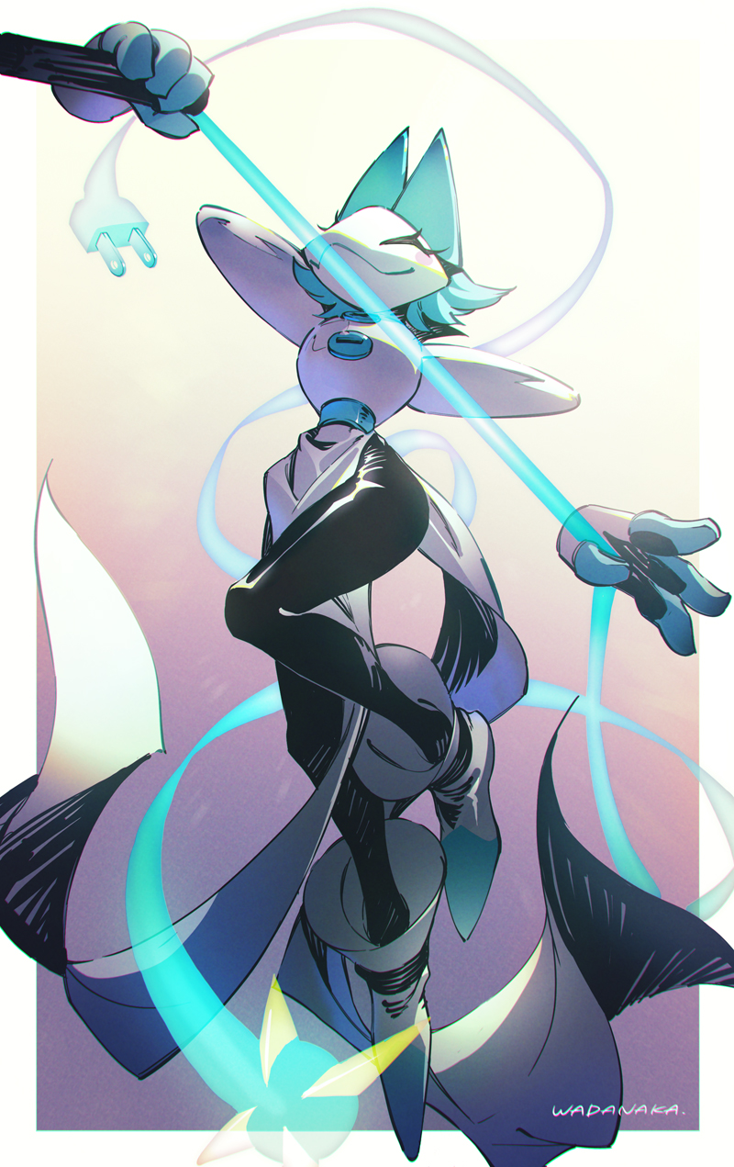
“Just in time to get everything back on track!” I could no longer stifle the voice inside my head – one that pushed me to pursue order in its purest form. That meant conducting myself orderly, enforcing order on others, and maintaining the order already pleasant in this digital realm. Such was my role as this computer’s Tasque Manager. It was my title, but also my very identity. If my name had been different before, then I certainly didn’t remember. Such memories would conflict with my efficiency. They might inspire
c h a o s.

The reality of the situation was that everything felt as it should have. I had no questions about my mission or myself. Where I was, what I was supposed to do? Those were all questions that had answers programmed into me. And so, after fondling my muzzle for a moment – and why had I been doing that? – I guided my limbless hands about until an icy blue whip appeared in their hands as if from nowhere. It wasn’t nowhere though, I knew that. It was from within myself. A perpetual smirk upon my face, I declared what had to be declared.

“Processes! Services! Performance! Details! Tasque Manager is active to maintain them all!”

