**Inclined Plane Problems**

**Worksheet**

7 Practice Questions

Organic Chemistry Tutor

1. A block slides down a 30o incline starting from rest. (a) What is the acceleration of the block? (b) What is the final speed of the block after it travels 200. m down the incline?

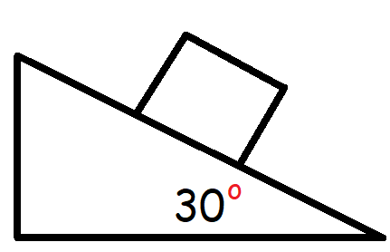

2. A block travels up a 25o inclined plane with an initial speed of 14.0 m/s. (a) What is the acceleration of the block? (b) How far up will it go? (c) How long will it take before the block comes to a stop?

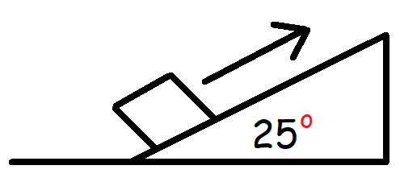

3. An 8.00 kg block begins to slide down a 25o inclined plane starting from rest. The coefficient of kinetic friction is 0.200. (a) What is the acceleration of the block? (b) How far will the block travel after 15.0 seconds?

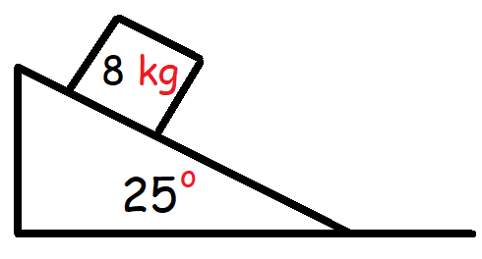

4. A 10.0 kg block slides up a 23o inclined plane with an initial speed of 18.0 m/s. The coefficient of kinetic friction is 0.25. (a) What is the acceleration of the block? (b) How far will the block travel before it comes to rest? (c) How long will this take?

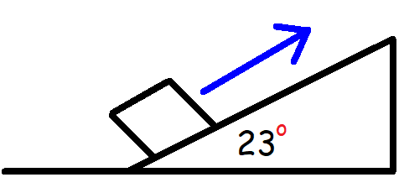

5. A 5 kg block rests on an incline with a coefficient of static friction of 0.30. What is the minimum angle at which the box will begin to slide?

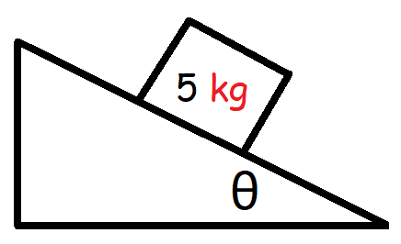

6. A 7 kg block rests on an inclined plane with an angle of 15o. The coefficient of static friction is 0.40. Calculate the magnitude of the static frictional force that is active on this block.

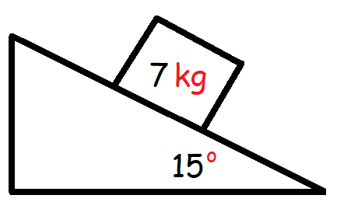

7. A 10 kg block is being pulled up along an inclined plane with an angle of 20o. The coefficient of kinetic friction between the block and the inclined plane is 0.25. (a) What is the magnitude of the tension force that must be applied to pull the block up at a constant speed of 0.5 m/s? (b) What is the magnitude of the tension force that must be applied to pull the block up along the inclined plane with a constant acceleration of 3 m/s2?

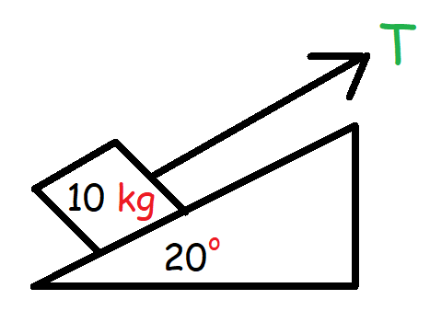

**Answers:**

1a. 4.9 m/s2

1b. 44.3 m/s

2a. -4.14 m/s2

2b. 23.7 m

2c. 3.38 s

3a. 2.37 m/s2

3b. 266 m

4a. -6.08 m/s2

4b. 26.6 m

4c. 2.96 s

5. The minimum angle is just above 16.7o

6. 17.8 N

7a. 56.5 N

7b. 86.5 N