DANGANRONPA: SOCIAL EXPERIMENT
CHAPTER 4: KUNG-FU CUTIE
BY CHALDEACHANGE
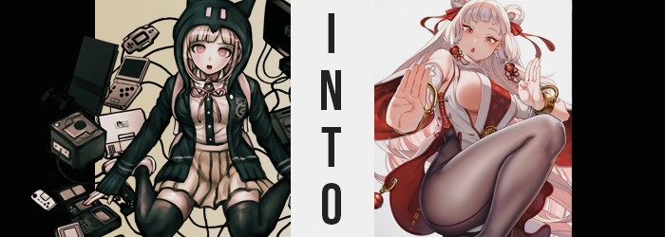

She definitely recalled being executed as the culprit behind one of the incidents involving the death of a participant in a killing game.

Chiaki Nanami, or at least the AI that represented her, held vivid recollections of this moment to be sure. It had been a necessary sacrifice in the grand scheme of things, one that she had hoped would push Hinata in the right direction. Evidently it had, or at least he had informed her of as much now that they were present in yet another game.

The both of them had already put two and two together. This space was not a physical one but a digital one. There was no way that Nanami could have existed here if it was the real world, but there was still the question of how she could have existed in the digital realm, too. Had her data been preserved somehow? She tried not to think too hard about it, because quite frankly there was no way for her to get an answer at the moment.

As we already know, she and Hinata had parted ways from one another after stumbling upon a section of the spa that was set up like a sprawling mall. She could only imagine the sheer breadth of size of the entire resort building, much less the property it rested on. Then again, if this was a digital world, then there was likely no limitations to how big of a place it could be.

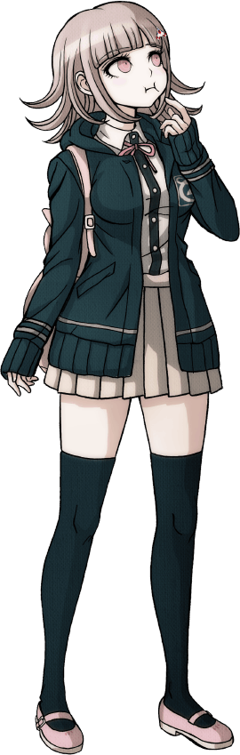
“A transformation game? I suppose it would be possible to change our data if this world truly is a digital one, but what purpose would that serve?” Nanami really didn’t have any answers to that question either, but sometimes it was helpful just to speculate aloud. There was little reason she could see to bring any of them back to life – specifically when the likes of their group included Junko Enoshima – just to ‘change’ them. Not that she understood in what capacity that even referred to.

Before long, Nanami stepped into an arcade nestled in the depths of the mall. It had taken all of her willpower to avoid poking her nose in, and even then she hadn’t been able to resist in the end, being the gamer that she was. All of the machines seemed like they were knockoffs of popular game series. For example? This one arcade cabinet. “…Road Striker?” It was clearly meant to be a clone of the popular Street Fighter series.

Her curiosity did get the better of her, and before long she’d reached to grab one of the joysticks. No sooner than she did, however, did a rather sizable shock jump from the machine into her body, making her jump back. “Huh!?” That felt weird. Very, very weird. Almost like something had rippled through her very code? …Code? I’m not some kind of robot! I’m a living, breathing person!

If Nanami had been in her right mind, she would have immediately recognized that thought for what it was: wrong. Perhaps she wasn’t a robot, but the fact that she was not human was something that she shouldn’t possibly have forgotten. Yet here she was, oblivious to her own existence. But could it be considered obliviousness if reality changed to match the reality that she perceived?

For some reason that reality began to bend in a way that was different from most of the past cases. After all, it was the AI’s physique that quickly began to differentiate itself first. Her body mirrored that of the real Chiaki Nanami typically. That is to say it was soft without even a speck of muscle, with a tummy that was just the slightest bit chubby. Yet beneath her clothing that was all changing, with the softness fading some as strong muscles tightened and came to the surface, and as her tummy toned so that she had a clear set of abs.

With her body now fitter, the girl somehow found herself fidgeting as she kept her distance from the arcade cabinet. While normally the passive sort, she was now grappling with a newfound energy. Her quiet and calm demeanor was showing cracks, and a tiny smile tugged at the corners of her lips. “I feel kind of… nice?” Was that an odd thing to say? She wasn’t quite sure.

Either way, her figure’s changes didn’t cease with an increased level of fitness alone. And, in fact, the softness that had once given her body a different kind of appeal did return in some fashion – but it ultimately left her to look rather sexy as it combined with her new muscles. But before that softness retuned, there was the uncanny sight of the young woman growing taller. Little by little she gained about four inches, which untucked her shirt from her skirt, and left that skirt resting higher on her thighs while her socks slipped beneath her knees.

“Mm?” From her perspective she could tell that something was wrong with the fit of her clothing, but Nanami never quite pieced together what was causing it. Even as her pleated skirt was pushed out to the sides, for she was gaining weight beneath her hips… hips that had in fact popped wider… did she not notice that it was, in fact, her body that was changing and not her clothes.

Nonetheless that was what was happening, and her hips had actually been forced wider because of the weight accumulating around them. Largely in her ass, which while it had recently become tight and firm thanks to the muscle that had swelled there, was quick to soften as fattier flesh bloated it nicely. It left her underwear to slip in between the cheeks of her bloated rear, and their waistband ultimately snapped thanks to how her plumper rear forced the hips so wide.

And while you might expect there to be an immense gap between her legs thanks to the wider gait of her hips, it actually filled in quite nicely thanks to the overflow of weight from her rear end. Try as it might, her ass couldn’t completely contain the weight that saw it flourish, and so that excess extended her thighs substantially. “Aiya! This is so uncomfortable!”

Nanami blinked at the sound of her own voice. Had it always been that high? That energetic? Had there always been Chinese mixed in with her Japanese? As much as she thought to question it, she just felt stupid for asking herself those questions. Even as the base of her shirt began to rise, and the top few buttons seemed to pop open.

The cause? Well, there could only be one. Her already impressive bosom had begun to grow, with breasts pushing past the fit of her bra and swollen nipples rubbing up against the underside of her shirt. Once the buttons popped and her deepening cleavage became free, she idly unbuttoned the rest despite being in public. “Tight clothing is the worst!” Despite the fact that once upon a time she had found comfort in that outfit.

The restlessness that had been developing before continued, and she was practically hopping in place. Before long she kicked her shoes off because the felt a little too tight, which was of course because her feet had grown. Her point of view continued to change along with her body, preventing her from taking much of an issue with what had changed and what would change, not that there was very much left in the latter category.

Nanami’s shorter hair style cascaded dramatically down behind her, while in the process it took on a snow white color that was identical to the sprite model of one of the characters on the character select scene in front of her. Her bangs in the front rearranged into a straight cut with a plethora of partings, and spilling down to her ankles the length in the back had split out in every direction.

Even her eyes came to resemble those of the character, taking on a fierce red while their corners tightened and upturned ever so slightly. It suggested what her change in the language her thoughts were processed through had already done: that she was a Chinese woman now, rather than being based on a Japanese girl like she had been. To those ends, her lips also swelled and the shape of her face became a little rounder.

A sudden glitching sensation ran through her outfit like a shockwave, and when it passed through again it completely redefined her outfit into a crimson qipao with the sides cut out so that you could see the sides of her breasts. Her legs were clad in dark tights, she bore silver heels, and her hair was done up into two tiny buns held with crimson bows. It was naturally the very same costume as the character on screen. Just in real life.

“A video game arcade? What am I doing here?” Strands of silver hair shook about as the kung-fu artist examined her surroundings with confusion. She almost looked out of place, if not for the fact that she was the mirror image of one of the characters on the fighter select screen for Road Strikers. Chu Hua, the character in question, had actually been inspired by this woman here, who shared the same name. Or at least that was the memory Chu Hua had been given, even though she could also recall being Nanami in some vague sense.

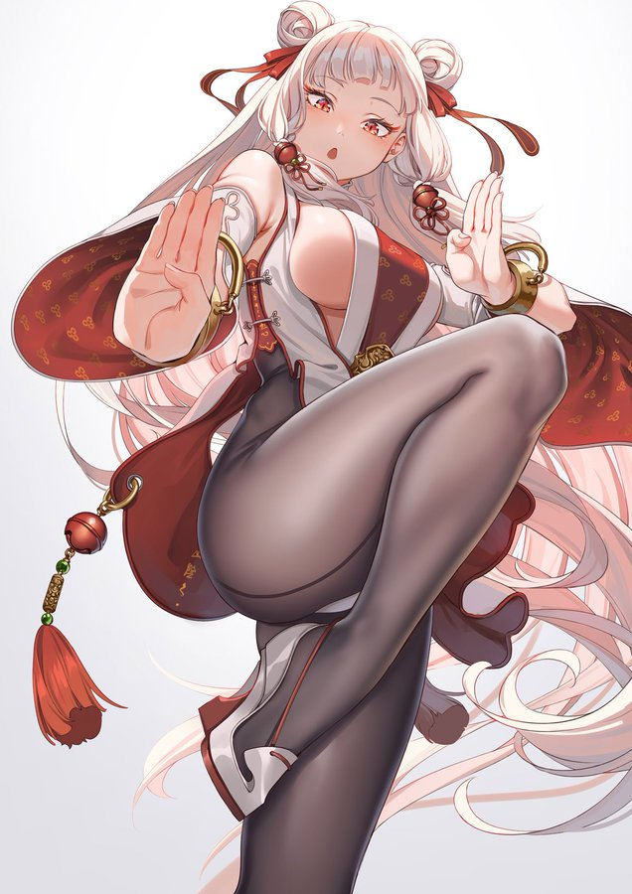
Who she was before just didn’t matter. She understood that she had ‘lost’, and that this was just who she was now. With new memories in the forefront while forcing the old ones to take a back seat, she had practically fully embraced who she now was. Side cleavage and all. “Ugh, is this the game I’m in? That’s waaaay too embarrassing!” Her pale cheeks burned pink remembering this, and she quickly shuffled out of the arcade. She had no time for games, she should get to training.

Although maybe she was keen because she had noticed she’d had something of an admirer since arriving at the resort. There was a room for training, and a girl a few years younger than her had been watching as of late. Yet when Chu Hua had tried to ask her about it, she’d gotten strangely forceful. Which also was kind of cute. Being the big, 20 year old lesbian that Chu Hua was, however, she hardly minded having the attention of someone cute like that.

“Perhaps she will be there again…?”

