DAZZLING PEARLS
BIWEEKLY STORY #127
BY CHALDEACHANGE
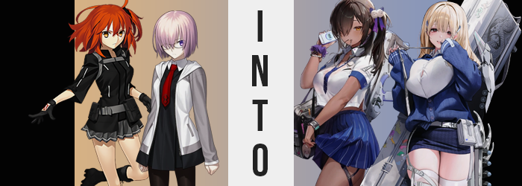

It was a rare occasion. For once the Chaldea Security Organization wasn’t involved in solving a Singularity or Lostbelt that was based on the historical past nor some sort of fantasy realm. This was one of the few rare occasions that the place where its Master, Ritsuka Fujimaru, and the Demi-Servant, Mashu Kyrielight, was a wholly futuristic landscape. And admittedly? They weren’t even really certain how they had ended up there.

“Senpai? This is a school, isn’t it?” Mashu asked after they had gotten their bearings to the best of their ability. The two had awoken inside what was clearly a classroom, likely one designed for high schoolers or the like based on its design. Desks were aligned neatly in rows, and beyond the teacher’s desk at the front of the room? There was a large monitor that seemed to act as the ‘chalkboard’.

One that displayed the text ‘TACTICS ACADEMY’ in the corner.

Ritsuka, the orange-haired Master, had not only noticed this but the view outside the row of large windows as well. The horizon was sprawling, with forested cliffs surrounding the school they were in, well beyond a number of futuristic and modern looking buildings that gave the location a somewhat confusion aesthetic. From what she could tell, it seemed like those buildings had been propped up without much thought. “Looks like it. But we need to contact Chaldea… Do you think…?”

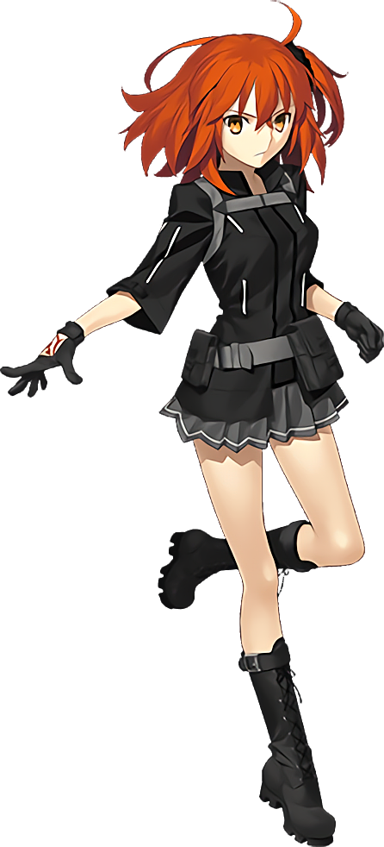
The Demi-Servant knew exactly what Ritsuka was suggesting. “Oh! Right! I’ll look for a place!” They needed a location with a reception strong enough to reach their base of operations, and so it would probably be better for them to split up and search one out. The school seemed to be safe at least, so splitting up for just a few moments should have been fine. Ritsuka smiled and nodded at her, and Mashu quickly departed through the sliding door ahead of her Master.

…But Ritsuka never left that classroom.

She had intended on it, but that large monitor at the front of the room had lit up all of a sudden. “Huh?” Ritsuka didn’t pay it much notice at first, but before long she couldn’t look away. It was a recruitment video? One that showed numerous woman of varying ages carrying guns. The words being spoken went over her head, but at the end of the video the display on the monitor changed to read: WELCOME TO DAZZLING PEARL SQUAD!

It seemed a shake of her head was in order. “What… the heck was all of that? So I guess this is a military outpost of some kind then?” She felt a little weird though. Why had she been unable to look away from the recording? It almost felt like she had been momentarily hypnotized. But that couldn’t have been the case, right? Well, not exactly? Ritsuka couldn’t have anticipated just what was about to happen to her though.

“Huh? Was that a spot of arrhythmia?” For a moment it felt like her heart had skipped a beat. It had happened before and da Vinci had told her that it wasn’t anything to worry about unless it was persistent, but in this case? That might have been an underreaction. Because her heart had skipped a beat because it was no longer a heart. At least not in a traditional sense. And it was no longer pumping blood either.

The ‘heart’ that beat within her chest might as well have still acting like one in terms of purpose though, and it didn’t exactly look all that different from a human one. But as human blood passed through it? It emerged as a red-dyed coolant instead of blood. And as that was passed through Ritsuka’s veins it began to have an effect on the rest of her body; with some changes happening immediately and others over time.

In terms of what was immediately obvious? Color changes. As the coolant traveled through her veins, the skin overtop of these veins was immediately darkened in color to a tan that almost bordered brown. It spread from her chest, down her torso and arms, then through her legs and face as the coolant was spread. Although it was immediately clear that color differences weren’t limited to these regions alone as Ritsuka’s orange hair darkened to brown, and her equally orange eyes merely darkened a little.

“W-Wait, something’s wrong here?” The Master had raised her right hand and had noticed how dark the skin on her forearm and under her glove was. That was already alarming. But just as alarming was the sight of her Command Seals fading away until there wasn’t even a trace of their existence. No, it wasn’t just the seals? “My mana!? I can’t feel my… Huh?” What even was mana? Wasn’t that a term related to magic of some kind?

But magic isn’t real! That’s a silly thing to think!

Ritsuka reached up to scratch behind her neck. She felt more than a little confused by all of this, so much so that it was debilitating and made it hard for her to concentrate on anything else. So the fact that her now brown hair was tricking down in length so that it was a few inches shorter in the back went unnoticed, and for some reason bangs lengthening so that they completely covered her right eye and even most of her nose didn’t bother her whatsoever. It was seen as normal.

These bangs, in fact, disguised a great deal of change to the young woman’s face. Structurally? Any traces of the woman’s Japanese heritage were softened away. Her face’s shape narrowed and her chin sharpened. Her nostrils flared and lips swelled. But what was most damning were her eyes, which ultimately adhered to a much rounder shape when it came to her eyelids, removing their more almond-shaped structures typical of a Japanese girl. She looked like she belonged to a Western race more than anything but she clearly wasn’t white either.

But was she a little younger? Maybe around eighteen now.

She had tugged off her gloves subconsciously for some reason, though when she did she revealed perfectly manicured fingernails that were now painted purple. “Why was I wearing those? What am I wearing?” This ultimately led her to examine her outfit. She could recall putting it on that morning but Ritsuka also couldn’t remember why? It didn’t seem like it should fit her, right? After all, her figure was much more… much! Perhaps this understanding on her part didn’t immediately make sense, but it also wasn’t long before it did either.

Dark skin had begun to stretch around the flesh of various parts of her body, not because it was tightening but because what the skin contained was swelling. With the skirt that she wore being so short, you could easily make this out around her thighs. They were thickening and ultimately did so until several inches of jiggly fat were applied not only to her thighs, but to her ass in a way that both lifted up the back of that skirt and prompted a wedgie that she was forced to pick. “And what’s up with these panties?” My ass is pretty big, so why would I put on the wrong size? That’s just asking for discomfort…

“Wah!?” While leaning back so that her manicured nails could try and tug her underwear down, her body randomly lurched forward as a great amount of weight built beneath her jacket and undershirt rather suddenly. Average sized breasts ballooned, growing to almost two and a half times their original size until perky, dark-skinned F-cups forced the zipper of her jacket down and snapped the top strap. The depths of this cleavage was enticing and evident, but it was also covered up quite promptly.

The teenaged girl blinked. “Was something wrong with my outfit a second ago? But this is my normal uniform…?” She wasn’t wrong. Her Chaldea uniform had been entirely replaced. She now wore a short-sleeved uniform blouse with blue sleeves and a blue tie, the shirt so short that you could see her navel – and the fact that her tummy had a bit of softness to it now as well. A pleated, dark blue skirt reached the middle of her thighs and frumpy socks sat baggily over new loafers. But she was also accessorized out the whazoo, with a watch and purple scrunchie on opposing wrists, a mounting strap hiding around her left thigh beneath her skirt, and a cute little hair ornament done up in purple that gave her a leftward side-ponytail.

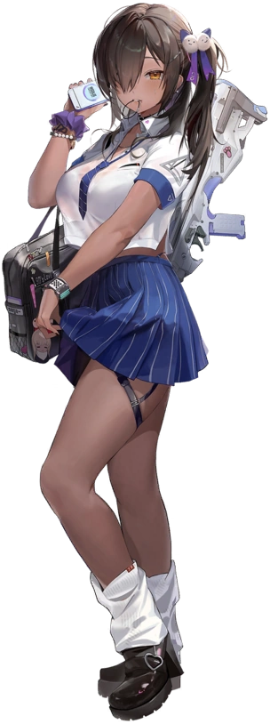
Modeled like a girl in her late teens, Naga understood what her position was now – although she certainly wondered how she had forgotten in the first place, albeit ‘briefly’ from her point of view. “Uh… That was weird. I’m obviously here for class? A little early though…” Well, that was because she and Tia were here for class prep, right? They liked to help their teacher out with setting things up for the day and so they always arrived an hour before everyone else. “So where is she?”

The skin of her dark tan glistened against the light of the early morning sun that glistened in through the windows of her classroom. She may have resembled a human, but truthfully? Naga was a NIKKE, an android of sorts that had been designed for combat. That didn’t mean that she wasn’t just as much of a young lady as she appeared though. And dressed in that school uniform of hers? She was quite the attractive young lady to boot.

“Don’t tell me she ended up in the wrong classroom again?” Naga was like a mother hen when it came to her fellow squad member of the Dazzling Pearl squad. Tia had a nose for trouble at times, and Naga was always guiding her when needed. Turning to the door, she sighed and began to walk. “I guess I should find her…” It really wasn’t as much of a nuisance as she was acting, however.

“I think this classroom might work!” This entire time Mashu had been working on the task she had been given. Even though she hadn’t equipped her Servant attire and shield, she was experienced enough at this at this point that she could more or less tell what locations could be used to communicate with Chaldea just by channeling her mana a certain way. She had ended up in a different classroom from Ritsuka, one just a few classrooms down the adjoined hallway. And so she had been prepared to go back and report this to her Master.

And she would have accomplished that very simple task if not for encountering a similar issue to what Ritsuka had. “Oh?” The monitor in that classroom had turned on, displaying the exact same video that had been shown to the ginger a few classrooms down. In much the same way she had been unable to peel her gaze from it once it had finished. And she felt rather odd once it had concluded. “Was that supposed to be a recruitment video? So is this…?” Assuming it was a military base made sense.

But why only recruit young women?

Mashu arched an eyebrow. Had her heart just skipped a beat? It had been brief and only a single time, so as much as she could have dwelled on it? She didn’t really, despite the actuality that this meant that her body had already begun to undergo changes similar to what Ritsuka was experiencing back in the classroom she had left her in. Though, to be fair?

The early stages might not have been dramatic for the Demi-Servant. The pigmentation of her skin hardly changed at all as coolant passed through her veins, only really taking a slightly healthier shade of pink. The changes in color to her eyes and hair were much more noticeable, with those eyes coming alight with a pinkish red that really stood out beneath hair that soon shone with a pale and glossy blonde. And yet from this point on? Her transformation did not play out in the exact same order of operations that her Master’s did.

“Huh? What’s…?” After all, an almost absurd amount of pressure felt like it was gathering beneath her breasts of all things. At first there was no visual sign of any problem, and Mashu had wondered if maybe she was having an allergic reaction or something. But mere seconds after that thought had crossed her mind? “GAH!?” A shrill scream left her lips as the sound of cloth tearing and the sensation of something hitting her in the face and knocking away her glasses stunned her.

Mashu stumbled back from the shock, but soon found herself stumbling forward again as what had hit her bounced up and down, pulling her in the direction of their weight. Tatters of her black dress where everywhere and her bra was hanging loosely from her person, the strap having snapped in the back. It was hard to ignore just why all of these problems had come about. After all… “M-M-My titties!?”

An enormous pair of breasts now hung from her chest, surely no smaller than H or even I-cups. They were certainly larger than Mashu’s head with nipples that dwarfed her eyes. But as shocking as they had been? Once her back muscles strengthened to support their weight, the woman was left wondering what she had found so strange about her breasts? They were always that big! Just like her ass was always so— “Oh!”

She chirped with a voice that was not her own, much higher in pitch and bubbly in sound, as she could feel her tights tightening around even tighter skin, as well as her panties sliding into the crevice of her ass. Those naturally weren’t sensations she would feel if she was wearing clothing that fit her, and that was the logic that dismissed the true causes of these issues as now-manicured, blue-painted fingers tugged at what she was wearing.

Her ass and thighs had bloated stupendously. Perhaps not with the same level of excess as her enormous tits, but thighs practically tripled in their girth until they pressed up sensually against each other between her legs even when standing up straight; and that even accounted for her hips widening a few inches. In terms of her ass? It bloated into a heart shape and ate up her old undergarments. Needless to say, numerous tears formed throughout her tights both around this plumper ass and her ridiculously plush thighs.

“What was I thinking when I picked this outfit out? It isn’t even my uniform! Though maybe it’s just because I’ve been snacking on so many desserts? Ehe…” Her tummy grumbled at the thought of consuming a deliciously sweet treat, and the expression that she made was both cute and a little silly – just like her heightened voice sounded. But that silliness was likewise enhanced by changing facial features. Wider eyes expressed her emotions much more clearly, bee-stung lips bore an attractive glossiness, and a rounder facial shape gave her an almost jollier vibe.

Her blonde hair soon lengthened past her shoulders, whereas bangs grew to mask her forehead entirely.

The girl’s pink eyes blinked. “Ooooor maybe I’m going crazy~!” Hadn’t she just been fretting over her outfit? But why? As it was now, it seemed completely normal? But only because it had changed. A dark blue pencil skirt revealed her legs and thighs in their entirety aside from some white straps that bound the latter, while black boots reached up past her ankles.

Mashu’s enormous tits had been bound in a white, lacey bra beneath a white uniform shirt that was, uh, being pushed to its limit. The front buttons couldn’t even fully contain her breasts and you could see them fighting for their lives, her cleavage discernable through the gaps between them. A comfortable, blue cardigan was zipped up to just beneath them – because that was as high as the zipper could possibly go. Accessorizing her hair were two blue clips that were on either side of her head.

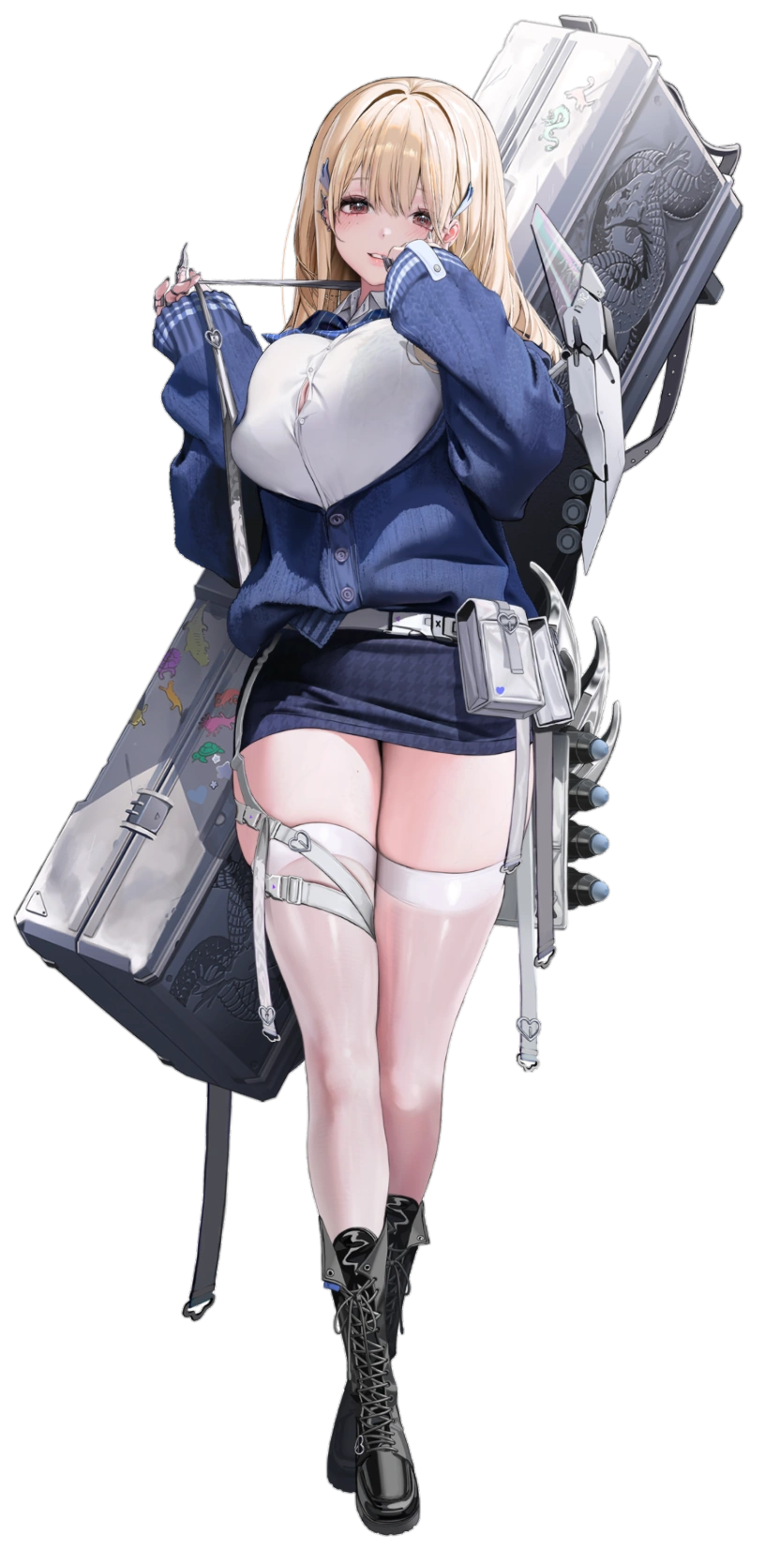
“Hmm~! I thought I smelled something delicious in here, but maybe it was a trick of the mind. Ehe!” Tia was much like Naga in many ways. She was a NIKKE of the Dazzling Pearl squad, and she had come to the school early to help with setting up. But unlike Naga? Tia was a fairly ditzy young woman, and this seemed to compliment her blonde hair and gigantic tits well. Wouldn’t breasts that large get in the way of combat exercises? Not really! Not when she had been programmed with the knowledge of how to best move despite them!

Being a VVIP foodie and a lover of all desserts, she was easily tempted by the scents of delicious looking treats and, oddly, reptiles. It was the former that had led her into the wrong classroom. She remembered smelling very delicious cookies or something? “That’s a shame! I really wanted to try them…” Her tummy let loose a pained grumble. It was because Naga had made her skip breakfast to come in early!

Still, she smiled! Tia was always smiling, and paired with how ‘out there’ she tended to sound she gave off the strong impression of an airhead. That was probably why Naga was always taking care of her. And speaking of? “There you are! How did you run into the wrong classroom?” The dark-skinned teen had found her and had walked in, gently taking Tia’s hand and tugging her towards the exit. “Geez, you had me worried.”

CHANCE!

Tia took full advantage of this and clung to Naga’s arm with a mischievous smirk, big tits pressing into her from the side. “Sorry~! I thought I smelled something really tasty! Ehehe!” Naga was definitely blushing! Of course she was! The two of them were close. So close, in fact, that they were more or less a couple… unofficially! It was funny though. Tia felt a little like she was forgetting something important as Naga led her back to their own classroom, the two cuddling while walking.

Oh well!

