DANGANRONPA: SOCIAL EXPERIMENT
CHAPTER 3: TSUN TSUN
BY CHALDEACHANGE
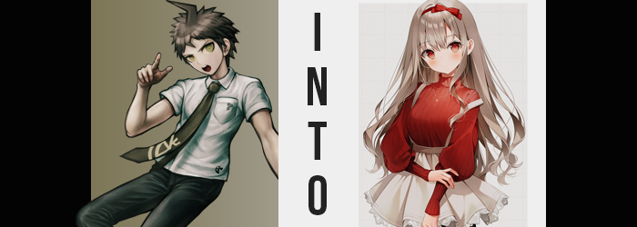

Hinata Hajime did very little to stifle his groans as he walked through the halls of this unusual resort building. After what had happened within the New World program, the last thing he had wanted to do was experience another game of this caliber. But he had plenty of questions about his circumstances as well, such as the current state of his body. As he’d learned, his real body should have been older – but this was the same appearance he had taken in the digital world, a reflection of his slightly younger self.

Then there was the matter of some of the other participants in this game. He was ecstatic to be reunited with Nanami after how she was removed from the Killing Game, but how was Junko Enoshima present? Even if it wasn’t the digital version they had faced, the real one should also have been dead, shouldn’t she? After all, he was… Well, it wasn’t something worth worrying over at the moment. So long as she didn’t try to kill anyone, that is, and she’d been keeping her distance from everyone at the first meeting.

And so he had been content on exploring the resort with Nanami. The two of them, if anything, were impressed with just how big the place was. It paled in comparison to the resort they had stayed at during their game, and there seemed to be everything one could even need inside. Case in point? They had found an entire shopping mall nestled inside. A shopping mall without any clerks, but in terms of scale it was huge.

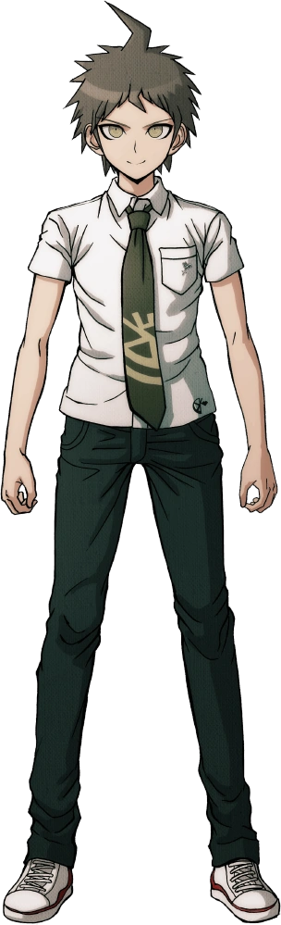
So huge that the two had temporarily gone their separate ways. There was a food court that they could meet up in later, and clues about their situation wouldn’t come about from them dillydallying. Even so… “Trying to find a clue in here is like trying to find a needle in a haystack!” Hinata had already poked his head into several shops, from electronics stores to toy stores, and just how exactly was he supposed to find anything suspicious? Everything looked normal!

To that point, he wasn’t even sure why he had wandered into this store. It was evidently a women’s clothing store, without fancy dresses, tops, and even underwear neatly hanging about. It honestly made him feel a little restless and embarrassed to even be there. But he couldn’t lie to Nanami and tell her he’d checked every store in this wing if he hadn’t actually done that.

Everything in the shop appeared to be neatly put away. That was why the one thing that hadn’t been had caught his eye. A crimson headband with a bow on it resting in the middle of the floor. Almost suspiciously, but he couldn’t fathom what danger cleaning it up might cause. Rookie mistake. Still believing the only threats there were the other participants, there was no way someone could have set up a trap to eliminate him just yet right?

But no sooner than he’d bent over to pick up the headband did it disappear, forcing him to stand up straight. “Huh? Where’d it go?” It was difficult for him to tell considering just how thick his hair was, but it was still very much on his person. Wrapped around his head, in fact, plain as day. While there were many mirrors in the store though, Hinata wasn’t near any of them to see that. “Was I just seeing things? I thought that headband would look really cute with my outfit.”

…? What had he just said? It had sounded strange to the boy somehow, but now that he was thinking about it he couldn’t really piece together why it had sounded strange despite the fact that it really should have been obvious. Because never in his life had he cared about accessorizing, much less looking cute. He didn’t have the type of appearance that made people think ‘wow, he’s adorable!’ after all.

At least not yet.

But there were signs that this was becoming a reality, primarily focused on his head – since that was where the headband had been planted, after all. Hajime’s face was showing plenty of signs of it, for one. His eyes appeared to be bigger, wider, and more expressive. In their roundness they appeared quite effeminate, and that wasn’t at all helped as his lashes grew longer. The boy’s complexion softened simultaneously, any blemishes wiped completely from not only his face but his skin altogether, for it all appeared to lighten several shades. That said, in terms of changing color a rather dramatic change had afflicted his eyes. They were now just as red as the headband nestled in his hair.

“Wh-Why do I care if I look cute for her?” Spoken through lips that were smaller, but also rounder and more pronounced in weight, a maidenly voice called out that sounded a little abrasive, but almost in the sense that it was like he was trying to hide that he was embarrassed. Boys didn’t typically fixate on looking cute, so that would have made some sense. But that wasn’t what he was referring to. He was thinking about a girl whose face he couldn’t even imagine. An imaginary girl he had a crush on? But it felt too real to be imaginary.

Nonetheless, his face was almost as cute as a porcelain doll’s now. There was nothing inherently masculine about it at all, and it definitely was strongly feminine. It would be readily apparent that his hairstyle didn’t suit a cute face like that, if not for the fact that his hair had been changing in tandem with his face, that is.

It had grown longer, the spikes that were so synonymous with most people’s impressions of Hinata softened and flattened out in the process. It had fallen far down his back, stopping just short of the peak of his bum, while curling slightly near the tips. But there was also the matter of its color, which had lightened dramatically from its original dark brown to a pale brunette that bordered slightly on blonde. It was brushed so neatly, and through the left side on of his ears could be seen – shaped smaller and rounder than it had ever been.

Hinata could tell that something felt off, but he also couldn’t tell what it was. “Was I… What was I doing in here?” He could hardly remember why he’d come into this clothing store. He felt like it had been important, but had it just been to do some shopping? Hey! Since when wasn’t shopping important!? A voice deep down seemed to take issue with the fact that he might not find shopping to be important, evidently.

It was certainly beginning to look like he might need new clothes, though. While it didn’t quite register with the young man himself, his height had suffered a sharp drop down to around 5’2”. This meant that not only were his limbs and torso shorter, but his feet had rounded and smoothed, and his digits were fairer as well. That said, his fingernails had not only lengthened but had become painted red, as well.

The sides of his torso pulled inwards suddenly, which in turn made his hips appear more pronounced. Then again, the hips in question were doing plenty to these ends as well, for they expanded several inches so that his legs were parted away from one another. Thankfully the fact that he had shrunken had left his pants rather loose, so they didn’t fall even despite this. That said, they did begin to feel rather tight once his thighs began to bloat with a soft, fluffy, feminine weight that rounded them out and made their shapes clearly visible even with his pants on. Even the fact that his butt had swollen slightly rounder could be seen, and it had taken a very cute heart shape that would certainly catch some eyes in tight jeans.

“Oh!? Wh-What’s happening here! Th-That idiot! Baka!” Who was he even calling an idiot? Not even Hinata could be sure, but the feeling had provoked this outburst was, well… the process of him becoming a her. Her dick had pulled inwards and formed a pussy, completely with the uncomfortable emergence of associated organs inside of her body. But while she had shuddered, her change in sex went just as unnoticed as everything else.

Hinata’s white tee was lifted slightly despite how it practically hung off of her now that her body was shorter and narrower, and it seemed that it did so for good reason. Her chest had begun to protrude, proper breasts firmly forming with the occasional bounce as they filled more and more in size. It didn’t take long for them to peak at D-cups, which looked quite bombastic against a body that was so small, cute, and thin. But it was just part of her appeal, wasn’t it?

It was enough to get her to peer down, but the reaction she had at the sight of her new breasts? Well… “Wh-What am I wearing!? These ugly boys clothes!” She didn’t seem to find it weird at all that she was a teenaged girl. She found it weird that she was dressed the way she was. But memories as to why that was the case came rushing in. She’d come away to this resort with her mama, and her mama had packed her bag with her brother’s clothes! That was why she was at the clothing shop! Because she had nothing else to wear!

“And if it wasn’t bad enough, I caught mama sleeping with some strange dancer woman! That baka!” That’s right, she was now the daughter of the transformed Kirigiri, Manaka Saitou. Hinata’s new name, Hina Saitou seemed to suit her quite well in how she looked like a little doll. But she also had a big temper and had difficulty expressing herself. As any good tsundere should.

There was also the fact that she wanted to impress a young athlete she’d met. “I-It’s not like I care what she thinks, but I don’t want her to see me dressed like this! So I better find a cute outfit here! …For no reason in particular.”

Ganbatte, Hina-chan!

