BATTLER IS DEAD
COMMISSION STORY
BY CHALDEACHANGE
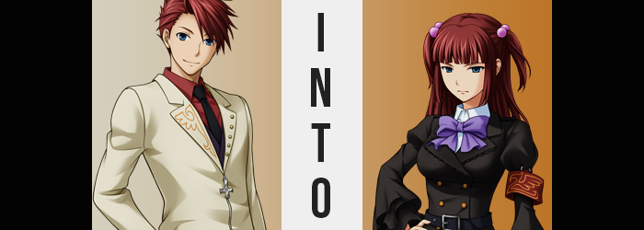

“You’ve done quite well, Battler. An amusing display if I do say so myself.”

For Battler Ushiromiya, it was a moment of celebration. After all of the suffering he’d both witnessed and been subjected to, he had finally defeated the Golden Witch. No longer would he be leashed naked or suffer horrifically in other ways at the hands of Beatrice. This marked the end of their game thanks to Bernkastel’s support, and he was happy to reap the rewards of it all.

He wasted little time in demanding that reward from his supporting party. “Right. Now, Bernkastel. You remember your end of the bargain?” In exchange for defeating Beatrice, the Witch of Miracles, Bernkastel, had promised to return him to his sister (and, by extension, the rest of his family). Too much time had been spent in this realm of witches, and he really just wanted to go home.

The witch in question, dressed in her usual purple dress, with her usual long, dark hair, with the usual cat tail thwapping back and forth behind her, was floating upside down in front of the young man. A bemused expression decorated her lips, the woman rather content with her choice in Piece in this scenario. “Oh, I suppose we did make a promise, didn’t we? You wanted to ‘be reunited with your sister’, did you not?”

It wasn’t like Bernkastel had forgotten, but instead she was presently plotting the most amusing way to distort that promise. It had been such a vague desire, and an immortal witch like the Witch of Miracles? She was always looking for brand new ways to entertain herself. Certainly within the realm of her character could be found a desire to bring about suffering even when granting humans rewards and gifts. And in this case? She had the perfect idea in mind. “Well then, I’ll return you to Ange Ushiromiya as promised. In an era where…”

BATTLER USHIROMIYA IS DEAD.

The last portion of that sentence was both spoken and felt, for it had been communicated with a Red Truth. A special truth that could not be refuted nor altered, for it was an undeniable reality of the world once spoken into existence. Bernkastel’s usage of this technique had left the boy stunned, but before he was allowed to question it he found himself in an unfamiliar bedroom by the way of a witch’s portal, with a girl staring wide-eyed at him.

No, a young woman. “Big… Big brother?” Hearing her voice, as well as himself identified by such a title, Battler’s heart, and mind both raced in tandem. He knew who this was, and he understood the kind of game Bernkastel had chosen to play with her promise. This was…

“Ange?” It was hard to believe since she appeared so much older. Her late teens? A young adult? He wasn’t sure how old she was, but it was certainly her. From his sister’s perspective though, he looked the very same that he had appeared when he’d died when the girl was only six. Now? She was eighteen. Twelve whole years had passed. “What… year is it?”

Bernkastel had sent him here, wherever here was, but obviously ‘when?’ was a question too if Ange was so much older. The Witch of Miracles had upheld her promise, but in the most bizarre way possible. There was also the matter of her Red Truth to consider, because now? Battler Ushiromiya was alive.

Ange slid off her bed, staring at her brother with uncertainty. “It’s 1998. But… You… You died. Twelve years ago.” Yeah, that math added up. So this really was the future? And a future where he was dead, at that. So why had Bernkastel thrown out that Red Truth? He had an awfully bad feeling about all this, but faced with his younger sister, and that look in her eyes, it was hard for him to worry too much.

How long had she wished she could be reunited with her family again? How much had she suffered as a result of their untimely deaths? It was all reflected in her dark blue eyes. “I did, huh? I guess- URK!?” Before he could finish his comment, a sharp pain rang out from his heart, forcing him to fall to one knee and jolting his eyes closed. But he wasn’t blind, even with his eyelids shut. He could make out some words in crimson, lingering against the darkness with menace.

BATTLER USHIROMIYA IS DEAD.

The Red Truth that he’d been left with! Was this it then? Was he going to die because he had shown up in 1998? What a devious ploy by Bernkastel! After all he’d been through, just to die like this!? But rather than die, the pain suddenly subsided. His senses cleared, and with eyes open once more, he found Ange kneeling beside him. “Big brother! Are you okay!?” She looked like she was on the verge of tears, almost like the six-year-old he knew too well. Some things never changed, it seemed.

“I’m alright…” He helped Ange up as he rose up to his own feet again, only to find himself in the girl’s embrace. “A-Ange?” How much had she needed this hug? He could only imagine. She’d grown up so much, so much so that her head was at the base of his chin. No, at his eye level? No, they were eye to eye? “…Huh?”

Ange’s eyes were closed, and so she didn’t really notice it like he did, but Battler himself was more than certain. Somehow, some way, the difference between himself and his younger sister had been completely eliminated. Not only was it evident because they were now eye to eye in their embrace, but the tanned suit the young man wore with a notorious amount of duty had come to hang off his frame like it belonged on a larger man than he.

“Ange, I don’t mean to ruin the moment but open your eyes.” He didn’t need to assume regarding the cause of what was happening, but he didn’t quite understand what the intended outcome was. This was the work of some sort of magic, somehow. Was the Red Truth related? He couldn’t fathom how a declaration regarding his death might be relevant. His sister’s eyes suddenly fluttered open though, and in response all he could muster was a deadpan: “Surprise?”

The girl was confused for a moment, but that wasn’t especially surprising. She had just seen her brother for the first time since his death, and so she didn’t know just how tall he was supposed to be from the three minutes they had interacted prior. But given a moment of pause, she eventually caught on. “Br-Brother!? Did you shrink!?” His clothing was actually the dead giveaway because it was very loose around his shoulders, and looking down she could see bare legs. His pants had fallen down. “What could have…?”

Before Battler could even confirm the obvious (and he did), Ange stopped paying attention to his words. Not to be rude, but something else had quite simply caught her eye. After all, she was watching her brother’s hair… grow? It reminded her of a Western toy she’d been shown advertisements of. Apparently, they were all the rage in the United States at this time. Chia Pets, they were called?

Regardless of the apt comparison, that was how it looked. At both his head’s sides and in the back, Battler’s crimson mane dangled longer and longer. It fell not only to his shoulders but past it as well, while the lengths at the sides fell to only his chin. Bangs, once swept to the left with a spikey lift, settled with an inconsistent shortness atop his forehead, the fringe across its entirety cut even. “Battler…? Your hair…”

“My hair?” He arched an eyebrow that was in the process of thinning, while a hand was raised to touch what he expected to be a short cut as it always was. He’d noticed Ange was fixated and something, and was that it? But much to his surprise— “It’s so long!” Long like a girl’s hair, in fact. Not that he didn’t know men who wore their hair this long, but Battler himself certainly wouldn’t. His eyes flickered frantically, and while doing so his lashes danced an inch longer in length.

Still observing her brother, the sister was actually in the process of trying to grapple with an uncomfortable possibility. Battler had shrunken down to her height, and now is hair had grown out to her length. Looking at his eyes, while they remained the same color, they were beginning to look bigger as well. More girlish. Like hers. “Brother? Could it be that you’re—”

Before she could finish that thought, the young man let out a discomforted groan. “Ngh!” A pressure bore against him from either side of his body, and the uncomfortable sensation of his bones crunching inwards drew a hand to the east and west of his belly. Pressing fingers against them from outside his suit’s exterior, it was easy to make out that his waistline was dipping in towards itself from either side, giving him a much more feminine gait.

As a direct result of this, not only did his hips look wider, but they legitimately were also wider. They had stretched, ultimately buckling his knees in towards one another – while up higher his shoulders had narrowed as well, making the fit of his tanned suit top even more depressingly vacant. “Shit! This is getting WORSE!” There was a sharp crack at the end of his sentence that brought the pitch of his voice up several octaves. Disturbingly, it persisted. “Ack! What’s going on with my voice now? I sound like—”

“Me.” Ange was finally presented with the opportunity to say what she’d been thinking all along. It was becoming difficult to deny, considering she knew her body better than anyone. The horizontal width of her brother’s body now matched her own, along with the height, hair… and face. It was becoming increasingly so that this interaction was like conversing with a mirror for Ange. From the sheen of Battler’s swollen lips to the gentler arch of nose – not to mention how feminine his eye shapes had grown, there was an undeniable resemblance to Ange herself. “You sound like me. And you look more and more like me with each passing second.”

It was a weird thing to have to say, but it as an even weirder thing to have to hear as Battler was finding out. He’d only just been reunited with his sister, and now he was being told he was becoming more like her. Why? Why…? Why? No, the Red Truth!? If Battler Ushiromiya truly was dead, then Bernkastel had picked a way for him to remain in this timeline regardless, was that it? “Damnit, that bitch!”

His hands were balled up in anger at this realization, though he had to adjust his fingers for the nails that tipped them had grown an inch past each fingertip, and each finger was smaller just as his palms were. Similar effects had plagued his feet as well, seeing toes become teeny and heels gentler by comparison to what they had once been.

Both Battler’s dress shirt and the tan suit jacket atop it had remained flat, albeit loose all this time. But now both parties could observe what appeared to be a set of growths pushing the free space forward. “Brother, you’re growing…” Ange didn’t need to finish that sentence, because the boy’s whimper was indication enough that he realized. He was sprouting breasts.

Ange’s bosom was fairly sizable, a pair of modest C-cups that looked fairly sizable in a brassiere. And that was the very size that Battler’s own chest was blessed with. He could feel her swollen nipples rubbing up against the underside of his shirt, and their weight undeniably lurched him forward. “BREASTS!?” For so long he’d desired to touch a big, bouncy pair. But never his own! This might as well have been a nightmare, as evident by the fact that his face.

There was certainly some karmic justice here, and Ange recognized it. Even though she had only been six at the time, she remembered her big brother became quite the character when a pretty woman was around. “And you better not touch them without permission!” Easier said than done, considering they were a part of his body now.

With his shrunken form, Battler’s dress jacket dangled halfway down his thighs, but it was enough to reveal a pairing of changes. The first? That all of the hair upon his legs had been shaven away. The second was much more pronounced, seeing the shapes of said legs engorge with fat. Compared to how thin his arms had become, they were practically four times the size. Ange knew her thighs were one of her charm points, and they were sizable enough for any impressions left in them by fingers to linger a moment. They were also big enough to fill the gap between his legs, which left his dick in a trick spot.

“Oh no, not down there…!” The shock of it all had Battler’s head spinning. But he was also battling a sudden exhaustion – a side effect of the magic, which expended his energy to shift his body’s shape. Fortunately, what he was fearful of most didn’t come to fruition just yet, but it wasn’t far off either.

The back of his shirt was forced upward as his ass ballooned in a similar fashion to his other sexual features. What this amounted to was a perky derriere that felt the room’s draft tickling its ample checks and the crevice between from beneath the shirt, while not so large that it lifted the top enough to reveal his junk.

“EEEEI!?” But it finally happened. The discomfort that suffocated his cock and balls gave way with the most disturbing of sensations, as they were pulled inside his groin and were mended into her new pussy – one that was of course of perfect match to her sister’s, the neatly trimmed bush above and all.

What remained of Battler Ushiromiya now was her mind alone, for her body was a perfect replica of the Ange Ushiromiya that stood, still dumbfounded, in front of her. From the slopes of her curves to the look of her face, to the beauty marks her body concealed; not a single part of her body differed. Only her mind. “This can’t be… happening…”

Battler wanted to sob. He wanted to curse Bernkastel’s name again. But he didn’t have the energy. Ange was actually forced to catch her new, twin sister in her arms, for the duplicate passed out in a standing position. “B-Brother!? …Or should I say sister?” Reunited with her brother after all of these years, only for him to be turned into her twin?

Battler wasn’t the only Ushiromiya sibling with complicated feelings to work out over all this.

But for now, she guided the unconscious Battler to her bed.

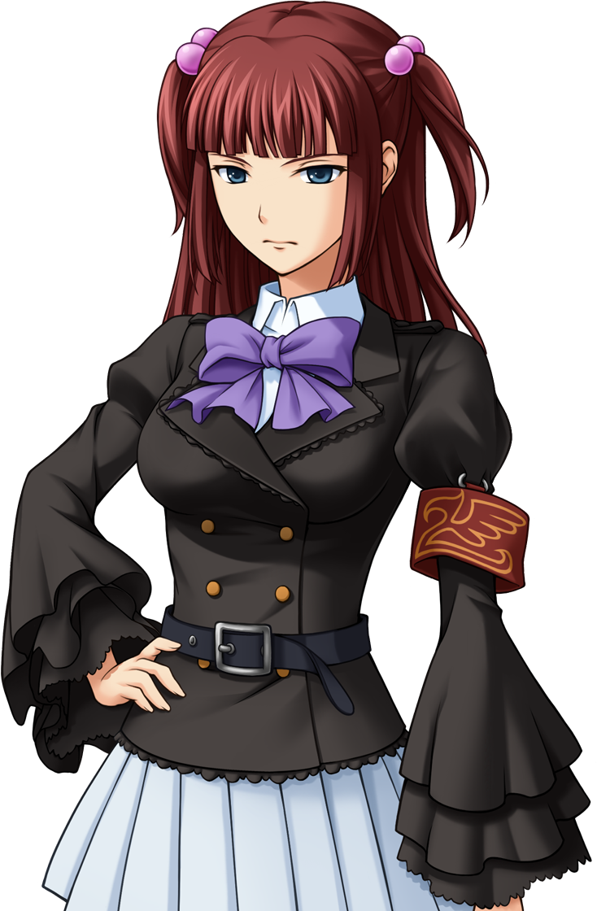
“This must be what hell looks like…” Battler had really hoped that she’d awaken the next morning to learn that everything that had transpired had been nothing but a dream. Yet there she stood with the light of the sun behind her, before a mirror that reflected her own sister’s face at her. Through Ange’s prodding, she had shed her oversized suit after waking, and the sibling had laid out a change of clothes on the bed before vacating.

Ange’s clothes.

But Battler was far more concerned about her own body. She was Ange’s twin sister now? Stripped naked, she was left marveling at her own curves, from her hefty set of breasts to her thick thighs, to the pussy between her legs. Ange was the sort of girl that shaved her pubes close to her groin, huh?

It was a miracle that none of this aroused her, considering how much of a pervert Battler had been before her transformation. But considering it was her own body? Her sister’s body? It was a little weird to feel any excitement about it, which was probably for the best. She wasn’t sure how she’d fare if she ever had to change in a women’s changing room, though.

“I got the panties on, but how does this work?” Holding the bra between her small hands, she’d already found her first hurdle. So she did the only thing that she really could. She called Ange in for help. At least she came quickly, because Battler assumed that she had assumed that something was going to go wrong sooner or later. “I need help with the bra.”

Already dressed in her uniform, Ange wore a haughty smirk upon her face. “You’ve never taken off a girl’s bra in order to know how to put one on? That’s a little relieving, honestly.” It meant her brother wasn’t a womanizer, at least. Well, her sister now. “But here. Lift your arms?” It was simple enough. As soon as her twin raised them, she slid the straps over her arms and pulled the cups firm against Battler’s breasts before hooking it in the back.

It was honestly a little strange, dressing someone else that looked exactly like you. “So are we going to talk about what happened? It was obviously magic. I know a little about it.” Thanks to the long-passed Maria, surprisingly enough. Magic had sent her brother here, and magic had turned her brother into her twin sister. It was the only logical explanation. Battler, on the other hand, didn’t reply immediately. Why was she being so tight lipped?

“Well, never mind that for now! Have you thought about your name? You can’t call yourself Battler looking like that, right? But I also need to convince people that I have a twin sister somehow…” This was, unfortunately, another topic she didn’t want to discuss. It was hard enough swallowing her current circumstances, but a name? “What about Celeste? It matches the angelic theming of my name, so it might be more believable!”

Battler sighed in response while Ange helped finish dressing her in the meantime. The only girl’s name that was coming to mind on his part was ‘Beatrice’, and… No, maybe that was a good name? “What about Beatrice?” At least it was a little similar to her old name.

Not like she could be called Battler-ko.

And so, the legend of Beatrice was reborn in the most ridiculous way possible.

