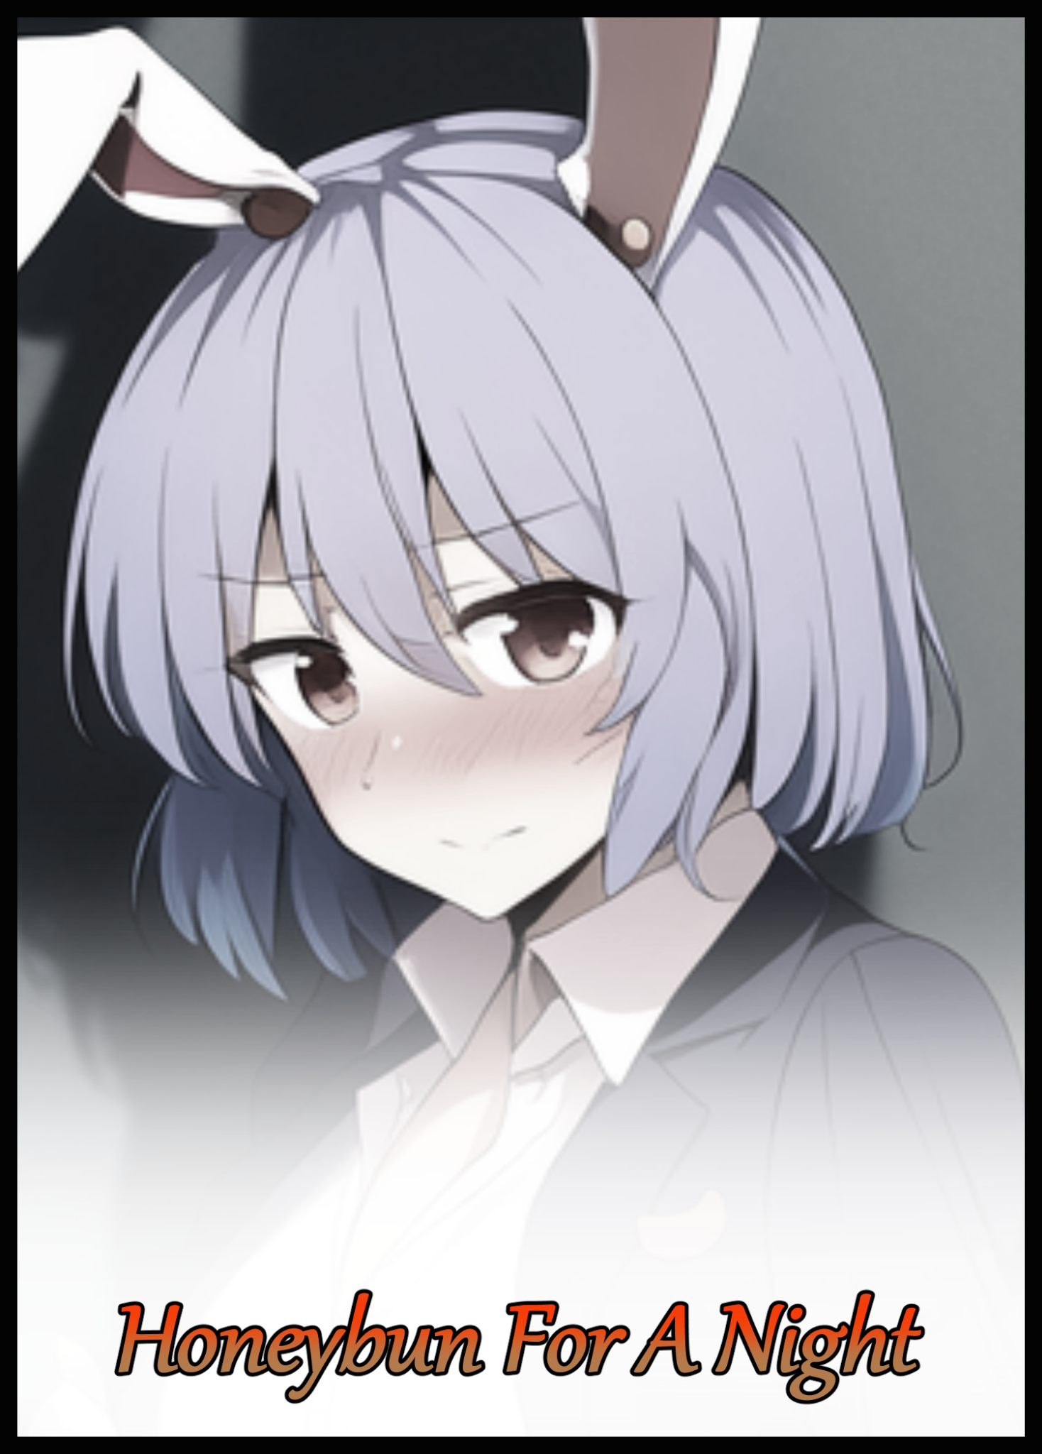

Awakening with a start, skin glistening with sweat atop a crumpled pile of sheets and blankets. A man with a ruffled head of hair panics for a millisecond before realizing the thing locked tight around his neck was a slender arm, a waifish limb that belonged to the brunette beauty lying fast asleep just beside him, the modesty of her form preserved by a pillow that would definitely need some time in the wash if the events of the previous night had been reason enough, stroking the rosy cheeks of his love in an affirmation of love before unhooking her arms as slowly as possible in an effort not to rouse her from her slumber while he shifts himself up into a seated position, basking in the warm rays of sunlight peering through the gaps in the curtains for a second or two before getting to work inspecting himself.

Sliding his legs off the bed and onto the floor with a slight tensing in the toes as they brushed against the floorboards in surprise, the man spreads his sturdy legs, curious eyes almost relieved to see his member while explorative arms run down the length of his rugged body, taking comfort in the presence of firm pectorals and a rock hard navel, stopping with a rub of his wrists before things got too awkward.
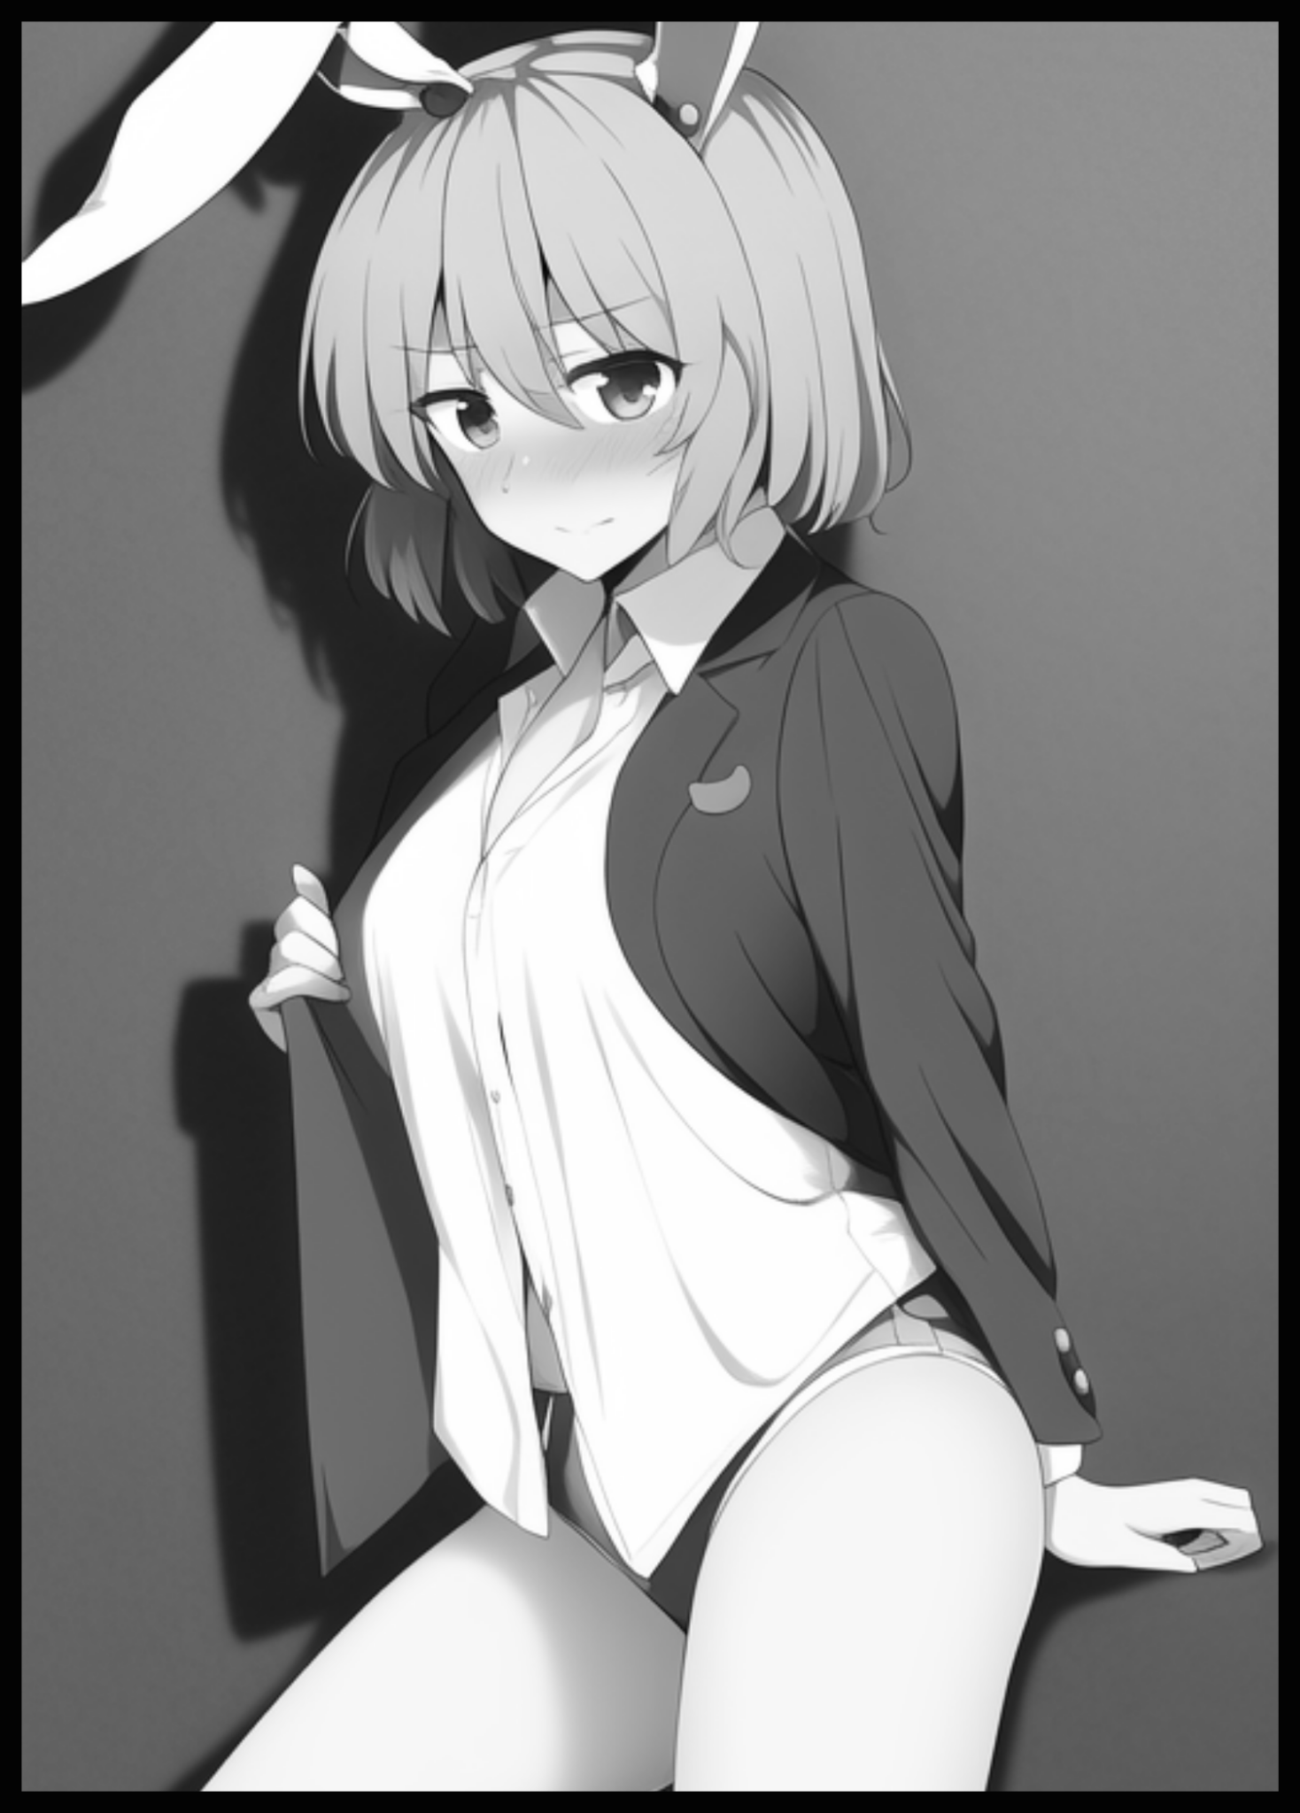
He was himself again, just like what his wife theorized would happen when dawn next came, a moment that had passed around…2 or so hours ago…a temporary alteration that had left him in a body that vastly differed from his current overbearing physique. One he had maintained for almost a decade, but in so doing had ended up lacking in other areas, like his temperament for instance…a foul mood and easily soured mind that, strangely enough, no longer seemed to bog him as much as it used to, rubbing his head in wonder with an inquisitive glance cast back at his still sleeping wife…

Whenever he would first come to in the morning, thoughts of work would always be followed up shortly afterward by analytical checks of the phone while on the way to the toilet, frowning at all the nonsensical messages left by incompetent colleagues, the demands by higher ups for the next term, bills to be paid, scams to be avoided…the daily wear and tear of adult life in the modern world.

Coffee and a quick breakfast would come shortly afterward before leaving the house, most often before his wife would come to in an effort to get to the office and clear the ever present pile that was ‘work’ before it overflowed, managing muck ups and other such things expected of the company’s model employee. Maintaining his ‘tryhard’ attitude in an effort to rise up the ladder, his mind focused on the future and what it might bring…but only the negatives, and never the plus sides of life, including the one person he shared it with.

So to not feel that familiar, overbearing weight pressing down hard on his shoulders for once in his life was...strange…alien…and most importantly; soothing. To wake up to a fine weekend morning with a clear head and a loved one close at hand, not able to feel the urgency he once felt, the impulse to reach out for his phone and instantly open that accursed messaging application, gone. The thought of which puts a smile on his face as he rises to his feet before making for the window, parting curtains and sliding open the window with half lidded eyes wincing at the rising sun peaking over distant skyscrapers and hilly horizons. Ears pricking up at the sound of cars and incoherent people rousing from their own houses. It was like waking up for the first time in a long while, to see a world he had blinded himself to in the closeted space he had shut himself in for so long.

And as his mind slowly drifts away, deep in thought. The events of the past twelve hours slowly come to mind as to how it all came to be. During a time when the neutral look currently plastered on his face had been a nasty scowl, etched deep like a carving into stone while his posture was stiff all over. Clad in a suffocatingly tight business suit that had only grown more itchier and frustrating to be in by the time he had been able to excuse himself from the office at day’s end, arriving thirty or so minutes late to meet his wife for dinner at a well known place she had picked out for them.

Except the stresses of the day remained close at heart like a virulent tumor alongside the infuriating memories responsible for seeding it. Like his assistant accidentally sending the wrong files to the wrong recipients and the sequential series of events that had culminated in a botched presentation, hence the massive delay required to fix it. A looping series of events churning away inside that worn out head of his, fed by the irritating noises of the crowd around him as he waited with his wife in the queue, the humid air, the tickle of biting insects as they swooped low, hoping for a bite…no surprise then what happened a few minutes later when the pair were inside and seated down…shivering a little at the unearthly roar he had let loose once the ticking time bomb inside of him had been set off.

"Please good sir, excuse our mistake. You must understand, she's new here, not accustomed to our ways yet…"

"Goddamn it…just…just go…."

What should have been a nice dinner experience at a cozy Chinese restaurant for most of the people there had been left slightly soured and tense after the reverberant sounds of an argument breaking out had bounced around the spacious interior, heard most clearly by those seated near the center where an awkward couple sits. The woman, looking weary and afraid…the man before her, furious and temperamental, looking disgruntled and irate, barely able to hold himself back with a furrowed brow as the urge to seek a reason to continue his tirade boils away inside his aching mind, rubbing away a trickle of sweat running down the length of his forehead once the throbbing onset of a migraine begins to break past the barrier put up by painkillers he has imbibed a few hours before during the strenuous task of reorganizing and digging through pages of digital documents alone.

His partner on the other hand fared better when it came to masking her emotions. Despite the concerned look on her face, righteous anger fueled by broken promises and mental exhaustion burned strong. Wanting to land a harsh slap on her husband's face for his outburst and the position it now landed them in, ruining a pleasant dinner date for the rest of the night. For there was just no way of wiping that stain away now when everyone would be stealing glances at the table seating a demanding neanderthal and his cozy wife who would verbally abuse a poor girl from abroad just because she had accidentally slipped and poured water across his shoes…it wasn't even a major spill, and yet, they had all seen him burst like he'd been assaulted, raging at her as she laid there on the floor instead of helping her up.

If it weren't for the manager's interference and diffusing of the situation, she feared they might already be out on the streets or worse judging from the itchy movement of the polished leather just aching to rear back and strike the vulnerable head of that poor thing…but just one look at his darkened face told her everything she needed to know about the reasoning behind his foul temper.

"Wasn't this supposed to be a dinner date? Why are you even thinking about your work right now?"

"I…it's not…you wouldn't understand dear…maybe we could…"

Excuses were evidently not what the lady had hoped to hear as her head droops low with a sigh, serving as a signal that cuts off whatever else the unfortunate man had to say as the couple falls quiet amidst the steadily climbing hubbub of the other customers once the energetic atmosphere recovers from the brief interruption, leaving them to pick up the pieces as the sullen man continues to boil away in brooding silence while his wife chews on her lower lip, obviously frustrated but at a loss for what to do next at the wrench that was her husband's temper being thrown into her evening plans. Thoughts he couldn't possibly have known about as he sits there in his chair, struggling with pangs of guilt, stubborn ignorance and simple exhaustion.

'The one time I get him to leave work early for some relaxing downtime and he goes and starts a row…why can't he just relax…'

Pulling the clear glass of water on her side of the table to stare into in an attempt to find peace, the lady's clear blue eyes glimmer at the sight of the sparkling water swirling within its cooling container, reminding her of distant stars in the night sky when contrasted with the dark tablecloth visible through the glass, and upon that sudden reminder, a strange thought slips from her stressed out mind. A silent prayer maybe, a pleasing whisper that she had rightfully assumed no one, not even her husband, could ever hear…

'If only for tonight…I wish he’d just drop all his worries…be less aggressive…more of a sweetheart…just like before…’

That must've been the moment she had made the wish she had told him about last night when they had gotten home from the restaurant, after he had become subject to an unbelievable metamorphosis starting shortly after she had tipped her head back, lips snug around the rim of the glass to funnel refreshing water down her parched throat after not having had anything to drink ever since stepping foot outside the house. Leaving her troublesome man to fiddle his thumbs alone on his side of the table.

Until a strange tingle runs down his spine, causing his frame to involuntarily shudder as the supernatural chill passes him by, leaving him with a strange weight in the stomach that he had initially dismissed as a side effect from the painkillers since they were from a new pharmaceutical brand he'd never seen before, maybe his body was just having a delayed reaction of something, or so he thought…

Because simple painkiller meds didn't make your whole body feel like putty unless said allergies were either fatal or severe, a grave realization that settle in as the slight tingle escalates into a feverish outbreak of cold sweat that beads his forehead, only realizing he was letting loose buckets when a loose droplet detaches from the trail before plopping into his cup, splashing a trembling wrist with cool water that stings glistening skin gradually 'tightening' itself, emphasizing the man's well built body as the outlines and extrusive curves of muscle definition and bulging veins begin to appear in tune with his own hide threatening to suffocate him as it continues to clench down tight with a firm grip, clenching his fist on instinct back in the real world as if to mimic the impossibly strong force he felt when the unseen forces guided by his wife's inner words had laid hands on his being, struggling to breathe while the unknowing perp behind his temporary discomfort begins to take notice of his tense posture.

“H-Honey? Are you feeling alright? You look really pale all of a sudden…”

Just when it felt like too much to bear however, the invisible entity let's him go, allowing air to flow through strangled lungs once again…alongside a subtle reduction of overall mass that leaves him looking far more slender and fair than he was a second before with the cuffs of his sleeves hanging loose to expose the beginnings of waifish hands tipped with lengthened digits while the gaunt bulk of his torso had given way to supple curves and smooth inclines hinted at beneath crumpled layers of fabric as they hang woefully short down near the armpits instead of continuing all the way in a more or less linear line of firm abdominals and solid pecs. With only the faintest rise of a mound tenting the region near the chest hinting at troubling implications taking place below the surface, enough for him to rise off his chair before entering into a brisk walk that almost had him falling right onto his face midway through a turn as oversized shoes snag on shrunken toes. A brief interruption that gives his wife more than enough time to walk on over to his side before recoiling from the briefest touch of his shoulders, depressing the shell of her husband's former silhouette while her the skin of her palm comes away slightly damp from the abundant sweat that immediately soaks into the fabric of his suit.

"O-Oh my god! You're…you're burning up! We need to call an-"

"I...I-I'm fine! Just gotta…gotta check something in…in the toilet…"

Not wanting to disappoint her any further than he already had with a rush to the hospital, the brash man had brushed her concerns aside after a brief choke of hesitation in his lungs seemed to hold him back, ushering himself into the men's toilet that thankfully wasn't occupied, shutting himself in before haphazardly blocking access to the door with a heavy cart tucked away in the corner, huffing and wheezing as if it were a demanding task, something that shouldn't have been the case considering his weightlifting capabilities. But as he would soon find out for himself with a single glance in the mirror, the root cause laid in more than just the sudden erasure of most of his muscles seconds after the invisible pressure had left him as layers of it honed mass softened into tender flesh, lining wastrel limbs with supple flesh and pliable fat. Turning strong arms into the wavy manipulators currently rooted against the basin while thick pillars, still masked behind baggy pants had become survey trunks formed by fattened thighs and thin calves, his mind still able to recall the way trapped air flowed and tickled the widened gap between his legs, tracing over smooth, sweaty skin stripped of hair and other such blemishes to leave a tantalizing void of vanilla, between which hangs a devastated pecker that had begun to shrink and fade away, dangling limp and flaccid with the faintest trickle of an uncharacteristic pale fluid dripping out of its puckered tip unnoticed to the man, who was more concerned with how his gloomy face had begun to sport very effeminate features in the form of a shrunken nose and slant eye sockets framed by silky lashes that weren't there before. Framed by luxurious threads of still lengthening hair that pushes past the browline while newly grown tufts trickle by soft earlobes and puffed up cheeks, quickly erasing the crew cut he had been careful to maintain for months in the span of a few minutes.

His suit was crumpled and baggy, the belt that once cinched his waistline drooping down lopsided along with the struggling hem of pants that were now far too big to fit, revealing the slightest glimpse of broadened hips that had gained too much curvature to properly keep them on alongside somewhat successful boxers whose stretch fit lining had allowed them to stay on, accentuating just how soft and plump he had become from the way it bites into the flesh, forming an undulating wave of creamy skin with a nice reddish hue to contrast the vanilla beige tone the rest of his body had since taken on in favor of the subtle tan he once sported.

But from the way the flesh beneath continues to bubble alongside the nauseating sensation from before continuing to roil in his core, whatever was doing this to him had yet to finish what it had started as a high pitched groan escapes softened lips once his already broadened hips expand yet further, filling him with panic upon hearing the subtle, wet sounds of bone snapping and reshaping beneath the flesh, extruding hips as a result while the already notable layers of smooth hide framing his mouth fatten up nice and smooth to form pristine cushions of pink, cured of the stubble that no longer fits his feminizing form.

Although he wouldn't have much time left to gape in awe and flounder in panic when the force that had strangled him earlier would return to see its work finished, taking on a more 'hands off' approach this time as a building gale of supernatural wind would manifest itself right then and there in the toilet with the girlish man at its center, erasing any notion in his mind that it might've had something to do with the medicine once his ill-fitting clothes begin to warp and change, shrinking down by a significant margin to fit his newly shrunken form while cleansing themselves of sweat and grime accumulated over the day, and in so doing, would make clear the effects of the ongoing transformation gripping him as baggy tents turned spherical before popping the buttons that held them prisoner, freeing the pale white undershirt beneath that had tightened around the unmistakable girth of swollen breasts as they sag forward, protruding from his chest after they had subsumed solid pecs to fuel their ongoing growth. All while a girlish yelp slips free from the combined efforts of disfigured pants exploding into a flurry of pink as black satin fades under a flowering wave of strawberry pink cotton weave that expands into the voluminous hem of a pleated skirt that hangs down the length of plump thighs to brush against angular knees that weren’t as knobbly as they once were leading down to slender calves and petite feet wrapped up nicely in black socks and polished sneakers instead of oversized shoes.

Except gale force winds and easily flippable clothes weren’t a good combination, so it wasn’t a surprise when the newly woven skirt’s length had begun to flap and flail in the air, exposing the sinuously gratuitous sight that was the length of young lady’s legs that had replaced the familiar bulk of his hairy trunks. Complete with the pearly length of plain white panties that were in the middle of forming themselves from the vestigial frame of his boxers, slapping straps around meaty hips while a securing length runs deep across the valley that was the crevice between the filled, firm cheeks of a heart shaped ass hanging low beneath an inward curving spine that further emphasizes the firm heft of his ass and the bourgeoisie weight of what must’ve been D cup or larger breasts standing proud atop his chest, tipped with erect nipples whose pale pink coloration and swollen areola could be seen vaguely through the semi-transparent cloth as they poked at it, sandwiching the crimson length of the only piece of clothing to survive the businessman’s inexplicable transformation; his red tie, catching his attention while the howling gale keeps the incessant knocking against the toilet door mute and out of mind.

He remembered the urge to fight back against the whipping winds, to lash out at whatever it was that was gradually robbing him of his former appearance. But the same choking hesitation he had felt when deflecting his wife’s worry had returned, stronger than ever. Rooting trembling legs where they stood while indecision and a newly ingrained sense of submission does the rest, keeping him frozen at the epicenter of the miniature tornado, helpless to do anything but watch as the last bastion of resistance beneath a warm, heated tummy dies away, blushing in severe embarrassment, a confused mind not yet registering the very girlish pose she had since taken on once the last of her former manhood slips away, complete with buckled knees, sloping, gentle shoulders and wide eyes of demure innocence pleading with no one in particular to stop her penis from settling into a tight gash of puckered folds and untouched lips belonging to a second, freshly formed opening that soils the pure fabric of her panties with a quick test of repurposed organs and shifted musculature as a glistening hole tightens, coaxing a small load of pale fluid through it’s slick interior before forcefully ejecting it beneath a shivering nub…one he had seen only once before when he had deflowered his wife so soon after their marriage vows had been exchanged..

A clitoris, cute and small, twitching like a pinky finger beneath moist panties that clearly illustrates each portion of her newly grown sexual organs; the puckered ‘mouth’ that was a drooling urethra…the subtle movements of her labia as they clenched and flexed around an invisible length like a hungry maw and the rest of her vaginal opening, a tight tunnel leading up and into a warm chamber nestled away beneath a plump stomach robbed of its former glory and flanked by repurposed sacs that betray their owner, flooding her system with female hormones and other feel-good chemicals that would slowly but surely help to settle her into her new body once the gale does away, leaving the newly changed girl standing alone in the middle of the opulent bathroom…seemingly unaware of the floppy growths hanging down a smoothened bob cut head of inward curling hair twitching in tune to the fluffy or twitching atop an adorable cutout at the rear of her skirt…

But with adrenaline and uncertainty ruling strong amidst a flurry of other emotions, panic would spur her to try and look for help, grunting as she pulls away the cart barring exit from the toilet with great difficulty, allowing the person knocking incessantly on the other end to come through with enough force to send the fragile lady tumbling onto her rump as the door swings inward immediately upon the removal of the blockage, leaving her midway through an attempt to get up onto her own two feet once more before the sights and sounds of familiar high heels and a concerned voice stops her just short…leaving her kneeling before her wife whose panic stricken face slowly gives way to stunned silence, confusion and mild excitement upon meeting the gaze of the strangely dressed girl kneeling before her. Sporting the physical traits of a lagomorph while her raven black head of hair paints itself a brilliant blue to contrast the pale pink of her wide, teary eyes…

"J-James?! Finally! I was about to call the manager when you…w-who…what are you?"

It didn't take much for James' wife to put two and two together after witnessing her feminized (and bunnified) husband struggle to speak, stuttering and falling over her own words…almost like she was too afraid to make herself known…and when coupled together with the business suit-esque top of hers struggling to contain her assets and the presence of a lone girl in the men's toilet her husband had vanished into, that left only one possible outcome the smart woman was quick to reach.

Fueled by the planted seed that was a crippling sense of social awkwardness and an inability to say no to whatever her wife had to say, James soon found herself being ushered out of the restaurant with her wife's coat placed over her head to hide the pair of authentic rabbit ears sticking straight out of her head in place of the human ones that used to jut out from the sides, leaving her feeling like a kid with a tummy ache being escorted back to the bus while the rest got to enjoy the excursion, a feeling further cemented when crawling into the enclosed space of the backseat of a cab she had called beforehand to take her hesitant place next to her oddly euphoric looking wife, a combination that, judging from the look on the cabbie’s face, probably had her looking alot like the younger sister who had one too much to drink after being taken out to dinner by her elder, who had to hide her face with her coat to preserve her public image after giving her a good laugh…close…but still a ways off the mark…

“Mmm…morning James…nice to see you’re…well…you again…even if Jenny was pretty nice to be with…”

Turning around from his present daydreams in the form of a panicky rabbitgirl melds reality with the vision as the image of a wry smile on his wife’s face merges with one looking over his shoulder, accompanied with a soothing rub of the shoulder by the same set of warm hands and smooth fingers that had gone all over him during the events of the previous night after being dropped off at the steps to their apartment to signal the end of a rather boring ride that felt like it had lasted an hour too long thanks to building trepidation and a smidgen of excitement mixed in with disbelief and shame.

“Morning Sarah…you really sure about that? Prefer something a little softer over me?”

That highly suspect tease of his had more weight behind it than one might think, especially when the warm smile on Sarah's face turns into a slightly devilish leer as she moves to join him by the windowsill with a mischievous giggle and a final squeeze of the shoulder, taking in the scent of dew mixed with the metallic afterburn of the city.

"Maybe…we'll have to see about that but…are you alright? Not feeling all queasy all over just trying to look me in the eyes~? No Lazer eyed focus on your job?"

"Heh…you wish…but…umm…”

“But?”

Retreating for a brief moment, James struggles to put together the words that would best describe how…beneficial the events of the previous night were. What Sarah had said about his work oriented mind was true, even when he'd been stuck in the form of Jenny, a name given to his soft spoken, female alter ego by his bubbly partner, the negatives to her job were all she could think about, wondering what to do if this state of hers were to persist all the way into next week. She had materials to present, plans to put forth, a division to whip into shape…and she couldn't do all of that the way she was; stuck in a petite, female body no one in their right mind would ever find intimidating. And nor could she do anything to make it so.


Any attempt to put on a frown would only deepen the worrisome look on her face with soft lips bunched into a twisted line. Trying to show anger or frustration through strong vocals was even more of a futile demand when the only sounds Jenny seemed capable of making were cute whimpers and defeated sighs…it was like wearing an invisible mask that kept her true self from peering through at all times.

That is of course, until Sarah had picked her up like a child, sweeping her now portable husband off her feet the moment they had arrived back in the safety of their home, abandoning the coat she had used to conceal her floppy ears in the rush to bundle her off to the bedroom, eager hands already busying themselves with undoing the buttons and clasps that held her crumpled attire together before spinning her over onto the bed in a heaping mess, shattering any last dreams of hopeful denial once the sight of her own two breasts jiggling hard from the impact registered itself in her mind, quickly (and futilely) trying to cover herself up with her hands and legs but only managing to rile Sarah up even further as the suddenly imposing form of her wife looms closer and closer from the foot of the bed…

“You're probably still thinking about your job…not about me…or our ruined dinner, are you?"

Against her will, Jenny had found her head slowly tilting back and forth in shameful, unabashed agreement. Not even jittering in protest as her body ignores the soulful words of her manly inner thoughts; the seething anger, the unjustful yelling to get Sarah to call for help, the vehement demands for whatever had done this to change her back. All would be ignored as her submissive form backs away further and further into the bed, grinding herself into the sheets as if wishing they would envelop her as Sarah clicks her tongue in mock disappointment, doing so as she slides over to join her on the bed, moving with firm legs planted on both sides of the rectangular platform, dexterous arms removing her own garment's just as quickly as she had done for her…and in a matter of seconds, there laid two naked women, one atop the other on a bed that once shook and trembled to the rigors of a loving couple, seeking to reignite a passion not seen in years. Doused by lengthy periods of inaction and an unnecessary focus on career…

"J-James…you're…"

Needless to say, what came next was undeniably amazing for both sides once Sarah had taken the first move in the form of a forceful hand diving down between Jenny's legs to caress the lips of her snatch as sensitive flaps and leaking folds instantly tighten around the middle finger that easily slides itself inside of the mewling bunny girl, causing her spine to arch itself up and off the bed in reflex as a jolting brain comes under the assault of an instant orgasm from having her pussy be penetrated for quite literally the first time. Despite the lack of a hymen, it was still the mind of a man, locked away inside of a frail woman's body experiencing what it was like for the other side of the fence when it came time to do the deed…a tiny taste of what it had felt like for Susan when he had taken her after moving in.

And as expected, the arousal from remembering such a thing had caused him to pop an erection, shying away from Sarah in earnest embarrassment before she could belittle him for his crude 'behavior'...but right as he turns on a leg to return back into the shadows, the warm embrace of his wife's hand grabbing ahold of his length with a firm, unrelenting grip had him jumping in shock, turning to look down at her vehemently opposed expression; frowning brows contradicting warm eyes and a small smile signed off by pleasant, rosy splotches on both cheeks.

"W-What're you-"

"Oh shush it…you remember what I said last night…when we…y'know…"

What she had said…James couldn't remember much after he…or rather she as Jenny had climaxed for the first time. Her senses were either dulled or firing on overdrive, barely able to feel her urethra squirting all over Sarah's hand while her ravenous wife continued to administer pleasure to the rest of her flaring form, giving a swollen right tit a hefty squeeze before nibbling on her left, eliciting a guttural moan and the loudest sound she had made so far into the night while her glands rewarded her wife with a brief release of milky sweetness out of both nipples to join the ongoing torrent down below as the second of many orgasms leaves her senseless and paralyzed by lust, a doll to be played with in Sarah's hands as she continues to vent her frustrations using her feminized husband like a man would a flashlight…except she had indeed been whispering words under her breath into Jenny's adorable ears, occasionally muting herself on accident whenever eager hands decided to squeeze them in the middle of a sentence.

It was how she had come to learn of the vague wish her wife had made in the restaurant, about how it would wear off come the next morning…and the satisfaction she had for her work ethics and increasingly deteriorating social life…that, and how he barely resembled the man she had come to love in a distant past, telling him to let loose and come back to her, all while warm hands emptied her body again and again, with each jet of precum, every droplet of milk, every tiny bead of sweat intermingling with the glistening later that coats her skin. All of it serving to lighten her in more ways than one, inching closer and closer to the aforementioned refreshing state she had woken up to earlier after awakening in the morning as her original self once more, freed of the suffocating lock that had kept James meek and docile as Jenny the Adorable Bunny Girl, returning Sarah's inquisitive glance with a suave look on his face as he drifts back to the present, unfortunately without clear answers.

"Sorry but…you're gonna have to remind me…you did make a mess of my ears after all…"

"Are you serious? I didn't think that would-"

The phone James had neglected to pick up that morning rings out loud, interrupting Sarah's words as he strolls over, silencing the thing with a furrowed brow locked over the screen…one of his bosses…probably looking to hand him a new assignment no doubt…or to check up on an existing one if not…but today was a weekend…now wasn't the time to be entertaining such things, job be damned. He'd licked their boots blindly for long enough, and with a clear leveled head, the wizened man simply waited for the call to end before turning the thing off, turning around to grab ahold of Sarah.

"You're not going to answer?"

"No…I'm tired…and it's the weekend…now's not the time for work…not after what happened yesterday…"

"Oh honey…knowing you learned a thing or two…maybe Jenny ought to come every now and then hm? Although…"

Using the momentum of her own fall to send James tumbling with her back onto the bed with a hearty laugh, the couple finds themselves back in the same position they had been the night before, except this time, James was on top, hands outstretched a d firmly planted around the head of Sarah who laid beneath him. Smiling a beaming smile he hadn't seen in quite a long time.

"You say you're 'tired'...but aren't you raring to know about what I said last night?"

"Really now…how is this…oh…I think I'm starting to get the picture…"

Sure, the last time he had slept with Sasha (as himself) had been ages ago. But he could never forgive himself if he didn’t know when his own wife was in the mood, especially after the vivid reminder from yesterday, doing his best to be gentlemanly about it as possible as James leans in to land a peck over Sarah’s cheek, stroking aside a stray tuft of hair while their gazes linger, shooting an invisible spark of revitalized passion at each other for a good long while before the man of the house takes the first step forward in their lives after an exorbitant stall…

Neither man or woman would ever be sure of the true circumstances behind James’ sudden transformation into Jenny or the equally swift vanishing of the surreal bunnygirl. But what could definitely be said was that their shared lives together going forward would be cemented into an unbreakable bond to last for eons, with James taking his chance to tone down from his foolhardy behavior starting with a well deserved apology to the waitress he had yelled at on that fateful night, follow up shortly thereafter with a decision to quit his well paying job shortly afterward despite the promises for a promotion he knew would never arrive…swearing to do better by Sarah from that moment onward as the married couple began life anew…and on the off chance were he to ever fall back on his words…Jenny might just show up on one fine day to set him straight once more…

THE END

Image Sources

Image 1 & 3 generated by NovelAI

Image 2 by Natsume : https://www.pixiv.net/en/users/2982283

