SWEET BLADE
COMMISSION STORY
BY CHALDEACHANGE
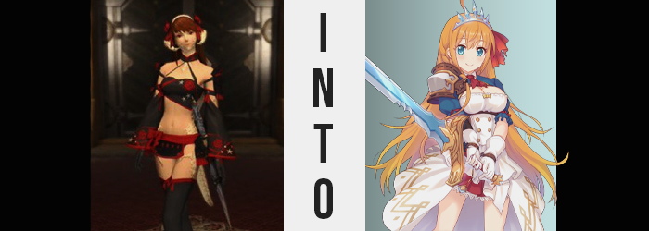

There were many ways in which being an adventurer was a rewarding experience in the world of Hydaelyn, and it was because of these benefits that so many individuals aspired to become one. There was, of course, the promise of renown. Few did not wish to somehow be thrust into the limelight, to become showered in attention in praise – and perhaps this was the shallowest of reasons for choosing this very dangerous career path.

Only slightly more admirable were those who were only in it for the money. Good adventurers were rewarded handsomely by benefactors, which paved the way for the greedy to thrust themselves into danger in order to line their pockets. This wasn’t universal, though. Some sought the Gil because they had to support family and friends, and earnestly believed in helping others. Those were the more trustworthy of the adventuring folk.

Then there were those that were in it for the adventure itself. They honestly enjoyed helping others, and the rewards they received were just a little extra. These adventurers went the farthest provided they weren’t self-sacrificing, and generally expected less generous rewards – in part because they were offset by another kind of reward. While exploring dungeons at the behest of benefactors, it was not unusual to come back with loot. Discoveries found within these places of exploration.

“Royal Equipment? That doesn’t exactly give me much to go off of.” Mitsu Kaisuri, an Au Ra Paladin, had recently had one such box of loot appraised by the local merchants in Ul’Dah, and upon receiving the items back and taking them back to her inn room? She had been left concerned by the notes that had been handed over with them. Among the trinkets and doodads was a set of armor – or at least that was how it had been described to her. But there wasn’t much armor on it, admittedly.

The ensemble had been folded up neatly in one of the boxes she had carried back, and consisted of white, cloth gloves, a white dress with golden decals and seemingly detached, blue sleeves, a crimson skirt with white frills, a hair ribbon and shoes. And discerningly, the only armored pieces were the silver and bronze pauldron and a silver tiara. In terms of the armor a Paladin needed? This was beyond lackluster. There didn’t even seem to be a blade that was part of the set? Which was a bummer.

So that was why Mitsu was squinting at the text the merchant had written down, baffled not from trying to read it, but because she didn’t really believe what it said. “It can incredibly boost my stats? There’s no way…” She could see something like a Red Mage wearing an outfit like this, but a Paladin? Maybe they had appraised something else around the same time and mixed up the notes?

Still, the Au Ra peered into the box at the dress for a few moments, her eyes narrowing into a notable squint of suspicion. And then she just snatched it out of the box with a groan and began to strip. It didn’t take her all that long to get dressed up in the gown – an outfit which, by the way, was far more different than anything she was comfortable with wearing – and in the end she was left trying to patch up areas where it didn’t fit properly.

And there were a few of those.

The most notable of which was the dress’ bust. It was clearly etched for a chest that was significantly larger than her own, and so the puff of white cloth that was clearly meant to hold much more dangled loosely, showing off her nipples. While the skirt was loose as well, and the outfit overall felt too long? “So it was designed for a woman that is taller and has a better figure than me, got it.” She didn’t sound all that impressed with this inevitable assessment, but at the very least it was good to know what was wrong with it. She could always take it in and have the size taken down.

“I don’t really feel any stat boosts though? Maybe this was a waste of time.” In a way Mitsu wanted it to be so she didn’t need to worry about wearing something so ridiculous if anything. So maybe she’d just undress and put her Shisui gear back on? At least that wasn’t falling off of her. Before she could bother to start doing so, though? A gurgle erupted from her stomach.

Why was she hungry? She had grabbed a bite on the way back from the merchant she had been using precisely to avoid getting hungry again this soon. It could have been more dismissible if it was just a slight hunger, but ultimately she came to realize something important. That it wasn’t just slight. Rather, she was extremely hungry, so much so that there was no way she could get changed first. She needed to eat something now.

Did she keep any food with her belongings at the inn room she was renting? Technically yes. When you were in the adventuring business, it was always important to bring along some snacks in case you were caught out in the wilderness without any food supplies nearby. Sometimes you could walk into a forest and not find a single animal for miles thanks to monsters, and not every adventurer was comfortable with sucking it up and chewing monster meat in the first place. Mitsu was usually counted among them.

But thinking of it now, you could probably cook some delicious things with monster meat, huh?

Mitsu was quick to wander over to one of the dresser drawers that had been given to her, knowing full well she had stashed a sleeve of crackers there. The state of the clothing she was wearing no longer appeared to be much of a concern to her, at least compared to the hunger that toiled in her tummy. And once she had acquired the sleeve? She was quick to scarf down its contents, thinking little of the crumbs that spilled onto the ground below. And those that got caught in her cleavage.

Although… that in of itself was already a strange outcome. Au Ra weren’t exactly known for commonly having much in the way of cleavage. Their breasts were usually paltry when compared to the other races (Lalafell excluded), and so there shouldn’t have been much of a valley between the two sides of her bosom for crumbs to get caught in. Yet so fixated on stuffing her face, Mitsu was unaware that something had changed.

The moment she’d started eating, the nipples upon her breasts had grown erect – which at first could have been attributed to the cool air of the room, but that was quickly dashed once the size of her areola began to appear larger than she was familiar with. In fact, they blossomed an additional coin size, and this was only an indicator to choreograph what would come next.

Because with her nipples now plumper and puffier, similar traits were ultimately inherited by the soft flesh beneath them. Her tits began to grow, pale skin stretching around them as meager B-cups bounced into a much more fulfilling size. Which was how the cracker crumbs began to get caught between them. Before long they had outright ballooned, pushing out the cloth cups of the dress she was wearing and standing incredibly perky against the tyranny of gravity as a pair of fully formed DD-cups.

“Oops! That’s not good!” A higher pitch affected the woman’s voice in the form of a voice crack once her gaze eventually travelled downwards, and she began to wipe away the crumbs with gloved fingers. The fact that she hadn’t immediately noticed the new size of her chest was concerning enough without comment, but the comment she did make might have been just as bad. “Huh. Was my chest always this big?” It was just as bad because it certainly wasn’t something that should have been doubted in any capacity!

Regardless of how notable she found what had happened to her chest area, similar trends had begun to emerge across the entirety of her body. Her skin and the flesh beneath it all just appeared softer and in a way fuller, depriving her of the firm and muscular appeal that had been earned through all of her training and battling as a Paladin. But nowhere was this more apparent that the areas directly below the Au Ra’s hips.

Hips that, given no choice, seemed to pop a few inches wider. It was difficult to blame them all things considered, because an Au Ra woman’s lower half was generally no more impressive than their chests were. So for any sort of abundance to appear there would mean that adjustments would have to be made. A swelling of the woman’s thighs was certainly one of these notable contributions, because they swelled to about one and a half times their normal size, pushing around scales that framed them in the meantime.

While her rump? Well, her ass bloated keenly, so much so that it ultimately lifted the base of her tail in slight. Cheeks rounded and pushed out her own underwear, but fortunately the cloth seemed to lax around bloated cheeks – because the black panties she had kept from her own wardrobe had lightened and grown into a pair of white ones with lace trim that perfectly matched the look of the Royal Equipment she was otherwise adorned with.

“Mm… I don’t feel so good… It must be because I’m so hungry?” That voice crack from earlier had apparently returned with the vengeance, because every word she uttered came with this higher, much more effeminate tone. But at the same time? Mitsu’s face was changing to better suit it, for as it was she almost seemed like an adult speaking with the voice of a teen, for what that was worth. Rather than acknowledge any of this, though? She had wandered over to her travel bag and was sorting through it, looking for more snacks.

Not noticing the clothes inside were all like the dress she was wearing.

Nonetheless, the pursed appearance of her lips as she rooted through the clothing soon seemed a touch more pronounced. Her lips were both plumper and shinier, and the former trait was something that became common amidst the woman’s facial features. Her cheeks for example? Rounder in shape and fuller in quality. Her nose? While it was no longer as long, it was more circular in its button shape. Even her eyes appeared wider in the end, though racially there didn’t seem to be anything in terms of a change. She did look significantly younger though, like a teenager. “Huh… I wonder if I ran out of snacks?”

Hunched over as she was, it was difficult to see. But several inches had found its way into her height. She was taller and it certainly helped with the fit of her ‘armor’ even more effectively now. Eventually she gave up on finding snacks in her bag and stood back up, but as she did? Her hair swayed in a way that wasn’t exactly typical of it.

It was atypical because it seemed too long, but it was clear as to just why that was. Her red hair had been and continued to lengthen, locks spilling out well past her ass and dancing about. Their color lightened to boot, and while a hint of red was ultimately preserved? It was only preserved midst the tangerine orange that had bled in otherwise. Her hair long and orange now, a single ahoge also stuck up from the center of her head. All while eyes that were now bright blue surveyed her surroundings.

“Whoa!?” Shortly after standing, on the other hand, the girl stumbled forward suddenly. Her balance had been set off-kilter? It wasn’t apparent to her as to why, but she had also missed a loud THUD behind her, where a great deal of weight had suddenly been lifted from her person. Because right below where her tail should have been? There was a long blade of blue steel on the ground, and absolutely no tail to speak of above it.

This change prompted the remaining alterations, ones that ultimately stripped away the things that made her an Au Ra in the first place. Her scales white scales were seemingly scraped away by an invisible force, leaving pinkish skin free of any hardness not blemish in the end. While her horns? Little by little they crumbled away and opened up, and by the time the last few pieces fell from the sides of her head and bounced onto the ground? They had revealed a pair of round, fleshy ears that were just like those of a Hyur.

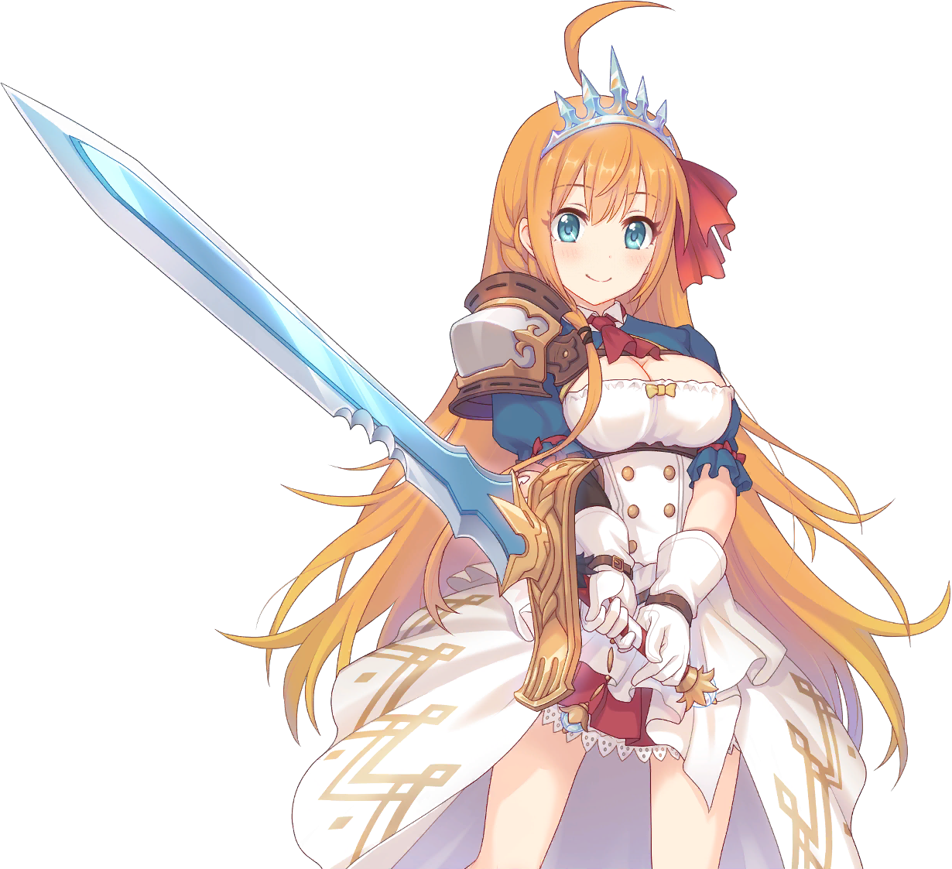
The crackers she had scarfed down when her transformation had begun had brought the girl some relief, but there was no point in denying the voracious hunger that now accompanied her youthful form. Such was the very nature of Pecorine, the busty teenager that now fit perfectly into the Royal Equipment gear set that had been uncovered and put on. There was no shying away from the fact that adorning the gear in the first place was what had caused her transformation.

But Pecorine herself was oblivious to the fact that anything had changed at all.

“I’m still so hungry! But…” From her voice to the way she spoke, to her overall mannerisms, there was just so much more energy boiling up from within compared to her previous self. Perhaps it wasn’t too unsurprising for a girl who could convert her calories into strength to be both hungry and bouncy – and the bosom upon her chest was certainly in the latter category as she danced around the room while trying to figure out her plans for the day. “Meals are more fun with friends!”

But who would she bring along? Well, her friends of course! Considering the seemingly chaotic state of her memories though, that didn’t make things any clearer. Pecorine believed that she had been a resident of this world her entire life, though the events of it were still strikingly similar to those of another life to boot. Memories of starting up a guild named Gourmet Edifice along with her friends. And those were the friends that she wanted to go out to eat with!

Those friends did not exist in Hydaelyn though. At least not yet. So rather than make that known to the teen, her mind instead replaced memories of there friends with memories of Mitsu’s friends. And when she eventually found them and invited them out to lunch? Well, the same magic that had transformed her would readily take care of the rest. “I should find Kokkoro and Kyaru! I bet they’re hungry too!”

And so she set out in search of an Au Ra and Miqo’te that were not these two girls she had just named. But they would be.

