PRINCESS SWAP
COMMISSION STORY
BY CHALDEACHANGE
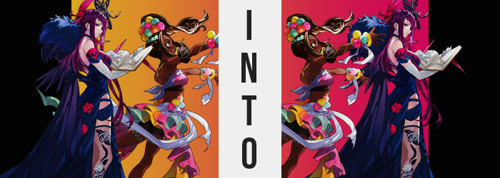

The world was such a place where not everyone got along.

There were reasons for that which were more obvious than others, of course. Some people just didn’t jive for extremely polarizing and sensitive reasons, particularly in a world at war. Some saw killing as an objectionable means to an end, while others were more willing to embrace it. The same could also be said about more unsavory tactics. What was okay to one person wouldn’t necessarily be okay to another.

But there were a lot of little, less heavy topics that could keep two people from getting along of course. A difference in interests was typically more than enough to keep two people apart, and in this case that was when you took out the fact that they hailed from two very different kingdoms. Such was the issue between Princess Ivy of Elusia and Princess Timerra of Sohm. Not only did they come from different kingdoms altogether, but they had lived very different lives and developed very different interests.

“An entire night outside in the desert… Are you sure we’ll be alright, Timerra?”

“Mhm! I’ve told you not to worry, right? I’ve slept under the stars out here plenty of times!”

In the end, however? The two had decided that their differences should be celebrated and bridged. That was what had brought them out to the deserts of Sohm for a camping trip of all things, seeing as the Divine Dragon’s army had been making a pit stop at the capital. Ivy had agreed to go along begrudgingly, prizing the interests of her nation and its relationship with Sohm above all else. But at the same time? She did wish to learn more about Sohm’s princess. How could someone that had the same status as her have been shaped into so different of a person?

“Huh? Did you pack these, Ivy? Oh, maybe Alear did?” After finding a place to set up, Timerra had begun to search through their bags for the shared tent that needed setting up. It was mid-afternoon, so they’d have to do that and hunt dinner before the sun set; not to mention gather fire wood. But what she had found was a small box containing a pair of rings – one inlaid with a blue gemstone, and the other sporting a red.

Having difficulty navigating the sand, Ivy eventually came over. “No, it wasn’t me. But I wouldn’t be surprised if they sent something like this. Look here.” There was a note tucked in the side of the box, and Ivy delicately removed it before reading the contents. “Ivy and Timerra. I heard you two were going on a camping trip to grow closer! That’s so cool! So I prepared these rings for you two from the Bond Chamber. Apparently they help people grow closer, so try them out!”

An awkward silence followed, because Ivy had gone as far as to mimic Alear’s tone. “A-Anyways, shall we try? I would never refuse a gift from the Divine One.”

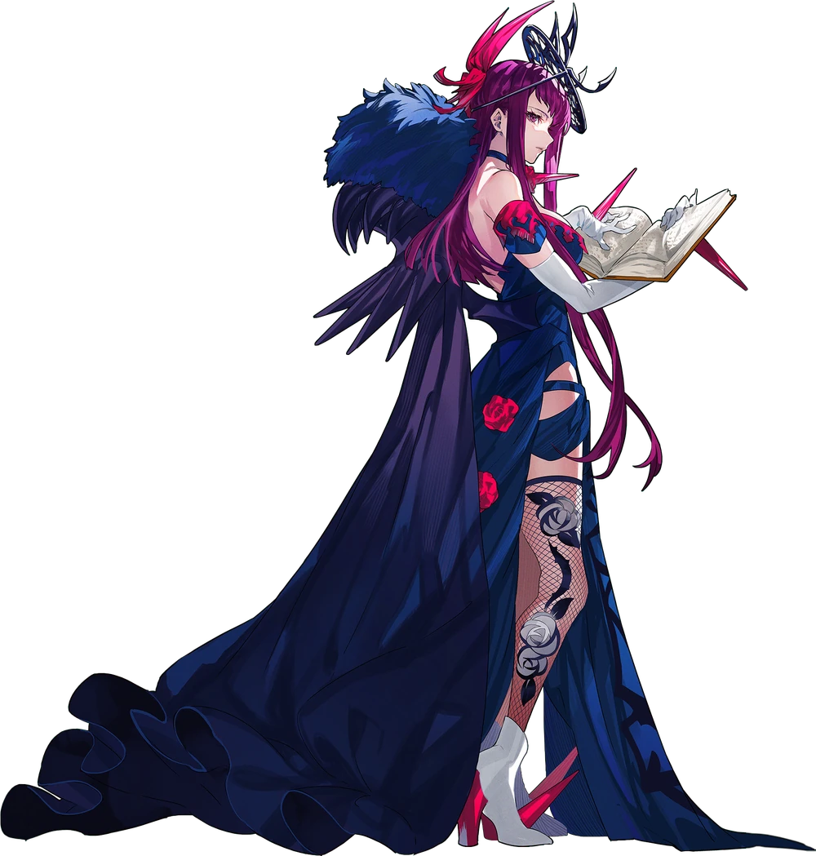
It had been about an hour since the rings had been found, and both young women had carried on while wearing them. Ivy wore the red one, and Timerra the blue. But not only had the rings not done anything to make them feel closer. “Hm? Did the color of the ring change? I’m certain I put on the red one…” Yet the gemstone in her ring was now the same blue of the one Timerra had put on. She would have asked the Sohmian princess if hers had changed, except for the fact that they were currently separated.

Timerra had gone to hunt for dinner since she was much more proficient with that sort of thing, while Ivy had been tasked with putting up the tent. It was a task that she had finished shortly before she had noticed the color of her ring, so she wasn’t quite sure when the color had even changed. “I suppose I’ll just wait for her to get back. It’s not like a change in color is harmful.” There were plenty of gemstones that could change colors under special circumstances after all.

But was the stone supposed to glow as well?

Ivy gazed with bewilderment, though perhaps she should have been a touch more concerned. In her eyes the Divine One would never give her something harmful, and so the warmth that flowed from the ring and into her body? It was easy to dismiss it as something that would provide positive effects, at least at first. The warmth was pleasant, if anything. “Perhaps… it is nothing.”

No sooner than she had said this, of course, it immediately became something. “Oh!?” Ivy took a step back, her footwork unsteady with feet sliding about within her own heels. It felt difficult to remain upright, or perhaps it was better to say that her balance was off kilter? It took Ivy a moment to realize why, and it eventually struck her. The tent she had put up appeared taller… her clothes were looser… “A-Am I getting smaller?”

She was, and it wasn’t exactly subtle either. Whether it was the princess’ arms, legs, or even her torso – everything came up shorter and shorter, shedding a full five inches from her height that left her outfit in shambles. Her fishnet thigh highs had bunched up at the top and were in danger of slipping, her dress now sat even more against the sandy ground, and her long, white gloves were in danger of slipping off as well.

For even her hands and feet had grown smaller now that she was only 5’3”. Taking steps saw her feet slide easily out of her boots, but she quickly put them back in to avoid the warm sand. Her hands, on the other hand, beneath gloves that clung to them, seemed a little rougher. Her fingers had grown hard and calloused, nails cut short and boyish. It looked like they were much more accustomed to wielding a tool of some sort constantly. Or, perhaps, a weapon? Being a spellcaster, Ivy didn’t concern herself with melee weapons.

“No… this cannot be… This is super weird!” How did she become smaller? It had to be the ring of course, but what kind of enchantment had been intended? She had to be around the same height as Timerra! She’d certainly just said something that wouldn’t have been out of place coming out of the mouth of Sohm’s princess too, but evidently she hadn’t realized this.

It hadn’t been long before she realized she felt lighter too, and thanks to two key areas. “Oh no! What’s… happening to my chest?” In a gesture that was a little more indecent than Ivy might have committed to, both of her shrunken hands immediately reached up to grab her breasts, gloves flying off in the process. They weren’t as hefty as she remembered them, and she could feel them becoming smaller and smaller within her grasp. But technically she wasn’t even sure if their shrunken sizing, now only B-cups, was wrong. A part of her not only felt like this was correct, but that she preferred them that way.

Ivy had to push the neckline of her dress against her bosom now, because her tits were so small that they were completely exposed if that neckline was left to hang at its usual length. This afforded time for changes lower down to take root, namely a similar loss of fatty, sensual tissue around her ass and thighs. Her bum became more compact yet perkier, while thighs were scarcely what they had once been.

But her body obtained a new appeal. “I…” Her head was spinning and she could hardly keep track of what was happening, but adding to this stew of confusion was energy building within. She felt very peppy and, for lack of a better term, raring to go. Not to mention she was feeling hungrier and hungrier by the second. As these feelings grew, her smaller, leaner body acquired something it hadn’t previously possessed.

Firm and toned muscle. Her arms and legs bulged without becoming unappealingly thick, and pectorals enhanced the supposed size of her bosom. Above all else, though? Ivy’s tummy had been rendered exceptionally toned, with not a single speck of unnecessary fat upon her frame. “Why am I so hungry!?” And why did she sound like that?

She patted herself down. “A toned body! Short! Hungry! And even the sound of my voice!” She was gradually piecing it together, but she had left out her peppier demeanor. Nonetheless, it was time for the color scheme of her body to undergo its due diligence. Almost deathly pale skin was hasty in its change, melanin levels shooting through the roof in her skin cells so that she went from white, to pale, to sporting the same dark skin tone of a Sohmian local in a matter of seconds. Though the same was true of her hair, which lost its purple hue and took on a striking chocolate brown.

“Aaaand my skin!” The princess had been looking at the hands that were patting herself down as they darkened and so the final piece of the puzzle came together. All while the structure of her face thinned, drawing more attention to a widened nose and slightly fuller lips that had also adjusted in color. Even her eyes weren’t spared, pupils whitening and expanding into star shapes as purple irises darkened. Paler palms clapped together, stomach rumbling around the same time. “I turned into Timerra!”

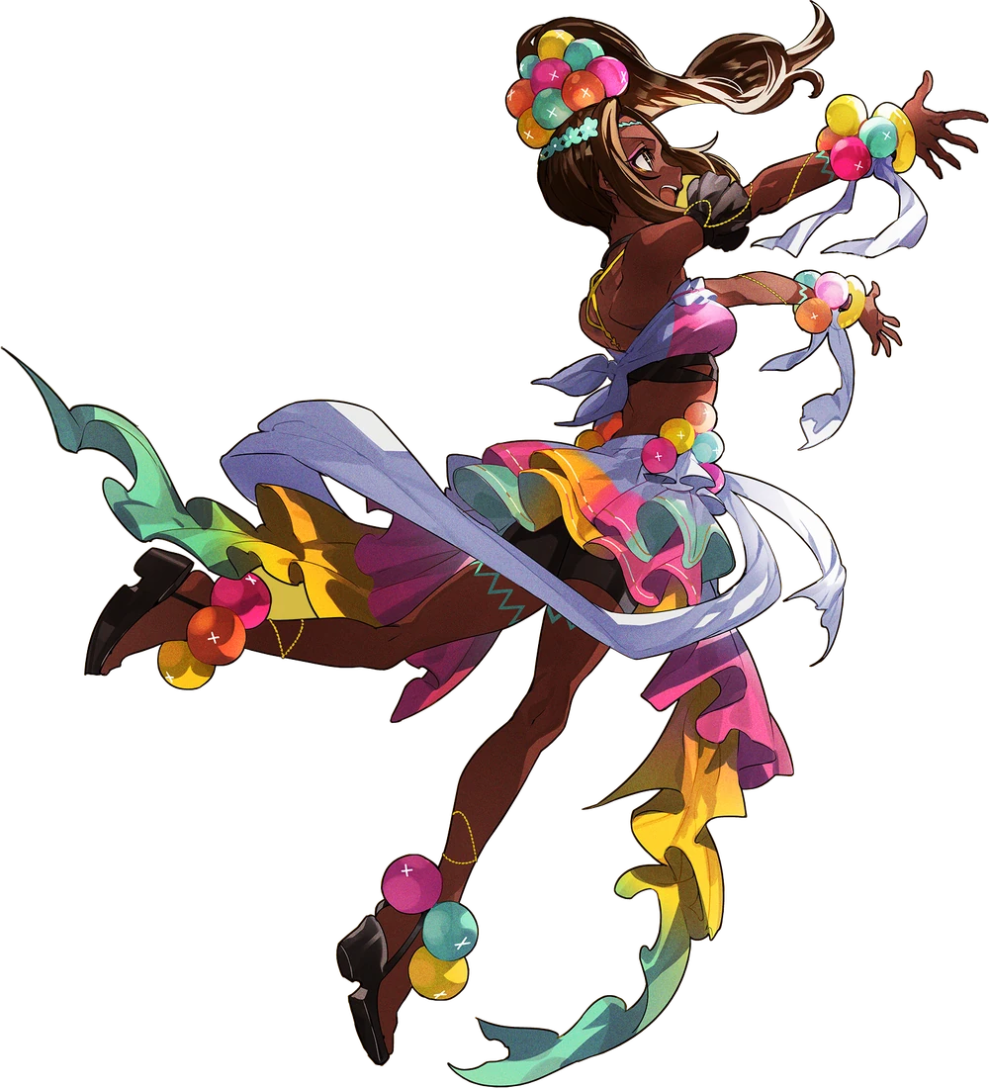
The gem on the ring finally stopped glowing, but with the light gone? It was revealed that the stone sported no color whatsoever. It was grey now, and as such Timerra became concerned. “I can’t believe this! Does this mean I won’t be able to change back!? But the Divine One wouldn’t do this to me!” It was difficult to move around in her old dress, but the boundless energy of Sohm’s princess was ever apparent in every erratic movement of her small and muscular body.

“W-Wait! If this happened to me, then what happened to Ivy!?” She jumped up, her dress almost slipping right off from the motion. But it quickly struck her that she had said something wrong. “Ivy? I’m Timerra, I meant to call her Ivy! Wh-What!? My name isn’t Ivy, it’s Timerra!” But in her head? She was referring to herself by her old name. Her mouth had other plans, it seemed, and she couldn’t refer to herself as Ivy no matter how hard she tried.

Which made sense, because even her memories were largely Timerra’s now.

But this malfunction revealed what had happened to the original Timerra, at least.

Some minutes early, around the same time Ivy had noticed that her ring was awry… Timerra actually hadn’t been all that far from the place they had designated as their camp. “Oh! Ivy got the tent up okay, that’s good!” She was carrying in her hands a steel trap with a rabbit inside. It was small, but it would have made a good enough dinner for two young women at such short notice. There was only about a minute or so of travelling left.

The young woman had been so busy with hunting (something she enjoyed doing) that she hadn’t paid any attention to the blue ring on her finger. At least not enough to realize its color had changed to red at some point since she had set out to hunt. “I wonder how well she likes her rabbit cooked… Ah well, I can do it no matter which way!” She was an old pro at cooking in the wild too. No one could prepare meat like her!

But before she reached their camp, a surprising turn of events shocked her into dropping the trap along with the dead rabbit inside. “Whoa!?” The ring that Alear had given her was glowing? But that wasn’t even the strangest part! “Why is it glowing red!?” It had been blue when she had put it on, right?

That said, her transformation began just as quickly as Ivy’s had – although what was affected did not transpiring in the exact same order as had been the case with the other princess. For example? Rather than her build being affected primarily, it was her skin tone. Timerra just didn’t realize what was going on yet, and so her melanin levels dropping dramatically escaped her initial notice. Before long she was almost unhealthily pale, like her body was accustomed to a completely different climate.

Just as striking was the change to her hair color. Hue and vibrancy saw to it that her locks inherited a vivid, reddish-purple tone that was vaguely familiar. Dyed locks became finer and smoother, but the length overall didn’t change all that much. “That’s really strange that it’s glowing! But… is it a problem?” That second sentence had been spoken with a much softer voice than the first one.

She eventually looked back down at the ring though, and instead noticed the finger it was being worn on. Or at least its color. “Wh-What!? Why is my skin so pale!?” Most of Sohm’s people were darker skinned, and yet not only her hand, but her entire body was a skin color more akin to the people of, say, Elusia. “That’s not right! Is… Is it the ring?” That was the only thing that made sense, wasn’t it?

But come to think of it, hadn’t Alear’s note mentioned the rings helped two people grow closer?

Facially, Timerra’s racial traits continued to grow farther and farther from what was typical of her people. Her lips thinned, but darker than the skin of her face they almost stood out more now with a resting pout. Her nose was rendered thinner too, and eyes became larger and took on the same purple as her hair – pupils becoming the regular, black dots. All in all, there was an undeniable resemblance between her face and the princess of Elusia’s.

“Nn…” Her voice, too, was deeper and almost sultrier, but it had been used to make the first discomforted noise since her transformation had begun. The reason? Her body had begun to feel strangely heavy. Not that this was surprising, for the firm muscles of her build had weakened and softened, leaving her pale skin looking suppler than ever without the toned quality. Even her fingers, which lost their callouses and grew out manicured nails, were strikingly different.

And this was all just a precursor to the main course. One that was soon felt in the restrictive quality of her chest wrap and shorts. Space had already been a touch too restrictive in these places after her muscles had been stolen, because the softer flesh took up more space. But before long it became incredibly uncomfortable. “This feels unbearable. How could my figure fit into these clothes?” She wasn’t even referring to them as her clothes any longer.

Regardless of what she had said and what she should have said though, she was certainly correct that the fit was too burdensome. Her hips swung several inches wider at first, tightening shorts around their gait. And from there? The already limited space within her shorts became nonexistent. Her ass inflated so that underwear and shorts alike were flossed into her bubbled, abundant crack – and thighs bloated with an intensity so great that the base of her shorts were practically strangling it. Not to mention the blue wire decorations that Timerra always wore around her thighs were now digging into them.

Elsewhere, further up on her body the cloth that was wrapped around her chest endured similar struggles. “They’re getting so big.” Her breasts, that was. Plumper and fuller, pinkened nipples swelling in kind, before long they climbed to a D-cup sizing that pushed the chest wrap to its limit. While it didn’t snap, this didn’t mean that it was any more comfortable. And Timerra’s nature had changed so that the idea of taking off her top, even for a second, in the open felt far too scandalous for a princess of her renown.

“Everything about me reminds me of Ivy.” As if to reinforce this, just saying the name led her to believe she had been talking about herself for a moment. Nothing had taken completely hold in terms of her memories just yet, but her past felt very blurry. So much so that she was having a hard time saying for certain whether or not her body, as it was now, was wrong.

Yet it still required one little change before the ring’s work could be deemed completed. Timerra was too short, and that made her thickened figure seem even thicker without Ivy’s height to compliment it. But that was only a temporary issue, as bone was produced to lengthen her existing limbs, spine, and so forth. Feet grew too large to fit properly in her old sandals, but otherwise? She was lucky that her outfit was so segmented. There wasn’t any real additional clothing malfunction by the time she grew to 5’8”.
“I… Oh dear, this outfit doesn’t fit me at all. But how did this happen?” The light from her ring finger gone and the gemstone now gray, Ivy looked down at the state of her dress. Ivy’s figure was much ampler than Timerra’s, and so her big breasts were being smothered by the girl’s top, and her shorts saw to it that her pale yet plump ass was bulging over and under the hems. It was fortunate they hadn’t ripped. “I’m… Princess Ivy of Elusia? But I’m supposed to be Ivy. No, I meant to say… Timerra is Timerra…?”

Princess Ivy was a calmer and more intellectual individual than Princess Timerra, so she calmly worked through this even though she found she now had the same issue that the new Timerra was. “I cannot refer to myself with my old name? This could pose to be an issue…” How would she explain it to others? Not to mention that, in referring to the original Ivy? She had referred to her with her old name, Timerra.

And the cause became clear as she finally returned to camp (which had been a real struggle moving in clothes that were that much smaller than her body now was) because upon arrival? She’d found a Timerra in Ivy’s clothes running around in a panic. “You’re finally back!” Another awkward silence followed as they both realized… they had both succumbed to the same thing. “Um… Maybe we can change back, right!? We just need the…”

“Rings…” Ivy exhaled, deflated. Because looking between her own ring finger and Timerra’s? Their rings were gone. But maybe it was for the best? As much as she didn’t want to admit it… “But we’ll have to live like this, won’t we? Can you imagine going back to your old life? My life? Regardless, we need to switch outfits.” She couldn’t even really remember what her old life had been like now that time had worn on.
And it had been the same for Timerra.

Though, those rings weren’t exactly gone for good.

They just weren’t there anymore.

