

A musty diner situated in a corner of Watson's busy streets, a handful of Kusanagi bikes and a rustic Thorton Colby parked outside. And within it, an unusually high number of Japanese women outfitted with Realskinn augments painted with inconspicuous dermal imprints masquerading as tattoos and cybernetics loitered around the place, taking orders from another of their number manning the counter, reading from the newspaper or chatting with each other. With the exception of a handful of individuals and waitresses nervously glancing at the gangers around them, it would've been easy for one to mistake the place for a Japantown business.

At the far end of the diner however, two men sit facing each other, unfazed by the fact that they were surrounded by members hailing from one of Night City's most notorious gangs. One more so than the other, evident in the way he displayed himself; reclining into the leather sofa without a hint of tension in his posture, dressed in a light singlet, baggy trousers and a beanie over the head of a keen eyed bruiser of Asian descent compared to the thick sleeved, bullet resistant jacket and jeans his associate sported with the grip of a Liberty pistol peeking out from his thigh pocket, leaning forward with elbows on the table, keeping his angular eyes locked with the man before him. To a bystander, it looked like a confrontation between two associates with no deeper connection to tie them together, and they'd be right.

But what boiled beneath the surface was a silent standoff with both sides gauging the other's capabilities in their own way. And while there were no certainties established, both men seemed to have their own trump cards at play. For instance; the more cautious man secretly communicating with his partner a couple seats behind them through secure comms only opened to members of the Night City Police Department.

[How's things on your end Matt? Hear our choom here loud and clear?]

[Transmitting nicely! Gonna be able to wring all the juicy detes outta this guy by the time you're done wrangling him.]

[Preem, gonna start-KZKT-woah…that interference from your end?]

[Glitch in the system, no problem. Diner network's clear…I'm more worried bout your side boss. Too many chrome domes for an early dinner you think?]

[Yeah, something's up…though I doubt these gonks can do anything really…think some Joytoys can take out an officer and a runner?]

[Any old street whore packing iron can do a man in…watch your six boss, it's all I'm sayin'…C-YA.]

Frowning a little at the ominous warning while thinking back in time to a few days ago when he'd still been scouring the alleys and monitoring the chatter within the ever crowded cyberspace of Japantown looking for possible leads on a source after a recent string of disappearances and violent confrontations began to plague the district. The detective's partner had received a tip in the form of an informant claiming to have in his possession good information that could shed light on what the Tyger Claws were up to and that if they were interested in sealing the deal, all they had to do was meetup at Tom's Diner in Watson, guaranteeing safety, privacy etcetera etcetera. It sounded fishy, but after a thorough background check and a little back and forth, the duo had agreed to the informant's terms.

With the NCPD stretched thin enough as is and word of the Tyger Claws becoming emboldened. The last thing they wanted was open war between them and Maelstrom, a gang predominantly based around the abandoned industrial regions of the district. If they wanted to snip the problem in the bud, a shady informant was leagues better than wandering blind.

But when the time came for the meet, the pair were mildly surprised to find the parking lots outside occupied by a bevy of colorful bikes with enough space barely left for their four wheeler to park. Stepping out of the car before being immediately confronted by Tyger Claw gangers loitering around outside, with even more already milling about the place inside where very few ordinary NC citizens could be seen, with some taking their leave in a hurry…and the usual proprietor of the place was nowhere to be seen behind the counter, replaced by a pretty looking thing taking orders from Claw and citizen alike. A strange turn of events.

And near the windows, far at the back, sat the informant, halfway through a meal as if he didn't register the danger he was in; surrounded on all sides by members of a gang with a penchant for striking so fast the victim wouldn't even know what hit them. And even if they bore no weapons, at least from what the detective could see, he had dealt with enough of their number to know the Claws preferred melee weaponry. So he wouldn't be too surprised if they came outfitted with Mantis Blade implants alongside the usual tanto/katana combo.

But there was a reason why the Detective, a certain Richard Mills, showed no hesitation in stepping foot inside the diner. A seasoned vet in the NCPD with a record number of resolved cases under his belt and more than a few skirmishes with Cyberpyschos to last a lifetime he'd walked away from unscathed. To him, a room full of gangers was less threatening than one well armed combat vet. And it wasn't as if he was slacking in the cybernetics department as well when he was one of the few rated for Sandy's; rare, top of the line, military cyberware capable of tipping the scales to the side that had someone equipped with it. Although the downsides of using it made it a double edged sword, it was what allowed him to survive this long as a lawman in Night City.

If he was going to be facing some of the most ruthless and crooked individuals with access to black market tech, then no one could complain if he did the same…especially if it meant he could dish out just a little more justice each day he went by without taking a bullet to the brain. And with his trusty partner and capable Netrunner by side, the lax detective was all but certain that today wouldn't be any different.

If only he knew how far the Megacorps that governed Night City were willing to go in ensuring their control over the people held strong…

Taking up an innocuous position a few seats away just as planned, Matt would provide backup for Richard while he 'negotiated' terms with their informant. If things went well, they'd soon be walking out with the info they needed to put a stop to whatever the Claws were planning. But on the off chance that this was all a trap, Matt would already be jacked into the next, ready to neutralize the man before he either got hurt or decided to flatline himself. A scenario the detective was all but certain of after taking his seat before the informant, finishing his silent appraisal with a heavily accented greeting.

"You must be Mister Mills, correct? A pleasure to see you were not lying when you said you had accepted the offer."

"Richard...just Richard, might want to rethink that last but because that remains to be seen. For someone looking for 'privacy' and 'protection', you've got a funny idea about what company you keep around…"

"Ah! But that is where you're wrong! I am indeed speaking in privacy with you right now Richard, and well protected so to speak."

"But you said you had beef on the Claws? What good is it if you hire em for security? Besides, taking over an entire establishment in foreign territory's a little too much isn't it?"

"Oh no no no, I'm afraid you've gotten it all wrong there. We haven't taken over anything…at least, not yet. You'll find the owner has quite graciously allowed our presence here on their own terms. Why, they've even decided to make themselves honorary members of the family!"

"But…Tom's a Watson local with a veritable food chain in NC…why would he even agree to joining up with your…'friends'? You're telling me he suddenly decided to let the Claws run the place carte blanche?"

"Yes, that is exactly what I am saying…although, I think the name Tom is highly inappropriate for a woman like her, don't you think?

Gesturing toward the counter where the young woman from earlier was still busy tending to her customers, Richard turns to face her, running a quick scan that brings up nothing for a moment before new information appears, failing to notice how there now seemed to be even more Tyger Claw gang members populating the diner with one of the waitresses mysteriously replaced by a lewd ganger dressed like she was an expensive Joytoy hitting the floor at a club rather than a place for honest folk to hang out and eat at. But the information seemed dubious. Besides her name and age, nothing else was recorded in her biometrics…which meant she was an illegal immigrant or had her chip tampered with so as to remain off the radar.

A quick cursory scan of the informant bore no fruit either. He had a blocker running, nullifying any attempts to do so.

[Hey, Matt, you there?]

[Yeah, already on it...Rina Amano…23 years…no record…she a Bennie or something?]

[Dig deeper, there's no way someone like her's managed to lay low this long till popping up again halfway across the world. And while you're at it, see if you can hit up where they're holding Tom, homegrown boy like him doesn't just cozy up to the Tyger Claws without reason.]

[Sure thing boss…but what he said earlier…about Tom not being a name fit for her…the hell does that mean?]

[Gonk's either trying to pull our leg or he's just a really drugged up brain potato…you worry about the search, I'll deal with him.]

Turning back round to focus on the informant who was halfway through ordering something from a waitress who seemed eager to excuse herself from the floor on account of the increased Tyger Claw presence as she quickly skitters back to the kitchen with a knowing glance from Rina's effervescent eyes as she too slides behind the doors. Richard clears his throat to catch the man's attention.

"Ah my apologies, Rina was as beautiful as always…now, what was it we were discussing?"

"Quit playing around and just spill the detes already. Information; I promised you good, hard Eddies for it so talk. What're the Tyger Claws planning?"

"Hah…come now Richard. I believe I've already told you plenty, showed you as much too! Do you know how hard it is to run the latest Saka technology on a constant?"

"Not seeing your point, how's showing me a bunch of Joytoys supposed to tell me anything? And really? Saka tech? Doubt you and your girls even managed to klep anything if you’re exposing yourself like this."

"I implore you to take a look once more Richard, take a look around the Diner, you will see what I mean I am sure…"

[Matt, get ready to Delta on my signal, I'm not liking this already, I think we just wasted time on a false lead…]

Doing as the informant asks just to keep up appearances, Richard scans the diner once more, noticing nothing off besides the large number of gangers populating the place…

'Wait…Where'd everyone else go?'

…Everywhere he looked, women affiliated with the Tyger Claws were all he could see. Some were dressed in their usual attire ranging from modified biker gear to skintight latex their close quarters combatants favored while the others just seemed to serve as eye candy akin to the Mox clique, walking around the place with very little to shield their bodacious forms with eye catching tattoos doubling over as body paint that only made them look more attractive, filling the cramped interior with banter spoken entirely in Japanese vocalized by sweet, husky voices that would've tingled the detective's jimmies if the circumstances were better.

But amidst the storm of Tyger bodies, he couldn't see his partner. Ignoring the informant and rising to his feet, Richard pushes past the women, with some muttering Japanese curse words while others purr salaciously, trying to catch the burly detective's attention to no avail as he continues on past them before his eyes widen in shock at the sight before him where Matt was supposed to be sitting.

"Matt! What've they done with you?!"

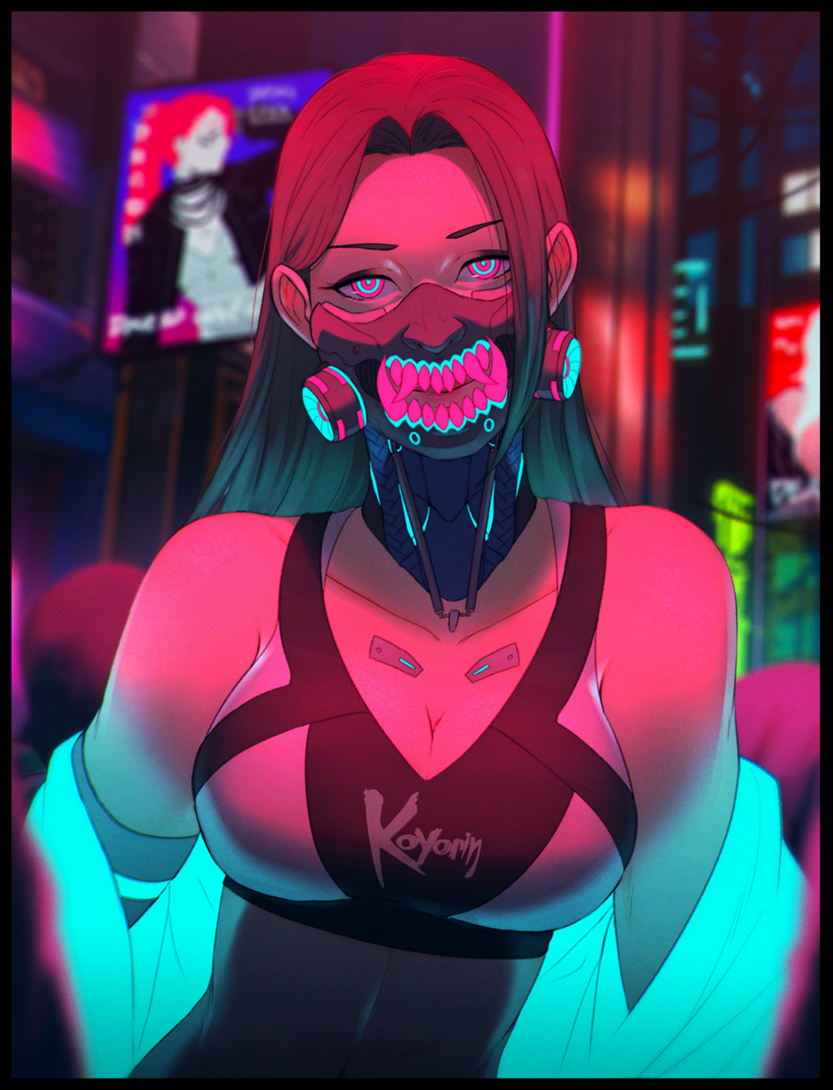
Pushing his way past the last few bodies blocking the way forward, Richard rushes over toward the booth his friend was seated at, his body convulsing with visible plumes of smoke and steam escaping gaps in the Runner's Realskinn…except the detective didn't recall his partner ever getting such implants. Nor was his hair supposed to be this long or luxuriously soft to the touch as it pours down over soft shoulders and a cinched in waistline that didn’t seem fitting for any competent soul under the NCPD’s payroll. Whatever was happening to Matt seemed to have struck him a while ago, probably a short time before he had told him to prepare for a quick getaway. No wonder he didn’t reply then. He had assumed the man was too busy tearing down ICE or perusing important data folders, never once assuming the worst considering how many missions the two had made it through together. Now his negligence had cost him as he watches a strange series of hexagonal patterns run across his partners entire body, reshaping at an extraordinary rate with each pulse that runs over the rapidly feminizing man as his affliction strips him of his former appearance, granting supple flesh that further accentuates killer curves, pliable meat in all the right places like a heart shaped derriere and the beautiful face of an oriental maiden staring him down with cold glassy eyes devoid of will and intelligence, sporting an artificial jaw fashioned after the menacing maw of the Japanese Oni from mythology and folklore, cycling filters that allow for airflow once more , filling her lungs as a pert set of C cup breasts squeezed tight by a sleeveless low cut top that highlights the silhouette of her body begins to rise and fall with the effort, tense shoulders relaxing after the brunt of the transformation was over with a subtle sigh of satisfaction filling the air, neon lights coming online from the freshly grown cybernetics her body had been enhanced with as her doll like eyes flicker with an eerie glow.

Within seconds, the detective's partner had vanished, replaced by a Japanese babe who seemed better suited to running with gangs than a lawman. With his scanner already toggled, what Richard feared was all but confirmed as he watches Matt's personal details flicker and change in real time as what he could only assume to be a body jacking virus of some sort works on his biometric data; erasing the man's former NCPD profile, his status as a NC citizen and whatever else it deemed unnecessary before inserting new detes such as a name and age, just like Rina Amano before him…

“ベイビー、親身になって警察官を捕まえてくれるかい？” (Babe, be a dear and apprehend the policeman would you?)

Before Richard could spin round and clock the bastard responsible for this, a searing edge to his throat along with an impossibly strong grip under the shoulders apprehends him. Locking the detective on his knees while making it impossible to move, not when he had a razor sharp, superheated blade threatening to burn him to death drawn dangerously close to his bare neck. At that distance, the heat was already hot enough to singe, any closer and he'd be feeling the pain of third degree burns long before the Arasaka crafted blade ever got to bite through his neck like it had with the Liberty pistol; gutted at the handle as it drops to the floor, useless.

But what shocked him more was the one who held the blade at his throat; Matt. Whose narrowed eyes showed no recognition of her former friend, threatening to end his life if he even dared to move an inch forward. Just a second ago, she'd been lying like a defunct android against the window, but with a simple sentence, she had sprung to action. Enticingly soft body pressed up close to her prisoner, flexible legs locked around his and her weapons drawn. And from the lack of a bulge pressing up against his back, Richard was all but certain his friend's member hadn't survived the conversion as well. He'd been dominated in an instant, his mind, his body, twisted to serve as the Claws latest femme fatale.

Bereft of memories from another life altogether, the ganger leans forward, extracting a dripping wet bioluminescent tongue from the bowels of her throat, running it over Richard's neck with a cool gust of air exhaled over his face. It smelled of fragrant tea leaves and sweet mochi…a fitting combination for the sultry Japanese vixen who could kill just as easily as she seduced.

“やんちゃ坊主... 俺達の事を調べてるのか？ご主人様を見下してるから 今すぐ殺してやる...” (Naughty boy~ Thought you could dig up shit on us? I should kill you right now for disrespecting Master…)

"C'mon Matt, you've gotta be in there somewhere…don't give in this easirgh!"

“黙れ！求められた時だけ話す...” (Shut the fuck up! Speak only when asked to…)

Motioning for her to stay her hand, the informant steps forward, parting the crowd of women that had gathered, sneering and jeering as they laughed at Richard's predicament. With the doors to the kitchen swinging open, Rina returns looking positively dazed alongside the waitress from earlier, except she too had succumbed to whatever it was that gripped the diner, looking drastically different from the African American woman from earlier as she joins the crowd as just another Tyger Claw, pushing past with a drink in hand, offering it up to the informant with a playful kiss on the cheek, something Richard could tell made his former partner seethe with jealousy as he hears her produce a scratchy sound akin to a frustrated click of the tongue from within her mechanized bowled.

"I am sorry for the rough treatment but Tsunade's fiery temperament can make her very unpredictable. I had thought the Runner to be an unknown, didn't guess you two were-"

In that split moment, Richard takes the opportunity to use this opening to his advantage, activating the Sandevistan while muttering a silent apology to Matt before elbowing her in the side and uppercutting her beneath the jaw with his head, sliding out from under her before making a beeline to the cocky informant with a fist outstretched, inches away from connecting with his cheek, unaware of how his body seemed to bulge and bloat at an inhuman rate, sparks flying from the cybernetic implant attached to his spine as muscles deflate around snapping bone that shrinks and reconfigures so fast the mind bending pain from such a hellish experience lasts less than a nanosecond. Bestowing upon Richard a broad set of handlebar hips resulting from a widened pelvis leading down to twin pillows with a tantalizing gap wide enough for a man's hand to slide between them. Baritone yell transitioning into a waifish cry as he trips on non-existent boots, sharp, angular eyes widening into soft almond shaped slits atop a face gradually losing its Caucasian edge as an oriental touch slides across his visage, painting the faintest blush on cushioned cheeks as his brain bears witness to the horrific sensations of a man's pecker being folded in on itself; feeling every second of it as Richard's shaft recedes back inside of his groin before imploding, hollowing itself out into a sopping wet cavity of flexing muscle as a jet of fluids spray out of a newly formed urethra, dampening vibrant pink folds while wrinkled sacs smoothen out before reshaping themselves into swollen lips pressed tight around a virgin slit dripping with honey, staining the latex material of an altered Netrunner's suit meant to show off the wearer's body, leaving little to the imagination instead of providing protection.

With the Sandevistan implant fizzling out before being surgically removed from Richard's perfectly sculpted back, the detective flies way off his mark, landing hard against the counter with enough force to knock the air out of him, gasping in a womanly voice, paralyzed in response to the searing pain running through his sides and sending a tingle running through his suddenly softer, more curvaceous body as multiple arms rush forward to pin Richard down amidst an enraged chorus of women cussing Richard for his audacity, spinning him around onto his back as he grunts in protest before an involuntary cry escapes soft, fuller lips from the electrifying jolts shooting through his chest as the women greedily pinch at erect nipples through black rubber, tugging hard against malleable breasts while the stunned detective cranes a slender neck forward, sending bangs of turquoise falling over his right eye and the threads of a side hanging ponytail against the nape of his sensitive neck, all while struggling against hands with a meager grip strength he should've been able to shrug off without trouble. Trembling with a notable jiggle while he struggles to shake them off. Instilling a momentary sense of dread within the detective's mind as the adrenaline rush of being pinned awakens him to the alien sensations assaulting him in addition to the fact that he’d been shouting in Japanese this whole time with a higher pitched voice dripping in Kansai dialect.

“ま、私の声！？ な、なぜ私は...なぜ私は英語を話すことができないのでしょうか!” (M-My voice! W-Why aren’t I…Why can’t I speak English?!)

Cold air lapping at a smooth, exterior shell wiped clean of hair follicles, scars and calluses. Ridiculously large, ganic breasts straining against inadequate rubbery fiber that might as well not be there. Long slender arms stripped of useful augmentations tapering off into dainty hands extending into dexterous digits tipped with trimmed nails. And while her abs were somewhat untouched, her manhood wasn't as lucky. Left as nothing more than a hairless cameltoe pressed up against the stained bottom of her new leotard with fluids still rubbing down her immaculate thighs stuffed full of artificial muscles that simulated the best of both worlds; a woman's supple warmth and the solid reliability of raw strength. Strength that was beginning to build as her rewired nerves link fully with her altered and downgraded cybernetics, lashing out in anger with her feet, kicking off her assailants with a thunderous war cry before directing her feet toward the informant's head, toward the sleazebag that had done this to her.

“このクソ野郎を殺してやる！うっ！” (I'll fucking kill you asshole! Ugh!)

Until her assault was instantly beaten down by a concussive slap to the face in addition to a personal link being jacked into the access port behind her ears. Scrambling her vision with error messages and obnoxious static while her cybernetics temporarily stall, locking her in place with the limb meant to knock off the bastard's head halting inches to the side after being pushed off point by her assailant; an irate Tsunade who didn't seem too pleased with letting her live, keeping her rage in check as she stomps off to the side, leaving the new girl alone and helpless to resist the sneering informant whose personal link was now jammed into her, closing the distance between them before coming to a stop uncomfortably close to her. And it didn't help that Richard had been frozen in a highly compromising position; leg raised high in the air, leaning backward with arms bent and poised against the counter. Almost as if she was propositioning him…

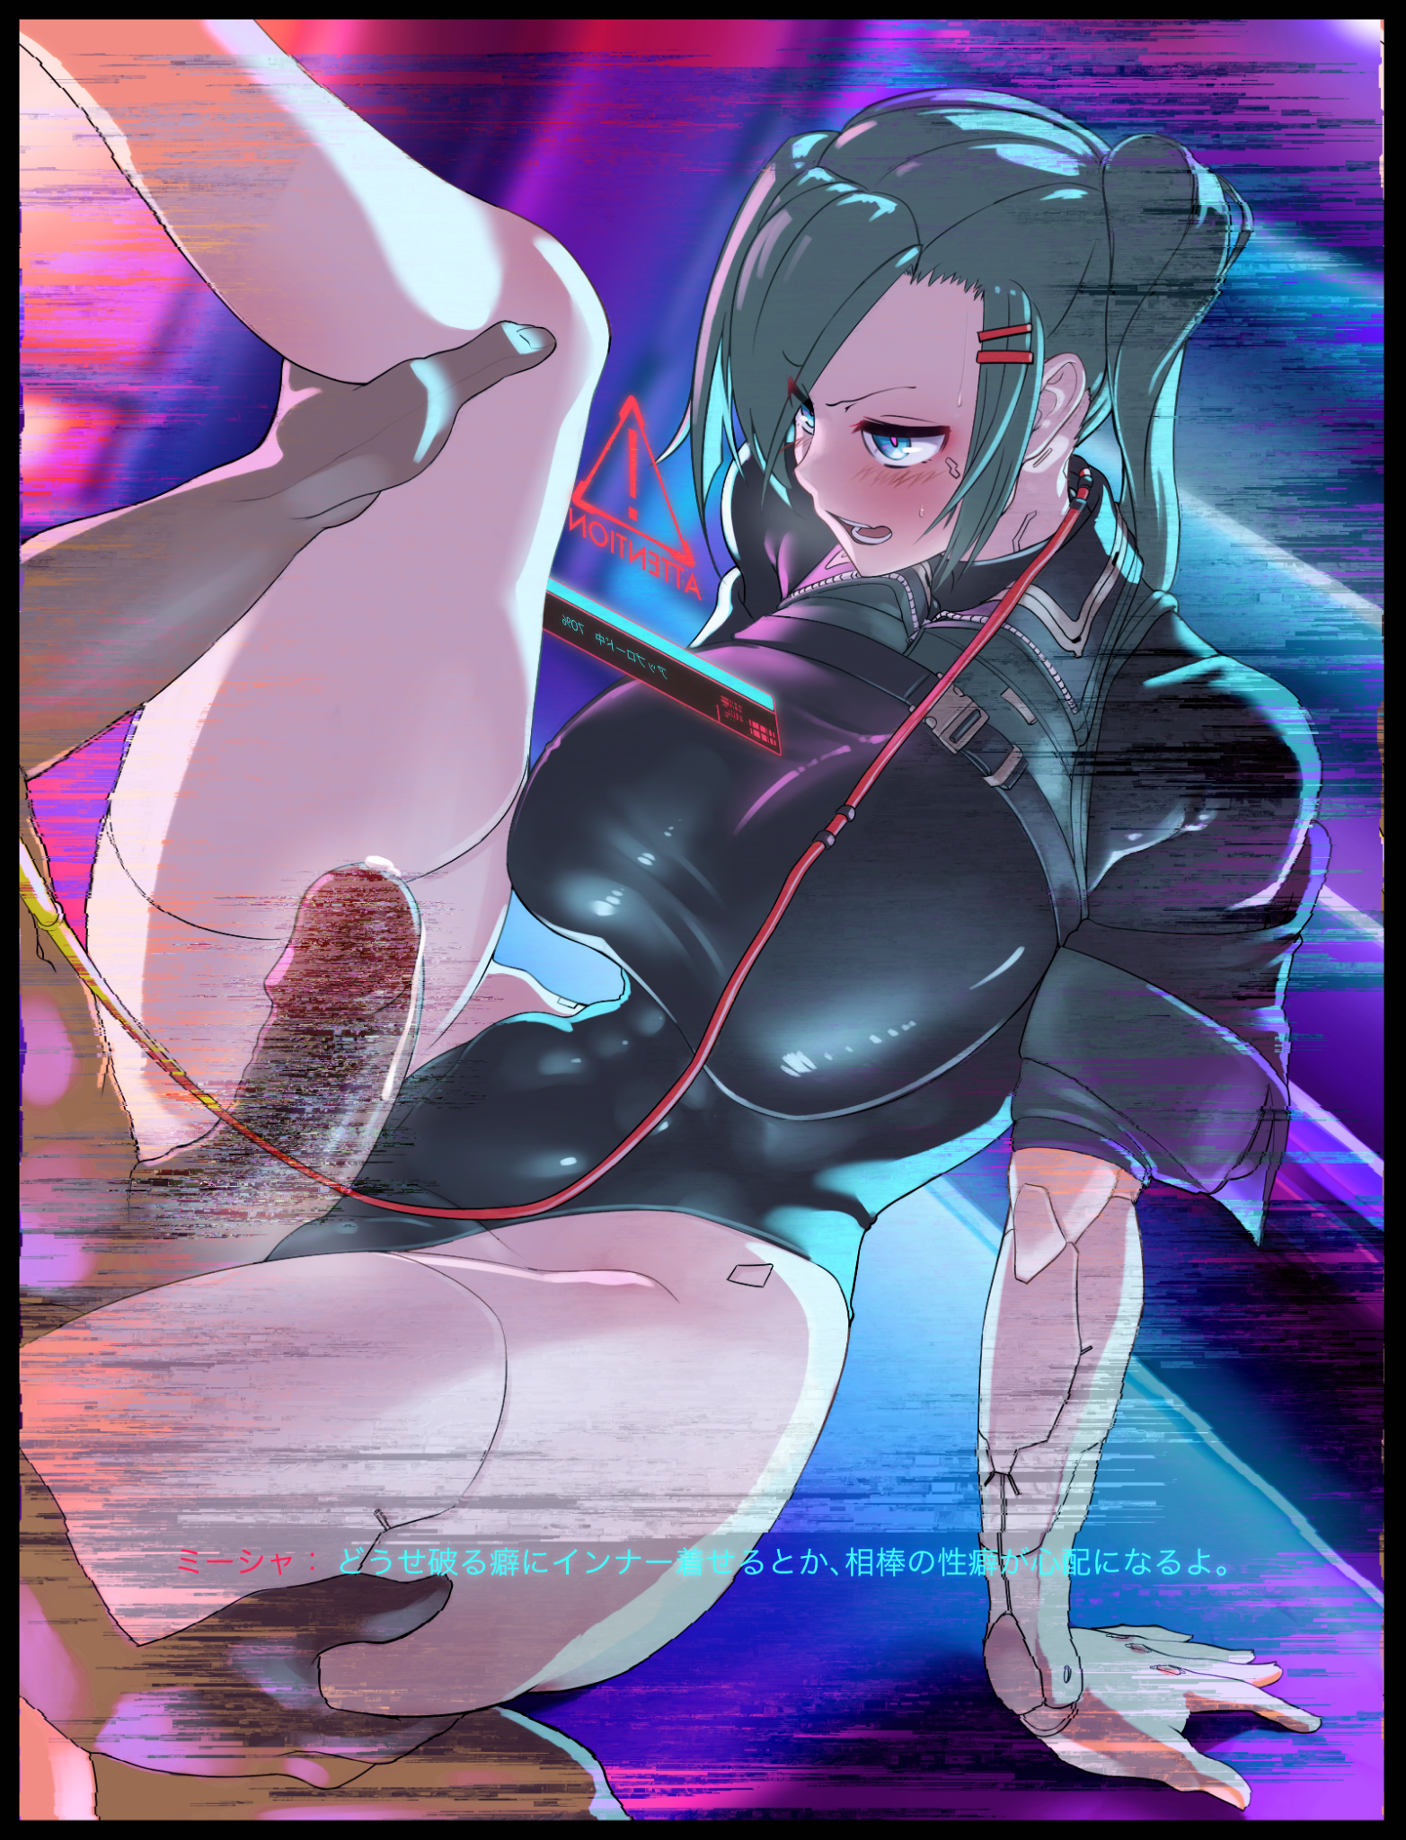
“あなたがサンディを持っていることには、正直言って驚きました。もうダメかと思ったけど......なるほど、それがあなたの欠点でもあったんですね。目で見るよりも早く動けるように体の性能を高めることで...変身も早まったんですね! 面白いですね...心も保たれているのですね...しかし、それは私たちが許せることではありません。” (I must say, you having a Sandy surprised me. I wasn't sure if I was going to make it out there…but it was also your downfall I see. By enhancing your body's performance to move faster than the eye can see…it's also sped up the transformation! Interesting…I see you've also kept your mind…but that's not something we can tolerate.)

“くたばれーーーー お前の...ああ...になるくらいなら死んだ方がマシだ。” (Fuck you! I'd rather die than be yourrrr….ohh…)

Green eyes dilate at the sight of an erect sausage springing out from loosened pants, shrinking irises reflecting the image of that perfect rod that was far larger than her old one. It was delicious to say the least, so tempting to the point that Richard just couldn't help but drool as her gaping lips begin to glisten with saliva, feeling her esophagus widen in anticipation while the fleshy walls down between her legs clench and squeeze in need, thrusting her hips on instinct as a freshly brewed egg manufactured by her tingling ovaries slots itself into her highly fertile womb, fueling her womanly urge to be inseminated with the semen of the man before her.

Before lunging forward, biting madly for the man's jugular in a last ditch effort to free herself and the others; Tom, Matt and the diner folk caught under his magical, Saka sway to no avail, missing way off the mark just like her previous attempts, leaving her panting and horny before an upload message appears in her hazy vision, filling with digital noise and discolored static the more it fills. She didn't even have the strength to resist the man's pecker as he rubs it between the cushy lips of her vagina while caressing her perfectly crafted legs.

“私はあなたに私の考えを理解してもらいたかったのですが、今はそれが不可能であることがわかりました。そのことに誇りを持ってくれ リチャード君...そしてさようなら。ご安心ください、私はあなたを大切に扱います、たとえあなたがこの偶然の出会いを思い出すことはないかもしれませんが...” (I had hoped to make you see things my way, but now I see thats impossible. Take pride in that Mister Richard…and goodbye. Rest assured, I will treat you well, even if you might never remember this chance encounter…)

A brief glimmer of light, and then darkness. Her mission was a complete loss. And by the end of the night, no one at the NCPD would ever see her or Matt ever again…

Reporters would gather outside the emptied out main branch of Tom’s Diner the following morning, talking about eyewitness reports about a large number of Tyger Claw members ransacking the place, leaving nothing and no one behind to provide an accurate report of what had occurred after a seasoned Netrunner had presumably fried everything on the system. There was nothing left to recover; surveillance footage in all possible vantage points that covered the diner, customer transactions, even the proprietor's personal logs were wiped clean.

The purpose behind the raid would remain shrouded in mystery for a long time to come, with some speculating that Tom had dealings with the Tyger Claws and he had failed to uphold his part of it, leading to a massive retaliation that probably served as a warning to others not to double cross them. Whatever the reason, it was simply the latest in a string of unsolvable cases alongside more baffling ones like a rise in the number of illegal immigrants in Night City, all of which were Japanese in descent but with chips and biometrics with zero traces.

Meanwhile on the other side of town, a bodacious woman with a messy head of turquoise awakens from a good night's rest, yawning a little as her eyes flutter open, turning in the sheets to face the familiar face of her boyfriend, lying right beside her just as naked as she was, remembering the wild ride they had on the way back here from some gaijin food place in Watson as well as the bountiful payload her man had shot inside her, rubbing her belly and loving the way the still warm spunk within sloshes inside her womb, blushing a little upon sensing a tiny leakage spilling forth from her still aching lips below. They’d rutted like mad, on the bike ride home all the way into bed, much to Tsunade’s spite of course, she loved the way the woman vented whenever she walked in on the two having sex since she considered herself a competitor to her, to who would receive Ikage’s love, even though she probably knew just as she did that their man loved them all equally.

And as the doors to their room open with a subtle creak, Himeko’s weary smile broadens upon the sight of her fellow Tyger Claws peering in with jealous looks on their faces. As a big sister figure next to Tsunade who more resembled a grumpy aunt, it was her duty to ensure the girls were all tended to and happy. And with their devotion proved after last night’s robbery, she could only see one fitting reward for them all as she shakes her boyfriend gently on the shoulder, leaning forward to land a soft peck on his cheek before beckoning toward the door.

“おはようございます...娘たちが落ち着かないようです...起きたらすぐまた行くのは構わないのですね？” (Good morning dear...it seems the girls have grown restless...you don't mind going again right after waking up now do you?)

THE END

