Masina
A Short Story
By Maryanne Peters

He thought that she looked athletic. She was clearly the biggest woman in the room, but there was no belly on her. Her cocktail dress clung to her curves showing her perfect breasts and her ample but tight, butt. Her long dark hair hung down her back clipped away from her perfectly made up face by a single clip with a flower on it. She wore no jewellery. Her skin was golden. He was unsure of her ethnicity. The hair was straight and swung about her as she moved. She was a vision.

There was a strength in her when he took her manicured hand for the first time to lead her on to the dancefloor. She moved with grace to the rhythm, her eyes, large, dark and deep, meeting his often. He had no desire to dance with anyone else. It seemed to him as if those eyes were huge dark pools that he might dive into.

Her voice was soft and mellow. It was the kind of voice you would expect from such a woman, coming from depth.

“My name is Masina,” she said. Somehow, it seemed perfect – somehow exotic and mysterious.

He bought her a drink. She asked for a pina colada. Somehow a little old-fashioned. A traditional girl. That was his remark.

“I am a homebody,” she admitted. “I like to keep a tidy house and put a good meal on the table. But I like to dance too.”

Her movements were graceful. She moved in time, even with the faster beats, as if it were ballet, but it was the way that she moved her hips that fascinated him most. Hips that he could place his hands on in those slower numbers, when his hands were clasped behind his neck, and her scent was bewitching him, and those eyes …

“I know it’s sounds corny, but do you come here often?”

“I am in town for the game tomorrow,” she said. Was she talking about the same game he was in town for? The football game?

“Which side are you on?” he asked.

“Oh, the Raiders are my team,” she said.

“But you are from out of state?”

“I have come over from Hawaii, just for a week or so,” she said.

“So, you are Hawaiian?” he asked, somehow excited by the prospect.

“Not quite,” she said. “I am from Samoa. I am Polynesian but not Hawaiian.”

“Masina is a Polynesian name, then?”

“Yes, Masina or Mahina in Hawaii – the moon goddess,” she said. “The name my mother gave me.”

“The moon is a woman?” he smiled.

“Always,” she said. “It’s the monthly cycle, you see. So it’s not really the right name for me at all. Because I don’t have a womb.”

And at that moment he knew. She was still in his arms, but he saw it now. He was ready to scold himself for being so blind. This was a man in his arms. How could he have been so bewitched? But then he looked at her eyes. They were full of tears. So big, those eyes, that it seemed to him that he could drown in those tears. But the words “I don’t have a womb” had brought forth some huge sadness. All he could think to do was give comfort. He put his arms around her and hugged her.

He knew what a transsexual was. The idea was odd, perhaps even funny, but not tragic. This was a tragedy. He squeezed her. He did not need to say anything.

He had to release her as she struggled to find a tissue. From somewhere, she produced one and dabbed her eyes as he stood in front of her.

“Thank you for that,” she said.

He realized that those long eyelashes were not false. Now matted with the moisture of her tears they made her eyes look even bigger. That was it. He saw only her eyes. They were a woman’s eyes.

“Do you want to tell me your story?” he asked.

She led him off the dancefloor, to collect their drinks and find a quiet spot in the further reaches of the bar.

“I was the youngest of five boys, growing up in Pagopago in Samoa,” she began. “We all played sport. Wrestling and boxing, the local game kilikiti, that I will not try to explain, but mainly rugby, which is a lot like American football – passing by hand, running with the ball and tackling as hard as you can. We were all good at it, my brothers and I. Football was available in high school, even in Samoa, but as the oldest two of my brothers were so good, we had the opportunity to move to Hawaii when I was in High School. My mother never liked Hawaii and she went home to Samoa after my father died. By that time I was recruited out of high school to join the Raiders training squad.”

“You played for the Raiders?”

“I told you, they were my team. They always have been. They send me tickets.”

“So, I must have seen you play?”

“If you are a true fan, yes. But in those days I had another name. But as the youngest in the family I was always known as “Junior”, and that was the name you may know me by.”

Could it be? He looked at her again. She pushed a lock of her long glossy hair behind her ear. The ear was delicate, with a pearl stud and a pearl drop below that. Her lovely lips were moving again.

“I played a few seasons and then I got injured. A shoulder injury – rotator cuff – not uncommon. I could work through it, but my mother was ill, so I went back to Samoa. I went back to take up the role that had always been waiting for me. I went back to care for my mother as a fa’afafine”.

“So, what is that?”

“In Samoa we have a tradition that in a family of all boys, the youngest should act as her mother’s daughter. That was always who I was. But, well, we all played sport. When I was younger, before we moved to Hawaii, I had long hair which I wore in a pony tail or a bun, and I wore a traditional floral dress, but I still played with my brothers when I was not helping my mother. It was a happy childhood. I could be both a boy and a girl. I liked some girly things, like fixing my hair and dressing up, but I liked boy stuff too. Because of the fa’afafine tradition, nobody condemns you. When I went back to Samoa after I was injured, I just went back to being Masina. It was surprisingly easy, with the assistance of modern medicine that is”.

“What are we talking about? What medicine?”

“In the old days, fa’afafine was just about attitude. They would pull out the beard, grow the hair, shave the body, and sometimes, rarely, the balls could be removed. But that was dangerous. No, it was just made obvious, and everybody accepted. But now we fa’afafine have access to hormones, breast implants, and bottom surgery.”

She let the last words hang. It was not deliberate on her part, but he wondered if it might be.

“So, you are completely a woman now?” he asked, as softly as he felt he could.

“Well, I am disqualified from playing for the Raiders gain, but I can still support them.”

“We could go to the game together, if you like,” he said.

“Are you really interested in seeing me again? After all that I have told you?”

“I don’t want to think that I … I have never been with a … a trans-person before. I really know nothing about it.” He was wading his way through the words, with nowhere to go, but he needed to tell her something. “I never saw you as anything other than a woman. Looking at you now, I sort of think that I was right. Was I?”

“I’d like to think so,” she said. Her smile was a big as she was. Perfect white teeth between bright red lips on the golden face, and those eyes.

“Would you like to come to my hotel, tonight?” he asked.

“Do you have something planned for me?” she replied.

“I’d like to think so,” he said.

The End

© Maryanne Peters 2019
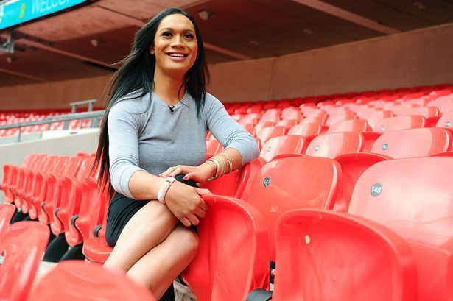  Jaiyah Saelua, fa’afine soccer player | 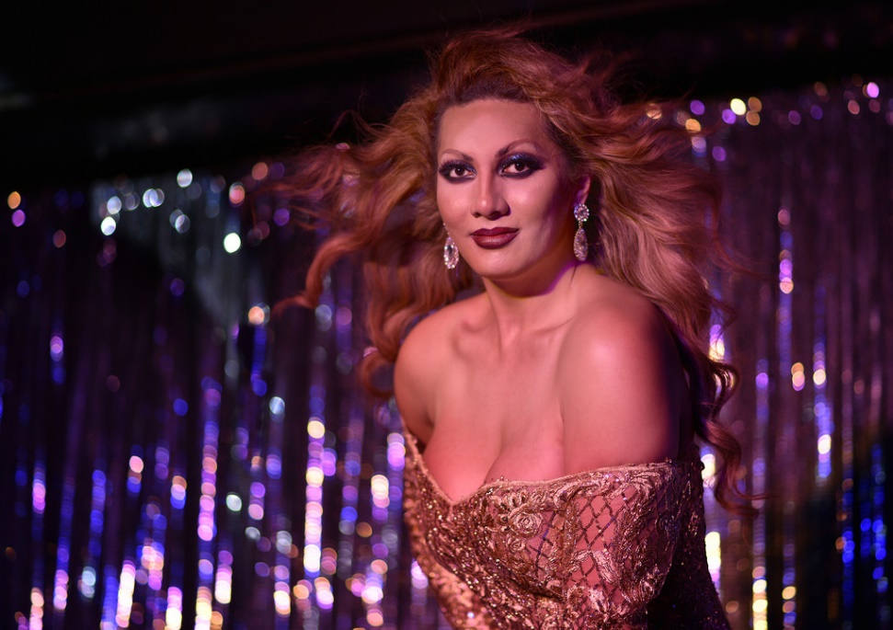  Honey Solofa, fa’afine performer
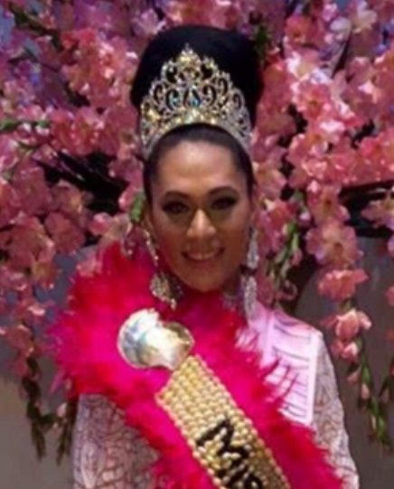  Jessica Auva’a, fa’afafine beauty queen | 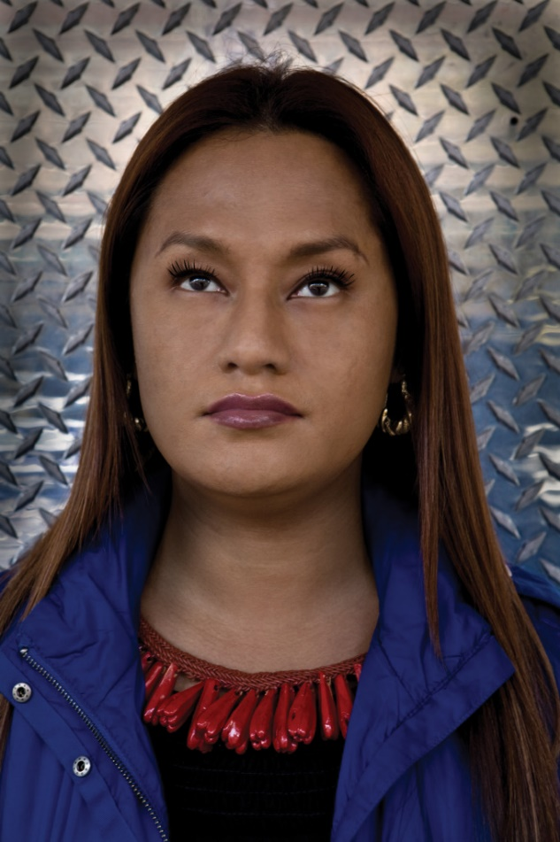  Shigeyuki Kihara, Japanese/Samoan fa’afafine visual artist

