In a distant land, nestled away in grassy plains and forested hills lies a mansion. Populated solely by a family of nobles and their loyal workforce. As for why a home seemed to be built in an isolated locale far removed from civilization, the answer was simple; to avoid the ravages of war, protecting family while the men were away fighting alongside their countrymen.

So all who remained to populate the mansion was a handful of select workers in the form of maids and groundskeepers, maintaining the homely place under the watchful eye of the family matriarch and her youngest daughter; Sylvia, a quiet girl with raven hair who preferred to keep to her personal study during most of the day. Undisturbed by the others while a personal tutor drilled her on etiquette and education to ensure she became a lady most fitting to inherit her mother's influential role in the family and beyond.

During what little moments of respite she had, Sylvia would excuse herself to the bedroom, preferring to enjoy a quiet moment in the afternoon and evening without anyone to bother her, a behavior displayed long before they even arrived at the forest mansion.

Except rumors had begun to float around the maid's ranks regarding a mysterious blonde amongst them who had been sighted around the mansion, often near the little mistresses quarters before vanishing mysteriously. Some spoke of her enchanting beauty and grace while others simply dismissed the 'Phantom Maid' as a preposterous rumor, especially Sylvia's mother, who seemed strangely keen on stamping out any mention of it…

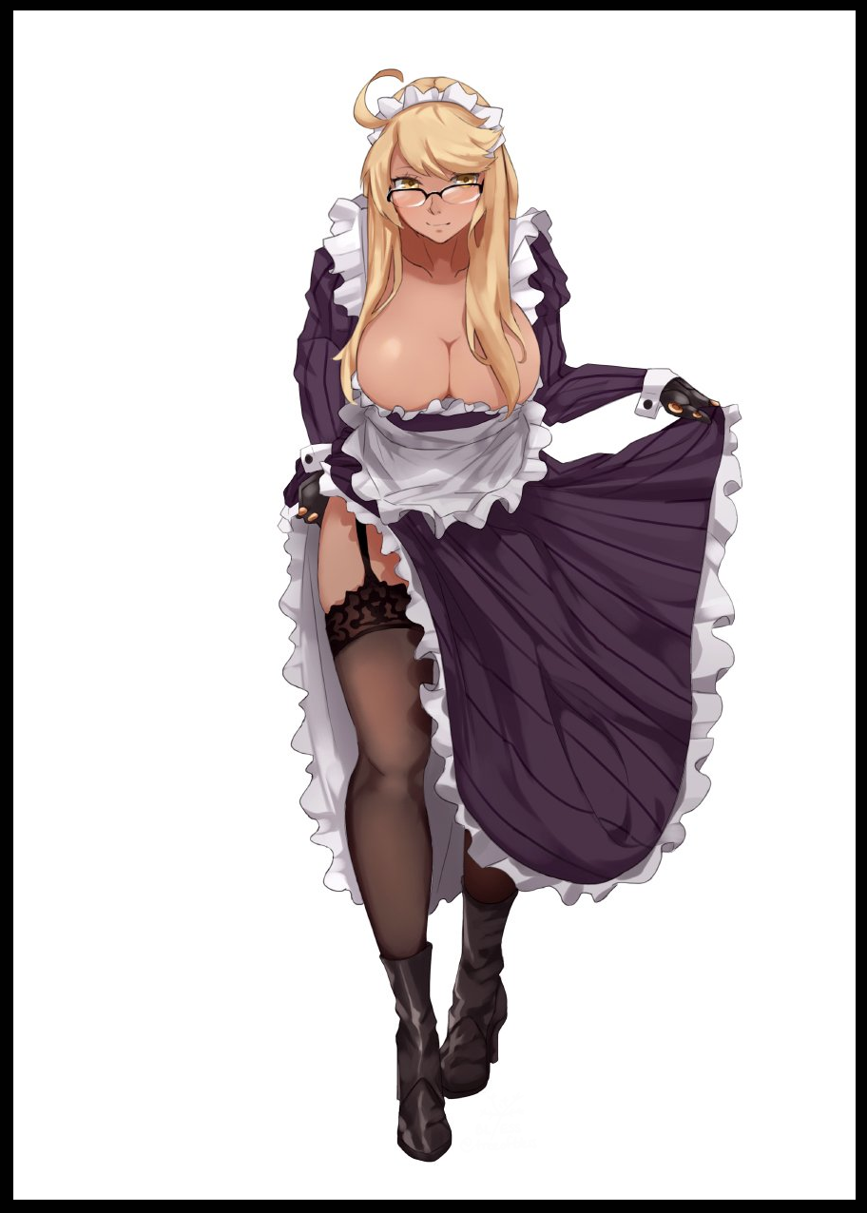

But there was one thing closely related to the Phantom Maid that had changed regarding Sylvia's lifestyle shortly before she and her mother had moved. And it involved her tutor, more specifically, the previous one who held the position, a man who had taught her everything she knew for almost her entire life. As everyone knew it, the man had vanished shortly after the announcement for a nationwide draft had been made, leaving them to assume cowardice, with some romantics shining another light on the story; that he had left quietly for the front lines so as not to make Sylvia cry…how little they knew…

In truth, the Phantom Maid and the vanished tutor were one and the same. Transformed by a careless wish made over tea and biscuits when the news broke, the man who had known Sylvia ever since she was a babe in her mother's arms had been irrevocably altered into a young lady of a similar age to her charge, all because the unknowable powers that governed the world had heard her unspoken plea to save her love and keep him by her side.

Since he could not be with her, his age had been cut significantly. To keep him from war, his burly masculinity had been mellowed out and smoothed into that of a bewitching flower. And to ensure she remain by Sylvia's side forever more, her place in life had been reallocated from that of simple tutor to loyal maid, retaining her knowledge base and skillets in grace and lethality to ensure she be up to the task…once her mind had adjusted to her rather bodacious form of course…something Sylvia was more than happy to lend her 'expertise' in…

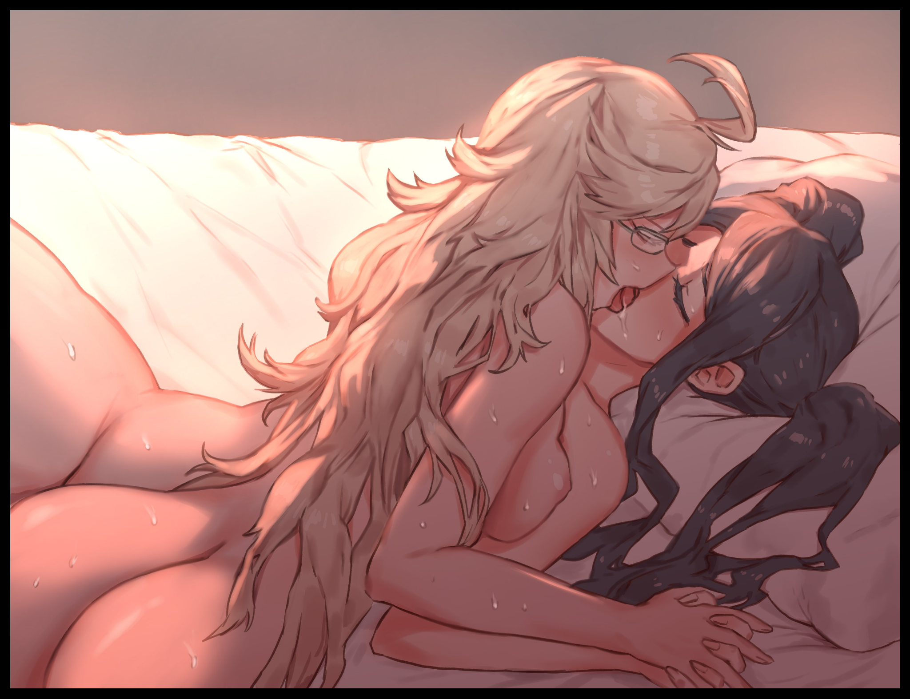

Reborn into a younger, more sensitive shell free from the draft and to be with her charge. It would only take a few days to get thoroughly familiar with the intricacies of the female form. Keeping her hair and privates clean, putting on underwear of the feminine persuasion (most often of Sylvia's choice). There were so many other things she needed to have Sylvia teach her, it was like being given a second chance at life to do the things she never could. And the best part was; they had all the time in the world after realizing the wish had turned Lyra into Sylvia's handmaiden, to always be there by her side through thick and thin.

And a handmaiden's role extended far beyond bodyguard duties, as Lyra would soon discover after the first taste of coital bliss provided by her mistress's touch; teasing a heavy, milk laden breast. Stroking a creamy smooth core in such a tender way that it made her womb tingle in ecstasy. Gently rubbing and pushing at a tight flower between cushioned thighs that would leak nectar against Sylvia's dexterous fingers…the former tutor loved every second of it, especially when it came to returning the favor, enjoying the feel of their soft bodies melding against each other as teats squished, nipples rubbed and wild hair coiled around their nubile young forms…an experience far more euphoric and rewarding than the time she had a pecker in a distant life.

For as long as she lived in this new life, Lyra had every intent to continue her secret romance with the girl she had watched over from birth till now, to make her the happiest maiden in the land with all the power she had, forever thankful for giving her this fresh shot at life…

And so the secretive pair would continue as they were while the war ran hot in the background, all while the story of the estate’s Phantom Maid would continue to spread, with some renditions even citing strange vocalizations that could be heard around the mansion’s halls from time to time, emanating like ghostly wails from somewhere in the depths, never once realizing that those were the sounds of their young heiress and her lovely Phantom making their love for each other known loud and clear…

THE END

*Image Sources*

Image 1 by BL/ESS : <https://www.pixiv.net/en/users/8594439>

Image 2 by Senmura : <https://twitter.com/NSFW_senmura>