BRIDES ONLY!
JUNE 2021 REQUEST STORY
BY CHALDEACHANGE
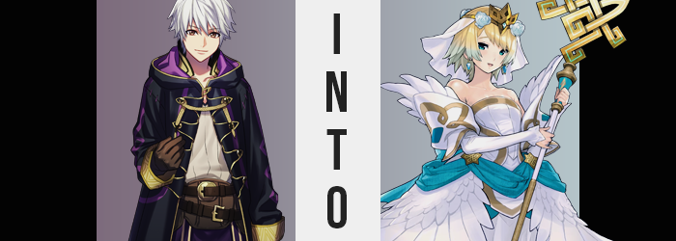

Ylisse’s tactician, Robin, didn’t always understand the point of the many celebrations that took place in Askr and the surrounding regions, but he certainly enjoyed seeing everyone in high spirits. In this case, he’d opted to attend the Wedding Festival on the behest of his daughter, Morgan. She’d so desperately wanted to attend, and yet all of her friends were too busy to show. That had left the responsibility to fall on his shoulders.

“Now where did she get off to?” He certainly hadn’t minded attending, even if a festival meant to celebrate the blessings of union did not entirely appeal to him. But it appeared his daughter had taken off without his knowing. Just as the brides in question had been about to throw their bouquets as well.

It appeared that such a thing was tradition at this festival. Supposedly any woman that caught it would be blessed in a union of their own, but it was quite clearly only superstitious nonsense – good for those that believed in it but being a skeptic himself led him to believe that such a thing was a bunch of baloney.

Had Morgan taken off to get closer to the stage that ran down the center of the city street? No… He’d seen her run back towards the alley earlier, hadn’t he? Robin simply hoped that his daughter wasn’t in any immediate trouble. There shouldn’t have been any danger with the guards on such high alert for the festival, but these were war times. You could truly never be too careful.

“Morgan!?” Not able to see her in the crowd of women that had gathered to catch the bouquets, he headed back into the alley attached to the main street that looked like the most probably escape route to pursue. This was his best bet, and with any luck he’d stumble across a guard that might help if not finding Morgan directly.

Before he got very deep into the alley though, something suddenly fell into one of his hands, and the second outstretched to catch it. “A bouquet?” Of pure, white flowers, at that. Based on the commotion in the crowd behind him, it seemed it was one of those thrown by the brides sent wayward by a very terrible catch. Morgan’s terrible catch, incidentally.

He had completely missed her in the crowd.

This bouquet actually was enchanted despite his skepticism, however. Which in itself should have been harmless, but the bouquet was meant to land in the hands of a woman. It was meant to enchant to love life of a woman. Placed into the hands of a man, this enchantment ultimately forced a corrective protocol of sorts.

“I… should return this.” Considering the fuss on the main street behind him and the lack of a use for something like a bouquet, there really was not benefit in keeping it. But before he could start back to the crowd to do something about it? He froze up as a thought paralyzed his very being. No! This is my bouquet! I shouldn’t part with it from any place other than the stage!

Robin shook his head, trying to shake this thought away. “What in the name of the gods was that?” It was something he’d thought on his own, yet it wasn’t something that matched his typical thought process in the least. The sheer pep it was conveyed with just wasn’t him, nor was this sudden reverence for the flowers. …But it was enough to prevent him from letting go.

Even so, the bouquet was still destined to fall into the hands of a woman. So the very first thing it addressed after implanting the thought to not let it go into the man’s brain was, naturally, a change of sex. “Nn!?” Robin’s knees buckled as a sharp… He couldn’t really describe the feeling as painful, but it was more like a sharp tug between his legs that felt unnervingly bizarre.

In actuality, his penis had folded in against itself, cock and balls alike tucking back and into his groin, where they merged with the insides of the subsequent crevice to form her new pussy, one that burrowed deep within and rearranged her biology to demonstrate feminine fluency. Lips swelled around them, and a clitoris emerged, more or less sealing a deal that soon began to affect the surrounding area as well.

“The thing between my legs!? It’s gone!?” Responding to her altered sex, her voice had jumped to hum a much more melodic tune. She could have just as easily yelled ‘MY DICK’, but considering she was still in a vaguely public space, Robin had used enough self control to not blurt it out even despite the circumstances.

Within her pants, she could feel things proceeding with their rearrangement. Things never became uncomfortable thanks to how loose her clothes always were, but the woman could certainly feel the space within these pants limiting as a young woman’s physique bled in to present her with a fresh shapeliness.

Her butt, for example? Flat short of a little muscle from her time as a man, it was soon engorged by a sensual weight that drew those cheeks to a jiggling mass. The hump of her rear grew round, sloping the arch from her back dramatically while hips were forced to part from the added abundance to her trunk.

“I’m still changing?” Thighs soon rubbed together while Robin pondered her options, feeling the excess fat that had blessed her ass slither into her legs to grow them plumper as well. The way her thighs had widened had left ample space between her thighs in the beginning, but as they’d thickened that gap was soon closer except for at their pick, where a slight gap remained. “The bouquet!? Is it the bouquet’s fault!?”

Robin felt with all of her being that she was right, and yet she could not bring it upon herself to set the flowers free. I need to throw them from the stage, I can’t discard them here! Temporary, dutiful ownership was an overpowering impulse that held her back, even as her boots felt larger thanks to her feet regressing in size – and upon her wrists, her hands did the same. The fingers that gripped the bouquet were dainty now, fingernails brought to a proper manicure.

Her arms became both shorter and slender, something that also affected her legs in slight short of the thickness of her thighs. It was clear that the tactician was growing leaner, particularly as her waistline dipped to give her torso a muted but effeminate slope and her tummy firmed up in a way that saw the depths of her bellybutton expand.

“The bouquet is to blame, but why am I fighting this?” It was a peculiar question to ask considering how shocked she’d been before, but this was still the bouquet’s power at work. She was doubting this reality less and less, as memories of another past, another kingdom bled into her ego to irreversibly alter it. Of a childhood in the kingdom of Nifl, as a young princess…

Her face, in the process, began to fit along with these memories. Lashes lengthened and dances around rounder eyes that now reflected an icy blue, her complexion fairer without a single blemish. Lips pursed into a natural pout, plump and reflective, while her nose wriggled until it had practically halved in size. Robin’s cheekbones brought about the most dramatic change, for while they raised, they completely altered her face’s landscape so that she was irrefutably the picture of a young, beautiful woman.

“My name… it isn’t Robin. It’s…” It was on the tip of the princess’ tongue, all while blonde swept through the roots of her hair only to become an icy blue near the tips. Her hairstyle softened and flattened, bangs swept to the left and framing her face, but never growing so long that they did more than brush up again her neck. And her brows? They reflected the blonde as well. As did the hair of her loins, trimmed close to her skin as it was. “Fjorm? I am Princess Fjorm of Nifl?”

That sounded correct, even if no small part of her was trying to reinforce the fact that she was a tactician. The problem with that? Tactics were not her forte. She couldn’t remember any of the complicated battlefield maneuvers that this dwindling voice insisted she must know. Unless breast growth was a tactic?

The underside of her top was bloating as her chest finally came to life, contributing the final aspect of a woman that her body was missing. Erect nipples scraped against cloth with no shortage of agitation as they widened, and the flesh beneath brought about a perky pair of breasts that her palms would just barely wrap around if she attempted to cup them.

She hadn’t paid much attention to them though, if only because now that she was past her confusion about her identity, she was confused about her manner of dress. “Why am I dressed like this? Where is my radiant gown? I cannot present myself on stage like this!” She could recall toiling to bind herself with white cloth and feathers, but these oversized robes certainly didn’t match such a description.

The bouquet then bestowed its final gift, for her clothing began to radiate an icy blue. “Oh!?” For but a brief moment, she wondered if she had been stripped naked for her body suddenly felt noticeably light and unbound from the weight of her clothing, but the next she blinked? The gown she saw in her memories had decorated her flesh.

White and strapless, gold trim ran across her breast while feather sleeves, detached, were draped across her shoulders. The skirt of the wedding gown was layered and turned an icy blue near its ruffled base, while a straight skirt hung overtop, but beneath additional wings attached to the blue wrap that hung around her waist. Selling the look was the veil attached to a golden tiara atop her head, accessorized with light blue roses and paired with white and gold thigh high boots.

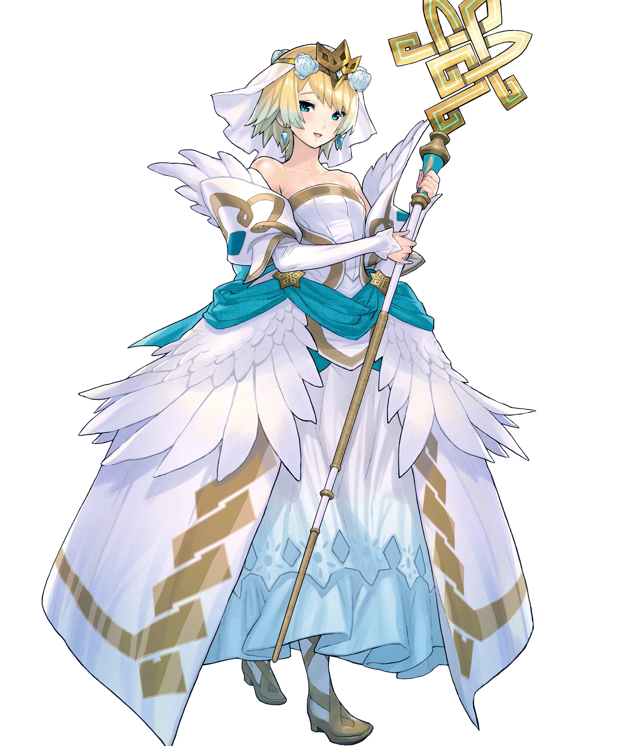
Ever the bashful bride, Fjorm looked around the dark alleyway with no shortage of sheepishness. “Er… How did I end up back here?” She was at risk of soiling her beautiful wedding gown, much less the bouquet of white flowers she was clutching to her chest. More than anything, the woman knew that she couldn’t allow any misfortune to befall this floral arrangement.

She peered back at the crowd of people on the main street, wondering how she might get back to the stage without causing a ruckus or risking the safety of her outfit and flowers. But the one thing Fjorm wasn’t wondering was why just moments ago she’d thought of herself as a man. All of those thoughts were without merit, for she could only recall who she was now.

“Miss Fjorm!? What are you doing out here?” Before long, a familiar face peered around the corner. A young woman with short, purple hair, wide-eyed and confused. That was Morgan, was it not? She was the daughter of one of the tacticians allied with Askr, and— Why did this all feel so familiar? She had studied up on the kingdom’s allies, but somehow this all felt very personal.

Fjorm raised not a single question about this. Instead, she smiled, filled with reassurance that an ally had found her. “Miss Morgan! I seem to have wandered away from the main stage. Do you think you could help me find a secure route?”

Her role today as a bride in the Wedding Festival? It was more important than anything else.

