FATE / REINCARNATED
CH3: BUNBOT
BY CHALDEACHANGE
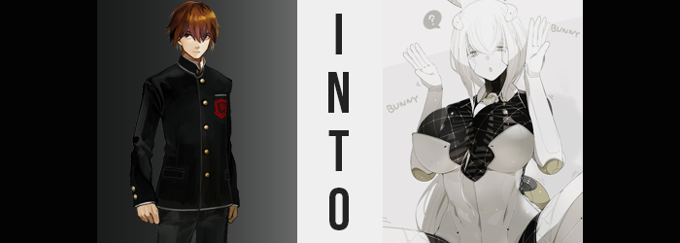

Hakuno Kishinami didn’t really understand what had happened, but there was so much about the day that hadn’t made sense in the long run that perhaps it was easier to sweep under the rug than it might have been normally. From what he could recall he had just been experiencing a normal day at school, when all of a sudden? A chain of events had pushed him into some extremely bizarre and dangerous circumstances that compromised his own safety.

And just as it seemed like he might have been in the clear? …It was hard to describe, but it almost felt like he had been sucked into something he hadn’t had the displeasure of seeing before it was too late, and the next he realized? He didn’t recognize anything around him. Again. But this was different from the place he had been in previously, with the wire-framed structures that such a place had possessed.

This felt much more normal by contrast, because it was much more normal. The structural integrity and design of this place felt like a normal building, even if it appeared to be the backrooms of a casino. He could only tell as much by peeking through the nearby door, where he could see people playing slots and other games outside – all while well-endowed women in bunny suits delivered drinks and snacks to them.

He really didn’t understand how he had arrived in this place, but at least it didn’t feel like he was in any imminent danger? “Maybe I should just ask someone where I am?” That really would have made the most sense, all things considered. There was no indication that anyone out in the casino was a bad person or meant him any harm, so he could more or less square things away just by reaching out.

But for some reason? He just couldn’t seem to muster the energy to step through the door. Or would it be better to say that he could not muster the will? Because even though he wanted to do just that, he somehow didn’t want to do just that at the exact same time. Almost like something else, deep down, wanted him to remain rooted in place like a tree. Just for that moment, if anything. He wasn’t sure why this was the case, but a thought ultimately manifested to help him understand, if anything.

I haven’t been ordered to go out just yet.

…? Ordered? By whom? He didn’t take orders from anyone, and not certainly to the extent that he would be so docile and obedient to a force he could not imagine. There was also the matter of the ‘voice’ that this thought was communicated in… It was colder and even more emotionless than Hakuno’s usual demeanor, which was most certainly saying something.

In a way it triggered his fight or flight response, but honestly considering his personality it was so subdued that it was easy for new impulses to keep him rooted in place while some unusual transfigurations began to occur to his body. For example? While the boy always kept his brown hairstyle somewhat shaggy, it had begun to appear even longer than normal. Not overdramatically so, but it tickled his shoulders while inadvertently becoming straighter and flatter in the process. There were even changes seen in his bangs, which turned in towards the center from either side.

But Hakuno himself didn’t appear to notice this. As had been the case with the other two whom had been caught up in this phenomenon, honestly.

There was an almost unnatural stillness to him as the changes that plagued him began to turn much more severe. For example? He was already rather sizable in stature, yet his height overall began to inch higher and higher, inevitably jumping up to almost 5’10”, which in turn lifted his school jacket and undershirt from his hips to reveal his stomach. What this also revealed was that there was nothing very consistent about this growth.

He had gotten taller, yes, but proportionally his body was not the same. In order to accommodate the greater pull of his spin, the sides of his tummy had curved in more towards his hips. Of course his arms and legs were longer than his clothes had previously been designed to fit, and that showed, but there was something about his hips…

The changes most certainly hadn’t been consistent, yet even with his heigh maxed out, a growth had found the gait that established the bending of his knees (which began to buckle in towards one another). This was because his hips were widening, and they were doing it with gravitas. It didn’t take long for the front button on his pants to pop right off, bouncing off the nearby door and landing somewhere on the floor nearby.

The sides of Hakuno’s pants were forced slightly downwards, but those hips had grown so wide that they were ultimately hooked against them too. It certainly didn’t help that they were tightening around his legs and rear to boot, because both areas had begun to bloat exponentially. “Ngh…?” And regardless of how dramatic this all was, he hardly did much other than moan away some of the discomfort.

A ripping sound soon permeated through what was otherwise silence, for the flesh of his thighs had begun to tear through the material of his uniform pants. They had bloated quite significantly, crushing his dick in between them even with widened hips. The discomfort of his groin wasn’t at all helped by a swelling in his rear that saw his ass fill to an almost ridiculous size, pulling down pants and boxers that got caught halfway, showing a bare top half of his new ass.

Or her new ass.

Gone were her cock and balls in all but a brief moment, leaving in its place a pussy and shaved hair above it. There was no denying her natural sex, and yet something about this orifice? The way it shone wasn’t quite natural, almost like it was made of rubber or something. Because Hakuno hadn’t noticed to realize, it hadn’t occurred to her that she didn’t really feel anything from it, either.

With much of her body transformed into that of an attractive woman, there were clear signs in her face that this was the case as well. Features became lighter and fairer, while her eyes narrowed only to be adorned with longer lashes. A shrunken nose and dramatically plumper lips highlighted this as well, and those features contorted all at once due to a change she just couldn’t respond to. “…Oh?”

Because all at once? The front of her jacket had blown open and her white undershirt had been torn straight through. Thanks to nothing more than the prompt and substantial eruption of a pair of great tits. Each breast was as large as her head, and with little cloth to bind it danced about freely. But there was something bizarre about their emergence in a different sense. They were clearly a pair of humongous boobs, but where had her nipples gone? It was as if they had been nip-knapped!

With Hakuno practically unrecognizable from her old self now, her clothes (or at least their remnants) were seemingly stripped from her by an invisible force, only to be replaced with something different entirely. A bunny costume not unlike those being worn by the women outside, complete with a puffy, black fabric that bound her breasts, ass, and thighs beneath the open white leotard, gloves, and thigh high boots that bound her otherwise. Even a pair of bunny ears had been adorned atop her head, yet they hovered slightly above her head on a white headband.

What wasn’t clear was that while her leotard could be removed, much of this outfit could not by. That was because the boots and gloves? Well, they weren’t simply above her skin as much as they had become her skin. This material hardened, her ability to sense things via touch waning in the process as their movements would become stiffer and almost robotic. Which, as copper joints began to expose themselves in her elbows and knees, that wasn’t all that far from the truth.

The same white that was now bound to her appendages began to creep into her hair, turning it the color of snow while the skin on her face – the only skin on her body not covered by clothing, began to bleach as well. You could clearly observe it all hardening in the process, as the sleek sheen of plastic or something similar spread across these harden features. Her irises even flickered, changing from their usual brown to a silver that somehow matched her otherwise monochrome aesthetic.

But this flicker had accompanied what could be considered a ‘reboot’. Like her mind had just been refreshed with new information – information she embraced as ‘herself’. Like a computer turning off and on again after having a new hard drive installed.

Which might as well have been the truth.

Slowly, the white ‘skinned’ woman tilted her head to the side. For a moment it had almost seemed like she had felt something, which most certainly would have been impossible for an individual of her make. That was because she was a subservient BunBot, an android created in the image of a tall, well-endowed woman that would serve customers within a casino – a modified version of gynoids that were already on the market.

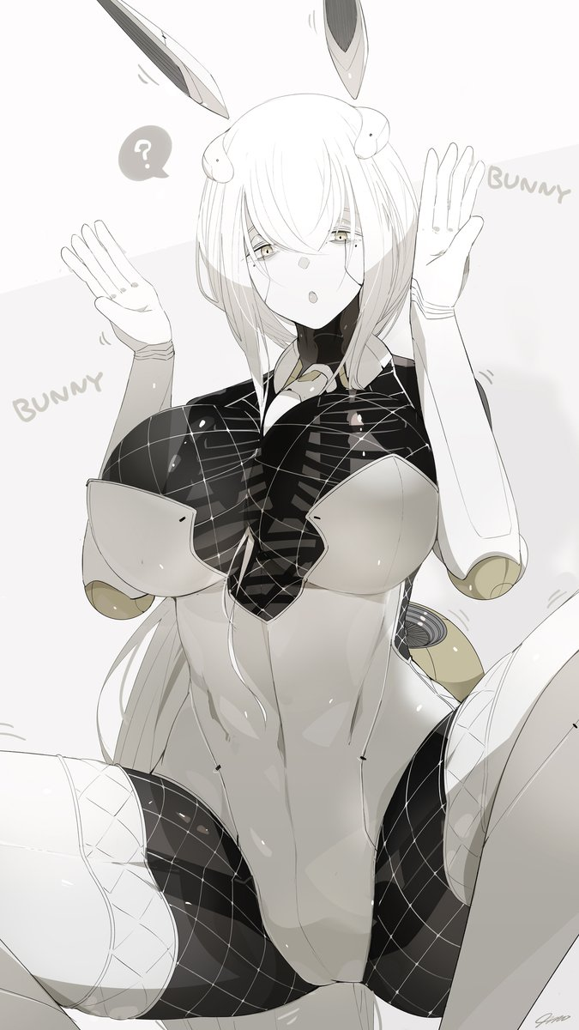
To these ends? While her limbs and frame were all composed of hard paneling, there was a legitimate softness to her ample breasts, thighs, and ass. The BunBot designer had sought to recreate the appeal of an actual woman in their aesthetic, and jiggly bits meant they would actually bounce about while serving the customers. This also meant they could be used to pleasure the customers for a high enough price as well. This helped justify the high costs for maintaining them.

And now that was all that Hakuno was. A will-less BunBot that would serve drinks and have sex with customers for profit, all to justify her own continued existence. She did not feel anything and that included pleasure, so even sex with strangers had her left feeling nothing. Not that she minded, because she wasn’t exactly afforded the free will to think too much of it.

She simply stepped out into the casino once she digitally received her orders, ready to begin a shift.

“Can I get anything for you, madame?”

