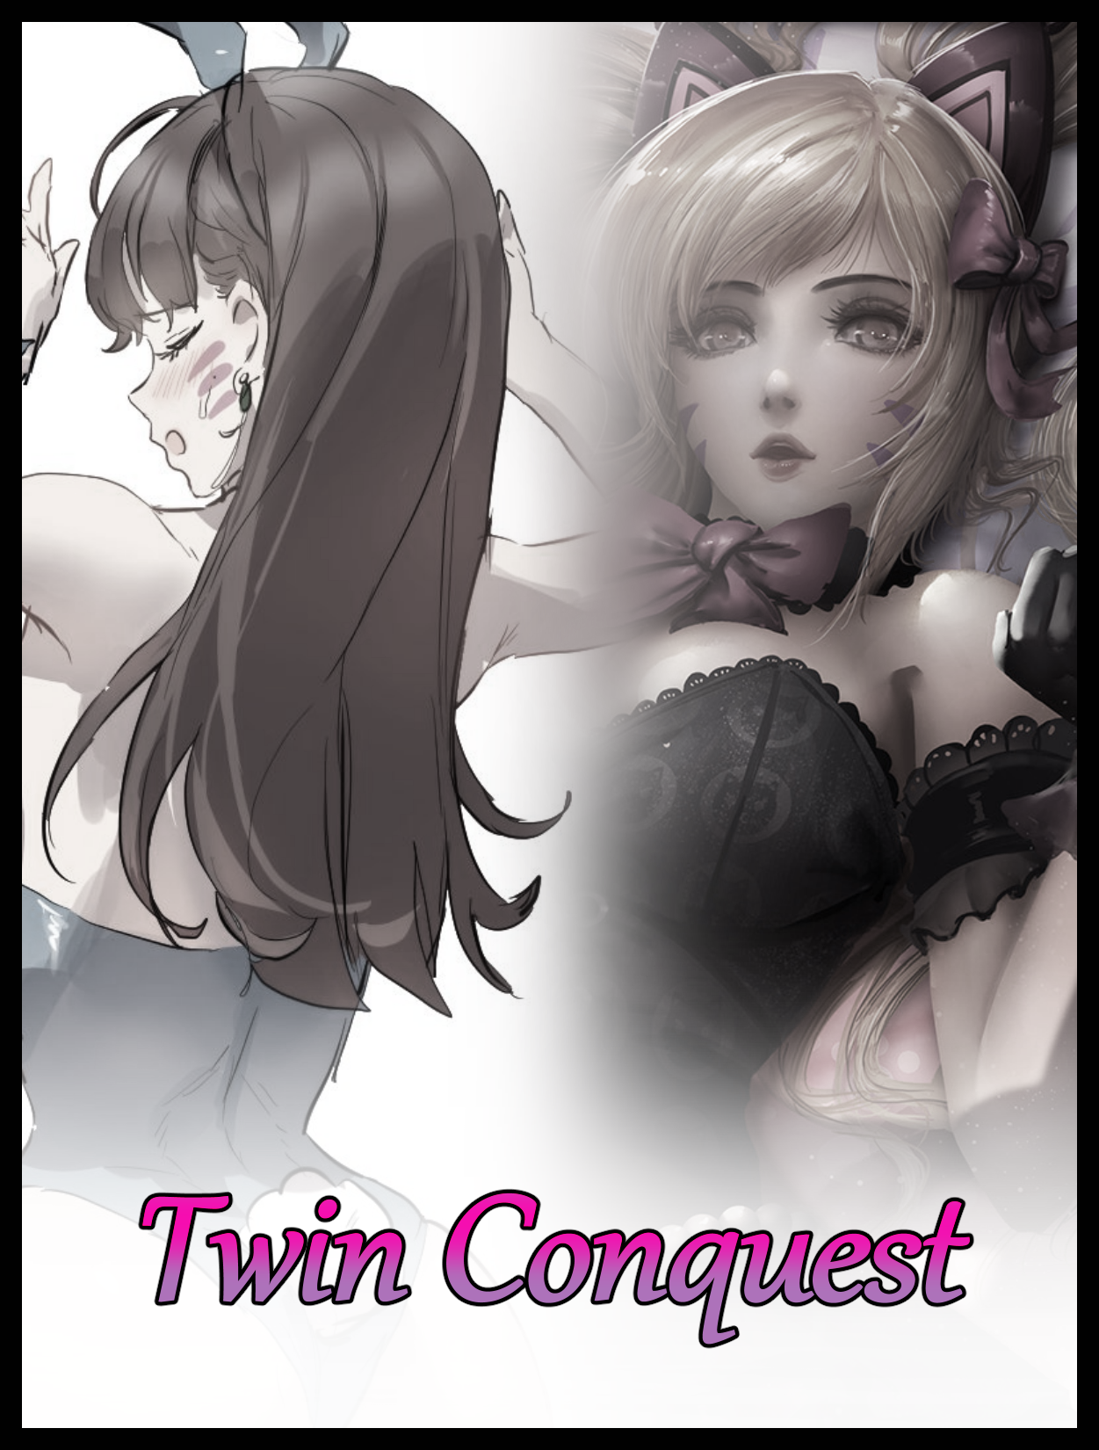

A few weeks after the winter festivities had come to an end. Few would ever recall the missing occupant of a stuffy apartment flat downtown, spirited away in the blink of an eye with the power left running and the doors locked…nothing out of place to suggest a break in or scuffle…save for the exploded desktop computer in the tenant's room.

Without much else to go off of, the ruffled landlord had simply marked him as a no-good runaway who could no longer pay the bills once the expected number of days awaiting his return had come and gone without news, hence his silent departure from the world at large.

The flat was cleaned out, belongings and furniture sold or repurposed. Until eventually, nothing would remain of the missing man, his mark on the world thoroughly erased with only vague memories lingering in the mind of his associates to remember him by. But even that tiny mark would soon be whittled away by the ravages of time as they moved on like people usually did, with barely any contact made between them besides simple workplace etiquette or casual greetings, very few even knew of his disappearance, and those who did only had a word or two to say before shelving the memory, they had better things to worry about anyway…

But out of all the random bits and baubles recovered from his apartment, the exploded desktop remained an item of interest for those left to investigate the case. Some suspected it to be a simple case of the power pack being overloaded after it was left to run for who knew how many days without rest, but fewer still couldn’t help but make the assumption that the destruction had been a deliberate act. For one, the placement of the chair and the surrounding mess seemed to suggest that someone had been seated at the table, presumably tampering with the hardware before a premature detonation had scattered everything, including the perp who must’ve sustained some form of damage if the scorch marks and soot were any indication to the force of whatever it was he had set off.

The second and most damning piece of evidence however, was the fact that the moderately intact hard drives on the desktop had been thoroughly…’screwed’...a kind word to say the least about their condition…

Scoured clean of information despite their more or less pristine condition, the techs who were left to pick up the pieces could only assume that some form of powerful magnet had been used to thoroughly wipe the thing, ensuring no one would ever find out exactly what it was the vanished man had been doing before then.

Unbeknownst to them however, they were simply picking at scraps. Residue left behind by someone who had been plucked from the realm of the physical. Converting an entire human being; their body, memories, genetics, personality, etcetera etcetera into simple data and code, overloading the inadequate hardware of the modern gamer not built to withstand the full scale of two bona fide artificial intelligences that were self aware and fully capable of decision making, digital clones of people that could not be housed on a one terabyte drive, hence the explosion…but no one in their right mind would have assumed that absurd train of thought. After all, the A.I of the current generation were still in their infancy; generating images to fulfill the hormonal dreams of men or tasked with mundane ‘jobs’ that basically revolved around giving lonely people someone moderately believable enough to chat with…

With their attention turned elsewhere, the two digital entities were free to roam the expansive and infinite realms of the Internet, a far more suitable haven for the two to roam around in…although the words ‘free’ and ‘roam’ could only ever truly apply to one of them more than the other, simply there to tag along wherever the dominant one wished to go…although that one-sided dynamic was gradually beginning to change, turning from captive to willing associate once the weathering effects of incomprehensible time in the digital realm and the drastic modifications to their ‘being’ had begun to set in; turning the former human being into a fellow construct, gradually adopting the mannerisms of the fictional character they had been reshaped into by the more capable and sophisticated hands of the A.I brought into existence by the festive spirits of Christmas past…

And after quite a long period of inactivity, the peppy, nonchalant hacker that is Sombra was ready for another go at the real world. More specifically; scouting out another head or two to add to her digital ‘friend’ group now that she had grown more or less satisfied with rehabilitating the loyal individual currently massaging her shoulder with gloved hands as she leans backward into her seat, loving the feel of dexterous fingers kneading into her muscles while she did her work, grinning at the sight of not one, but two potential targets to grace her eyes…

“Tracer?”

“Not hitting the right spot, love? I could go harder if you want…”

“Good…your reaction timing to the new name’s coming along nicely cariño…how would you like to handle a job…something along the lines of what I do for a change?”

Swiveling around to face the similarly animated young lady standing behind her, the futuristic hacker’s eyes give the brunette’s tight body a quick once over, hardly able to believe for a second that the one-to-one replica of the bubbly heroine had ever been a man. But then again, that only went to show how effective (and admittedly terrifying) her newfound abilities were. Being able to convert matter into easily modifiable bits of data would allow for Sombra to pull off so much more than she remembered being able to back on her version of Earth. She could ‘grow’ an army, subjugate the opposition by making them think her way, steal prized treasures by digitizing them…the possibilities were endless…

But alas, the powers that be had been careful when orchestrating her introduction into a much more grounded universe that would no doubt be left reeling if she were to be let loose willy nilly. For one, potentially ‘vindictive’ thoughts and temptations were stifled in her mind, keeping this version of Sombra from ever becoming a real villain. Instead, those temptations and urges were redirected towards the aforementioned ‘rehabilitation’ process she had already put to the test on the owner of the desktop she had been seeded in; the very same vanished individual who no one would ever look back on with fond eyes, standing in front of her in a very effeminate stance with the body, mannerisms and that oh so delectable accent of Tracer herself, better known by a select few as Lena Oxton, another individual from Sombra’s realm…except instead of the heroine she was, this replica of the British, time hopping lady was more subdued and…’sultry’, losing most of the excitable air the Talon agent had grown used to seeing in her former adversary when her mind seemed to have accepted her fate of being a subservient underling to an empowered Sombra. Providing a range of services that mostly involved the use of her body as a playmate to the lustful hacker whenever she wasn’t busy absorbing the knowledge of a far less interesting Earth…

The mildly obese man she was before had become a blurry figment floating around in Lena’s mind, and with every passing moment spent in her new body, that fact would only cement itself further and further until the remnants themselves were completely lost to the recesses of her digitized brain once the life of an A.I ingrains itself into her very being; becoming Sombra’s willing comrade and joyful bedmate, nothing more, nothing less.

But one person wouldn’t be enough to keep someone company for long, much less someone like Sombra, and as she watches ‘Tracer’ ponder over her question, the intelligent being already knew full well what the words coming out of her mouth would be as she swipes her hand in the air, directing the holographic display she had been fiddling with over to her side, splitting the interactable lightshow into two before handing one rectangular panel over to her partner.

“Don’t look so surprised chica~ I know what you want to try this…you’ve seen me work yes? So I presume you know how to make one of these things purr like I do?”

“Uhh…y-yeah…I guess…it’s just like playing a computer game right? No sweat!”

“Something like that…but with a bit more finesse and other such things you don’t need to know about…I’ve already fine tuned the controls so they’ll fit someone who’s new to the scene; the man doesn’t even realize i’ve digitized him into a replica of his room…he’s basically all code now, ready and waiting for alterations you can input through a provided menu. He won’t realize anything’s wrong of course…until it’s too late~ Simple and intuitive…just like a computer game!”

The look on Tracer’s face seemed to suggest mild annoyance at the thought that she was being treated like a child, but then again, she was new to this whole thing so it probably was for the better if she didn’t want to screw up while doing her part. But the thought only serves to bring to mind the question of what exactly she was supposed to do as wide eyes squinted in confusion at the sight of what looked to be a real time display showing a man with an admittedly off putting appearance raving in front of the screen, oblivious to the hidden eyes watching him from within the safe comforts of the digital realm.

“You’re on conversion duty today…well, just a portion of it anyway. We’ve got ourselves a double catch, and I want you to have a go at…hmm…beautifying our little beastie here~ Just think of an associate you might know and give that miscreant a proper makeover…you do know what I mean yes? After all, it wasn’t too long ago that you were nothing but a childish mocoso, screaming at a monitor as if it meant something…”

“R-Really? I…was…I don’t remember ever doing something like that…but if it’s as you say…then I guess it’s all for the best huh? I can’t ever imagine myself acting like-o-oh!”

‘Yes…because you can’t my sweet carino~ Not after another day or two here with me…’

Giving Tracer’s belly a smooth rub with firm hands through the rubbery material of her pants before ending off with a sharp flick to her loins that had the satisfying effect of making the girl jump with a noticeable spasm to her hips, Sombra turns her chair right back around with her side of the display, confident in Lena’s loyalty to her as the shapely brunette moves to take a seat by the couch, unaware of Sombra’s prying eyes giving the globular cheeks of her ass a good long look before finally focusing on the job at hand, murmuring under her breath as she gives the target’s ‘records’ a thorough look once again after clearing her mind of any lingering desires. With a heightened control over her powers and a greater understanding of its limitations, Sombra expected it wouldn’t be too long till she had her target mewling before her just as fast as she had done to Lena…

Maximillian Ford, otherwise known to those who knew him closely as Max. An insufferable douche of a man whose only purpose in life was to brag about the fortune he had inherited from no-good parents alongside his younger brother. An equally rotten soul who was still in the final years of his highschool life…or he would be, if he had actually been a proper student instead of a sloth who paid off the faculty to give him moderate enough grades to graduate without lifting a finger…Nicholas Ford.

Two like minded bastards for Sombra and Tracer to handle respectively as they both began to think of a fitting punishment, one more so than the other who, like the hacker had suggested, was treating the powerful alteration interface Sombra had invented much like a child would a video game with curiosity overtaking caution as the woman's gloved hands flew across the screen, eager fingers tapping on different buttons that only added more options to the mix, narrowly avoiding tapping on some of them in her haste to see it all…neither side seemingly able to notice a startling change in figure for the gamer as his obese physique crunches inward upon an accidental misclick. Nicholas, fueled by adrenaline and rage, too consumed by digital illusions to differentiate reality from fiction. And Tracer, a newbie too excited by the power she had been handed to realize just exactly what she was doing as her mind stumbles onto the perfect associate to replace her charge with…

Sombra on the other hand, wss already well on her way toward setting up an appropriate 'stage' upon which she would use to begin Maximillian’s reformation. A spacious interior in comparison to the dark cramped interior space his brother had already been whisked away in while he remained none the wiser in the living room, lounging around on the couch with nothing to do on a humid weekend afternoon, arms held high above his face with a lazy eye glued to the screen of the phone held tight in their grip.

Beginning with a subtle change in scenery, the oblivious man would remain blind to the the gradual spread of a glitch-like effect webbing out from the spherical collection of holographic halos and glyphs burning beneath the couch, consuming the polished marble flooring of the mansion home and replacing it with a velvety smooth material to serve as carpeting for equally extravagant tiles beneath. Doing away with irrelevant furniture and other such interior decor to make way for a vast chamber…

Despite the physical renovation of the interior space, it wasn’t really the home that was changing, but rather, Maximilian’s senses to be specific. If he was cognizant enough, he would’ve noticed by now that almost half of his grand living room was disintegrating into a glittering mess of scarlet, gold and silver. But to the naked eye unaffected by Sombra’s hacking powers after utilizing her victim’s phone and the surrounding electronics to kick start the change, all they could see would be an unexplainable sight akin to an optical illusion as the lazy man begins to ‘flatten’, compressing into a two dimensional image of sorts while more and more of his body disappears starting from the back up, almost as if an invisible line was steadily deleting the unwary human from existence.

By the time etched pillars descended from a pristine ceiling and the interior mechanisms for coin filled slot machines and other sinful attractions took shape, all that remained of Maximillian’s home was the couch he remains splayed out on, beginning to grow annoyed once the internet reception starts to worsen upon all the interference in the air reaching a peak as the background changes finally spill over to the lone man, manifesting as a cartoonish outline that creeps out from the roots of his scalp, adding definition and artistic shading that serves to ‘animate’ the individual strands of the drab mop of raven black hair atop his head, all while an unbelievable softness that could only be attained through weeks, probably months of care is simply bestowed unto the lengthening locks of brunette threads as the growth spurt carries the metamorphic affliction over to the rest of Maximillian’s lax form, starting with his cranial extremities as they become the first parts of his body to fall victim to a ‘cartoonifying’ transformation, one that would leave the young human man irrevocably changed forevermore…

Pimple pocked cheeks rejuvenate and grow firm as wayward tufts impart their magic. A weary browline smoothes out while haggard eyebags recede and heal, giving plenty of room for beady eyes to slant and contort, granting a perpetually husky stare formed by alluring eyes of dull magenta mixed with cocoa hues to form an exceptionally delightful package once a fat ridge riddled with blackheads compacts into a barely noticeable peak that ends in a cute button nose set atop a vanished stubble right as rippling flesh balloons outward to form puckered lips. Pale strawberry cushions glistening with a fresh coat of lipstick to complete the attractive visage of an oriental lady hailing from the distant lands of Asia, no longer that of the foul tempered millionaire it once was…but that was only the beginning.

A subtle pop goes unnoticed as bones reshape themselves in accordance with a petite neck while an Adam’s Apple shrinks, tuning up a whiny shriek into a sonorous tune fit to leave the lips of a songstress. All while the porcelain smooth, matte exterior of subtle yellowed beige that had already encased Maximillian’s head spreads over the beginnings of his feminizing torso alongside more of the sketchy outlines and artificial shading, replacing the real man with a simulated 3D model that didn’t bear the least bit of semblance to the ‘material’ being morphed to fit the surroundings as evidenced by the fact that the baggy t-shirt he had been wearing up till now was gradually being replaced by a far more scandalous piece of attire that left plentiful skin on show; exposing small, rounded shoulders divorced from the bulging tree trunks that once hung by his sides, an enticing, clean shaven neckline framed by curly tufts of brown and most alarmingly; the undeniable beginnings of a woman’s bosom as inert glands, stimulated and rewritten like the digital assets they now were, come to life, fuelling the insertion of baby fat and supple flesh until sturdy pectorals were molded into sensitive teats. Tipped with trembling nubs of dull brown that revitalizes into smooth mounds before perking up into pristine pink nips set in the middle of rosy areola, ready for a good squeezing if one was interested in extracting a sample of the sweet nectar that now laid sloshing within the ample assets resting atop Maximillian’s chest, their modesty hidden behind the twin cups of a playboy bunny suit beginning to take shape from his disintegrating clothes, slender biceps rubbing against the pendulous teats every so often as he continues to mess with his phone, trying to get reception with vapid eyes none the wiser to the reflection of a stunning Korean babe looking back at him in the reflective surface of the malfunctioning device as unseen hands paint two pairs of matching stripes across rosy cheeks…

‘Did she always act like this? I can’t really remember what a gamer girl like her would do if…ah well, there’s always time afterward to figure out the kinks I guess…in the meantime…blimey, does he even wash?!’

On the other side of the room, Tracer was having a tad bit more ‘fun’ in her alteration of Maximillian’s brother after coincidentally settling on the same individual Sombra had chosen for the eldest sibling, save for a few minor cosmetic differences that made it all the more easier to tell the two apart as they inched ever closer toward becoming twin sisters instead of the distant brothers they once were.

In place of a long flowing mane of brunette, Tracer had decided to give Nicholas a twintailed head of blonde, tinted with an extra steely luster to further differentiate her creation from Sombra’s…except her choice of mixing behavioral changes with the physical had left her with a perverse caricature to suffer through for the moment as she leans back into the couch with folded legs holding up the screen, watching with mild disgust on her face as the prompt of ‘Gamer E-Girl’ had the unintended effect of forcing Nicholas to act like…well..a gaming E-Girl…complete with all the raunchy implications that followed such as the occasional tease and of course, the obligational ‘show’ put on whenever ‘she’ lost a game.
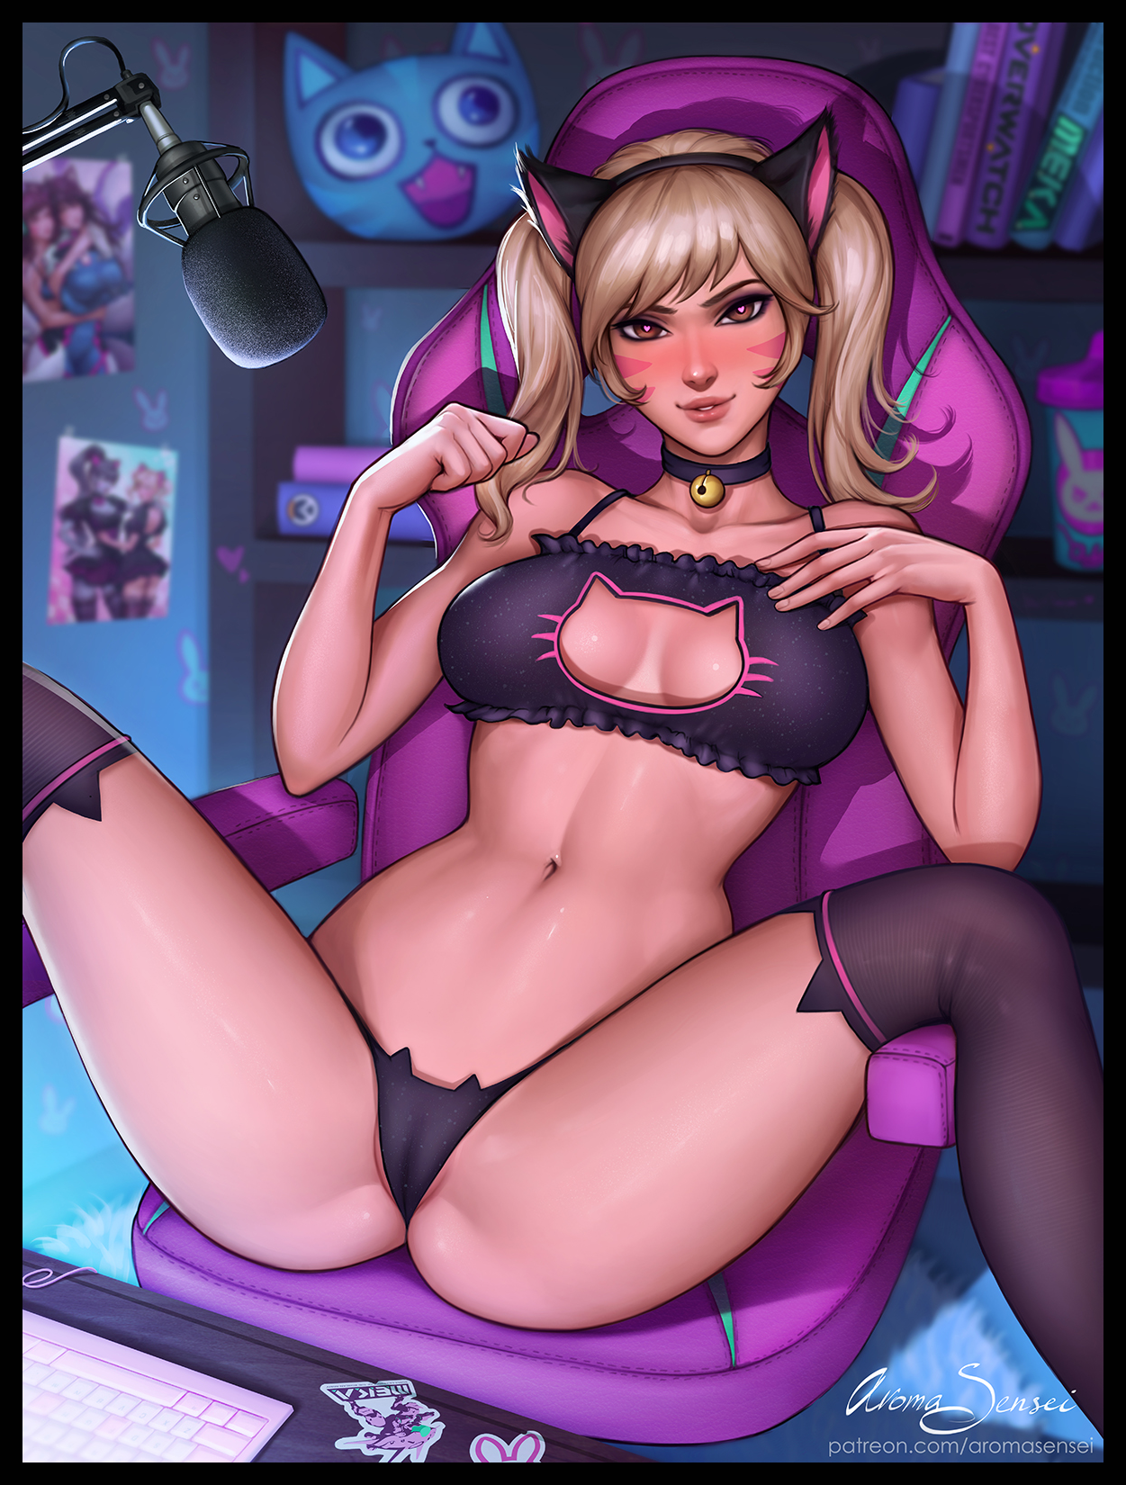
The idea of watching her friend put on such a titillating display would’ve been nice…but while most of Nicholas’ piggish exterior had been replaced by a far more appealing form, that statement only applied to the man’s upper half…and so she was left with a monstrous fusion between Korean eye-candy and the lower half of a sweat infused boar, wincing everytime those drumstick legs folded in an attempt to show off what laid beneath…none the wiser to how the memories of her past self had influenced her decision making…because the woman Tracer knew would never resort to such a deprecating gig like earning money through the use of her body…

But over time, Nicholas’ poxy gut and sagging legs would give way to the transformation, shrinking inward as roiling layers of fat flattened into a toned mound of sturdy flesh and well oiled muscle, inlaid between broad hips that surge outward to the side, accommodating for slender pillars composed of creamy thighs and lanky calves bereft of curly hair. A much more fitting vessel for the skimpy feline themed set of revealing underwear that had entirely supplanted Nicholas' singlet and boxers, complete with a cat shaped cutout on the bra itself. Testifying to her body's squishiness as black thongs and thin straps bite into her skin, thrusting child rearing hips forward once a lean ass balloons outward into a certifiable bubble butt perfect for a harsh squeeze or a firm slap, causing Tracer to gnaw on her lower lip as seedy thoughts enter her mind in sync with Nicholas losing the composure to hold back against a tidal wave of raw emotion and lust coursing through her feminized form once the last remnants of a shriveled penis slinks back up inside of her dripping folds, rough ballsacks smoothened and filled with pliable meat to form the fat, moist entrance to a juicy vagina, wrapped up tight by woefully inadequate panties that served more as eye candy than modest cover…

And with the emergence of a piping hot opening just beneath the sweat slick surface of her pulsating tummy, the newly converted and hypersexualized instance of Hana Song that had entirely consumed the pudgy man could no longer contain her bliss, cooing into the microphone while heart shaped symbols sear themselves into dull eyes, locked on the big GAME OVER icon on the screen as a switch at the back of her mind flicks in response, lackadaisically raising both stocking clad feet to plant firmly against the table with a jingle from an overly tight choker around her waifish neck and a satisfactory jiggle from the rest of her perverse body as barely supported tits bounce to the motion while the rejuvenated thighs and plump buttocks shake to the tune…drawing the eyes away from the last girl band poster hanging on the wall being converted into a more ‘personal’ picture. One amongst many implicating shots of Hana Song’s voluptuous form on show in a variety of equally salacious outfits, some alone, some with other equally beautiful and daring women. Sentenced to live out this new life of hers without even knowing anything had changed at all thanks to the unintended mercy Tracer had imparted to Nicholas once her decision to reconfigure his mind at the same time she did his body had been set in stone, rendering her blissfully ignorant the whole way through, not once realizing her memories of a crappy childhood had been entirely replaced by a more or less enjoyable one as a local born Korean girl…except the moments spent learning about games from her father had been tweaked to accommodate for her newfound perversions; taking after bad habits from online friends and one-time flings to become the E-girl she now was instead of a celebrity Esports player the original was supposed to be…
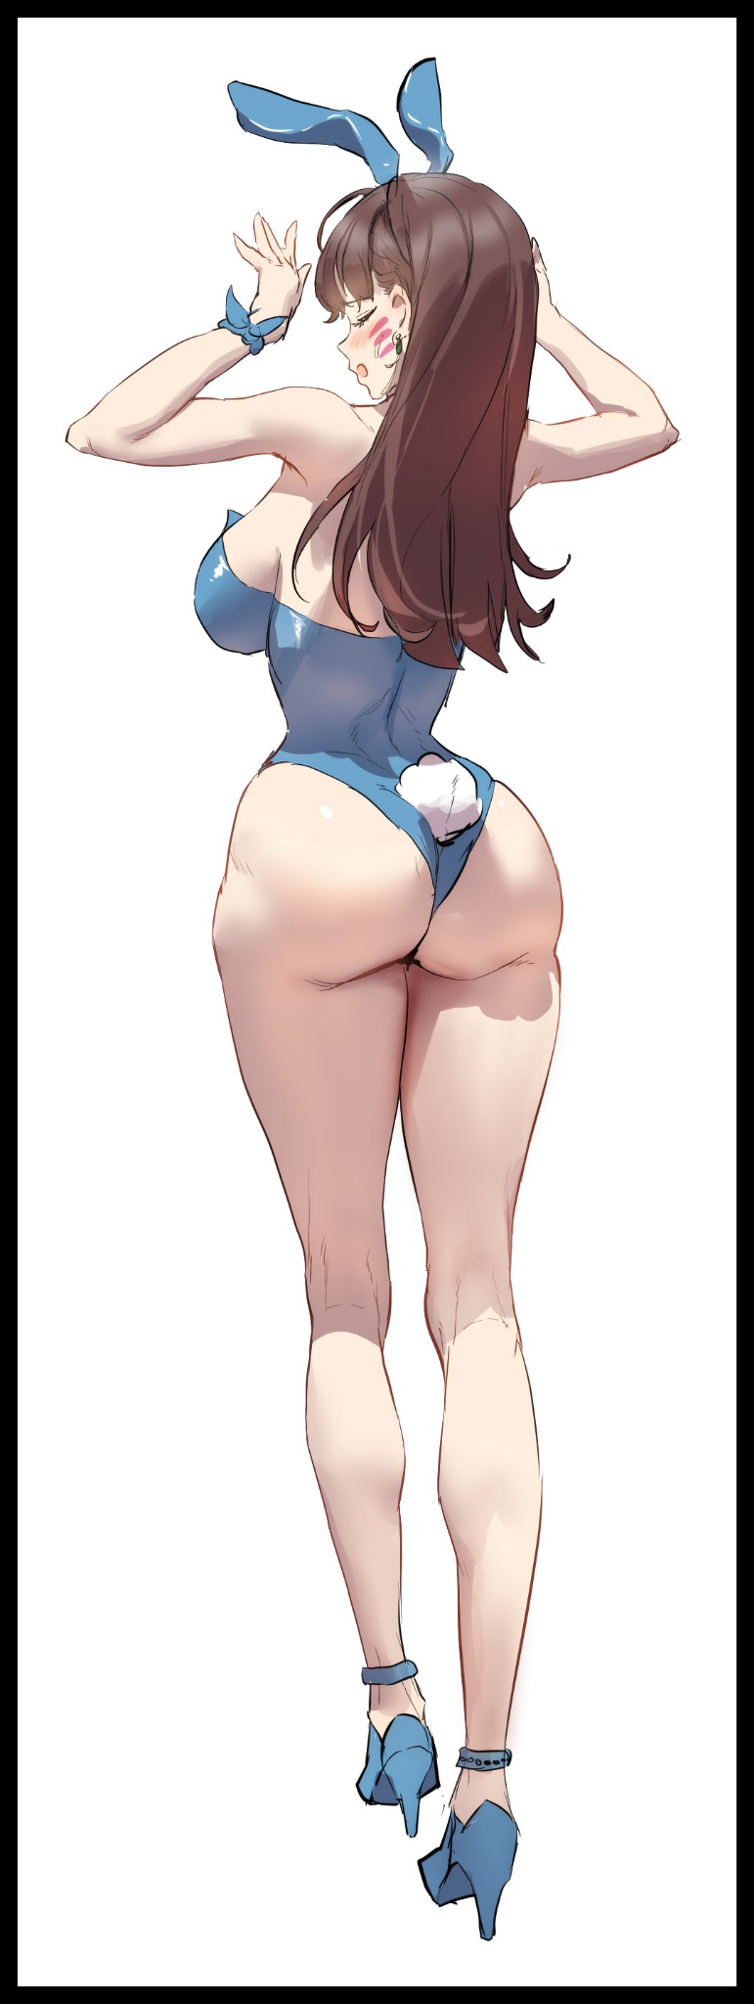
Although the same could not be said for Maximillian, who was already wide awake and alert to the physical makeover on both himself and the surroundings.

After all, it’d be pretty hard to dismiss the throbbing sensation of muscles that weren’t there before pulling on one’s loins, alerting the fading man to the alarming sight of his pecker being sucked up inside of a widening slit between impossibly wide hips that had since taken over the gaunt figure of his once muscular body, now sporting curves and dips aplenty now that Hana Song’s curvaceous form had overwritten his entirely, landing on the floor with a thud and girlish yelp dripping with a noticeable accent that leaves the former man frightened and alienated, accidentally losing track of a phone that distorts into a server’s saucer to carry drinks with by the time it comes to a stop a good distance away from the very confused Korean woman who had no idea what she was doing in a bustling casino dressed up like a sexy bunny girl, complete with a floppy pair of faux, rabbit ears once a headband pops into existence atop her head. Painted a mesmerizing blue to match the leotard riding up tight between the cheeks of her smoking rump and the sagging lips of a woman’s snatch, leaving Maximillian unable to do anything but whimper in a mix of denial and fright as she watches the last bits of her manly length retreat out of sight between the outlines of a camel toe, settling into place above a freshly opened hole as nothing more than an itchy clitoris, spasming against the stimulation provided by the rubbery suit as the newly bred girl sits there on the floor, legs spread wide much to the chagrin of the digital patrons of the once empty casino slowly spawning into existence as the mastermind herself watches on from a bird’s eye view.

In her eyes, it must’ve been only seconds before the last of her former self had ultimately faded away. But Sombra knew she only had herself to blame…although it wasn’t as if she could’ve done much to avert the inevitable…but it had made for a poor showing of her resolve, and a half-hearted transformation did little to stimulate the hacker’s heart as she looks to up the challenge, dissatisfied by Maximillian’s ‘too little, too late’ stunt to leave her be like Tracer had done to Nicholas, trying not to touch herself in the corner with hazy eyes fixated on the first Hana’s ongoing stream.

“Come conejita…show me what you can do~”

Steadily tweaking a slider that has the expected response from the way Maximillian’s shoulders jitter in shock, Sombra leans back into her seat, watching the frail bunny girl rise to her feet after a few more seconds of attempting to rouse herself from a non-existent dream, visibly shaken by the ordeal and the sudden realization she was wearing high heels, feminine equipment her very much male mind was not used to walking in.

Predictably, the afflicted woman had decided to seek help from one of the many men and women walking around her, most not even batting an eye to her presence when there were plenty of other bunny girls to ogle. But in so doing, Maximilian would only serve to seal her fate yet further once a wayward pair of hands emerges from the surging mass around her, giving her ass a hearty caress before slinking back into the crowd, eliciting a very girlish yelp far unlike anything the former brute might’ve mustered if she were touched in that manner before the loss of her body.

Her backhanded swing would come seconds too late to make contact with the perpetrator who had already made themselves scarce, leaving the Korean woman panting in a sudden fit of heat as the twin flaps of her suit swell with noticeable nubs atop wavering breasts; nipples hardening, growing erect just like the already tingling clit between her legs as the unsoiled flower nestled between quivering thighs spasms with muscle contractions and a tiny release of pale fluids, causing Maximillian to stumble for a moment as her already unstable gait falls apart, forcing her to lean against a pillar for support while her feverish body struggles to adapt to the heat of a needy woman’s estrus as it consumes her mind, leaving her overwhelmed…and vulnerable.

Predictably, another pair of hands would surge forward to take advantage of Maximillian’s confusion, and in so doing, would begin a downward spiral once the cracks in her ego multiply drastically upon yet another blow delivered to the heart of her perceived manliness; the very thing keeping the sensual persona slinking around the back of her mind from taking over as a vice grip squeezes her left breast while the other massages her stomach, causing the horny bunny to arch her back in surprise and pleasure, tossing her head back in utter bliss while a lustful scream goes unheard amidst the deafening jingle of slots and a raucous crowd, finding her whittled physique inadequate at removing the devilishly precise hands roaming her body, hazy eyes contorted into a wanton look of lust telling bystanders to leave her be as much as the dwindling soul of a confused male within sorely yearned for their aid as the stranger continues to fondle a lactating tit while making her newfound womanhood known to her by massaging her baby maker, and in turn, her vaginal canal as the first trickles of a female’s desire leaks down the supple length of her eye catching legs…

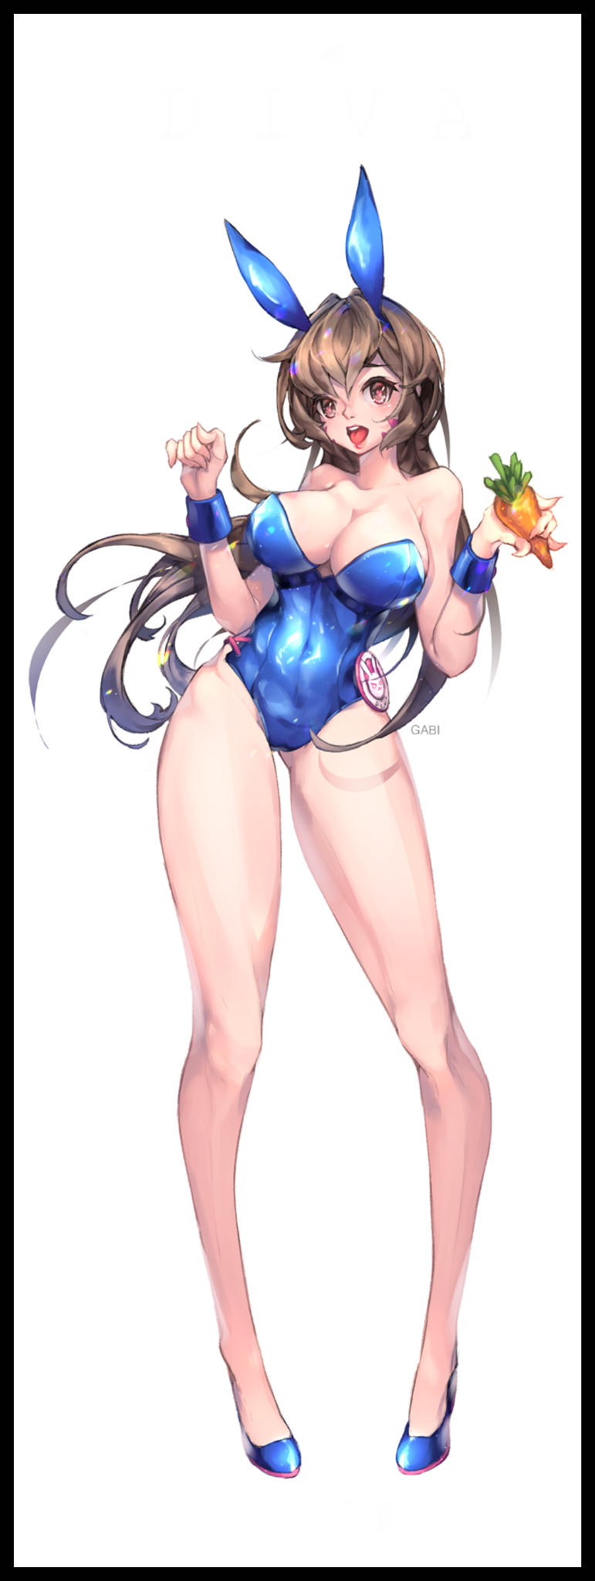
A desire for aid would be twisted into a want for more stimuli as lazy hands depart the ones already glued to her body, coaxing yet more to ravish her body. Memories of being pampered by careless parents and fighting with an insufferable sibling bleeds away to more humble beginnings in a homely South Korean home instead of a pristine mansion somewhere out in California. But just like her sister…no, her identical twin before her, Hana Song’s life would diverge from that of her original self sometime after being handed a mission to infiltrate an organization suspected to be in cahoots with the terrorist organization Talon.

Instead of being a college dropout, the training of being an Overwatch member and talent with the piloting of her personal mech ingrains itself within her brain, fried into the synapses as they flare everytime a rogue finger slips up into her drooling folds. Each successful mission or deployment lingering in her mind with each euphoric release once orgasm after orgasm rocks D.Va’s perverted body, letting loose squirt after endless squirt of slick juices across the casino floor with a wet tongue lolling in the air in tune to her spastic contortions as all that she once was forever falls to Sombra’s mindwiping code, imprinting the life of a subservient collaborator to Talon within the clone of the famed Overwatch member by the time she fully settles into her current role of a bunny girl waitress within the halls of the very same building her failed infiltration had taken place in, turned into a loyal seductress who had all the fighting skills expected of the original alongside a new found flair for both men and women,...particularly the latter once the imprint of her mistress takes center stage within the second Hana Song’s mind as she turns her neck up to face the camera pointed down at her, directing a knowing wink through the inky lenses straight into the smug visage of a satisfied Sombra as she leaves the newly converted woman to her own devices in a simulated world she had yet to realize she was now a permanent fixture in after a spectacular failure that had her brainwashed by the Talon hacker…

“Sombra?

“I presume everything’s gone well on your end? You didn’t mess anything up, did you cariño?”

“Oh no, nothing of the sort…when you said you locked that guy up in a sim…where exactly did you put him in?”

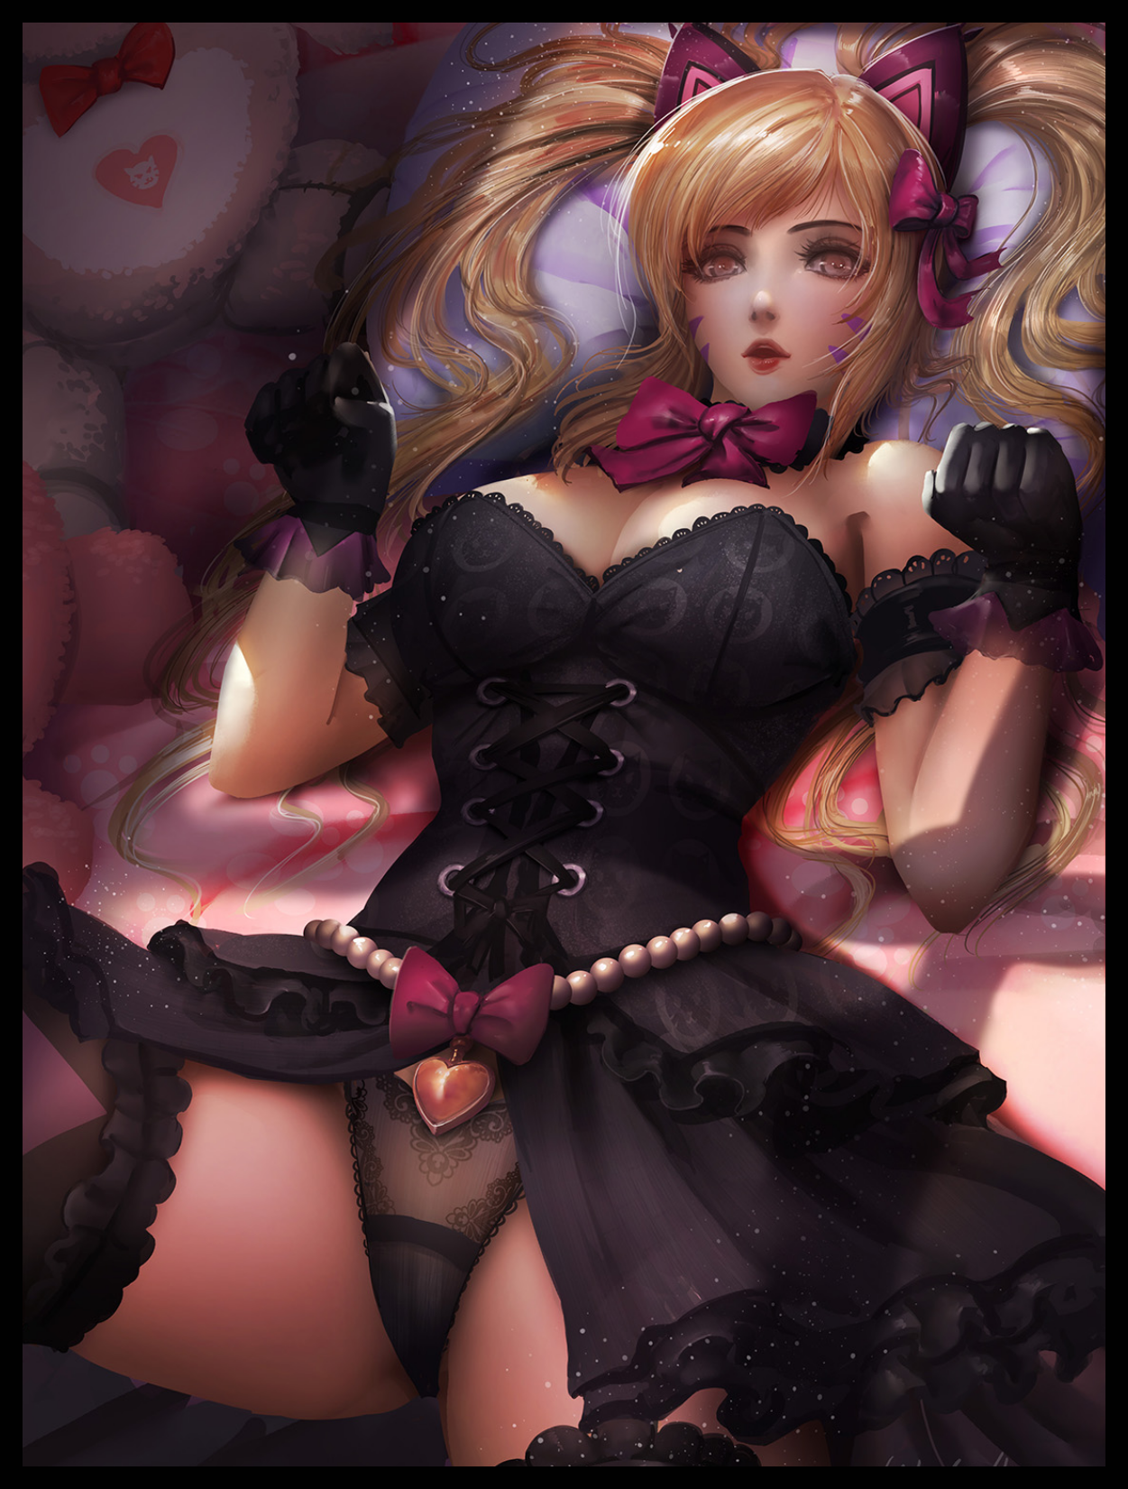
Grinning as she walks over to join Tracer on the couch, Sombra gently takes the holographic display from her partner’s hands to examine her work…and the sight was honestly a surprise, earning her a satisfactory pur as a sentence uttered entirely in Spanish slips out of the hacker’s lips at the sight of what could only be described as an even more dumbed down version of D.Va changing into a new set of gothic styled clothes that remained just as revealing as her underwear was after a ‘sweaty’ session of gaming, mind melted so badly she probably wasn’t even given the chance to realize she was even supposed to be in trouble at all…

Whether or not Lena had done so on purpose or otherwise, Sombra could hardly care as she beckons toward the door with a wry smile on her face. She certainly was living up to the expectations of being her number two.

“It’s just beyond the door mija…well? Go on, you’ve earned it~ I’ll see you two later…”

“Aww~ Cheers Love! I’ll catch you later then!”

Turning her attention back towards the screen before reaching out to fuse both displays together with a firm clap vanishing the bright glow emanating from either one, a thoroughly satisfied Sombra leans back into her seat as the spacious room reverts to a more, cramped if familiar setting; her old ‘base of operations’ from a time before Talon. She had so much power now that it was almost hard for her to believe the fact that she was supposed to be a fictional character brought to life, acting like a just hand to deliver punishment where it was needed…an obnoxiously righteous goal she had been saddled with by the powers that be…although a part of her was now thinking just how much she could skirt that restriction in tandem with her control over the physical realm. Sure, she could pluck things, human and otherwise, and pull them into her world, where she was free to do with them as she saw fit…but what about the other way around? Could she one day hope to walk amongst these ordinary people? A veritable Goddess amongst mortals so to speak? Those were nice thoughts to have now that she had all the time in the world to dwell upon them…alongside the potential repercussions of doing so if there even were any to speak of.

But there was a time and place for such things, and now clearly wasn’t. Not when she had two new assets to manage a ‘love’ to get back to as she rises up off the rickety chair, sauntering out of a disintegrating room as the door slam shuts behind her, archiving that old memory of hers back into the depths of Sombra’s mind as she returns to the present…

THE END

Image Sources

Image 1 by Aroma Sensei : https://www.pixiv.net/en/users/49675064

Image 2 by Gabi : https://www.pixiv.net/en/users/16954319

Image 3 by Turewindwalker : https://www.pixiv.net/en/users/2283717

Image 4 by Muloli : https://www.pixiv.net/en/users/7914067

