GENSHIN IMPACT: METEOR MASH
CH1: JUST A CHURCH GIRL
BY CHALDEACHANGE
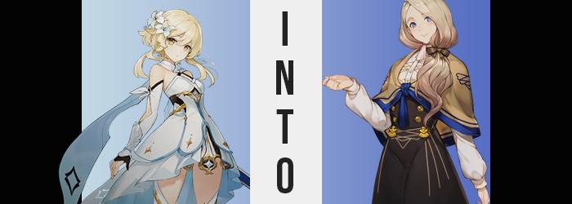

It was a spectacle observed from all over the world of Teyvat.

A meteor shower that looked entirely normal to all of those that watched, and yet it was likewise more dangerous than anyone could imagine. These rocks rained down for nearly an hour, each glimmering across the sky before setting down somewhere else in the world as tiny fragments of stone. Each glittered a different color of the rainbow, inspiring awe in the onlookers from just how beautiful it was.

Many of these fragments fell harmlessly into the ocean, never to be seen again, while others? They pelted towns and smashed through windows, small as they were. The damage wouldn’t be hefty, and their distribution spread out, but the fall of the rocks themselves weren’t an issue. Teyvat had seen meteor showers in the past, and people always forgot about them just as quickly as they occurred.

Sitting on the steps in front of the Church of Favonius, the Traveler, Lumine, was one of those watching the pretty lights race across the night sky above. Her partner in crime, Paimon, was talking with sister Barbara about something inside and so Lumine was just awaiting their conversation’s completion, but at least she had a show to watch.

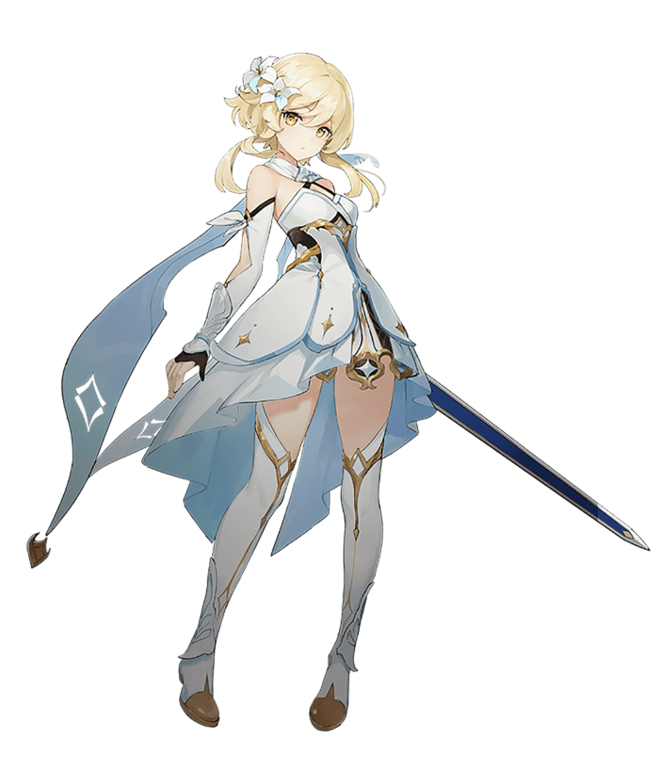
It helped take her mind off of things. Like the revelation that her missing brother was working for the bad guys, like how she had to figure out a way to reach Inazuma, and like how even trying to weigh her problems now only resulted in turning her tummy to knots. Little did she know that Paimon had caught onto the Traveler’s distress, and the conversation she was having with Barbara involved plans to throw a party for Lumine to help take the edge off a little bit before they traveled to Inazuma’s distant shores.

“Isn’t that shooting star coming a little close?” While observing the shower of space rocks above, Lumine eventually found herself squinting at a dark blue light. It had caught her attention because it seemed to swerve towards her direction, and the light was growing closer as—

CLACK!

Lumine flinched as a natural response to the realization that the falling debris was about to land on top of her, but after hearing it hit the steps she realized she’d recoiled in fear for naught. “Oh…” The meteor had shrunken to such the size that it was now only a pebble that rested a few steps below her, still glowing blue. That color was unique. Maybe she could have it fashioned into an accessory of some sort? Not for her, but she thought the color might go well with Barbara’s outfit, perhaps?

With this in mind, the blonde jumped up from her set on the stairs and skipped down to pick up the stone – unaware of the fact that her form was already at the mercy of the aura it was giving off. Not only did she not notice, but she picked up the source and slid it into a pocket cut into her white dress. “Maybe I should go check on Paimon?”

But at the same time, Paimon had asked her not to eavesdrop. It wasn’t like that girl to be so secretive with her. It should be alright. I should ease my anxieties through prayer to the Anemo Archon. “…Huh?” The strangeness of the thought that crossed the girl’s mind did not go unnoticed. She wasn’t a resident of Teyvat and did not pray to any of the Archons. That went double for the Anemo Archon, whom she had met personally. There was no way Lumine would pray to Venti, not in a million years.

“Perhaps I’m just tired?” It had been a long day, and she hadn’t been sleeping properly since the revelations about her brother had come to light. Though, things had been put into motion now at the meteor’s behest that would prove that this thought wasn’t born sheerly from her fatigue. In fact, she immediately recognized that something was amiss with her body.

It was her clothing that gave it all away, for she could feel everything tensing around her flesh as things began to change. The first of these notifications came from her thigh high boots, or at least through how the boots were interacting with the thighs in question. At their peaks they felt too restrictive almost like… “Are my legs thicker?”

The girl had leaned forward to get a better look past the hem of her dress, and the meat of her legs looked like it was pressing over the edge of her boots. In the beginning it was only a little bit, but with her eyes trained on her legs she could now make out the flesh swelling still, muffining well over the boots at her thighs’ peaks, while the insides of the boots felt so tight that she worried she might not be able to pull them off.

Lumine was at a loss for words, and all she could muster was a confused “Uh?” as her discomfort became more widespread. The increased size of her thighs had unintended – or entirely intended – side effects, most prominently forcing her hips to part with how her inner thighs were pressing so intimating against one another between her legs. It was painless, but either hip popped and creaked as several inches were applied to her girth, forcing them to push out the sides of her dress as well as the straps of her panties.

The band of her undergarments remained in tact despite this stretching, though the panties themselves were promptly subjected to even further abuse. “Oh!” For the front of her panties were pulled in tight against her groin, while in the back they were promptly wedged within the cracks of her ass. The cause of this malfunction was fairly obvious considering there was only one region that could dishevel her undergarments in such a manner.

Her has was swelling. “My butt!?” It was a strange thing to cry out on the steps of a church, all the more so when hands immediately reached back to caress this swelling bum overtop her dress. She could feel the shapeliness pushing cheeks larger and firmer, the dress itself slowly creeping up to reveal the base of her cheeks as a result.

Um… Why am I touching myself so indecently, and in front of where I pray at that!

There they were again! Thoughts that didn’t make any sense! She’d never been a devout practitioner of Mondstadt’s faith. Even though ever since she’d been a little girl, growing up in a religious family… “No that’s wrong. I’m not… I…?” Lumine was unsure. Why were her memories so jumbled? Her childhood had actually been… exactly as she’d just described? She could have sworn it had been different!

Abiding by the concerns of indecency the sweet voice at the back of her mind had expressed, the girl had removed her hands from her swollen rump. She likewise resisted the temptation to grope her bosom as her dress’ front shared in the discomfort that her lower half had previously endured. The front of her dress was open above her chest, but only because she didn’t have much of a chest to show typically.

That wouldn’t persist as a time-tested certainty any longer, though. For an unsurmountable pressure resulted in a swelling of her bosom that forced the front of her dress forward. The black straps that bound her dress to her detached collar were forced to stretch as the front of her body filled out several cup sizes, nipples digging into a brassiere that suffered a snapped strap in the back near the growth’s peak. Even the straps broke, her chest jiggling despite barely being bound by the dress. Some of their milky flesh had bulged over the dress’ peak, but they stayed in place enough to preserve her decency.

Although that decency wasn’t eternal. “Were the steps always that low?” Lumine, her voice softening as she expressed this question, looked down while wearing a puzzled expression. No longer did she feel any panic about the fact that her body was transforming. Nothing even seemed awry to her, at least not according to her memories. She’d always had a chest this big, and hips this wide!

In a similar vein, she couldn’t quite register that she’d grown a few inches taller because she was now perceiving it as the height I’ve always been even if it felt off initially. Brought up to almost five foot seven inches, the mass of her thighs looked a little more even with limbs lengthened to accommodate her destined size. It extended to her fingers as well, and within her boots her swollen tootsies felt almost like they were going to burst out of her footwear.

Unfortunately, this meant her outfit had been ruined even more. The dress now clung intimately to her torso and had been hoisted off her hips, meaning that her wedgied, cameltoed black panties were fully exposed to the night air, and she rose higher out of her boots. Those detached sleeves of hers also rested farther down her arms. “Wh-What am I wearing!?”

Lumine’s cheeks were flushed crimson, apparently no longer capable of recognizing her signature dress. Though she had a trick to even look down at it for a time, namely because her hair had been getting in the way. Shoulder length, blonde locks cascaded down her back, growing quite soft and wavy in texture as a browner tone swept through her born gold. What remained was a pale brown that permeated into her brows and pubes as well, with the bottom half of her hair carrying a gentle sway. The flowers in her hair were pushed down along with the added length and ended up caught in her luscious locks.

As the woman blinked, her golden eyes fluttered into a steely blue that appeared to narrow in shape. An undeniable maturity soon settled into her features, bringing the mass of her lips to rise and the arch of her nose to curve. The natural chub of her cheeks persisted, but there was something about the lengthened design of her jaw that allowed her to give off the impression of an ‘older sister’, complete with her bushy eyebrows.

Once sixteen, Lumine had grown gratuitously into the body of a twenty-three-year-old woman. One that was clad in a teen’s clothes, much to her dismay. Even mentally, she could not recall her old life. She believed herself to be a Mondstadt native, and an enthusiastic churchgoer. “Oh!?” A sudden gust of Mondstadt wind swirled around the girl, and as a result her clothes began to glow and reform until she was adorned in a simple, black villager’s gown with a brown throw tied with blue. Blue legging reached up to her thighs above tanned boots as well, while her long hair was tied in the front by a brown bow.

The Anemo Archon blessed me just now? That was how she ended up perceiving it, forgetting that she’d even been dressed in something else before the wind had swirled around her. It was easier just to justify things she didn’t understand as the result of the Archon’s blessings. But where was she again? And what was she doing here?

“Oh? The church? Why was I coming here at such an hour? It must be well past midnight!” The twenty-three-year-old woman looked around at the steps before the Church of Favonius with caution. She was a devout believer in the church and its worship of Barbatos, and was a frequent visitor of the church at all times of day – or, well, most.

Mercedes von Martritz typically had a respectable rise and shine schedule that she tried to keep to. She always went to bed at 10, and woke up at 7 the next morning to attend morning prayer. It was strange for her to be up so late, much less walk to the church from her humble Mondstadt home. And, in fact, she had lived in this great kingdom her entire life. That was what her new memories told her. She lived here with her brother, actually!

It took her a moment, but her eyes eventually settled on the sky above. “Was I watching the meteor shower? That much be it, since they’re so rare and beautiful!” Surely a sight so pretty was a blessing from the Archons themselves. She was so distracted that she hadn’t even heard the sound of the hefty church doors opening at the top of the stairs.

“Miss Mercedes? Have you seen the Traveler? Paimon said she couldn’t sense her…” The speaker was the young Barbara, who was looking around worriedly. The fact that she recognized Mercedes despite her not originally existing in this world spoke plenty about the power of the meteorite that had transformed the missing Lumine.

Of course, Mercedes had no answers. “Sister Barbara! I hope you’re having a pleasant evening! Unfortunately though, I have not seen Miss Lumine… Would you like me to help you look?”

And this incident was only one of many that would plague Teyvat over the coming twenty-four hours.

