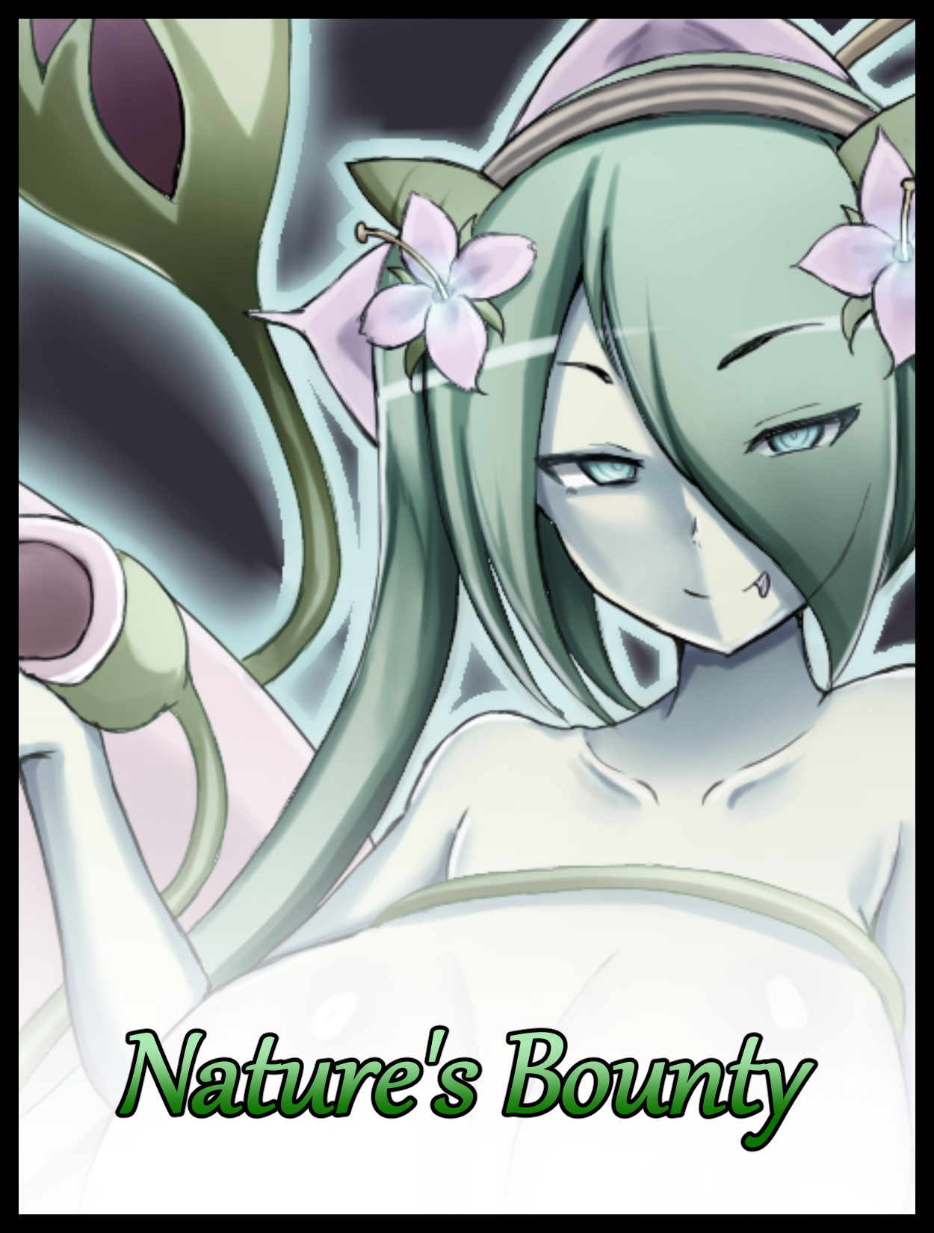

To tackle life on one’s own out in the wilderness was a gamble. Without sturdy walls to hide and protect from external threats and a tight knit community to rally around in times of need, a lone wolf’s days were numbered. And in a perilous world where any misstep could lead to potentially fatal consequences, that time frame was entirely dependent on an individual’s luck. With some managing to beat the odds and go on for lengthy years without anything noteworthy cropping up while others wouldn’t be able to last for more than a day, falling victim to treacherous terrain, turbulent weather or just dropping off the face of the Earth entirely.

But to find oneself becoming a wanderer against their will would usually mean their luck was never really good enough to begin with. And for one such individual, that sentiment would probably have been the truest words he’d ever heard spoken to him…*if there were anyone left to vocalize them in the first place…*

Left without anything but the raggedy clothes on his filth caked person to defend himself with, ***Finn*** had been the sole survivor of a supply convoy making it’s usual rounds between the scattered settlements dotting the land after the mountainside path they were in the middle of traversing had come under siege by a cleansing wave of mud and boulders loosened by inclement weather battering the region for a few days before their crossing. And thanks to a sheer drop above and the lack of wary eyes to watch the skies, the landslide borne as a result of all the previously mentioned effects on the environment had come so fast that there had been no time for the convoy to do anything as the rushing mass of granite and grime sweeps them all away. Leaving no trace of man, horse or cargo left behind seconds after.

Those caught outside the relative safety of the caravans would either find themselves being buried alive under choking mud or slammed and ground into crimson mush against the rocky hillside. Relatively swift cuts to life in comparison to the long, drawn out agony faced by those in the tumbling wooden shelters proper as they were tossed around like beans in a can the entire way down, with some drawing the short end of the stick and smashing apart halfway through. From bruises to concussions, all manner of injury had been sustained by the remnants holding out in the last remaining caravan before their tumbling ride came to a crashing halt at the base of the mountain. And of the five remaining survivors, Finn had been the only one lucky enough to keep himself relatively conscious if a little shaken, saving his own life in the process when he realizes that the danger wasn’t over as an endless stream of mud and boulders large enough to kill continued to rain down around the wrecked convoy.

Left with no other choice and fueled by adrenaline stemming from the winding panic of the experience, Finn had been quick to make his escape from the irreparable husk, leaving behind precious cargo and the rest of his associates, who were either knocked out cold or too injured to be mobile…that, and the weathered guard simply had no faith in his physical ability to haul them all out of there. And even if he did, the conditions outside told him all he needed to know; that it was do or die, every man for himself…

By the time he had managed to swim through the ever growing bog while narrowly avoiding falling rocks intent on seeing him turned into paste, what remained of the caravan had been crushed and consumed, swallowed by the bubbling muck until nothing but the ruined canopy remained. And as if in mockery of the sole survivor, a large boulder would land directly atop the sunken coffin, sending a huge explosion of mud flying everywhere with enough of a shockwave to knock Finn right onto his bum, languishing in literal grime at the sight of the monolithic headstone staring him down with invisible eyes full of contempt for the lone survivor that had escaped it’s crushing wrath. Cementing the fact that he was all on his lonesome while a fitting backdrop of dark rain continues to fall, broken on occasion by sharp thuds and wet splashing from plummeting stone making impact and amber shafts beaming down from a fiery red sun dipping behind the jagged peaks high above. An imposing sight that spurs the battered survivor to turn tail and leave, putting distance between himself and the site of the accident in an effort to find a safe haven to hole up in before the darkness of night sets in.

Shadowed by the imposing mountains. Finn would find no luck in seeking out a hidey hole to tuck himself away in. Not when the entire forest seemed to have taken root on flat terrain, making it highly unlikely for the troubled man to find a natural cubby that wasn’t a burrow dug by a large animal…or worse, one of the creatures whose deceptive appearance served as a mask; utilizing the alluring traits and gentle curvature of a fair lady’s silhouette to obscure the fangs, claws, wings and whatever else might make up their true, beastial forms. An oddity to the world's ecosystem that had kept the rest of mankind sequestered to their respective holdouts and settlements, known to most as *'Monstergirls'*. A simple term coined by their general appearances and the fearsome reputation they had built up over the millennia since their discovery back during a time when those in Finn's generation hadn't even come into existence yet.

It was a series of events lost to the minds of those living in the current age, with only a scant few out there in the greater world being privy to such knowledge, nomads whose sole purpose in life was to accrue as much knowledge as they could. Collecting bits and baubles most would pass up as unsalvageable garbage, living beyond the safety afforded to most by tested village walls and even studying Monstergirls wherever they might live, documenting, noting behavioral patterns and oddities…all in an effort to ensure the people were educated and kept up to date about such things. No one knew if there was an organization to these 'scholars' or if they even had a greater purpose besides the collation and dispersal of vital information, and few had ever thought to ask. Not when these wanderers only ever spoke to whoever led the respective settlement's they would come to rest for a moment before departing just as suddenly. Off to do whatever it was they did best. Utilizing a skillset to make it to their next destination intact Finn could only regard with envy as he continues to fumble his way through the brush. Battered body screaming for rest and care while festering mud and grime irritates exposed hide, leaving the man confused, exhausted and highly irritable as he continues to struggle in his search for cover. All while the skies painted themselves a bluish shade of maroon, heralding the onset of night and worsening visibility for the imperiled guard.

By the time unseen insects and nocturnal birds began to sing their incessant song, everything had come under darkness' embrace. Restricting Finn's vision to a few inches beyond the bridge of his nose, a deprivation of his visuals that leaves the man reliant on his hearing alone to navigate the forest. And as far as he remembered, Finn was a caravan guard, not a bat. And for all the training he had, nothing could prepare him for the reality he faced; of survival out in the wilderness, alone…and afraid…

Unsure of where he was even going and fuelled by an all consuming sense of dread, all Finn could do was stick close to whatever solid object he could lay his hands on, moving from tree to tree with shaky steps while jittery shoulders jumped at every little crack of mottled leaves being crushed under foot. Unsure of whether they were his own or those of an unseen entity that had caught his scent in the wind, its biting chill seeping through soaked skin to gnaw at weary bones while paranoia conjures auditory tricks and visual horrors to further the man's torment. Hallucinations that came in the form of fading phantoms flickering into existence for the briefest of moments before dissolving into thin air, wearing the shredded remains and mud-caked visages of those that hadn’t been as lucky as he was to survive the fall. Taunting Finn with mocking words and vengeful invitations to join them on the other side.

But Finn would continue to move, never stopping despite the screaming ache of protest in his joints and a throbbing migraine banging on his skull until the cloak of inky darkness gave way to the first signs of color from above. A spot of raven blue, followed sometime after by actual light shining through breaches in the obfuscating canopy as morning comes to bring relief to the lone human wandering the seemingly endless expanse of the prolific forest dominating the landscape. A disappointing discovery that wouldn’t be able to register in Finn’s mind once relief had caused his overworked body to come to a crashing stop, collapsing in an unwashed heap onto the overgrown forest floor where he would lay for an unknown amount of time until the piercing sting of a curious bird’s talons would stir Finn from his comatose slumber, coming to under humid conditions wrought by a blazing afternoon sun. Freed from the haven afforded to him in the depths of his mind back into the waking nightmare that was his current situation; stranded in the middle of nowhere with no one to call on for help and not a single tool to aid him on this hopeless endeavor. Leading up to current events where Finn had decided to do the only thing he could; and that was to keep walking in the direction he vaguely remembered where the sun rose, hoping to find some sort of route that would set him back on the trail proper…however unlikely that outcome seemed after being sent tumbling all the way down a mountain.

Awakening in the middle of the day would soon prove to be a detriment however. With countless days having gone by since Finn had lost consciousness, his impromptu rest would do little to soothe the wear and tear of exhaustion. And without food and water to fuel his body, the negatives wrought by dehydration and starvation were beginning to set in as well. Making every step feel like there were buckets laden with freshwater drawn from the lake near his village strapped to blistered feet that had since come free after flimsy boots of shoddy make had fallen apart at the hands of the landslide. All while a hazy vision hampers progress, finding himself bumping into tree trunks that were closer than the distance measured by dilated eyes while upraised roots and thick bushes went unnoticed, tripping Finn up everytime he would cross an area filled with such obstacles. Narrowly avoiding potential meetups between his face and the ground he stood upon, composed of cracked mud and decomposing greenery that soon gives way to more than just an endless array of knobbly trees and miscellaneous shrubbery indiscernible from each other, unknowingly crossing over into a region separate from the repetitive forest he had been trekking through without any real notice paid to his surroundings. Not when his stomach had been grumbling without end since his return to the real world, demanding food be sent into its depths while a struggling mind does its best to do without.

Eventually, even the likes of Finn would take note of his surroundings when new forms of plant life he’d never laid eyes on began to appear in voluminous amounts right before his weary eyes. Interconnected vines looping around branches and hanging down from a lush, vibrant roof composed of leaves showcasing their health through a lustrous coloration of ivy green. Colorful collections of fungi and flowers growing low and unnoticed around and beneath the shade. Strange bushes and leaves that were far more distinct and unique than the ordinary overgrowth from before. There were even flying insects to behold as well! Small, nimble critters that would leave a lasting itch wherever they landed on Finn’s exposed hide. That, and the markedly cooler and fresher quality of the atmosphere made it all seem like he’d stumbled upon a partitioned segment of the world free from the harshness of reality. A haven operating in its own bubble he had unknowingly walked into…

Greeted by such lush bounty and unable to discern any immediate danger from his surroundings, Finn’s cravings for sustenance would begin to take center stage, multiplied tenfold by bright colors and teeming life that could only mean one thing; ***food***. For how could all of this come to be in the first place without?

Hastened by yet another rumble from within, Finn would fall into a maddened search for anything that wasn’t green or what he recognized as unsuitable for consumption. Ducking low between beckoning branches, pawing around callused bark and even digging up the soil like his innate instincts tempered by years helping out on a farm told him where buried spoils could potentially be lying in wait. An illogical move spurred on by a desperate desire to live. A lust for life that would eventually bear fruit in the form of strange plants Finn had never laid eyes on before. Divorced from what little he knew of the myriad species there were in existence as his rabid movements come to a stop before the unusual little growth protruding from the length of a thorn ridden cluster of vines.

It was bulbous in shape, sort of like a cup one would use to hold water, except this one was far larger and intricate. Boasting an outer skin of matte smooth fiber painted an unmissable shade of green and a bloated protrusion of sorts around the rim with a sinewy texture to it’s make, lined with faint lines and ridges akin to human lips with an eerily similar shade of reddish-pink to complete the faint image of a plant’s attempt at mimicking human physiology.

But with a single whiff of what laid within, all concerns and doubts Finn might have had for the unusual plant were immediately rendered mute and negligible. Hooking the starved man in one fell swoop as shaky hands reach out to grasp at the bulb, recoiling from the organic warmth it’s incredibly smooth hide radiates before securing it with a proper grip in both hands.

Pulling the bulb free of the vine it was anchored to seemed impossible. Even if he had a proper grip on the thorny tendril, the fibrous connection keeping it together was simply too strong for the weakened man to break through brute force, even if he had the will to act on it. So with no other alternative left and overcome by the urge to feed himself, Finn would resort to the direct option without hesitation. Bringing the bulb down to face level before unflinchingly meeting lips with the green organ, not even taking a moment to inspect the runny fluid contained within as the initial taste gives way to greedy slurping and ravenous gulps, suckling the plant like a baby latched onto their mother’s bosom.

The taste was unlike anything he’d ever eaten or drank and its effects were just as strange and delightful; wasting no time in permeating his being with a warm pulse that works to relieve and then eventually, wash away the pain altogether. Alleviating the stresses of the harrowing journey as Finn continues to indulge himself, not minding the fact that there seemed to be an infinite supply of the delectable nectar contained within the oblong plant…or the even more alarming sight of cracked, bleeding lips gradually taking on a more lively shade of pink, returning to its former liveliness in an apparent showing of the translucent juice’s remarkable properties. Too focused on indulging his hunger to care, even when the process of healing starts to take a turn for the strange…because men of Finn’s age weren’t supposed to have lips that appeared to be filled in like pert cushion. Inviting the bystander’s eye for a kiss in an unspoken invitation from the way those inflated suckers continued to flex and contort in an effort to funnel more of the delicious liquid down a wanting throat. Contained along the length of an undulating neck that grows thinner and thinner with each passing second, tightening around the lithe structure to make up for vanished mass until a shapely pillar, stripped of scarring and other facial blemishes like a mottled stubble, remains. Matching up perfectly with a face that had likewise, lost almost all semblance of its former self in the short time since Finn had started consuming the unknown plant’s nectar. Trading rigid edges for soft, inward curving slopes that meet in the form of a dainty little chin. A pristine mask around which lengthening hair begins to fall around and frame, showing signs of change in the way the once frayed locks begin to unwind as they grow. Turning into silken threads aligned perfectly with each other to form gentle, sweeping tufts that curl outward near the edges and opposite closer towards the heart of it all, toward a face that could no longer be considered Finn’s…

Sleek and sensual half lidded slits had overtaken beady eyes. Refining rough lashes until they were fit to serve as perfect highlights to accentuate their owner’s increasing levels of feminine beauty while he continues to drink his fill, unabated by it all. Even when rosy cheeks restored and fattened from their previous gaunt selves are tickled by the finalized length of side sweeping bangs, retaining only the faintest hints of Finn’s original male self through tomboy flair that unfortunately, could not be said for the rest of his body as it continues to soak and relish in the mutagenic fluid.

Under ordinary circumstances, Finn would have realized what was happening and detach himself from the compromising plant. But with an exhausted mind and a battered body, the soothing relief provided by the mysterious juice was simply too much to part from. He didn’t want his mouth to sting like a fiery coal had been jammed around its rim everytime inflamed, crack-ridden lips moved to draw breath. He despised the itching sores and painful bruises swelling up all over from his perilous tumble down the mountain. His empty stomach was finally being filled with a delicious something his body had passed off as an acceptable offering and as he continued to drink, the shame and regret wrought about by survivor’s guilt was all just…***gone***. There wasn’t a need to think about the repercussions of making it back to his village in one piece, if that were even possible. No more worrying about whether people would hate him for being the only one to come back, about the hushed murmurs behind his back talking about how much of a coward he was. Just solemn nothingness to enjoy while enjoying the finest nectar in the world…even when said nothingness had begun to extend past recent trauma and into Finn’s subconscious mind, eating away at memories of the past and knowledge gleaned and collected over the years. Leaving the human in a state close to that of a drunken haze, limp and vulnerable as movement begins to stir in the nearby foliage surrounding him…

And as the core pieces of the structure that was Finn’s identity continue to fall away and vanish into the depths of oblivion, so too would the rest of his physical self be reformed. Extending past smooth, supple shoulders that had lost their manly width for petite compactness attaching long, slender arms to a torso sporting a subtle S-curve that serves to accentuate the budding growths that had begun to push out the front of the faltering man’s chest. Melting sturdy pectorals to serve as pliable reinforcement, jiggly yet firm cushions encompassing the globular length of what were unmistakably breasts as they came into being. Firm, perky tits that must’ve measured in close to the double D mark tipped with dull violet nubs, discolored faucets that waste no time in proving their functionality as brief squirts of fluid spray from their erect tips. Not the creamy white drops expected from a woman’s mammaries, but more of the very same pale, sticky nectar Finn continues to consume with glee. Letting a clear, feminine gasp slip free of luscious lips from the titillating feel of lactation as repurposed glans continue to produce more of the infectious fluid oozing out the tips of those hefty heifers and down their rotund length. Tracing raised bits of rib cage that adds a sensual arc to a navel heart stripped down to the bare minimum, leaving supple flesh and a thin coat of blubber to compose a womanly stomach unspoiled by wiry hair or bulging muscle, marked by a cute little belly button in the center. An alluring package wrapped from head to toe in pristine skin healed of bug bites, injuries and painted over in nature’s staple color; pale green hues over drab, speckled beige.

By this point, scant little remained of Finn’s former self besides the tattered remains of the clothes that once clung nicely to his athletic figure that had since seen a drastic level of change that leaves them hanging in the wind like the dregs they were, hiding little of the increasingly curvaceous form beneath now that the groundwork for the last few modifications to set in were prepared. Filling in an hourglass with firm meat and warm flab until no hint of a human guard stranded far from home remains in the bodacious female standing with waifish hands cupped in girly fashion around the bulb, looking less like a demanding suction and more like a romantic kiss as womanly sighs and affectionate moans vocalized by a husky voice laced with lusty air breaks the silence. Hinting at how pleasurable the experience was as a dangling sausage, already hit hard by the ordeal, breathes its last as a firm hand formed of muscle lining a newly opened passageway of organic folds and moistened flaps between pillowy thighs pulls hard, reducing the pathetic remnants into a tiny collection of hypersensitive nerves, a shivering head that spasms in violent need as the pert mound beneath it splits into a sopping wet set of lips; a vertical gash indicative of womanhood that empties itself of the bitter batter it could no longer produce, a taste made known to the newborn female as animate vines swirling around her still frame picks up on some of the wasted cum in their bid to rid her of the ugly rags masking her beautiful new self, dabbing phallic tips in the creamy expulsion before redirecting it over and up to fill the space left open by the parting bulb as the vine hosting it shifts away, gagging the woman that had replaced Finn in his entirety with a mouthful of green and white, sending her tumbling to the forest floor with a notable thud as a heavy ass makes contact with shifting ground that parts to reveal a pink surface. Meaty, firm and with chalk yellow highlights around its star shaped rim, the petals of a titanic plant that had remained unseen till now. Emerging to lift its prey up into the air, coaxing the limp lady closer toward its central mass with gentle motions of the flap she sits on. Kept docile by the tendril plugging her oral cavity as a happy tongue swirls around its perverse length, slurping up every last drop of her own semen with half lidded slits concealing vapid, empty eyes void of intelligence turned upward in mindless bliss. Making sounds that would befit a bedroom once the rest of her sensitive body comes under assault by the innumerable manipulators descending upon her pudgy flesh. Squeezing leaky breasts, tickling a perfect waistline and scratching at buoyant thighs rivaling the size of her head while limp hands twitch and flex in crazed need…a desire fulfilled by two additional tentacles joining their brazen brethren as they take a moment to test their target’s dribbling snatch and puckered ass, prodding select holes before acting in one swift thrust from both ends. Causing the green woman to stiffen against the throes of coital bliss rocking her drugged up brain from the sensation of a newly formed vagina spreading to accommodate for a lively mass as it bumps against the entrance to an altered womb while a virgin butthole quivers in ecstatic fright from being penetrated without warning. An act that causes the once thorny vines to flower with a bevy of alien growths extending beyond ordinary looking pink flower buds…

Snapping jaws that close with enough force to produce a sharp clap. More bulbs with eerie energy about them as organs in the shape of tongues emerge from their depths to flick at fresh air. Even Finn, or rather the woman she had turned into, would bend to the overgrowth. Shivering in a worrisome display as plant-like protrusions begin to emerge, primarily centered around her skull as a sturdy crown of sorts takes shape. More akin to extravagant headwear than an ornate symbol of royalty once it all comes together. Formed completely out of petals, vines and a matching pair of leafy extensions that trail and pool around both sides of the prostrated woman. Whose folded legs cupped within them a fine pool formed of the collective juices milked from the depths of her wanton loins, splashing around every so often as the vines worming around her insides gain knobby protrusions in the form of faux spikes that were only sharp enough to impart pleasure as they scrape and prod against vaginal walls. Driving her toward maddening joy as the weighty punch of a female’s orgasm strikes the finishing blow, sung by a muffled scream before she falls well and truly limp. Unmoving in the heart of the giant flower that had turned her into its representative, the embodiment of its mind as the last residual bits of Finn’s mind collapses in on itself forevermore. Emasculated and stripped of his will as a second presence fills the back of his head, creeping in and melding with what little remained. Coalescing into a chaotic mix between two souls until there was nothing but one. A perfect fusion that allows for the newborn Monstergirl to blink as the light of her presence returns to illuminate irises of vivid blue while a sly smile crosses over her minxy visage. Looking upon her buxom form while tracing it’s contours with a dexterous touch, smoothing over her bosom with an index finger before scooping up a little spunky overflow from the sides of her lips and thumbing it into her mouth with the same unflinching neglect displayed by who she once was…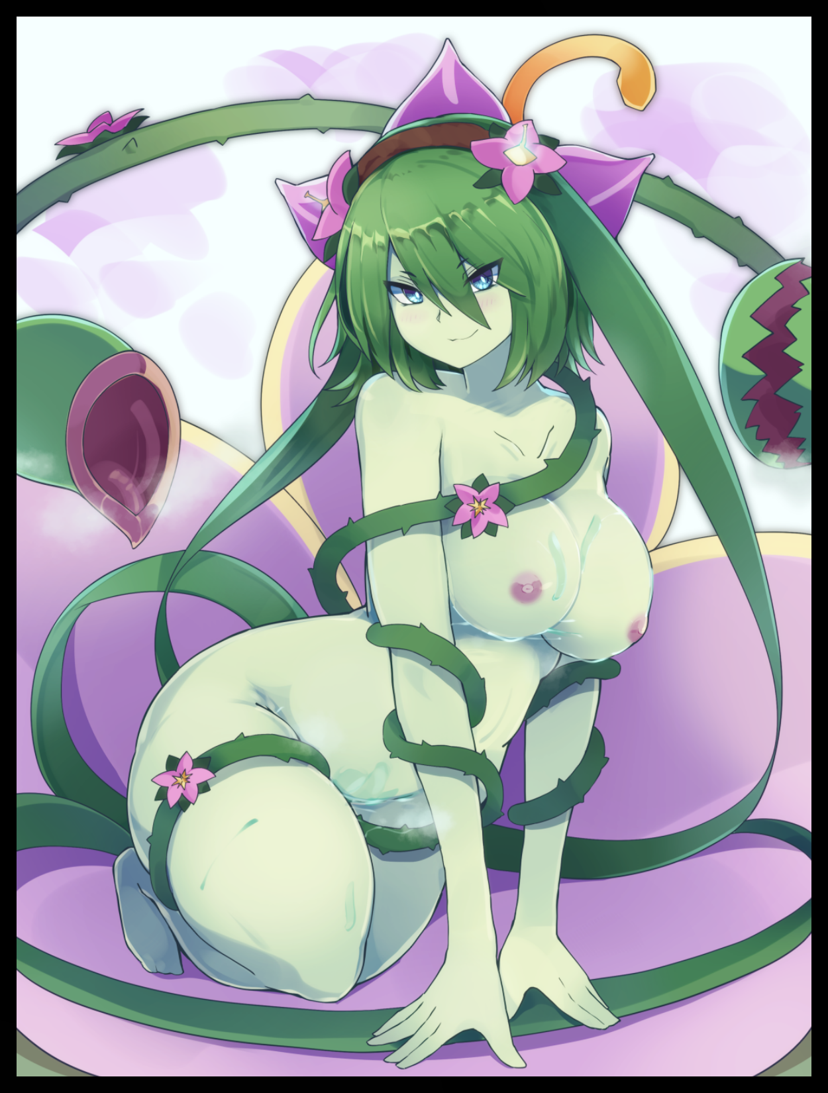

There was nothing left to salvage of the human who once went about with the name of Finn, not a single worry or doubt harbored by the lost caravan guard. For why would one need to worry if they were already home and content? And as far as the ***Dryad*** sitting cozy in her flowery domain remembered, this forest was just that; *home sweet home*. Savoring the taste of freshly spilt human sperm in her mouth as a bulging throat shepherds the freshly devoured tidbit into her simmering belly alongside the adequate batch she had already consumed, ready to produce a batch of spores with which she would use to flower and seed more of her glorious home to better foster and nurture life across the land. Just like her predecessors had done for the sake of all who knew to appreciate its bounty in tempered moderation.

But as much as she wanted to act on her instincts to seek out the source from which this sour, yet oh so delicious cream had come from, the Dryad could not yet move about so freely, finding herself consumed by exhaustion withheld from her former identity as an attempt to right herself from her roost ends in failure, collapsing onto her side with a startled yelp and a sagging of the vines. As effective as her nectar was at numbing one’s suffering, her own included. Nothing could stall the inevitable demand for the body to rest. And she needed it, *badly*.

Letting loose a final bout of air from between pert lips that had gone ajar, the Dryad’s main body folds in on itself, wrapping around the sleeping form of it’s humanoid vessel before the massive plant retreats back under the Earth, followed by a flurry of vines, flowers, bulbs and angry mouthpieces until all was quiet once more. Leaving nothing but the same thorny collection of vines and the inanimate bulb that had lured Finn in as she falls into a deep sleep. Never to see a fellow human of which she was no longer a part of in the same light she once did. Coaxed into a heavenly slumber by the feelings of contentedness she desired to take refuge in shortly after being forced into a terrible series of events she could no longer remember or care about…not even when the following days became weeks, and then months…

Until eventually, whole years would fly by after Finn and the merchant convoy’s disappearance. To many of those related to the vanished, the accident would be remembered as a terrible one. A tragic loss of life and a bad way for such a good and modest trade to come to an end. And as time would serve to mend their wounds, so too did it serve plenty for the newly inducted Dryad who had come to call the forest at the base of a certain, perilous mountain her home. Working tirelessly to proliferate nature’s warmth wherever she went, taking on a more laid back nature in comparison to her old self’s former profession while doing what Dryads did best in a carefree manner, no longer bound by base human emotions and memories that would’ve left her incapable of anything else besides shying away from the world out of guilt for something she could not have controlled.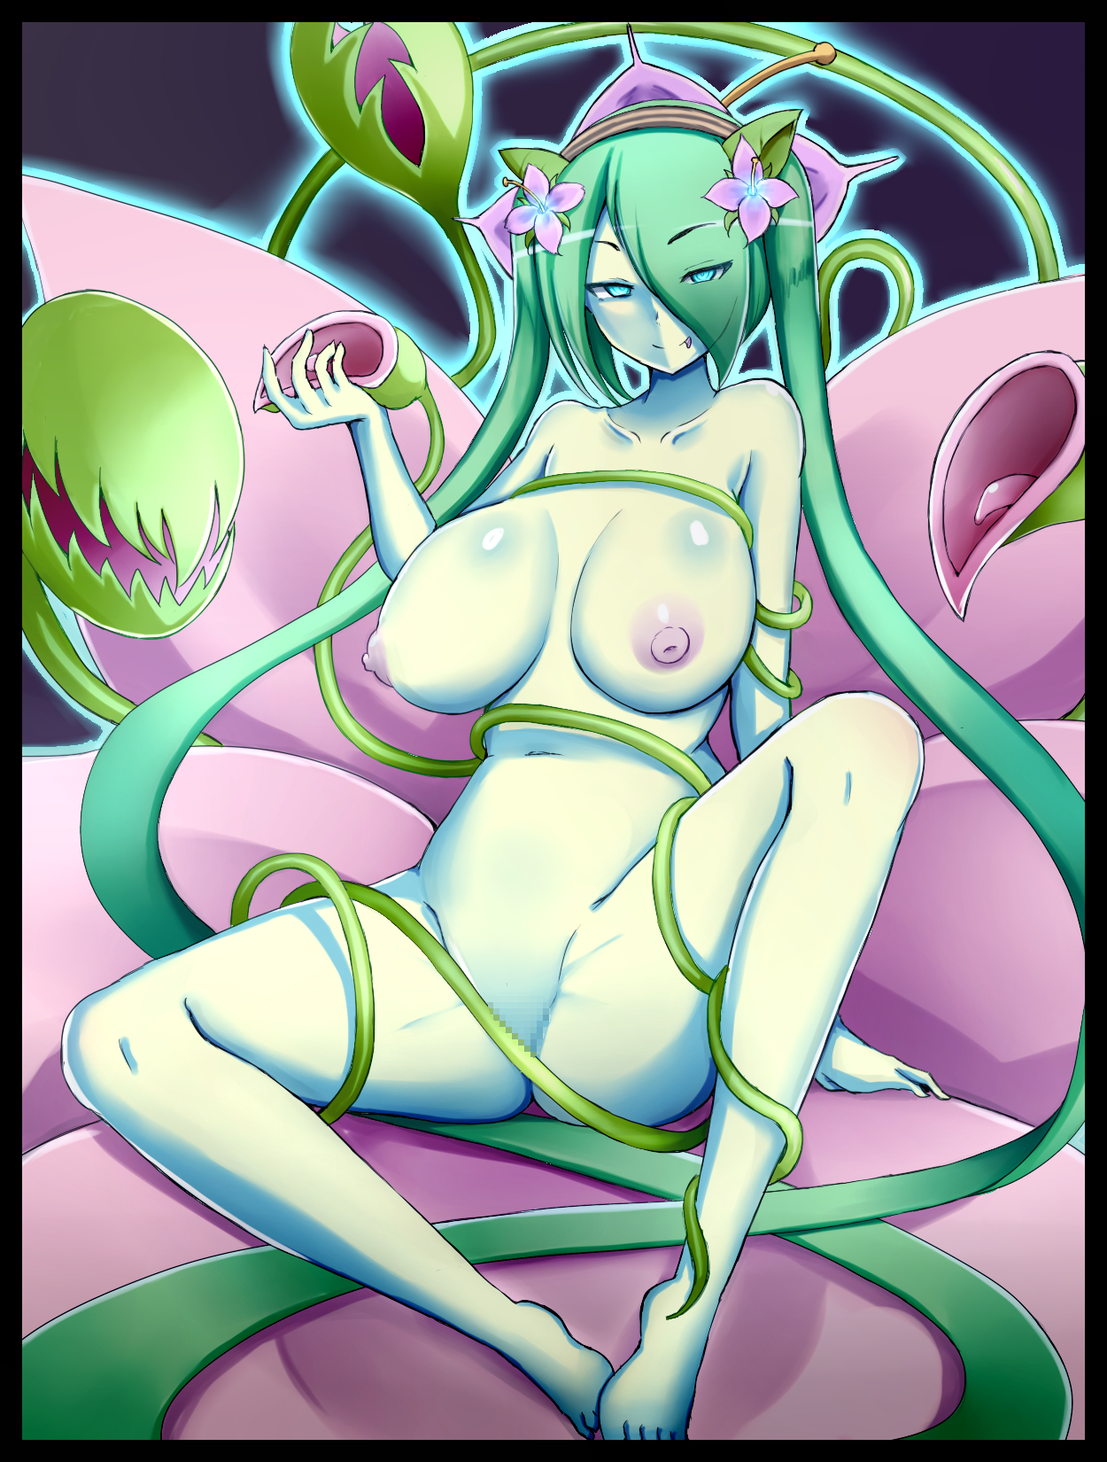

And for the unwary human who would occasionally stumble upon the path of the nomadic Dryad without knowing otherwise, they would never be able to guess that the lascivious maiden of green had ever been a mud soaked human crawling limp and battered through the brush. Displaying no signs of shame at having her modesty displayed so openly for everyone to gaze upon…and if that someone just so happened to be an easily aroused man…well, suffice it to say, that both parties would walk away from the encounter happy and content.

That is of course, if they were mindful enough to avoid the intoxicating bliss offered by their sexy bedmate’s clear, runny excretions lest they feel for themselves the glory of becoming one with nature…

THE END

Image 1 by Yonaga San : <https://www.pixiv.net/en/users/7995098>

Image 2 by Raichi : <https://www.pixiv.net/en/users/20710662>