**PART 4**

Jimmy could hear them coming, the footsteps of multiple women. Sophia had mentioned she was having friends over, Carly and Alanna. Both of them were names he had heard often around the house over the years, Sophia had been friends with them both since childhood. Brittany would share Jimmy’s mouth with her closest friends but the occasions were far and few between. It was rare that any ass would be on his face except Brittany’s, and Jimmy preferred it that way. His body had begun shutting down over the years, the massive amounts of feces he had been ingesting were slowly killing him. But now, Sophia would be joining in daily, increasing the loads to double the amount, and then there were her friends. If this treatment was going to continue, Jimmy wouldn’t last long.

Brianna walked ahead of her best friends, leading them up the stairs to the master bedroom where Jimmy was locked inside the bathroom. She had always loved having new things, whatever the latest trend was, either fashion-wise or technologically, she had to have it! Her mom and dad spoiled her terribly and she knew just how to push their buttons getting them to spend even more! She adored the look of envy and longing on her friend’s faces as they saw how she was treated like a princess. That was the way it should be though…

“You better not be lying, I’m about to explode!” Alanna laughed as she held the stair railing with one hand steadying herself.

“Trust me! You are going to love this!” Sophia giggled as she led them into the bathroom. Reaching in she flicked on the lights and kicked the door open. Sophia looked down at Jimmy with a cruel smile before stepping aside to allow her friend’s room to enter. Both of them pushed in and looked down at Jimmy with pure shock!

“Oh my god! This is fucked!” Alanna laughed with her eyes glued to Jimmy…

“Can he hear us?” Carly asked with a look of confusion as she waved her hand back and forth in front of his face.

“No, he’s a complete vegetable!” Sophia laughed as Jimmy looked back and forth, listening to the conversation. They had no idea about the specifics of his condition, even Brittany was oblivious.

“Why…. Why is he here? I mean, uhmmm” Carly asked while stammering with her words.

“On my mom’s eighteenth birthday, she accidentally ran him over with her new car!” Sophia explained, Alanna snorted and giggled from the thought of him being crushed under a car. Sophia paused for a moment before continuing.

“The doctors did everything they could to save his life, but his digestive system was damaged, so the only way he could receive nutrients was by having someone use his mouth as their toilet. My mom couldn’t bear the thought of her brother having an assisted suicide so she kept him around, using him as her personal shitter for the past twenty years!

“Can he taste it, and smell it?!” Alanna asked with a huge grin, Sophia laughed…

“I hope so, but unfortunately I don’t think he can, if he truly is paralyzed and a vegetable then I doubt his senses work” Sophia waved her hand in front of his face and began calling out.

**“HELLO?? ANYBODY IN THERE?”** she asked as all three women laughed!

“This is totally fucked!” Carly laughed as she stepped back and pulled out her phone, snapping a picture of Jimmy’s face. Sophia looked over with slight concern...

“Hey, don’t share that with anyone, alright?” She asked as Carly smiled and nodded.

**VVVVVVvvvvrrrrrrttttttttttpphhhhhhsssss**

A sharp messy vibration of a fart sprayed loose with a wet splatter at the end as Sophia and Carly both turned towards the toilet. Alanna was sitting with her leggings still on and Jimmy’s face smothered under her fat butt as she fanned her behind and smiled.

“I figured, when in Rome, right?” She began to laugh as all three of them broke into a fit of giggles! The laughing turned to gagging as they all began fanning their noses from the foul stench. It had a deep undertone of rotten meat with a sharp earthy shit smell!

“My god! What did you eat!” Carly laughed while holding her nose!

“I had a Spinach and Broccoli omelet this morning, with a big side of beans and a big glass of 2% milk. Speaking of which, do you two mind giving me a tiny bit of privacy?” Alanna asked as she rose from Jimmy’s face and began working her leggings down over her fat ass! Both Sophia and Carly rushed out, closing the door behind them.

Jimmy was choking to death as Sophia’s friend sat on his face with her full weight! He was used to having big fat asses on his face, but not with a layer of cloth leggings overtop! His nose was pressed inwards as her pussy and crotch covered his mouth, he could not get any air! The fart this girl had cut loose was sharp, shitty, messy, he could taste it on his tongue as the mass of Sophia’s shit bubbled in his stomach, he felt like he was going to be sick! She wiggled back and forth, her fat ass smashing his face flat as all three women laughed. This was not good, Jimmy prayed that Brittany would come home, walk in and stop this, end it all! He longed for just her ass on his face, being at the mercy of Sophia and her friends, this was too much!

The woman on his face rose to allow him to gasp and suck in a deep breath of air! She looked back over her shoulder, her brown hair cascading down her back as she smiled. These women, these terrible immature women, they had no idea he could taste this, no idea he could smell it!



Jimmy watched as she reached back and pulled down her pink leggings, her ass popped out and it was enormous! Almost as big as Brittany’s when she was the same age! Each cheek was as big as his head, wiggling back and forth before crashing in the middle and sending ripples down her thighs. He watched as she bent down, pushing her leggings and thong down to her ankles, her ass looming over him like the moon was about to crash into the earth! She began to bend but stopped, her ass hovering just over his face, he could feel her body heat he was so close. Alanna reached back, her manicured fingernails digging into the fat of each cheek and separating them to reveal her deep brown puckered dirty asshole. It was so wide, winking at Jimmy in a teasing motion. Suddenly it spread wide, a harsh hot wind sprayed forth splashing into his face with devastating force!

**BBBBBBBFFFFFFFFFFRRTTTTTTPPPP**

**Spppprprptptptptptptpr BBBFRT**

The far was loud and explosive, blowing the hairs back on Jimmy’s head as it filled his lungs with the stink of her breakfast! He began choking on it as her anus fluttered, it bubbled as wet shit formed at the center before blowing out once more, Jimmy could feel the wet shit speckling his face as he closed his eyes! The stink was so powerful, he could feel Sophia’s shit fighting to come up his throat. Without warning, less than a second after the fart had ended, Alanna dropped, her ass smacking his face and slapping his cheeks as her asshole squeezed his nose. He could feel the dirty oily skin gripping his nostril and pinching as she wiggled back and forth driving it deeper! His nose entered her anus as she moaned and sat comfortably.

“Mmmmmmm perfect!” Alanna said with a smile as Jimmy cried under her!

Jimmy could not get a single bit of air, his nose was completely encased in this stranger’s asshole with her pussy filling his mouth. Her lips had a strange tangy taste, it was like she hadn’t washed in days. Jimmy slid his tongue up the center of her pussy and felt a large glob of cum accumulate on the tip. Alanna wiggled and purred…

“Hey! I thought you were paralyzed?” she asked while bouncing her ass a tiny bit and forcing Jimmy’s face further between her cheeks! He cried as his nose slid further into her rectum.

He had no time to adjust, Alanna began filling his mouth with her piss, the stream was so thick and strong that he could hardly keep up! His mouth filled to the brim in less than three seconds forcing him to gulp and swallow just to live! Alanna moaned above him in a relaxed state as she let her bladder loose, her piss spraying out full force. Jimmy could taste thick globs of cum and vaginal discharge in the urine, it was foul, his throat buckled and tried to close as he swallowed over and over! He could feel the hot piss splashing in his stomach, mixing with Sophia’s diarrhea and creating an even more foul mess!

“I wish you could taste this! I took my B12 pills this morning, they make my piss smell like acid! I can barely stand the stench, but letting it loose in your mouth…” Alanna paused to sniff the air…

“I can’t smell a thing, still, shame you can’t taste it!” She spoke while continuing to piss full force, her urine was so hot, it was practically eating away at the sides of his mouth! Jimmy’s lungs were burning and screaming for air as he sucked down more and more piss, it was like she hadn’t gone in weeks!



With urine still spraying down his throat with the force of a firehose, Jimmy felt her anus grip his nose and then spread! It began to vibrate and shake slightly as a hot gust of gas was forced out **DIRECTLY** up his nose! He had taken a ton of farts, thousands over his lifetime, but none right into his nostrils without any air! It felt like he was breathing in fire, or sucking in from the tail end of a car revving its engine!

The gas was so hot it felt like his entire chest was collapsing! He choked and spluttered, her urine building up in his throat before filling his lungs, trapping the gas inside! Alanna began laughing above him, her ass jiggling on his face. Jimmy was just about to pass out when her pussy began dripping, the flow was finally over! Alanna leaned left and then right, adjusting as her ass left his nose for a split second, enough for Jimmy to suck in a life-saving breath of fresh air!

**“WHO SAID YOU COULD FUCKING BREATH?”** Alanna screamed while looking back over her shoulder! She slammed her ass back down, her oily anus gripping Jimmy’s nose as she grunted and pushed!

**BBBBBBFRTPTPPPPPpspprt bbfppPSPPR pspppPPSspprttttttttt**

An incredibly messy fart left her asshole assaulting his nose with terrible wet gas! Jimmy could feel the sides of her anus flapping as they slapped closed on his nose letting the gas wash over his face! The stink was just like before but way worse, he could taste the broccoli! Alanna pushed her weight down, wiggling back and forth and grinding her asshole on his nose, trying to rub the stink off as Jimmy cried! He was fighting to keep the piss and shit in his stomach, it was sitting so heavily, refusing to digest! He knew that if he could hold out a bit longer he could get it through!

“I hope you’re hungry! I figured I would give my toilet at home a break, believe me, it needs one!” she laughed while wiggling back and forth and sliding forward, resting her full weight on his jaw.

Jimmy cried as she moved forward, he was praying she wouldn’t have to shit, even though her farts told a different story. He could feel her anus over his mouth, puckering in and out just above his tongue! She was sitting so heavy that there was not a single space between his mouth and her ass! It was like she had done this a thousand times before!

**BBBBBFRRTppspppprpspppppvprrtttttttt**

“God I wish you could taste this, it would be so much more satisfying!” Alanna said out loud as a wet pre shit fart exploded into Jimmy’s mouth! It echoed down his throat before splattering his tongue in a layer of feces! Jimmy’s entire body began flinching and reacting as the flavor ran over his taste buds. It was like eggy chemicals!! Her shit was so bitter, it was like battery acid! He started to choke as Alanna pushed, grunting, her anus pulling in tight as he cried!

Jimmy lay there, waiting for the inevitable. Her anus pushed outwards and he closed his eyes, trying to place himself somewhere else! It was impossible though! Alanna let loose, filling his mouth with a thick soft log, the thing was a monster! Jimmy whimpered as it hit the back of his throat, it quickly changed shape from how soft it was and began filling his throat while the remainder filled his cheeks!



“Ahhhhhhhhh” Alanna moaned with relief as Jimmy cried under her fat ass cheeks!

The taste was **ATROCIOUS!** The flavor was so bitter that every single moment Jimmy was gagging! Her massive log of shit filled his mouth, breaking down to a mush and forming to the shape of his throat! She pushed, more and more came out, even faster than before! Jimmy could not possibly keep up! He tried, tried to swallow, but his body wouldn’t let him!

**KNOCK KNOCK KNOCK**

“Are you almost done, I’m about to explode out here!” Carly asked from beyond the bathroom door!

**“JUST A MINUTE!**” Alanna called back as she grunted and pushed, Filling Jimmy’s mouth again with a huge amount of soft mushy shit.

Jimmy cried as the soft shit flowed down his throat, he could taste the rotten egg, the undigested broccoli, his throat was buckling, the shit in his stomach trying to force it’s way up but Alanna was so strong, her flow too powerful! She grunted and pushed, forcing more and more shit down Jimmy’s throat! It felt like swallowing burning bitter quicksand!

“My god, my stomach!” Alanna groaned as she grunted and pushed! Jimmy could feel her anus puckering in his full mouth as more shit began flowing out! What the fuck! Jimmy thought to himself! It was like this woman had not shit in weeks!



Jimmy cried as her anus released another long hot log! It instantly turned to mush inside of his lips before forcing the shit that was sitting in his mouth directly down his throat! His entire esophagus was coated in layers of thick greasy oily feces that he knew would torture him for days! Alanna seemed to be far from done though! A hot fart escaped inside of his lips as more shit creeped out, He could feel it turning into a ball of fire in his stomach, Mixing with Sophia’s shit and creating a broth.

“Whew, are you alive back there?” Alanna asked as she looked over her shoulder, beyond her thick ass cheeks she could just see Jimmy’s red watering eyes. He was crying, praying for her assault to end! He could not eat another single bite and knew another young woman was waiting to use him.

“I think I lost like ten pounds!” Alanna giggled as she gathered a thick wad of Toilet paper. Jimmy watched and waited as her hot shit cooked inside of his mouth, he could not bear to swallow it despite the terrible flavor! She reached back about to wipe, her ass almost lifted from his lips but she stopped and froze. Without warning, Her ass let loose one more thick hot log! Jimmy cried and whimpered, gagging as it coiled in his mouth forcing the feces down his throat! He choked and inhaled the soft shit into his lungs, the pain was indescribable.

“That’s much better!” Alanna laughed and lifted her fat ass off his face, sliding the thick clump of toilet paper up and down her crack. Her ass was so fat that she had to pray her cheeks apart with one hand before being able to reach and clean her asshole!



Jimmy lay there, his mouth filled to the brim with soft mushy feces! The odor that wafted from his mouth to his nostrils made him want to die, it was worse than anything he had ever smelled before! He began gagging, dry heaving, the shit inside of his throat was rising, fighting to come up as he tried to hold it down!

**“DON’T YOU DARE!”** Alanna laughed as she crammed the thick clump of dirty toilet paper into his lips! Quickly she began cleaning with more and repeated the process until his mouth was completely clogged! Jimmy cried as her mushy shit pushed against the blockage in his mouth, his entire body was shaking! Alanna turned and began washing her hands as Jimmy choked terribly! Her feces had begun squeezing it’s way out of his nostrils, leaking down the sides of his face. There was so much trying to come up and force it’s way out Jimmy felt like it may begin leaking from his ears!

**“EWWW GROSS!”** Alanna screamed as she was drying off her hands with a towel, she had just noticed what Jimmy was doing, he looked like a volcano about to explode!

She looked back and forth before her eyes locked in on the toilet brush. She grabbed it holding it above Jimmy’s face with a big smile.

“Are you ready?” she asked with a giggle!

**KNOCK KNOCK KNOCK**

**“ALANNA, PLEASE HURRY!”** Carly called from beyond the bathroom door as she knocked rapidly.

**“JUST A MINUTE!”** Alanna called back before **RAMMING** the toilet brush down into Jimmy’s mouth! The big clump of dried dirty toilet paper moved down his throat in a giant ball, soaking up the shit on the sides of his throat! It was so thick though, there was no way he could swallow it! His eyes began bulging from his skull as Alanna laughed, pushing and cramming the toilet brush further and further down his throat. Jimmy thought he was going to die until finally, the massive clump landed in his stomach. Alanna pulled the brush back up and out of his throat, the bristles scratching his throat like knives! She ripped it from his mouth roughly and laughed as Jimmy cried! He had never been through such torture! Carly began desperately banging on the door again as Alanna turned and opened it.

“I was just getting it all ready for you!” Alanna smiled as Carly rushed inside and forced her out of the bathroom. Jimmy watched with watering eyes as the young woman slammed and locked the door. His stomach was bubbling, it was full to the brim with a thick clump of toilet paper at the base of his throat holding the shit back.

Carly was an adorable blonde with a contagious smile. Jimmy had seen her multiple times through the years as Sophia was growing up, she was her best friend! He never imagined in a million years that she would be using his mouth as a toilet when she reached adulthood! She stood with her back turned to him, she was sweating and swearing as she struggled to get her pants down over her massive ass! Her cheeks swayed back and forth in front of his face, there was nothing he could do but watch.



“Oh god oh god oh no, ahhhh'' She spoke to herself while pulling down her leggings. Jimmy could not take his eyes off of her ass, it was fucking beautiful, he felt so sick, his stomach was physically pulsing from how much shit was inside, but he could not look away from this beauty. Her ass cheeks were so big, so fat but so perfectly defined. She was shaking, sweat running down her skin, it was clear she was in pain.

Carly threw herself backward, her ass **CRASHING** into his face as a messy fart crackled from between her sweaty cheeks. She wiggled back and forth, her asshole finding his lips as she cried and moaned. Jimmy had less than a second to adjust to her weight before she let loose, her feces spraying out with a vicious speed! He felt his mouth fill to the brim in an instant as urine began leaking down his chest. The taste was horrible, her shit was so wet and messy but stringy, almost like it was being held together by spaghetti or strands of string. Her asshole sprayed open and close, bubbles of gas letting loose in his lips with the pounds of shit. He couldn’t help but choke as the shit filled his throat and crashed into his full stomach!



Carly looked back over her shoulder at his eyes, they locked onto one another for a moment and it was like she could sense his pain, her eyes got watery as she looked away and cried out.

“I’m so sorry!” She muttered as more shit exploded from her asshole! Jimmy could feel it rapidly filling his cheeks, exploding down his throat! The flavor was so incredibly bitter that it made his entire body shake! He could feel the wet crackling inside of his mouth as her gas popped and exploded in his lips. He knew there was no space inside of him, her shit was filling up in his throat, quickly approaching his lungs. This could be it, Jimmy knew, he could die!

Carly kept her hands to her face, she couldn’t bear the thought of what she was doing. At first, it seemed exciting, the way Sophia and Alanna spoke of it, they made it sound so appealing. But now, being here, sitting on his face, hearing him choke, cry and gag, it was terrible, she hated it, she felt like he could taste it, smell it like her feces were killing him. She wanted it to end but she couldn’t stop the flow! Gas and shit exploded from her asshole as she pushed, forcing it out fast and trying to get this over with, she could hear him crying, the wet spluttering of the shit spraying down his throat, it sounded so painful. She had thought he would be silent, emotionless, just an empty shell, but this was too real.

Carly has just finished, her colon finally empty as she pushed a few times letting her asshole pucker open and closed. She quickly raised from Jimmy’s face and looked back, horrified by what she saw. He looked almost dead, her mushy shit was leaking from his nostrils! His eyes were rolled back into his head with just the whites showing! She quickly filled up a cold glass of water at the sink and splashed it into Jimmy’s face, he woke up instantly and began choking, gasping, feces flowed from the sides of his cheeks like he was an active volcano!

Carly felt terrible, she wanted to do something, but she couldn’t hold back the feeling in her stomach rising to her throat, the sight was just so disgusting! She bent over, blushing as Jimmy locked eyes with her! Suddenly her mouth opened as a slew of vomit rushed out hitting him square in the face! Jimmy gasped, his mouth full of shit, and now vomit too as she gagged and let loose another mouthful! It splashed over the sides of his face hitting her ankles and splattering onto the floor!

“I’m so sorry!” Carly muttered to him as Jimmy gasped and gagged!

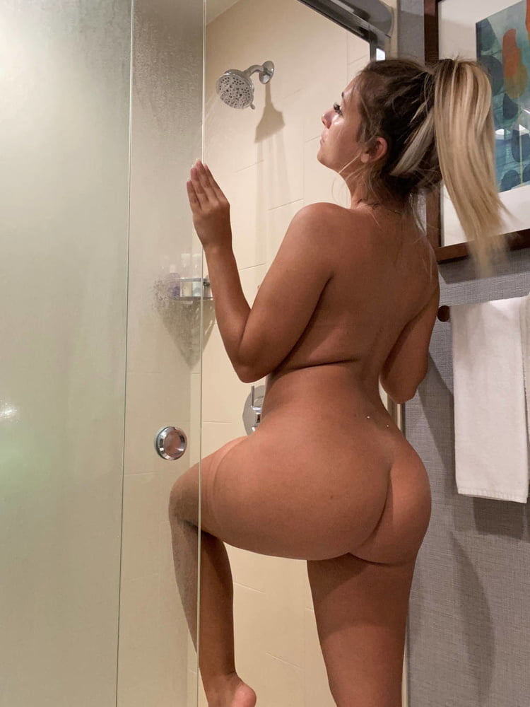

The last thing he saw before passing out was her thick chunky ass entering the shower across from him.



Sophia lay on her bed with her laptop, she had just pulled up Netflix as she looked back to Alanna who was busy texting.

‘Hey, what do you wanna watch, also, what do you wanna eat? I’m starving!” Sophia asked. Alanna did not respond as she giggled and sent another text.

“Hey, are you listening to me!?” Sophia asked as she reached out and smacked her leg getting her attention.

“Sorry, what did you say?” Alanna asked…

“Are you hungry?” Sophia asked again with a hint of frustration…

“Oh my god, starving, but, I have a question…” Alanna asked with a slight grin.

“What?”

“Do you remember, Taylor? Brian’s ex, she lives in the valley, we went to her house party last summer?” Alanna asked…

“Yea I remember her, we don’t really talk though, why do you ask?” Sophia turned and sat up a bit concerned now.

“She and I have been talking a lot lately, I sent her the picture of your uncle, she wants to stop by tonight, could she come over too?” Alanna asked while blushing a bit.

**“ALANNA! I TOLD YOU NOT TO SHARE THAT WITH ANYONE!”** Sophia whined in frustration and a bit of anger!

“She won’t tell anyone! I already told her not to share it! She won’t tell anyone, I promise! Can she come by?” Alanna asked again…

“Well, I don’t really have a choice now? Do I?” Sophia answered with a hint of anger.

Carly walked in and stood at the bathroom door, she had a towel wrapped around her fresh-smelling clean body.

“Hey, Sophia?” Carly asked quietly… Both Alanna and Sophia turned to face her.

“I think your uncle may be a bit sick?” Carly said while blushing...