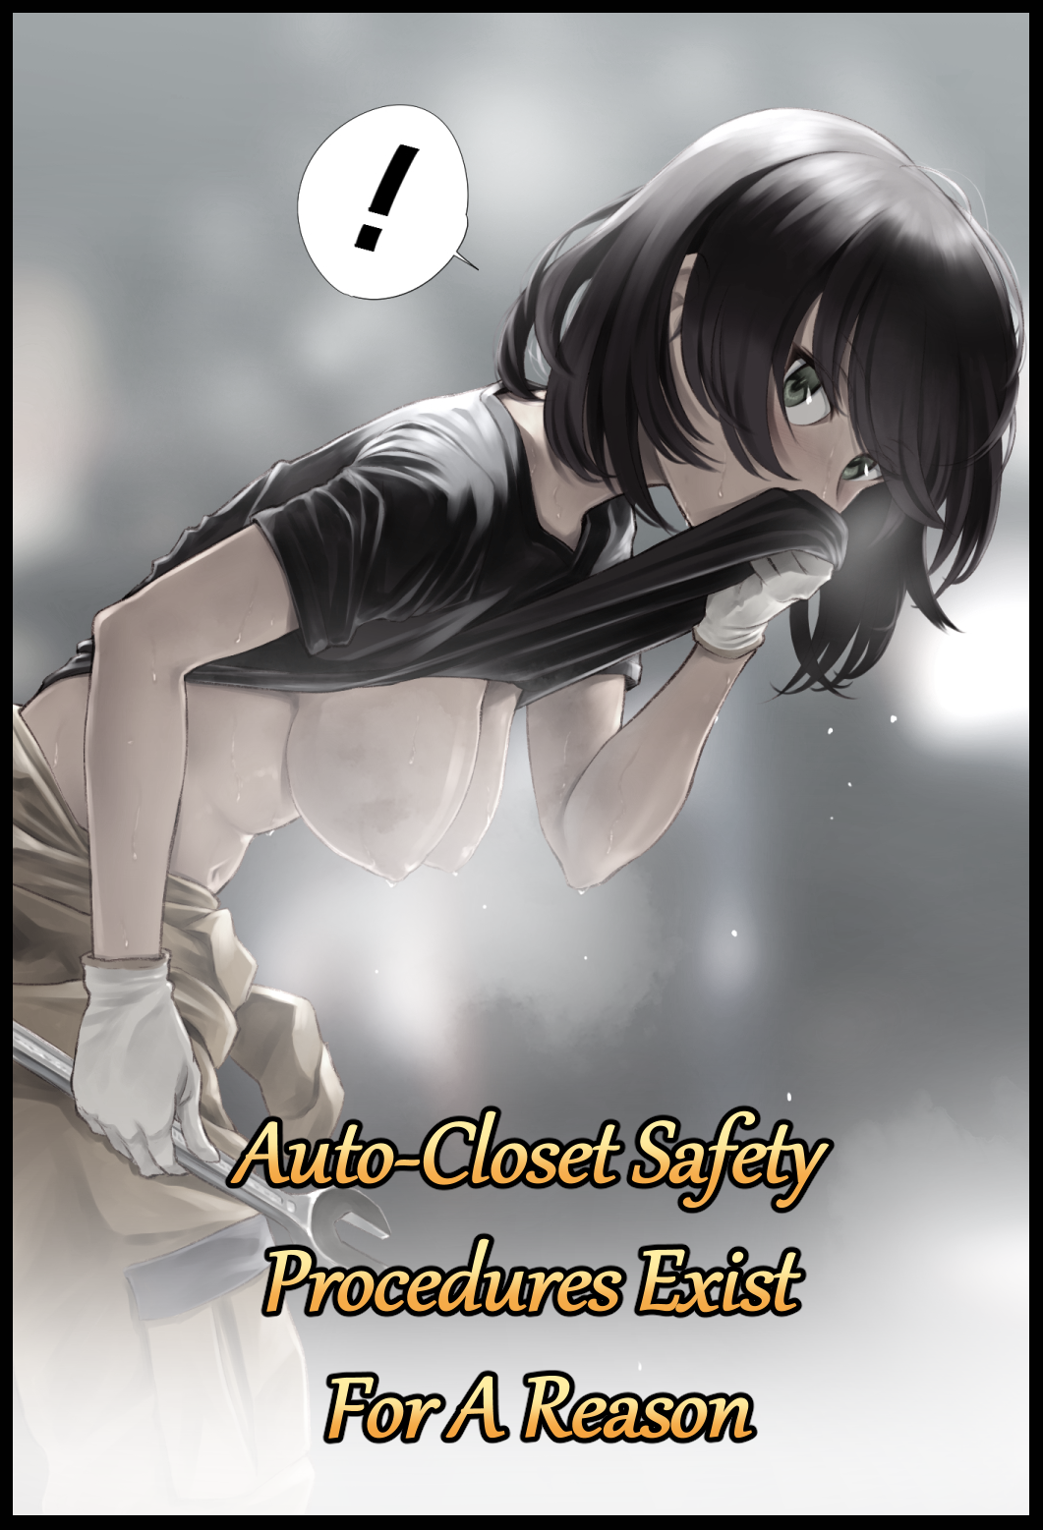

Watching from afar, a man clad in fatigues and heavy duty protection gear couldn't help but sigh at the sight of a female colleague wearing a slightly modified set of the engineer's standard trousers coupled with a simple black t-shirt soaked in sweat and grime, lacking the bulky vest and encompassing helmet he was wearing. Except her lack of safety equipment wasn't what caught his eye, but rather, her callous behavior in an open area where anyone could be watching…

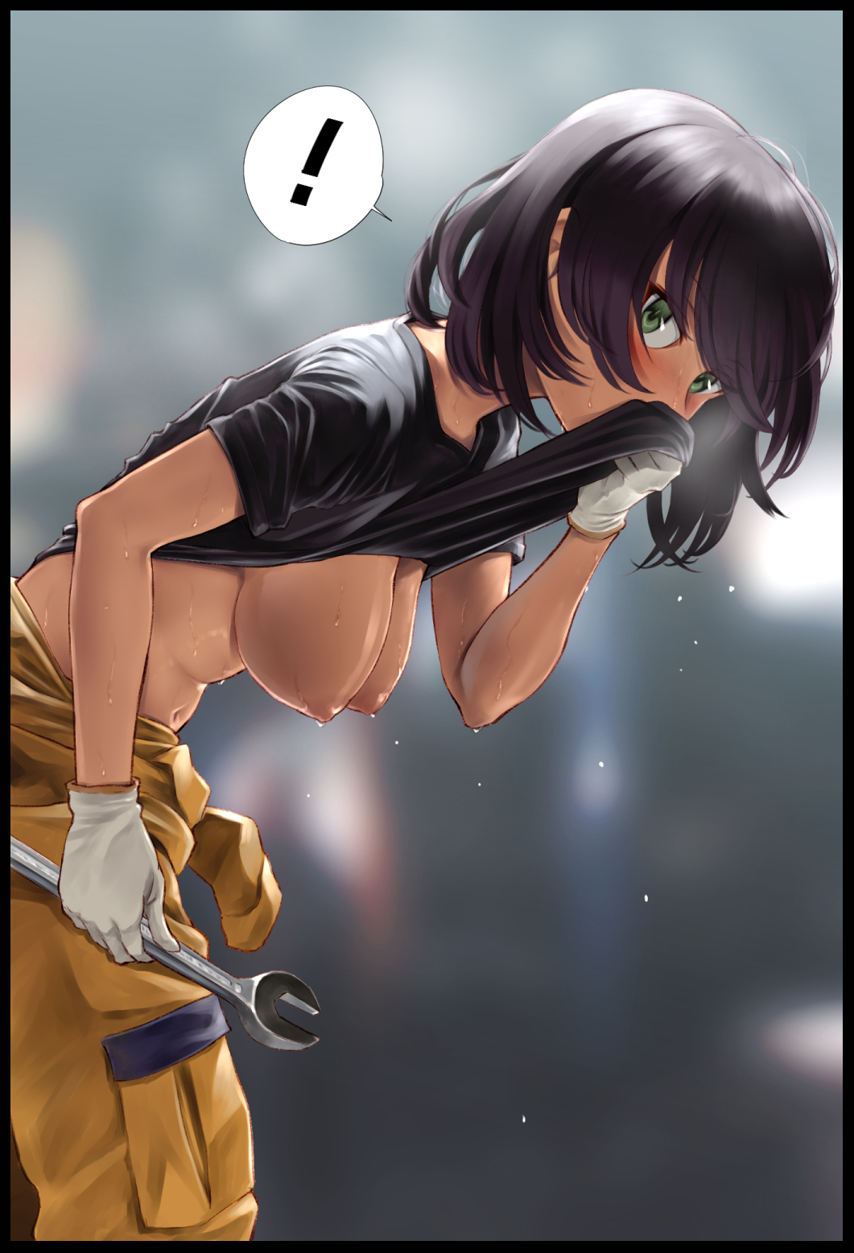

The man was no stranger when it came to admiring the exposed form of the fairer sex on his own time, but in this case, arousal was the last thing he felt as his gaze scans her exposed torso; tracing the undulating lines of a voluptuous figure clad in creamy smooth, caramel skin glistening with sweat as condensed trails run down layers of supple fat and toned muscle. Keen eyes noting the subtle rise and fall of a tight tummy with each heavy breath that escapes the woman's pert lips, at the center of which lies a cute belly button…

…overshadowed by a pair of drooping breasts tipped with dull ochre areola and inert nipples from which droplets of sweat fell off of as they spill over from the thoroughly soaked top that doubled over as a handkerchief for their unprofessional wearer, wiping up a sizeable amount with a gloved hand after having peeled off the suffocating mask cum face shield she'd been wearing up to this point, with a calm, practiced expression suggesting complete unawareness to the show she was giving to the menfolk pouring into the repair bay from the side doors, eyes instantly locking on to the hefty milkers before their eyes, promoting her initial audience member to cough before uttering a snide remark within earshot.

**“They’ve gotten bigger…”**

**“What? What’s gotten…bigger…”**

Realizing her mistake, the startled tomboy hurriedly shoves her shirt back down over her body, doing little to mask her embarrassment as she shoots the cocky man beside her a flustered frown, looking like she wanted to say something before deciding otherwise, turning to focus on the engine she was working on with a huff, blocking out the catcalls and jeers from the otherside of the bay as the men boo at the goody two shoes for ending their little show. No skin off his back though, seeing as how they were complete strangers to him unlike the careless girl in front of him as he gives her shifting back one last sideways glance before departing for a little bit of fieldwork.

**"Oughta get her some underwear or something before I come back…shirt that wet ain't gonna cover a thing…"**

There was a time when he saw his colleague under a different light, treating her like a close friend who needed help getting out of their comfort zone instead of the estranged one they shared now like an awkward couple…because how else could they react when one side had suffered a sudden and irrevocable change in gender due to 'unforeseen circumstances' with a client's machine?

A relatively new addition to the world of high society fashion, Auto-Closets were a staple in wealthy properties. Machines that worked by attuning a locally hosted A.I mainframe to the user's brain, allowing the Auto-Closet to choose the proper set of clothes tailor suited to whatever they had in mind before dressing them up in less than half a minute. And it just so happened that the engineering company they worked at was assigned to maintain one such instance, handing the task over to his friend when the order inevitably came to repair it.

According to his account (unblemished by the paparazzi), everything had gone fine at first. The machinery, while complex, wasn't too hard to work around and the problem was immediately identified and fixed; swapping a burnt out fuse for another. And that was supposed to be where the story ended…if the onboard A.I hadn't gone berserk, zeroing in on the unlucky engineer trapped inside of it, labeling him as 'outdated' and in need of correction.

If it weren't for the homeowner's constant vigilance and speed in decoupling the power supply after hearing his cries for help being stifled by an entire compartment of hidden machinery catered to genetic modification over a simple makeover, being fondled and violated by a machine that had robbed her of her manhood would've been the least of her concerns when a rescue team had finally pried open the jammed door, revealing the naked form of a nubile young woman lying on the floor of the circular chamber, covered in shredded clothing and unmentionable liquid, shivering in a mix of fright and hazy euphoria…

Despite the company's best efforts to cover up the incident, news of his friend's spontaneous feminization at the hands of the rogue Auto-Closet would inevitably spread, causing an uproar once people realized their unsuspecting wardrobes were outfitted with illegal body and mind altering technology and the sinister intent behind them once a pattern began to form in the buyers, who were predominantly influential folk in society and politics…needless to say, there wasn't any need to sue when the fallout would certainly spell their downfall. That, and they had been desperate enough to pay the newly changed woman a hefty sum to stay quiet before the client broke hers. Leaving her with a tidy fortune she had no idea what to spend on considering how she had always been a reclusive person in nature until recently that is.

Now that he had become a she, the relationship between Joanne (a name she had begrudgingly picked for herself after much persuasion) and himself was slowly beginning to change as previously mentioned. Even though she remained tight-lipped, Joanne was becoming more receptive to his suggestions; taking care of her personal health, working out, eating right, etcetera etcetera. And that in turn, had produced startlingly swift results in the form of her pudgy form gradually mellowing out alongside a gain in musculature after returning to work with new identification papers. But despite the progress, there were still a few quirks that needed ironing out…particularly her mildly unchanged perception of her world view. In Joanne's eyes, she remained unwilling to let go of her former identity, viewing the world as a man from the way she presented herself to the habits she clung to, particularly bad habits for a woman to partake in that had resulted in multiple embarrassing moments like what happened in the repair bay that morning. The thought of which keeps him busy in the back of the transport van as he compares the many instances he'd seen Joanne's body, noting a considerable increase in cup size compared to the petite B cups he remembered seeing after being allowed to see her in the hospital…they were probably in the range of D's right about now…but how could they have grown so big in just a few months? Not to mention her developing curvature and feminine allure…

**"No…it couldn't be that…could it?"**

Shaking his head before leaning back against the gentle rumble of the vehicle's interior, the engineer rubs his brow at the creeping suspicion that Joanne might just be hiding something from him, something that, despite his shame, had pitched a tent in his trousers as he envisions the image of his feminized friend, her sweaty, exotic body writhing in bed, slender arms ravishing her own body in a dimly lit bedroom, releasing sweet cries of ecstasy as twitching fingers pinch erect nipples while pointed fingers piston in and out of the dropping folds of a flower that hadn't yet tasted the girth of a man…snapping out of it just as the lewd vision of Joanne turns to stare him in the eyes with love and desire burning in those gorgeous emerald eyes of hers…

**"What the hell man? Are you deaf? Frederick! Get your bum out of there!"**

**"Y-Yeah…just…gimme a sec alright?"**

Shooing off the driver as he immediately sets to packing his work tools before hopping out the back, the disgruntled man heads off into the apartment building with a sigh, struggling to cleanse his head of erotic imagery with conflicting thoughts on what to do with Joanne going forward. Would they remain simple friends? Or…could they become something more like his vivid memory had suggested?

*'If someone had told me I'd be getting intimate with Jack a few months ago…I'd whack em and call em crazy…but now…now I'm startin' to think otherwise…that doesn't make me gay…right?'*

Meanwhile, not too far away in the industrial district, the woman on his mind had already retreated to the female locker rooms, having packed away her belongings and tools for the moment until the next work order came in…but a little ways off down the corridor, a soft voice echoes within a locked stall, granting a perceptive ear the delightful sounds of a woman embroiled in estrus; complete with the squishy sounds of a leaking snatch tightening around the length of a cold wrench, gentle grunts and airy sighs vocalized by a deceptively seductive voice, the soft slapping of a pliable bubble butt nudging against walls of the stall and…the uttering of a man's name amidst undecipherable moans…

**"Fred…you-*hnf!* Why-*ahn!*"**

For better or worse, it would seem Frederick's doubts about their relationship as friends escalating into something more might just be assuaged in the near future, for Joanne herself was beginning to open up to her newfound and undeniable womanhood. Where she once felt only discomfort and doubt when given advice by Frederick, Joanne would find her heart skipping a beat everytime her eyes fell upon her friend's strangely *handsome* features. Feeling a flutter in her tummy with every word he spoke, finding herself engaging in exercise and…*gentle*, *nightly* ministrations that only seemed to spur her desire for Frederick while her indecisiveness on whether or not she was still a man continues to break and wither away against the feeling of a makeshift dildo rubbing against her vaginal walls while her horny mind envisions Frederick in all his masculine glory, kneeling over her naked and his engorged pecker…lodged deep inside of her…

An undeniable vision that finally pushes Joanne over the brink as she claps a hand over her mouth to stifle a scream as she reaches orgasm, letting loose a jet of fluids out of a puckered urethra that splatters all over the floor in a translucent puddle, panting heavily with her sweaty, naked body trembling in exhaustion and lustful ire, wondering what Frederick would think if he saw her like this…he would certainly love it…right? After all, if anyone knew his habits and preferences best, it was her…and she knew how much of a horndog he was behind the noble façade he wore to work, deepening the blush on her face as the idea of a date flashes by and the many things they could do together…

*'M-Maybe…Maybe I could ask him out to dinner tonight…and with a little luck…get him to…c-come home with me…'*

With Frederick outside working till the evening and Joanne reserved to working on side projects in the company building, the two engineers still had quite a ways to go before they could set their uncertain plans in motion…but what was a guarantee, that by the day's end, their status as distant friends would be officially at an end, ushering in a new period made possible because of a little accident with a less than honest machine…

THE END

*Image Sources*

Image by Genryusui : <https://www.pixiv.net/en/users/502313>