The Best kind of protein- **ShaQueena**

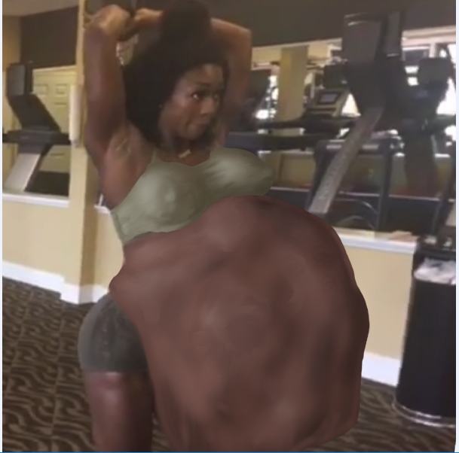

Raeshawn couldn't believe his luck. Out of the thousands of followers on instagram and facebook, **QueenaFITGYAL88** had chosen him to be her special partner to work with her. She had even liked some of his Instagram photos, mostly ones where he had taken his shirt off to pose after his own workout, and sent him a DM inviting him to participate in her unique exercise routine she called the “PrePostProtien Workout”. He had never heard of this workout before, but being a gym rat himself he always was looking for any new exercise routines, not to mention the chance to meet a sleek, powerfully toned beauty like QueenaFITGYAL88 was an opportunity he wouldn't miss for the world. Who knows, maybe she might want a massage after this special workout.

Stepping into the gym Raeshawn spotted the fitness model right away leaning on counter chatting with the Gym front desk attendant. She was a stunning chocolate goddess, wearing a pair of mega tight black spandex shorts and a green sports bra. When he approached she smiled finally recognizing Raeshawn and stood up to greet him. To his surprise she was a bit taller than his 6’1’ frame.

“Hey Raeshawn right? You made it! I’m so glad you decided to join me for my workout.” She reached out and they hugged briefly.

“Oh yea, I’m glad to be of assistance” Raeshawn said “.By the way...what should i call you? I only know you’re Instagram name.”

“Oh, duh. My name is ShaQueenah” She chuckled. “You ready to get this started? I’ve been waiting all day for this.”

“Oh yea? Hey me too. Where too?”

“Just follow me, No need to sign in.” ShaQueena said as she began to walk off. Raeshawn likewise followed behind her. As they walked she began to explain the basics of the PrePostProtien workout. Raeshawn barely heard a word, his eyes glued to her sexy tight round ass cheeks as they bobbled before him with every step she took. He caught something about Loading up on protein before the workout and having it already in the stomach after the workout for the body to have the fuel it needs. All Raeshawn knew whatever it was it had to be working with a voluptuous ass like that. Finally she stopped abruptly at the entrance to what seemed to be the sauna. It was dark and empty and the steam fogged the window on the door.

“Okay, here is where I’ll be loading up on all the protein you brought.” She said opening the door and walking in as steam poured out behind her. Confused, Raeshawn followed her inside the hot empty room.

“Protein? Protien I brought? Oh shit...sorry. I didn't know I was supposed to bring anything.” He said suddenly worried he fucked up his chances with Shaqueena. He forgot his worries abruptly as she spun around and pressed against him, pressing her lips against his while simultaneously sliding her hand down his sweatpants and grasping his already half hard cock. Not sure what was happening Raeshawn decided to just to with the flow and kissed her back feeling himself harden as she stroked him to full erection.

“Don’t worry, she said breaking the kiss” You’ve got all the protein I need.” She whispered still stroking his manhood slowly. “Now, Close your eyes and let me load up on all the protein you’ve got.”

Raeshawn did as she commanded, closing his eyes, not believing at his luck. He was gonna get a blowjob from the hottest fitness model on the internet. If she wanted protien he was more than willing to shove his meat down her throat as many times as she wanted. Needless to say he was confused when the hot moist air of the sauna turned into suddenly was replaced by the Hot moist breath of ShaQueena’s mouth as she engulfed his head in one loud **\*GLOMPH*.**

Before he could react ShaQueena swallowed hard pulling his head deep into her throat and extengin her lips down over his head and engulfing his broad shoulders. By the time he tried to fight back she was swallowing his torso, and lifted his legs in the air with surprising strength. Struggling and kicking uselessly, Raeshawn was mortified to find his still rigid cock being slurped into ShaQueena’s distended mouth with his hips. To his further surprise she stopped devouring him for a moment and began sliding her incredibly dexterous tongue inside his pants and over his shaft. Over and over again she licked, rolled against and caressed Raeshawns cock with her tongue, until finally, unable to help himself he climaxed, shooting his load down her undulating throat.

Almost immediately ShaQueena bagan swallowing again pulling Raeshawn deeper into the tight esophagus, shoving him into her now hugely swelling stomach, to share the same awkward fate as his own jizz. He was much easier to consume now that he has the fight, sucked out of him, and a few wet sloppy gulps later Raeshawn was curled up in tight mucky confines of ShaQueena’s hugely bloated stomach. The walls were slippery with slime and viscous fluids and were so strong every time Raeshawn tried to push against them they immediately snapped back into place, keeping him compressed in a tight fetal ball.

“That’s it big boy. You settle in on in there like a nice **\*H-Urp\*** manly meatball…”ShaQueena said, wiping the edges of her mouth with her fingertips before licking them clean “...A bit salty, but a nice cut of meat for my workout today.” She stroked her now gargantuan protein packed bulge of a stomach as she opened the saunda door and stepped out.

<What the fuck!? Let me out! *Huff* W-What the f-fuck is going on!? Did you really just e-eat me!?> RaeShawn screeched from inside her stomach. While ShaQueena could hear most of what he was saying, she only patted her stomach in response. It was obvious she had eaten him, what more was there to say. He jabbed an elbow against the stomach wall for emphasis, as he felt his now much smaller and tighter world shift and rock from side to side as ShaQueena made her way towards the gym floor.

For RaeShawn the next two hours were filled with absolute chaos and anguish. as ShaQueena went about they gym doing her workouts. She moved from exercise to exercise, pushing herself to her maximum with little to not regard for her immense Partner packed belly, which she sported with brazen confidence. At times she even belched loudly between sets, or smacked her belly when RaeShawn was particularly uncooperative, or throwing off her balance or stance while she did overhead tricep extensions or dumbbell curls. Most regulars in the gym had seen her in the gym engorged with such a belly and after a few nosy individuals went missing most knew they didn't want get involved.

On the treadmill RaeShawn was lobbed about wildly about inside ShaQueena’s huge stomach as the engorged fitness queen jogged at a relentless pace for thirty minutes her knees pummeling him constantly to the point where he passed out twice. When ShaQueena went to the squat rack, RaeShawn nauseous from the gastrointestinal stench nearly vomited inside the tight stomach chamber from the constant rise and pitch as she executed her squat sets. When she did crunches on the mat, he felt how absolutely powerful her abdominal muscles were as every set of contractions left him crushed and wheezing for the already thin stale air in the stomach. RaeShawn was weak, bruised and barely conscious by the time ShaQueena made her way to the women’s locker room to shower.

*BWOOAAAARRRRURP*

“ oh geez, ‘Scuse me. That was a helluva workout, huh? You did great in there partner. A bit feisty at the beginning, but you really h-hoOURP*...hung in there.” ShaQueena complimented RaeShawn, who shifted pathetically in her now loudly churning gut. She patted it proudly getting only a muffled groan in reply as she stripped out of her spandex.

“Hey, I don't want you to think I don't appreciate you helping me out. It’s fit tasty-ass fans like you that k**-oOOURP\*** ...keep me going with the best kind of protein. You keep me strong and well fed as I am.” She continued stepping naked into the locker room shower to wash the sweat and grime off her body she acquired during the workout. “I can't just gobble up any chubbo from off the street and keep a tight body like this, ya’ know. I keep a strict diet of the most yummy lean meathead like-**\*OouARP\***...like yourself. No offense. And for that, Hon, I’m going to hook you up with the best and most awesome shoutout on Instagram ever! You’ll see...well...maybe not, But I will for sure.”

RaeShawn wanted to reply. He tried to say something, but in the end he was too exhausted to do more than kick weakly. Every inch of his body burned and every muscle ache from the constant crushing and pummeling. A shoutout on instagram was not worth all of this...was it? Who else had she tricked into her stomach just like him? Eventually, he supposed It didn't matter. He was just another meal for ShaQueena; a beautiful woman who had devoured countless others, all for the sake of having a sexy, powerful body to show off. A body that men and women alike ogled and drooled over. A body that in the end he was digesting in and soon to be apart off. As he drifted off to the deep sleep of unconsciousness, he decided if he had to be reduced to protein to fuel a body, ***QueenaFITGYAL88*** was the best body he’d could've hoped for.

