ROLLING UP
COMMISSION STORY
BY CHALDEACHANGE
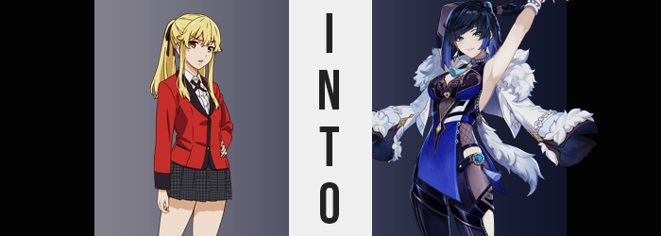

The life of Mary Saotome was a complicated one, but realistically this was the case of every student that attended Hyakkaou Private Academy.

It was a school for the rich and powerful, with its student body being almost entirely that of children from wealthy families or parents that had a powerful grip on Japan’s political landscape. It was a school where hierarchy was determined by the donations submitted by the associated students and families, and if you didn’t meet the mark then you would treated as little more than a mere house pet.

Because Hyakkaou was a school founded on status, it did not work in conventional ways. Wealth, status, power; these things were all more important than how talented any individual student might have been in areas such as extracurriculars, and the strength to grasp victory through their cunning was what was highlighted – through repeated, high stakes gambling.

Mary had lived at the bottom of this status quo, but she had also thrived higher up as well. Fortunately by this point in time she believed she could finally put her time as a house pet behind her, instead focusing on to maintain the status she had. Her family wasn’t rich and powerful – she was there on a scholarship. And so the arrogance and cruelty she had once acted with had dried up for the most part.

Her days were happier lived now because of it. She still strove to become a true winner in life, but she wouldn’t be as cruel as she had been before. That was why she now felt content whenever she arrived at her gambling den. Because she was now always meeting her friends there. And on this day she had expected the same thing, yet…

“Who are you? …Wait, where the hell am I!?” The seventeen year old had stepped through familiar doors, expecting to see familiar faces. But as those doors swung closed behind her? She found herself greeted by two completely unfamiliar face. Faces that she was unaware actually belonged to two friends she had come there to meet. But how could she assume that? The two women were clearly Chinese based on their facial configuration, and she didn’t know anyone with purple or pastel blue hair!

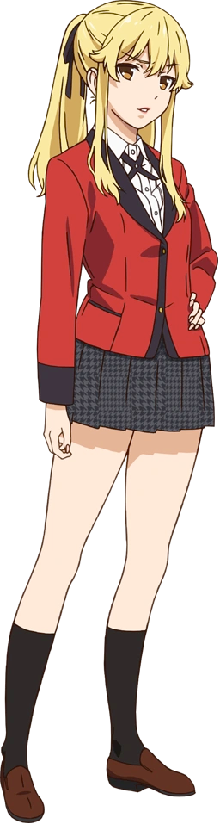
Even the room was wrong, though. Mary had to peer over her shoulder to check the doors she had walked through, but they matched the overall aesthetic of the room. They weren’t the same doors she had walked in through. Was she dreaming? How else could she have ended up in what was clearly a Chinese teahouse? Her school was in Japan! “So? Answer me!”

The two women, oddly dressed, had merely been staring at the girl with a smile the whole time. It was a little unsettling because they hadn’t talked. If this was a dream, it was a really messed up one, huh? But eventually, the blue haired woman with what looked like horn ornaments on her head approached. What the heck was she wearing? A skin tight outfit that exposed her breasts? But nonetheless, she handed Mary a letter. “This is for you. Your orders from Ningguang. Read them over, and meet up with us in the back room!”

Confused, the Japanese teenaged took the letter and watched the two walk off into a door in the back of the empty teahouse. It took her a moment to even recover. “YOU DIDN’T EVEN TELL ME WHO YOU ARE!” Or what a Ningguang was, for that matter! Was that name supposed to have some sort of significance to her? She had never heard it in her life! Mary, naturally, was becoming very frustrated with all of this!

Groaning, she unfolded the paper that had been handed to her. Considering everything that was going on, how much harm could there be in actually reading it before going to the back room to drill those two girls about what was happening. And when she unfolded the parchment? She noticed how important it looked. It was clearly designed by an office of some importance, yet when it came to the text? “I can’t even read this…” The characters almost resembled Chinese, but they were a little different. Mary could squint at them all she wanted but that wouldn’t bring her any answers.

Though she didn’t really need to, because in the end the answers were going to find her.

It didn’t matter if the girl could or couldn’t read the text on the parchment, the text all began to radiate a bright blue and a warmth traveled from the paper into the girl’s body through the fingertips that had been holding it. The feeling was certainly a strange one, strange enough to prompt Mary to let go so that the paper fluttered to the floor. “Why does this keep getting weirder!?” She had to be dreaming, didn’t she? How else was she able to plausibly explain all of this weird stuff that was happening? It surely wasn’t just a very expensive prank, right?

The teen glared at the parchment on the floor, watching the blue light eventually wane. How did they even pull that off? Some sort of extremely thin backlight hidden in the paper? And this room was all just redecorated, right? She was still at her gambling den, right? …Right? Unfortunately for the blonde, no amount of denial could ultimately reject the fact that something very supernatural was in the works, even if it didn’t make much sense.

Mary blinked. “I guess I have to go to that back room if I want answers, huh?” A hand planted firmly on her hip with her gaze affixed upon the door the two women had walked through after presenting her that weird note, there was actually something a touch strange about the gaze in question. It seemed to be a little more naturally piercing, almost like her eyelids had been altered in shape to make it so? But that was exactly what had happened. Her eyes were narrower, and in terms of the turn of her lids, they didn’t even quite look Japanese. Chinese, perhaps? Or at least something akin to them.

What’s more, the color of those eyes changed. Mary’s irises had always been a golden brown. That was the color that was always reflected in the mirror when she looked at it in the morning, but no longer. Instead? A bright blue had surfaced, crashing against the brown like the tide rising against a beach, until not a speckle of brown remained whatsoever. Nothing about her gaze was even a touch reminiscent of who she was supposed to be.

But then again, that same courtesy was quickly extended to the lot of her facial features just in general. Something about her face was left to feel fuller, yet her cheekbones had been raised higher and her chin sharper, while the complexion of her skin ultimately felt a touch more mature? This maturity could likewise be seen elsewhere, such as in lips that were fuller and rosier than normal, or a nose that was just a touch sharper. When you put it all together it was a face, perhaps, much more befitting of a woman in her late 20s at earliest.

And not even a Japanese woman in her late 20s.

“…I shouldn’t go there yet though?” Words escaped her fuller lips that felt like both a statement and a question at the same time. And they were spoken with a huskier woman’s voice, at that. She had said it, but why had she said it? What sort of business could she still have had in the teahouse lookalike? Idly, her blue eyes peered down at the note she had dropped onto the ground. “But I can’t read that!” So why was she so fixated on it!?

She probably should have been fixated on other things. Like the style and coloration of her hair, for example. Blonde locks usually fell roughly halfway down her back, with the hair in the back tied up into a tail with a black ribbon. And yet that ribbon? It was given little choice but to come undone as the hair that it bound crept inward, length pulled back until it only just barely dangled against her shoulders in the back – while in the front her bangs found themselves swept to the right, with one tuft curling upward.

Style now completely different from what it had once been, it was the color that followed suit. Roots darkened towards black before the color began to spread, and yet highlights emerged in the back that were suggestive of the idea that the darker color was actually a very dark blue, for an ocean blue emerged in the back as well as in the hairs that framed her face. Not to be excluded, her brows inherited the darker color as well – and so too did the hair between her legs.

“Ugh, why do I feel so…?” Woozy? It had come on suddenly, and now she was swaying from side to side as if she were having problems staying grounded. There were physical causes for this, but it was mental as well. Her mind felt like it was swimming, and unbeknownst to her, Mary’s memories and general personality were getting swept up in the tide. She couldn’t recall going to school any longer, in fact. And that paper on the floor? It felt increasingly important.

Not to discount the physical causes, mind you. Those were quite substantial in of themselves. Her body was swaying because, frankly, there was more of that body, and it was growing increasingly difficult for the girl woman to maintain her balance. Her height was no small part of this, in fact, with her limbs and torso gradually increasing her overall height so that she grew to almost 5’8” compared to her original height of 5’4”.

This wasn’t something inconsequential either, because it completely disheveled any hope of her uniform continuing to fit her. Her dress shirt came untucked from her skirt and was hoisted up to show her bellybutton, her blazer’s sleeves pulled back almost all of the way to her elbows, and her skirt? Well, it really didn’t cover much, leaving her plain, white panties exposed.

And with that area largely naked now, it was extremely easy to see that it hadn’t just been a matter of Mary growing up. She had begun to grow out as well, beginning with her hips widening several inches and pushing the waistband of her undergarments to their limit. They hung on, but it was essentially miraculous what with her the weight of her rump began to expand in kind. This white cloth was fed deep into the crack of an ass that was burgeoning forth with so much mass that the arch from her back to her now heart-shaped rear as much, much sharper.

To match? A similar weight saw to it that her thighs became much more thunderous as well. They bloated, bare flesh clearly jiggling while skin was stretched stupendously around the weight that had formed. Taut yet likewise firm thanks to greater muscle strength within, her shapelier legs still allowed an ample gap between them, offering an inside view of her cheeks.

“Ngh. What’s with these clothes? Why would I wear something like this? I’d be useless during missions.” As opposed to fixating on how her body was growing, Mary was evidently much more perplexed about her uniform. She couldn’t remember putting it on that morning, much less every day while attending Hyakkaou. Beside, it was red! She would look much better in something blue.

The issue with her manner of dress would be addressed, but not quite yet. A weightiness first gathered atop her chest that most certainly hadn’t been present before. It built and built, and as it did the shapes of her breasts became bigger, fuller, and bouncier. Her dress shirt and jacket had no choice but to unbutton as they grew greater still, until her neckline was torn all the way down to the tips of her new tits. Exposed cleavage revealed that a mole had even emerged on her right breast.

Her body and mind now transformed, the very same magic that had transformed them saw to it that her wardrobe was no longer a concern in any capacity. Cloth of crimson and black stretched, tightened, and reshaped into a new outfit entirely. A dark bodysuit and blue, qipao-like overcoat largely decorated her, with her cleavage just as exposed as it had been before. Her right hand wore a long, white glove, and her left was adorned with a shorter, fingerless white one – where feet now found themselves in high heels. And there was a fluffy, white jacket bound to her shoulders that didn’t really seem to match anything else she was wearing for some reason.

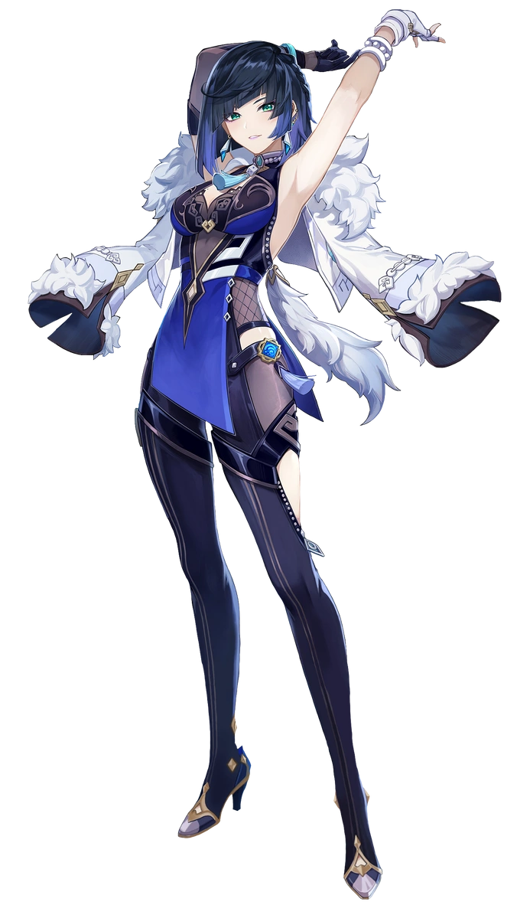
The woman that stood in the empty front half of the Yanshang Teahouse no longer bore even an iota of resemblance to the Japanese student that had stood there moments prior. Because just like Keqing and Ganyu in the adjacent room, Yelan had been completely reborn from the life she had once led. Mary was gone – and yet not entirely, for on some fundamental level she understood there was a past life. Yet it was unimportant when compared to the life that she had now. She was who she was, it didn’t matter who she had once been.

“Probably shouldn’t have dropped that, huh?” One hand neatly resting on her very wide hips, the seductive looking Liyuan woman bent forward to pick up the paper that had been delivered to her by one of the Qixing and their secretary at Ningguang’s behest. Considering Yelan’s field of unscrupulous work, what was written on the paper could only be an explanation regarding the next job that was lined up for her. Orders regarding who or what to investigate. Things that shouldn’t be read by anyone but the gambler herself.

Blue eyes quickly skimmed the text. Text that was much easier to read now that her mind had been wired to understand the common language here. Well, according to her own memories she had grown up in Liyue, so why would she not recognize the language? “I see. Another smuggling ring has popped up, huh? And the Fatui are involved? Sounds like my kind of job!” Yelan would never hesitate to crush the Fatui. The jacket she wore was spoils from a similar operation, after all.

Now that she had memorized the details, the woman tore up the paper into a bunch of itty bitty pieces before dropping them into a nearby wastebin. A roll of her wrist summoned a ball of water that was dropped into the bin after them, this Hydro energy wiping any ink that might have been on the scraps clean away. “Now, Keqing and Ganyu wanted me to confirm with them, didn’t they?”

Yelan walked with confidence and swagger into the back room. This was where all of the gambling happened, and there were numerous dice tables set up. Unlike the main room of the teahouse, there were plenty of people here including her benefactors, who were waiting in the back of the room. But seeing how one of the tables was missing a player at present? She waved back to them.

“ONE SEC, LET ME PLAY FIRST!”

Poor Ganyu and Keqing would be waiting hours for her to finish.

