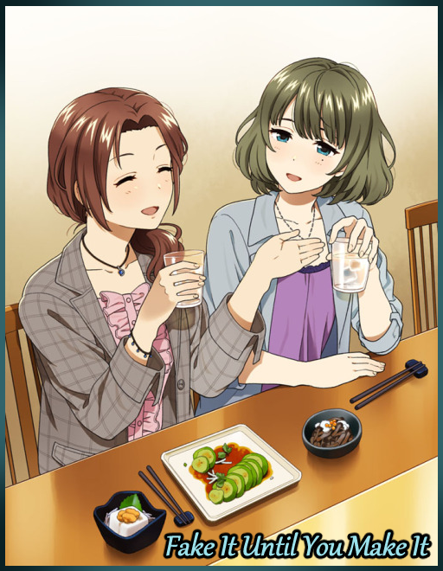

Within a lavishly decorated hotel space lined with tables polished to a mirror sheen with chairs neatly tucked away beneath them, the lights were glaring and the air reeked of wine and rosemary. It was easy to tell there was something big going on from all the well dressed people already mingling around tables stacked high with light snacks and drinks while the walls and floors were decked out in Japanese themed decor.

While most people might've been thrilled to be in attendance for a social gathering on this scale, some might be adverse to such an idea, especially when said individuals were forced to attend or had to conform to certain…restrictions…before they were allowed to set foot inside.

One such person had been Fred, a crackhead engineer living a modest life alone with the occasional visit from his one and only best friend; Leo. The two had hit it off in college, but while Leo had never quite set his two feet into designing cars like he had initially proposed to Fred, the latter was serious, kicking off his own business some time after graduating while Leo returned to his family's folds as next in line to inherit his folks automaker business which was beginning to become quite the popular name amongst the public.

With their paths diverged, Leo had tried many times to get Fred to join him, promising him the resources and time necessary to design and develop new automotives, citing his current business as a repairman a waste of his talents. But Fred wasn't going to have it, replying with almost the exact same answer every time the soon to be tycoon brought up the matter;

"Sorry dude, that stuff was your jam but I'm perfectly fine with things the way they are, no offense…"

Despite their disagreement on this one facet of their lives, the two still remained good friends, with Leo coming over to Fred's workshop with a drink in hand. Either to reminisce on the old days or to check up on him while he had time away from the family business.

While Fred wasn't one to mingle with members of what he saw to be a crowd too expensive for him, he wouldn't have said no to attending a gathering on Leo's behest; being that of a wedding ceremony for someone belonging to a family that had close connections to Leo's parents. So what exactly had turned him off to the idea?

A slip of the tongue, a failed excuse. And now Leo's mother was expecting her son to bring along a special she was dying to meet. And once the matriarch of the family had her say, there was no talking her out of it…nor was there any hope of surviving her wrath if she were to be disappointed…although that had probably been Leo's exaggerations on what his mother would do to him if she learned he had lied to her when the man had come to Fred not to drink or talk, but to beg. Prostrating himself before the startled man right outside his door with curious passersby raising their brow in concern and amusement.

"Please! You've gotta help me with this Fred! If I don't turn up at the wedding next week without who I said I'd bring to my Ma, she'll kill me! Disown me even!"

And now as a hubbub of activity spikes near the entrance to the hotel, the result of that meeting was clear to see as Leo walks in to shake hands with the organizers and the family of the lucky couple before turning to find his family amidst the growing crowd of people. Taking his mother towards the attention as the startlingly youthful woman bobs with glee beside her son.

"Oh I never thought I'd see the day my little cub finds that special someone~ So? Where is she?"

"Jeez Ma…talk about motherly love…uhh, hold on, she's a little shy but she promised she'd…ah there she is, Felicia? Over here!"

"Hm? Oh my, isn't she a darling~"
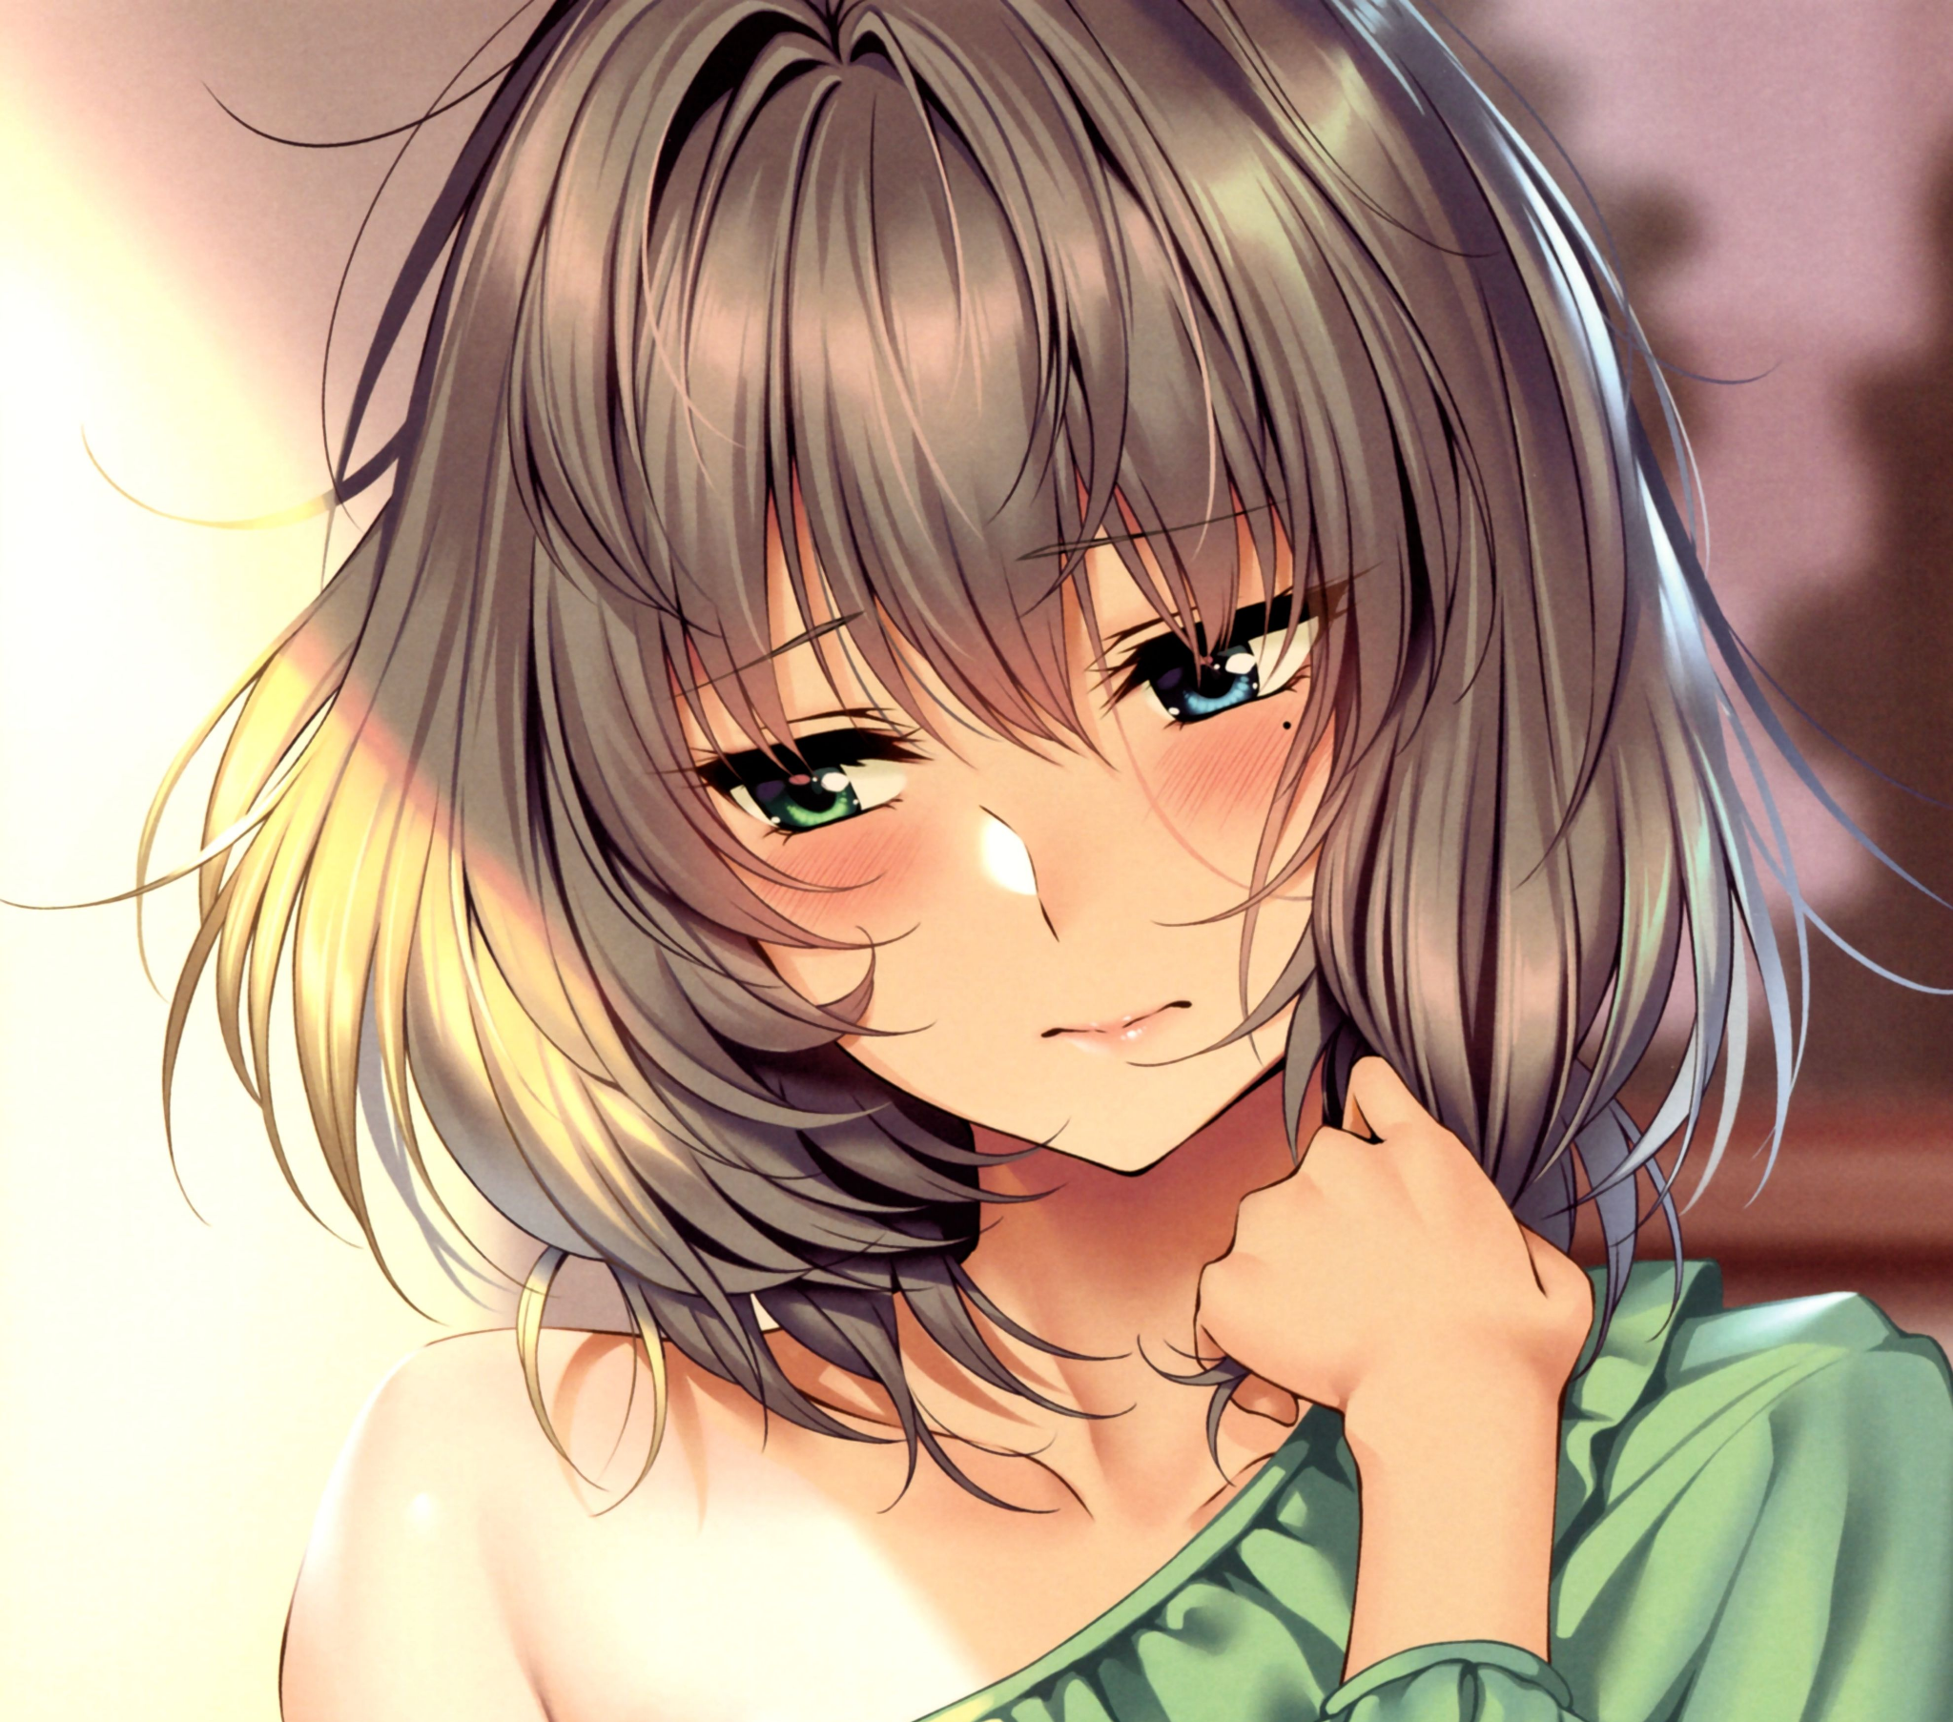
Walking past the gilded entrance upon hearing Leo's was a waifish damsel sporting an olive green head of hair with a natural luster to its silken locks that brought attention to her roguish face bearing an air of cool maturity about it that seemed to suggest a more tomboyish side to her. But yet, those same features were painted over in a furious blush, further accentuating her feminine appeal with the way she tugs at the hem of her flowery dress while fidgeting with its left strap, clearly uncomfortable with the attention she was getting while struggling to make eye contact with both Leo and his beaming mother.

But beneath the delicate shell, the girl's mind was aflame with less than pure thoughts as she struggles with the many eyes she could feel beginning to latch on to her from varying points in the crowd, clearly interested in her looks. She wanted to bash those eyes in, but her promise to her friend took priority over her personal feelings as she finally comes to stand before Leo and his mother, curtsying in a twitchy greeting that earns her a wide smile from the accommodating woman and a sigh from Leo, hiding her scowl with a smile of her own.

'Fuck you too dude, I'm trying my best here!'

Indeed, as one might have noticed by now, the girl was far from ordinary. But it wasn't because of her meek personality coupled with her extravagant looks but rather because of the fact that beneath the alluring shell, the mind of Fred lurked within. Partly wishing he had said no while another, slowly growing side of him was more than excited to partake in and enjoy this strange occasion as much as humanly possible despite his doubts.

It all started a week ago when the aforementioned outburst on a weekend of all days by Leo gave Fred no choice but to usher the sorry man inside his house. And after sitting him down by the couch with a mug of cold water to quench his thirst, Fred begrudgingly acquiesces his ears to Leo's request and the accompanying backstory behind it.

A family dinner a few nights back, the same as always, except this round included alcohol amid an excited buzz running through the household in anticipation for the upcoming celebration. And in a drunken stupor, Leo had told his mother he did indeed have a girlfriend when the topic eventually shifted to her son's personal life and whether or not he had found someone worthy to wed. Even going so far as to promise to bring his fictional partner along with him on the day of the wedding. And when he awoke the next day with a pounding headache, the bold proclamation he had made the night before instantly comes to mind the moment his eyes flutter open against the glare of the morning sun.

He knew there was no way he could simply hire an actress or god forbid an escort. His mother had an uncanny eye for character so there was no easy way out. And if he came clean, he almost couldn't stand to disappoint her more so than fearing her wrath like he had initially claimed.

But what painted the look of skepticism on Fred's face was the unanswered question of why Leo even came to him in the first place. If he needed a girl he was barking up the wrong tree, he was as much of a loner as he was!

"Look man…I get you're in trouble but…I don't think I can help you out. If it's a girl you want then there's this customer I-"

"I told you, didn't I? My Ma'll sniff out a stranger in an instant…I need someone who's known me a long time. An actual friend. I need you to do this for me."

"Woah, now hold on there. I know you're desperate and all but I don't swing that way!"

"Pssh! Whoever said I was suggesting 'that'? Look, while I was searching for anything that could help, I came across something, something that really can help with this whole girlfriend mess. Problem is…this little baby…"

Rummaging through his pockets before withdrawing his hand, Leo unveils a simple silver necklace that didn't look like anything special. If it did do anything, it only served to deepen Fred's doubts on his friend's sanity as he watched him sling it around his neck before fiddling with something beneath the main piece laying on his collar bone.

"...needs a body to wear it. And once it's on, all it needs is a little-hngh! Push!"

"Yeah, nice piece you got there but…what the hell?!"

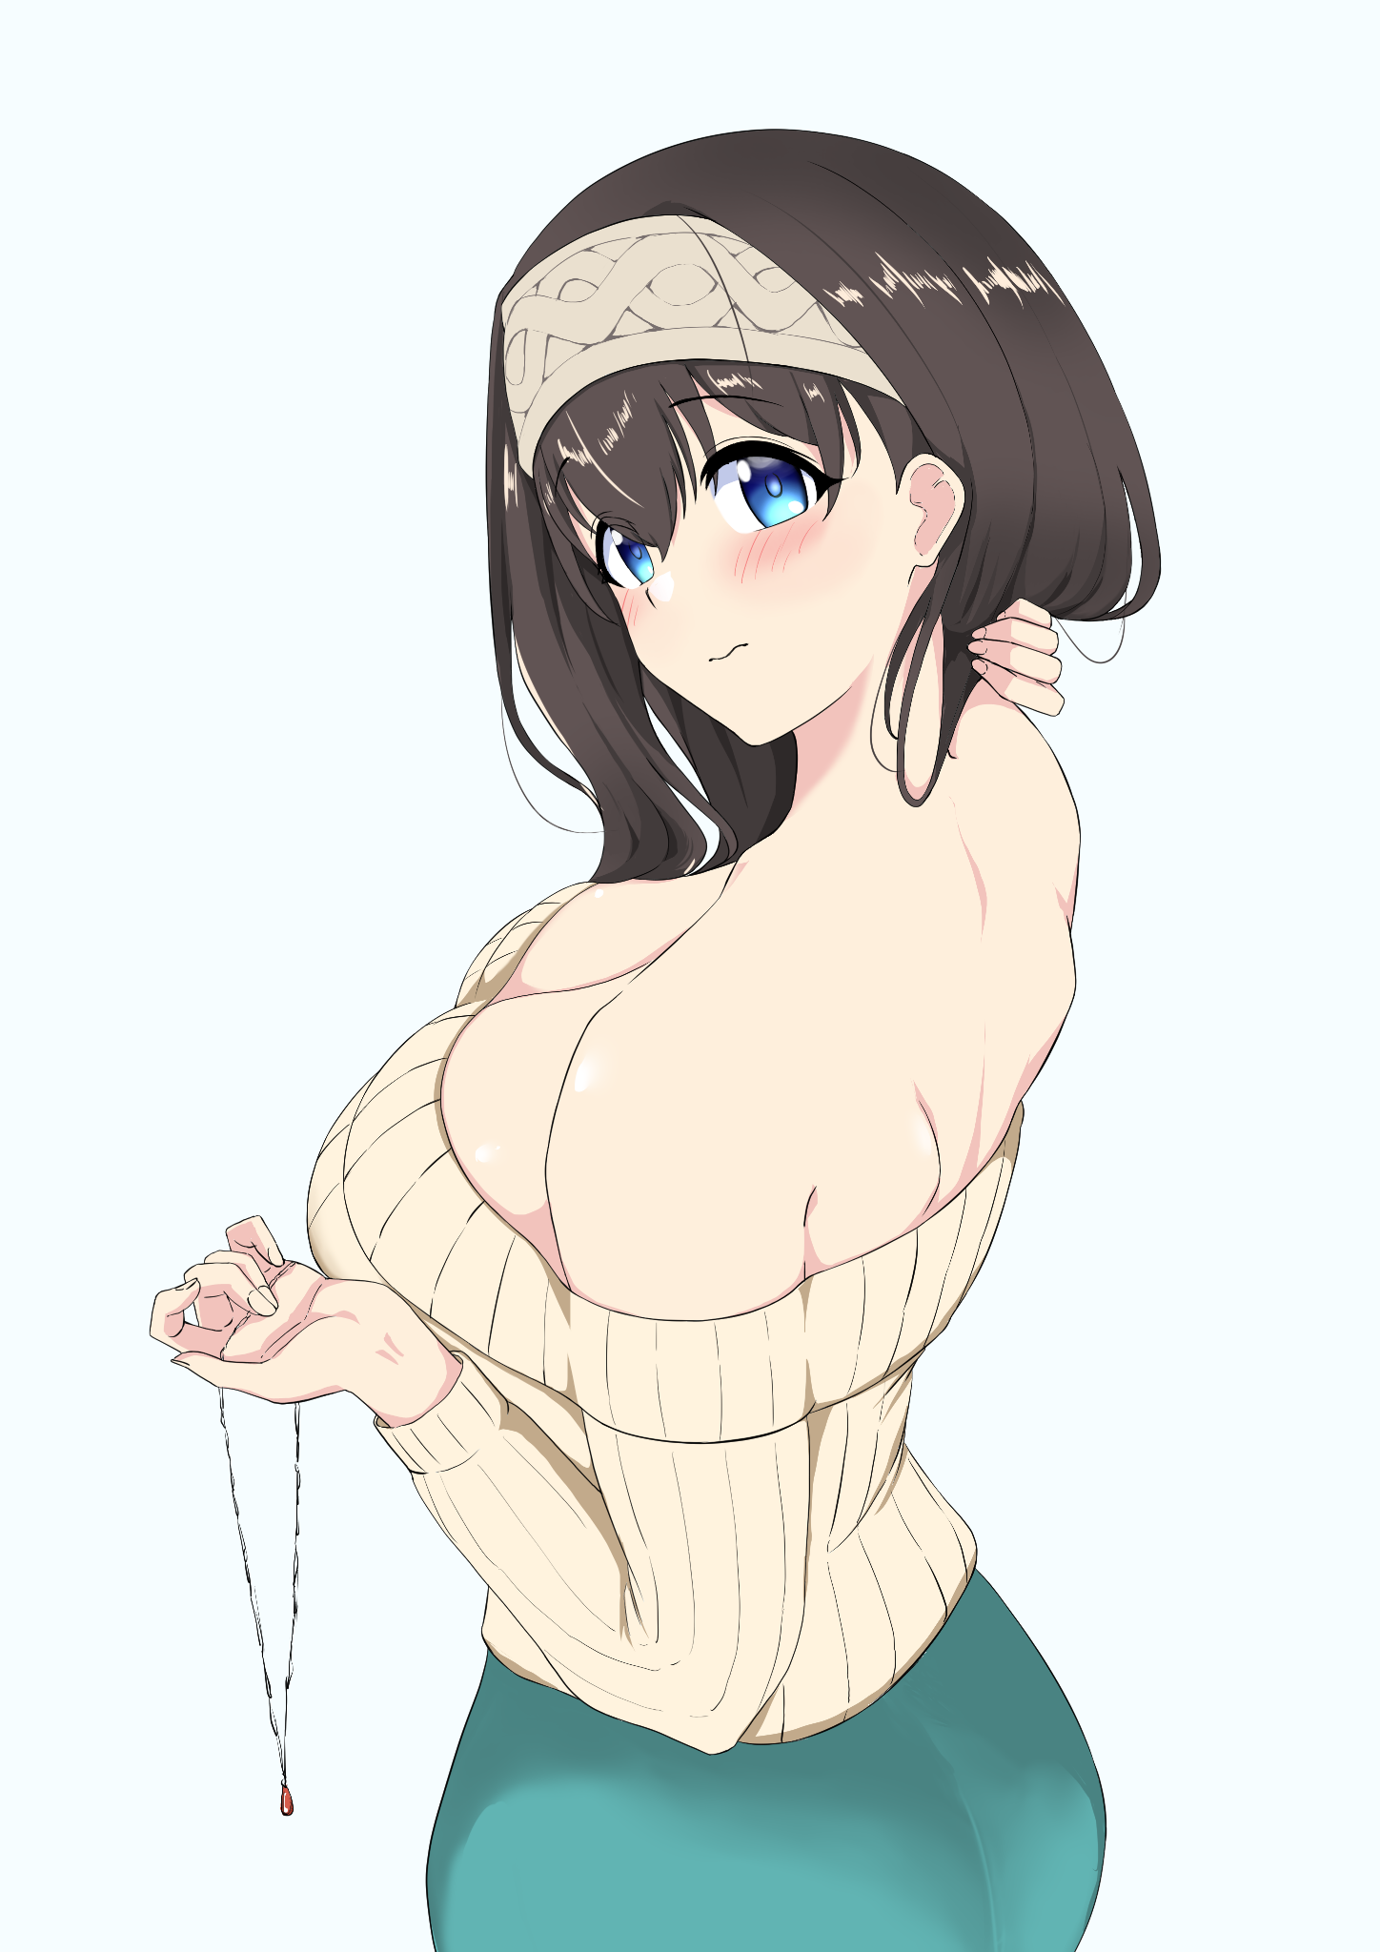
What came next was a complete surprise for Fred as he watches his friend's body rapidly begin to contort and shift, losing its tall, lean build as fair skin and buoyant fat rolls over it all, painting an entirely new individual over Leo's own. Everything, from his clothes to the flesh beneath it, all of it was soon unrecognizable to Fred who had backed away unconsciously, keeping his eyes locked firmly on Leo as his grimace morphs into the face of a blushing maiden in response to the hefty pair of breasts that had pushed out his barren chest, tenting the open shoulder cotton dress that had supplanted a plain shirt. Offering an eye watering view of the new bodacious figure Leo now bore, complete with wide set hips leading down to even thicker thighs protruding out of a pencil skirt of inadequate length, nary a hint of a bulge left between the sexy indentations denoting the lack of a member while a guttural groan mellows out into a sonorous yelp that stirs Fred the wrong way…

By the time long waves of silken brown cascade down a lean back, Leo had been replaced by a gorgeous plump lady trying her best to maintain her composure despite the fidgeting of her legs and the feverish blush on her cheeks, sighing as she lifts the necklace off her neck before returning her attention to Fred with a noticeable meekness to her gaze that wasn't there before.

"L-Leo? Is that…you?"

"S-So umm…yeah! It's still me in here but…as you can see, it turns the wearer into a girl…a pretty, hot one…and the transformation remains even when it's taken off, so no worries about your disguise being blown or anything. You can stop staring now, thank you."

"Oh…right…s-sorry."

Turning around while Leo puts on the necklace before the sound of shifting flesh and unwinding thread returns to fill the room for another moment before receding. Leaving Fred with his friend once more with the hot number nowhere in sight.

"Where the heck did you even manage to find something like that? Man…that's like some…magical nonsense or something!"

"You won't believe this but I got this 'magical nonsense' off of a garage sale last month. I'm guessing the previous owner wasn't aware of its additional function much like myself, it was entirely coincidental really; rummaging through my shelf when this little thing fell on me and…well, you know the rest."

"So…what you said earlier; about needing a friend…you want me to wear this thing?"

"I know it sounds like a lot to ask, but please Fred! You're my only hope for this! But I'm not gonna ask you to do this for nothing! Ten, no, a hundred thousand! Do this for me, and I'll pay you! B-Besides, the wedding's guaranteed to have some first class food and drink so even then you won't walk away empty handed…what do you say?"

Although he wasn't planning to ask for compensation, the fact that a hundred thousand was now involved meant that Fred really had no choice in the matter unless he really was a dimwit. A big transaction, good food and a day with the socialites…and all he had to do was play pretend girlfriend…

Did he even have to think about it?

With a friendly toast after Fred had given the greenlight much to Leo's joy, the two immediately began to plan their approach. Since Leo had never given his mother an accurate description of his soon to be real girlfriend, they were free to decide on what Fred would wear on the day of the wedding alongside specific details like the name of his female self and other such things his family would want to know; likes, dislikes etc.

After much consideration between the two, a resolution was quickly agreed upon (especially after Fred was beginning to lose his steam after being reminded of English related essays and projects back in high school) as the two men stared down the set of woman's clothes already loaded in an online cart with the sizes unspecified considering neither men were aware of what Fred's 'softer' side looked like.

But as Fred lifts the tiny thing up through his head before sliding it around his broad shoulders, the two would soon find out as his thumb eventually finds the depression in the metal Leo mentioned, pressing down on it before a brilliant sting of pain runs through his spine, doubling him over before the changes he had witnessed earlier in the day immediately begin to wrack the mechanics body, giving the man front row seats to what it's like to have your body forcibly reshaped into the opposite sex as his member immediately hardens into a throbbing erection.

Unlike Leo who gained mass, Fred was on the opposite end of the spectrum as his comparatively muscular frame begins to lose most of its bulk as arms trained in years of handling heavy car parts and tweaking gears are whittled into long petite limbs lined with just enough layers of muscle and fat to accentuate their growing beauty alongside rounded shoulders, an arching back and a navel instantly depleted of its abs for jiggly fat rush in to fill the gaps, cracking his gaunt sides into a wide hourglass shape to accommodate for the new organs forming beneath a shapely stomach with a lean slope leading down to the beginnings of a vagina with his emptied balls already being repurposed to form warm peachy smooth lips framing vibrant flaps of sensitive flesh around the dwindling remains of a decimated penis. Reduced to a twitching clitoris in seconds with just a tiny crown of smooth pubes to frame it.
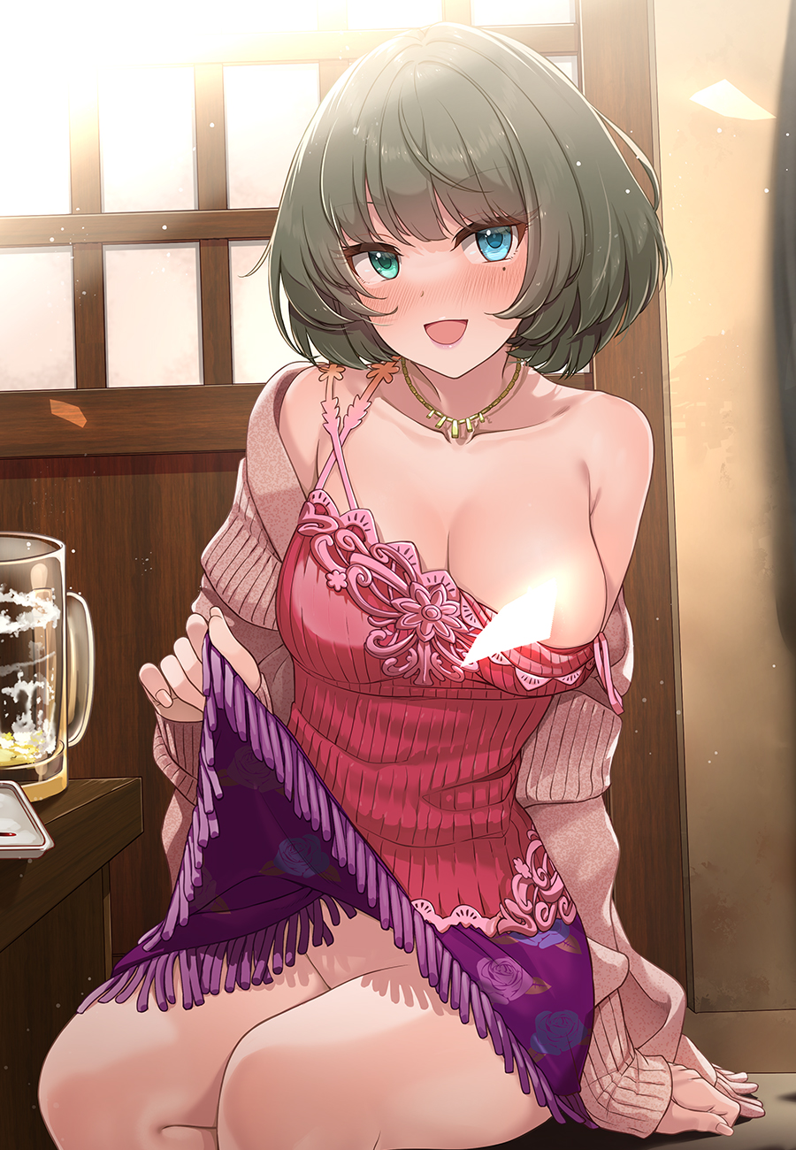
"Yeesh, the first time's pain in the bum so…hold on alright buddy?"

"It-kgh! Doesn't…hurt! It's…why is it-ogh?! Feel good!"

With her low baritone morphing into a soft, demure cry to the tune of her Adam's Apple being crushed into pulp midway through talking, Fred's resistant facial features finally succumb as his cracked lips bloat into kissable cushions while his mustache trembles before receding back under smooth, radiant skin that quickly slithers up and around his eyes, lengthening them into sleek foxy slits while a beauty mark manifests right beneath her left eye. Bringing focus to pearly blue irises and a smartly brushed fringe of hair that washes over with olive green, replacing the drab browns while healing damaged locks, replacing Fred's crew cut with a silken head of bob cut hair that frays at the side before coalescing inward as if to point at the gorgeous face that they hung over, panting erotically with a sleek tongue lolling in the air and a fevered blush to her cheeks, confident the changes were subsiding until a sudden "Ahn!" breaks the silence as Fred's chest instantly blooms into a pair of milk filled teats that weren't quite as large as Leo's female self but rivalled them in terms of perkiness as inverted pink nips ripen atop the jiggling mammaries as they come to rest above his chest.

Signaling an end to the transformation as her baggy singlet morphs into an extravagantly designed top meant to tease the hearts of men while her trousers instantly shrink into a flowery skirt with tassels lining the hem, Fred collapses to her knees in a huff, struggling to catch her breath before gazing up at Leo with a half expectant half embarrassed look, fumbling with her new attire while failing to notice the subtle lick of the warm afternoon air against her damp privates and the swollen nipple of her right breast jutting out of her dislodged top. More interested in the wooden appearance of a woolen jacket that had popped into existence hanging her lower arms. Oblivious to the show she was giving Leo as the flustered man struggles to keep his eyes focused on the excited eyes of the perfect realization of Felicia kneeling before him.

“H-Holy shit! That was amazing! So? How do I look? Leo? You’re…staring really hard there dude…”

“Ohh im just…trying to respect your beauty from a distance y'know? N-No biggy…”

It was only after turning downward did Felicia realize her privates were exposed, moving her hand to unconsciously cup her bosom while her knees buckled together to suppress any hopes of viewing her flower while she fumbled with her overly loose clothes in an effort to stuff her body back inside of it while Leo downs the rest of his drink before heading back over to the order details to put in the final changes.

"It really was a good idea to buy new clothes huh? What size do you think you'll need?"

"M-Medium…I guess…"

"And your three sizes? Oh wait, nevermind. I think I know already."

"You perv…"

With only a few days left till the big event, Fred, now Felicia, had to get used to her new body before then, practicing walking in heels, 'feminizing' her stance from the way she walked to the way she sat down. Admittedly it wasn't that hard considering the necklace's minor effects on her psyche. While she could more or less pull off the perfect walk with her hips swaying naturally from side to side, she could only do so unconsciously. With her mind still being that of Fred's, her very much dominant male state of mind was feeling all sorts of deja vu whenever she tried to focus on her new feminine qualities. Keeping her legs closed while sitting, making sure not to keep her dress patted down if she had to kneel to pick something up, not walking with her shoulders swinging side to side. Even the most minor of details were a struggle to get down.

But like all things in life, Felicia would eventually come to desensitize herself to the new concepts rather than master, passing her mistakes off as clumsy and adorable instead of a disastrous wreck. In addition to being able to do her own makeup and tend to her hair without issue, the road ahead seemed set for the two. However, with that tiny bit of adjustment to her new body came a minor setback that Leo saw no problem in, in fact he was beginning to like the demure lady Felicia was becoming the longer she remained this way. While she was worried it would affect her identity, Leo was quick to assure her otherwise…despite not having tested it himself and going this long without changing back, having zero idea how much the body could affect the mind on its own without external stimuli.

"C'mon! Can't I just change back for one second? It's been making me feel…weird…talking to people…just the other day I couldn't even enter the cafe I usually get lunch from because of how it's been making me feel!"

"And what exactly does it make you feel? Any strange thoughts you’ve never had in mind before?"

"N-Nervous…and shy…a little."

"But that's perfect isn't it? It saves us the trouble of coming up with stupid lines when you can just stammer one out! C'mon Fre-ahem-Fel, just one more day tomorrow as the nervous girlfriend, and you'll be back to your old self before you know it!"

“S-Stammer one…but I…grr fine! But you’d better keep your word on that reward!”

Begrudgingly accepting it with gritted teeth and trembling fists balled into petite clubs, Felicia had no choice but to remain in her new body up until the wedding was over. Hoping in the back of her mind that she wouldn't have to end up sitting down everytime she went to relieve herself from now on. Just thinking of her old body acting all girly without her knowing in front of a group of customers in the workshop was enough to send a shiver down her spine. Hundred thousand be damned.

Cue a sleepless night, and very soon the day of the wedding would soon bear down upon Leo and Felicia, with the fake couple making their way to the hotel together in the man's car, hearts and minds beating in a mix of excitement and dread. Leo hoping his mother wouldn't reject Felicia out right and hoping his friend had what it took to pull through, Fred wondering what people would think of her Felicia persona as she stares out the window, busying her mind with the sights and sounds of the business district she had never been through before, thumping her heels against the floor of the backseat in her fidgety state.

A short ride later and the two stood right outside the entrance to the spacious interior booked out entirely for the rest of the day's events. Staring down the imposing doors with lumps in their throats. Once they went through them, the real gig would begin, and as if to reassure each other, the couple share a glance with Leo's being more of an assuring gaze when compared to Felicia's hesitant look.

"Come on man, just…breathe in, chest out…sorry poor choice of words…but you get what I mean yeah?"

"Yeah, yeah…I won't screw this up…hopefully. You do your best too, huh? You're as much of a mess as I am!"

"S-Seriously? Shit…well, can't stand out here waiting any longer, you wait right here, I'll fetch Ma over so we can get the hard part out of the way first."

Before she could protest at the idea of the final boss being brought forward so early in the schedule, Leo's feet were already bringing him way past the entrance, leaving the flustered girl behind as he vanished into the growing mass of people already inside, only to return a few seconds later with a deceptively young lady in hand with a motherly figure and a warm radiant look of excitement that escalates into pure joy as Leo calls out to her, waving her inside with his free hand.

"Felicia? Over here!"

With her name being called, the unwitting girlfriend, faced with no other choice but to move forward, wills her shaky legs beneath the dress Leo had picked out for her, moving steadily forward while trying her best to ignore the sudden onslaught of stares piercing through her. Whether it was because of her body now thoroughly soaked in female hormones from her time spent in this form or because of something else entirely out of her control, Felicia's sudden social awkwardness thankfully didn't seem to detract from the expectant matriarch's view of her as she finally comes to stand before her, bowing politely but forgetting to say anything in greeting, not missing the snide sigh escaping Leo's mouth. But with Leo's mother; Rika, right in front of her, she couldn't necessarily scold him right then and there when the tall imposing woman instantly crosses the distance between her, cradling her chin while brushing aside a stray lock of hair in one hand. She felt small, powerless against the intimidating woman's strong yet tender grip as her big round eyes peer into her soul. Reading her like a book. Had she been found out? Were Leo's seemingly exaggerated tales about his mother being some clairvoyant genius true?

Giggling as she rubs head in a reassuring manner, it was clear Rika simply had a strong, straightforward presence. Not having the spiritual power to peer into the soul of the man lurking in the petite woman before her eyes. But like Leo said, it certainly was a hair raising experience to be met with his mother's overwhelming presence.

"My, my, aren't you a shy little babe? You're Felicia right? A pleasure to meet you…when my boy said he'd gotten himself a fitting woman I had my doubts to be honest…but now that you're here right before me, I see he's made quite the lucky find!"

"H-Huh? Oh! Y-Yes ma'am I'm F-Felicia! Nice to m-meet you…"

"Hmm, not much of a public person are we? No matter, if it's privacy that can help with your composure then it's privacy we shall get! Leo dear? You don't mind if I borrow your Felicia for awhile do you? Take your time to talk with the others! I'm sure Barrow would love your company!"

"S-Sure thing Ma, just…be nice with her alright?"

"Hohoho~ Whatever do you mean? You make it sound like I'm kidnapping the poor girl!"

Unable to do anything but send her a reassuring nod of the head before turning to mingle with the guests, Felicia was left to her own devices, walking hand in hand with Rika as she ushers her down along a straight path towards one of the side rooms where she could see chefs preparing lunch.

"Glad we could have this moment to ourselves! You don't mind being apart from Leo for a moment, do you Felicia?"

"No! Not at all…you're my…his mother after all…sorry."

"Fufu! No apologies necessary, in fact, if you stay the course…wouldn't it be fine to call me mother whenever you wish?"

For a moment there, the image of herself all dolled up in a wedding dress with tears in her eyes flashes by in her mind, making her cringe inwardly at the idea of getting married to another guy but replying all the same with a cheeky grin on her face.

"Hehe…well, we've still got a long way to go with each other so maybe in a year or two?"

"I'll be looking forward to it~ See, you can speak just fine when it's just the two of us! Come, its not much farther now."

Pushing open the tapestry that hangs over the wooden archway, Rika immediately scoots over toward one of the chairs to take a seat before waving Felicia over to sit beside her. It was a spacious interior that was surprisingly wide for its deceptively small entrance. Modeled after a Japanese barbeque restaurant just like the rest of the far eastern decor the awestruck girl had seen ever since stepping foot here. It made her feel inferior to be standing here amongst the elite as she folds the rear of her dress before sitting down next to Rika.

"Amazing isn't it? The bride's family specifically requested for the Japanese theming just so they could accommodate the lucky bride. Even the food is made by chefs flown in from abroad, here, have a nibble!"

"B-But lunch hasn't started yet hasn't it? Are you sure it's alright? And besides I-mpf! Mgnn! Mmm~"

Silencing her with a mouthful of sliced salmon strips, the mischievous lady leans back with a smile as she watches Felicia's muffled protests instantly mellow out into adorable mumbling as her tongue begins to savor the rich taste of fresh seafood procured straight from the shores of Japan, treated and kept preserved to deliver the succulent meat oozing with rich flavor currently sliding around in the stunned woman's mouth.

By the time she had swallowed, Felicia was raring for more, peeking at the full plate before her with puppy dog eyes before turning to Rika, who was more than happy to watch her feast upon the food with gusto, planting her head on her hands as she watches the hungry girl wolf down her food in the blink of an eye, remaining glued to her until she realizes the very unprofessional manners she had just demonstrated before Leo's mother.

"Don't mind me~ Do continue if you're still not satisfied. Did the two of you not eat breakfast before coming here?"

"Huh? Oh no we did it's just…the food…its my first time tasting something this good. So I couldn't help it."

"Humph, and Leo claims to have your well being in mind! I'll be sure to tell him to treat you more…speaking of, since we're alone now, would you mind filling me in on how the two of you came to know each other? The boy's mighty secretive of it!"

"I'd like to know too if you don't mind the interruption mother."

"Ahh Lucia! Come, come, the more the merrier!"

'The more the merrier? What happened to 'just the two of us?!'

With the sudden chirping of a new arrival's sultry voice chiming in from behind the two, Felicia now finds herself staring at presumably another member of Leo's strange family; a confident blonde who bore the powerful aura of her mother but none of the familial warmth behind that condescending gaze of hers as she seemed to scrutinize Felicia from head to toe while striding past them to take a seat on the opposing end of the table like, clearly taking her stance towards Felicia as a stranger and not a honorary member of the family.

She was an intimidating beast of a woman, and something told her that even if she was still a man, her attitude towards her would not have changed one single bit.

"Well? Mother asked you a question so how long do you plan to gape?"

"Lucia! That's no way to address your sister in law!"

"Not yet she is…I want to hear how that spineless oaf could have ever found himself a girlfriend…that is if she isn't here as a worthless parasite!"

"I am warning you one last time Lucia! Sto-"

"Enough! I get it alright? You don't like me…but it doesn't mean I'm gonna slink away like you think you can scare me!"

"Hoh? Then please, feel free to start whenever you feel like it…"

Clearly something she had said was enough to satiate this Lucia girls initial thirst for drama as she leans back into her seat, taking a sip of freshly poured tea from the kettle. Seeing no other choice but to go ahead with her bold proclamation that had stemmed from her pent up stress accumulated over the past few days, Felicia sighs before cradling her own cup, looking back at her reflection cast into the clear pale green surface before beginning her pseudo falsified tale of how she, as the young woman she now was, had come to meet Leo to the best of her ability.

It was a task both simple yet demanding. While she was simply recalling the past while altering her position within them from Fred to Felicia, the girl still had to fabricate new moments that were more in line with the usual tales of how a man and woman would eventually trip and fall head over heels for one another. But after a certain point, that too had slipped her mind thanks to the interrogation room atmosphere Lucia brought with her.

To her surprise however, neither Rika nor Lucia seemed disdained to hear about the times when 'Felicia' and Leo ran track around campus together or the moments they spent working down and dirty on a hands-on project for their course. No matter how mundane or simple the memory, the two women's attention never faltered. Absorbing each word for what they were. But that still left the proposal, the climax; how has they come to realize their feelings for each other.

And as the topic of schoolwork comes up, Felicia sighs before taking a long healthy swig from her cup, slapping her cheeks together as the perfect memory comes to mind.

"A-After we graduated…I thought that was the last time we'd see each other after a few months go by. We didn't see each other…didn't even text…until he suddenly turns up at my garage downtown by the bay with a…with a…"

"Proposal? Ohh the sweetheart! So all those times he mentioned visiting someone who could help 'enrich' the business…he was actually gunning for you?! Ohhh Leo!"

"Mother…please, continue."

Exhaling a little, Felicia continues on Lucia's behest while Rika continues to wiggle in the throes of romantic bliss.

"So…naturally I didn't expect him to hold any feelings for me considering how…tomboyish I am…but he kept coming by, begging for my hand…and I just…y'know…gave in…he was just so persistent and I…I've…held feelings for Leo for a long time…so it just took me awhile to realize that I guess…we're still new to the whole couple business but I think we're going along nicely…"

Preparing her mind for what she was about to say next, Felicia turns her gaze from Lucia who had noticeably eased her tense posture to Rika who was still giddy with excitement before reassuring herself that this was all just a lie. Just until the day was up…

"I've heard enough…"

Rising to her feet quickly before sauntering past Felicia and her mother, Lucia shoots her a wry smile before waving farewell to her mother. And just like that, the sudden intruder to their solo meeting had vanished just as fast as she had appeared.

"Well…that was sudden…"

"Fufu! Don't mind her~ She likes you y'know? And that's rare even for Lucia, she might be cold and a little bit too blunt, but please forgive her earlier words. She really does just have the family's best interests in mind…and I must admit I did have my doubts about you, but that tale was more endearing than I thought it'd be…to think you own a workshop! Yet you still look this beautiful? Please Felicia, how do you keep your skin this fair and smooth? It must be hard work cleaning up at the end of each day!"

"Ahahah…its uhh, a trade secret! M-Maybe Leo might know…"

"Awww…well, I don't know about you Felicia but we've still got plenty of time till the ceremony, and since Leo hasn't come looking for us…are you up for a drink or two?"

"Hmm…why not I guess…thanks Miss Rika…for your vote of confidence."

"Oh, no need for the honorifics! Feel free to call me Rika, or even mommy dearest if you wish!"
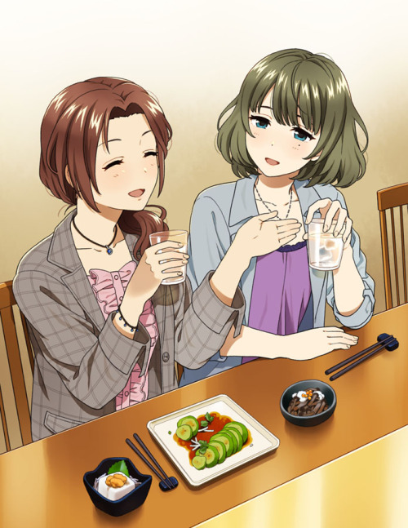
With the mood in the room slowly turning from cold and brooding to jovial and accommodating, Felicia begins to help herself to the food already laid out on the table, sticking to the greens while helping Rika scoop up some food into her now empty bowl while engaging in idle chatter with her, mostly revolving around Leo's untold past and her time raising him mixed in with some juicy tidbits of family life. But when the real heavy hitters come pouring into their empty cups, the women begin to grow a little tipsy, with the supposedly fake girlfriend forgetting she was even there incognito in the first place as she drank and spoke with her new acquaintance without a hint of worry on her face. It was surprising, but she truly was enjoying herself here. All while the rabble outside continues to grow as many more people arrive minutes before the ceremony.

That is, until a mildly drunk Rika returns the topic at hand back to the point when Lucia had cut her off.

"Teehee! You're a funny girl Felicia…but earlier, you seemed hesitant about something before Lucia left…what did you want to say?"

"O-Oh what? That? It was…was…nothing really!"

"Does it have anything to do with your future plans with Leo? Marriage maybe?"

Hearing that returns the earlier image she had scowled at to mind, only except this time she was feeling strangely euphoric thinking about it. A silken wedding dress, awaiting her beloved in front of the aisle with row upon row of family and friends watching with bated breath as Leo cradles her left hand gently before slipping a ring around her finger.

Was it really that bad? Living as a woman, as Felicia? What if Leo truly didn't care about her? Was she just this temporary figment of his imagination granted form just for this moment? What would Rika and even Lucia think if she were to just up and vanish after the day was over?

'God dammit…why's everything gotta be so complicated! This was supposed to have been a simple one off gig!'

Wiping her face with the back of her hand before slinking into her seat with a deflated look on her face, Felicia groans as her gaze fixates on the glaring warm orange of the light above them.

"Honestly…there's just been so much to think about…marriage…life with Leo…our relationship…how would you handle this sort of thing uh…Mom?"

"Oh my sweet baby girl! Well, it's good to know you're already thinking lots about your plans with Leo moving forward…but thinking too much isn't good! And it wouldn't be a relationship without a hiccup every now and then, I'll have you know I've had plenty of quarrels with Donald…but who can say for certain what sort of life you two could have together? At the end of the day, all I can really tell you is to take things slow…you don't have to rush right?"

In a way she was right; the necklace wasn't a permanent thing and she could always choose to return to her old form…but the doubts remained on whether or not it was a permanent power or the necklace's transmogrifying effects had limited use. Would she regret her decision to return to being Fred, only to realize there was no way back? So many questions, too little answers…

"Oh! Look at the time! There's only a few minutes left till the ceremony! Come Felicia, we must…Felicia?"

But before she can lose herself even further, the worrisome woman jolts as she turns to face Rika, rubbing her shoulder with a reassuring hand and sending a calming wave through her heart with that warm cozy smile of hers…but behind it, she could sense curiosity, a prodding energy just itching for answers behind those brilliant red eyes of hers.

"Huh? W-What is it?"

"The wedding's about to begin, come, come. We must get going! I'm sure Leo and Lucia are already waiting with Donald for us!"

"Ah r-right! Sorry…"

Pushing off her seat to join Rika as they quickly exit the dining room, Felicia hurries alongside her towards the doors leading to a massive auditorium where most of the guests had already been seated. But right before they enter, Rika pulls the startled girl aside, winking at her before whispering into her ears.

"As it so happens, we have a family vacation on a private island coming up soon…but here's the thing! Leo doesn't know about it…so? Would you like to come along? We'd love to have you…and I'm certain I can pick out a swimsuit that's guaranteed to give your man a good shock~"

"V-Vacation? S-S-Swimsuits?! But I…oh gosh…I don't know…I mean, yes! Wait…I'm not sure!"

"Oh you're so adorable when you're all flustered~ But like I said earlier, give it a thought…and if you agree~"

Passing Felicia a small note with her contact details written down on it, the mischievous Rika simply winks at her before pulling her inside the hall where her wide eyes meet with Leo's…unable to help the tiny blush on her cheeks as he waves her over. Cradling the necklace hanging around her neck before taking it off and pocketing it in the pockets of her thick leather jacket as she moves to join Leo's side, chastising him for leaving her alone with an uncharacteristic energy that had been absent till now.

Rika was right; she had all the time in the world to think about the future. And although she still had trouble staring at her own naked body…maybe swimsuits were a step in the right direction? Admittedly the idea had her excited to try on all sorts of fancy, sexy getups, and the bonus of surprising Leo seemed strangely enticing to her…

If anything, Felicia couldn’t deny it any longer; that agreeing to this had been a blessing. Good food tasted, new, eccentric people met and befriended, and a breakthrough in deepening the possibility of living this fax life of hers for real.

'Maybe this won’t be so bad after all…'

THE END

