Split Hersonality
A Mercynaries Story from https://www.patreon.com/SinComics

Phil stretched against the kitchen counter, his back cracking. With an uneasy grunt, he lifted himself onto the stool and propped himself up on his elbow. Another restless night, legs aching and all-around groggy. The hunger was new. He was absolutely starving this morning. Phil reached over for a bowl, grabbing his morning medicine at the same time. He fumbled in the cupboard for the closest cereal within reach and dump the box's contents into the bowl. Turning around, his back popped again as he grabbed the carton of milk and liberally applied it to his breakfast.

As Phil shoveled in spoonful after spoonful, he absentmindedly spun the pill bottle on the counter. It didn't make for exciting morning reading since it lacked even basic nonsense warnings about side-effects or dosing. Still, his doctor said two pills in the morning and one before bed. He unscrewed the purple cap and tapped two of the clear pills out of the unmarked white bottle. With a gulp of his cereal milk, he downed them.

The sample bottle the doctor had given Phil did have the usual medical mumbo jumbo and she did say the real packaging would probably look a bit different, so Phil didn't give it much thought. In all likelihood, it was just his rip-off health insurance cutting every corner it could. But if that's what the plan covered and what would cause the migraines to stop, he could do with finding his morning entertainment in re-reading the back of the same box of cereal.

Phil spent his medical leave mostly puttering around the apartment. It was boring, but if he could do more, he probably wouldn't have gotten the time off of work. In addition to his meds, the doctor recommended a few simple exercises and stretches, keeping his apartment cool, and keeping the shades drawn. He had to spend the day lounging on the couch watching TV. Doctor's orders.

After a few hours dipping in and out of sleep in front of the TV, Phil kicked off his blanket and decided to begrudgingly get ready for the day. He grabbed his towel and a change of clothes and tossed them into the bathroom. The night's clothing went into the washing machine and Phil went to the closet to grab the detergent. With a groggy yank, Phil's hand shook the doorknob but it stuck and his hand banged into the wall.

Shaking his bruised hand, Phil bent down and looked over the door. It didn't look stuck in the frame or swollen. He ran his hand over the door knob and noticed how shiny it was. Granted he wasn't intimately familiar with with the relative shininess of the doorknobs in the apartment, but after a quick comparison, this one was definitely different. Scratch-free and with a nice polish, it had been replaced very recently. Phil shrugged. The landlady probably came in to do maintenance while he was out grocery shopping and just forgot to leave him the key. He could head over to the office later on and just do laundry another day.

Phil went about his day, running errands, with a nap or two during the day. The doctor had mentioned some changes to his sleep patterns on the medication and it's not like he was falling asleep at the wheel, so he turned in early for the night after a hearty dinner, leaving laundry, closets, and more for the next day.

The next morning, Phil swung his legs over the side of his bed and groaned uncomfortably. The aches were worse this time around. He slept for at least 10 hours but was still groggy and exhausted. Worse, his muscles throbbed and he felt strange all over. Phil gently touched his chest and found it soft and tender. He grunted and forced himself off the bed, feeling heavy and wobbly. Phil's stomach grumbled and he started off towards the kitchen before banging his hip into the door frame on the way out. He yelped in shock and rubbed his sore side with a groan.

As Phil rubbed his side, his shorts jostled to the side and Phil caught the glimmer of shiny green fabric. Stretching out the waistband, Phil looking down in awe at his satin underwear. Then to his shock, it dawned on him that they were a green satin pair of women's underwear. Phil quickly limped to the closet door to find it still locked. He spun around and threw open the washing machine door, sifting through his pile of laundry. Grabbing an armful of it and dumping it to the ground, the light glinted off another pair of blue panties and digging deeper, a matching bra. Phil backpedaled away from the clothing pile and leaned against the wall.

Maybe with how tired he was, he grabbed the new underwear by mistake last night, but how did it get here in the first place?! Phil looked back at the locked closet. Was his landlady playing a joke on him? Had she dumped this new clothing into his place when she changed the locks? But why? Phil stared at the shiny new lock and the answer came to him. His lease had a fine for subletting. The landlady was probably trying to get him back for needing to do maintenance and would hit him with a fine to pay for it all. But he couldn't just accuse her of it, he needed proof.

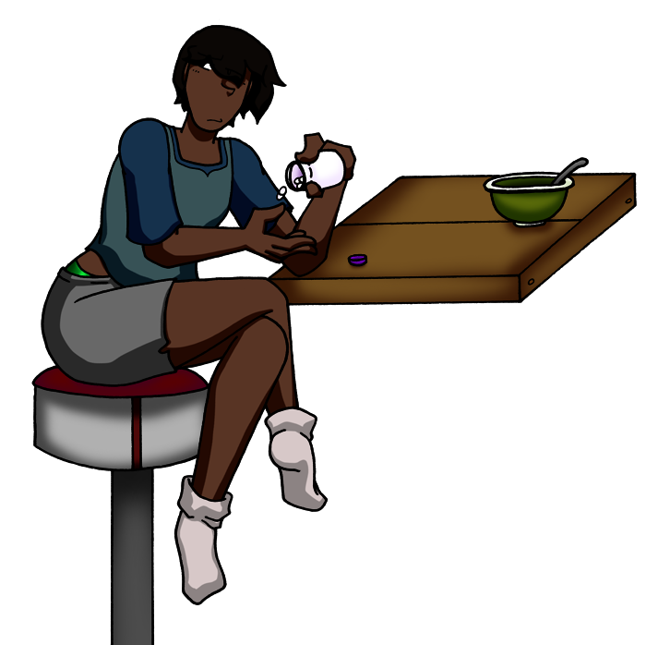

Phil quickly downed his breakfast and morning medication then spent his day digging through his closets and stash of old electronics until he found an old security camera. After another mid-day nap, he climbed up onto the kitchen counter and sneakily hid the camera on top of the cupboards. The next time the landlady came in to plant some phony evidence, the camera would start recording and transmit the truth to his computer!

When the alarm went off the next morning, Phil bound out of bed, muscle aches be damned. He felt a chill and then a soft brush across his back. His foot was on top of a clump of fabric and Phil looked down to see his night shirt crumpled on the floor. He rubbed the sleep from his eyes and looked down to see a delicate feminine nightie gracing his torso. Angrily yanking it off and throwing it against the wall, Phil declared this had gone too far.

Not even sitting down at his desk, Phil snapped open his laptop and bent over the screen too bright for the early morning. He brushed several strands of hair back and tucked them behind his ear as he opened folders to find where the camera saved its evidence.

Success! A brand new folder dated the night before was waiting for him with a video inside. Phil mashed the trackpad to open it and grinned, ready to bust the intruder. The video flickered to life, the light fading in and out until it steadied itself and settled on a blueish-gray scene when a woman walked through the frame. Her back was to the kitchen and long hair obscured most of the details. He couldn't remember for sure, but didn't the landlady have short hair. The mystery woman quickly slipped down the hall until she arrived at the couch and bent over at the waist, sliding her hand around under the couch. Phil cocked his head. Definitely not the landlady; he'd remember if she had a backside like that. The woman strut back to the closet and used her freshly retrieved key to pop open the locked door. She grabbed a bag, walked back out of frame towards the front door, and the camera switched off as she disappeared from its gaze.

Phil raced out of his room, making sure to swing his hips to the side to avoid the doorway again, skidding to a halt at his couch. He dropped to the ground and ran his hand along the floor then along the bottom of the couch until his fingers brushed against something metallic. He gripped it and tore it free. Examining it, Phil glared at the shiny silver key and the piece of tape that held it in its hiding place. He marched over to the locked closet and the key smoothly slid in then clunked to the side. Phil cautiously opened the door, revealing his normal closet, empty except for a large purple duffel bag.

Phil gently kicked at it and then slipped away. The bag didn't move, shake, or explode, so he slid it out of the closet with his foot. Gently unzipping it, Phil gawked at the contents before dumping them onto the hallway floor. Out spilled a summery light blue dress, a black leather skirt, a shimmering pale pink blouse, followed by several pieces of lingerie, then the hard thump of heeled sandals clunking out of the bag.
“The hell is all this?”

Phil picked up one of the sandals and glared at it. Somebody was definitely trying to mess with him, but there had to be more to it than just clothing. If it was his landlord trying to screw him over on fines, she'd hired somebody to be in on it but there had to be more.

Phil combed over his apartment looking for anything out of place or off. His first find was in the kitchen, digging through the trash, he found several candy bar wrappers in the garbage can. He didn't keep any candy in the apartment so it was clear somebody was coming from outside and planting stuff in his personal space! Phil continued his hunt, exhausted from the focus and his head throbbing as the day went on. He returned to the kitchen and saw the white bottle of medicine on the counter.

The bottle filled him with a sense of unease so he grabbed it, opened one of the cupboard doors, and whipped the bottle inside in a huff. As Phil was closing the cupboard door, he saw one of the cans propped up over the others. Pushing the food aside, there was a lone can of corn in the back that stood unevenly. Beneath it, Phil pulled out a wad of dollar bills and stared at them. He dropped it on the counter and continued to gawk with growing unease. If his landlord was trying to rip him off, why give up that much money to frame him... A quick thumb through the wad of bills revealed it was a mixture of 20s and 50s, so there had to be a few hundred dollars in there. More than a month's rent penalty would bring in.

Phil slammed the cupboard door and started to pace. Why was somebody doing this to him?! The only changes in his life were leaving work, going to the doctor, and starting treatment for his migraines. One of those areas could be the culprit, but why. His work could just fire him if they wanted him gone. The doctor was... a doctor, she wouldn't try to hurt him. And the medicine was helping his headaches. That was the only one he could change right now, so Phil swore off his medication until he got to the bottom of this.

First thing's first, Phil had to deal with this woman intruding into his life and causing these problems! Grabbing a plastic bag from the cabinet, he wrapped up the planted clothing, and sealed the bag shut with a liberal application of duct tape. Phil marched back to his room and went to the closet. Among his junk, he tossed the bundle into a container sitting at the bottom. There! Now there was no way the woman would be able to get to her stashed goods without alerting him! Phil grinned to himself but was then hit with a sharp throb in his head. He sat back on the bed and calmed his breathing as he felt the pressure grow behind his eyes. He was letting himself get too worked up over this. Leaning forward and putting his head between his knees, Phil let himself just breath until the headache passed.

The next step was to scare the woman off. Let her know he was on to her scheme, even if he wasn't sure what it involved, and that he caught her. Phil grabbed a sheet of paper and a marker before slapping them down on the counter.

“Get out of my house! I know you're breaking in and have you on tape! Leave or I alert the authorities!”

Phil plopped his message in the closet where the duffel bag had previously been. There was no way she would miss it and would now have to leave him alone. He closed the door, locked it once more, and returned the key to its hiding place.

The next morning, Phil was groggy and small spots of light swam around his vision as he sat up in bed and the high-pitched whine in his head gradually faded. A day out of his last dose of medicine and this was to be expected, but it made Phil appreciate the work the pills had actually done. Shaking it off, Phil kicked off the covers and glanced around. He was dressed in his own clothes! Success! Ha, take THAT, mystery woman. She had been out-schemed.

Phil shuffled to the kitchen and was greeted with his camera placed out in the middle of the counter. She must have found it! Stumbling back, Phil raced to his computer and checked the folders again. As expected, there were updates, but this time it was two new recording files waiting for him. Phil clicked open the first and the camera's blurry feed played out. It opened with the woman continuing her same path to retrieve the hidden key and invade his closet. She seemed only briefly taken aback before squatting down to read his note, then she stood back up and closed the door. The woman stood for a while, tapping her cheek, and looking around. Phil scrubbed through the video and watched the woman in sped-up motion zip around his apartment looking on and under his belongings until she disappeared from view under the camera. A slender hand curiously patted around the edge of the screen before its fingers connected with the camera and the recording wobbled. Shortly, an enormous hand engulfed the lens and the view went dark. Phil shook at seeing this and quickly closed the first file and went to the second. It picked up from the counter's viewpoint, looking up at a woman with an almost amused look on her face. She had changed clothes and was now in a dress shirt, so some time had passed. Phil checked the files again and saw this video was stamped as several hours later.

“Phil...” The audio was low quality and muffled so Phil cranked the volume. “Sneaky! But, I'm amazed it took this long. If I hadn't had some fun with your outfits, how long would it have taken? I have things to do, so we'll keep this short and let you sleep. Just leave it all alone, no more tricks or thinking you can get one over on me. I don't want you doing something dangerous or stupid so listen to me. Wait it out and all this will work out in the end.”
She gave a disapproving finger waggle at the camera, before reaching forward. The file came to its end.

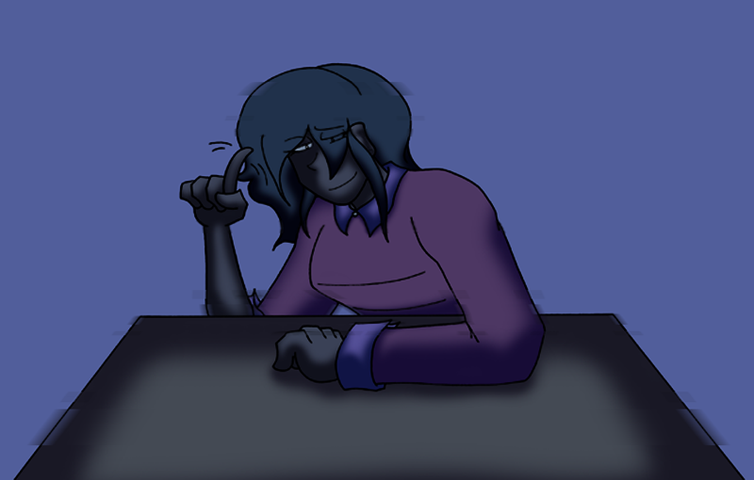

Phil slumped back. She certainly knew who she was dealing with and was acting this way on purpose. But the things she said, how long had this been going on... For a split second, Phil was glad he hadn't gone through with confronting his landlady, but worry clouded that small silver lining. What did this woman want with him? Was he part of some bizarre experiment she was doing? Phil gasped for breath and clutched at his chest. He winced and then gently patted at his torso. Even off the medicine, the muscle soreness continued. Great, so the headaches return AND he keeps the side-effects of the medication. That's all it was, just side-effects. Phil shook his head to clear his thoughts, but the sudden movement caused a flash of light and a sharp throb.

Phil stumbled out of his room, banging his hip on the door once again, but he could barely feel it over the pounding in his head. He shuffled out to the living room, absentmindedly set the air conditioning up high and collapsed down onto the couch, where he would spend most of his day clutching his head and drifting in and out of sleep.

Morning felt like it came quickly and Phil stayed in bed, his head fuzzy and his body numb. After an hour or so of a fitful attempt to rest more, Phil sat up and felt a leaden weight sink on his chest. His hand shot over and grabbed the undeniable growth. Phil winced at it and loosened his grip. Panicked stumbling brought him to the bathroom mirror and this morning's most recent unpleasant surprise. He had breasts. This wasn't just some puffiness or swelling like the doctor warned him about. He... had breasts. Phil knew it was just in his head but they felt like an oppressive weight dragging him forward, his body heavy and oppressed. In reality, they were small and would be easily hidden by a baggy shirt, but to Phil, they were inescapable abominations attacking his body. He leaned towards the mirror, inspecting himself for more changes. His hips did feel like they stuck out more, but he was leaning and angled to look at them in the mirror, and focused on his hips after bruising them... His face WAS a bit more round, but he'd been eating a lot lately and couldn't really get out to exercise, so could that be just some extra weight? But, it was the morning and his face was smooth and looked better than clean shaven. There was no denying that wasn't normal.

Phil gripped his head and shook side to side to chase away the thoughts and ideas building up in his mind. He wrapped an arm around his chest and ran to the kitchen. He rushed over to his phone, but a sheet of tattered white paper caught his attention first.

“Take your medicine, Phil.”

The writing was large script with looping letters and confident flourishes. Nothing like his own neat, compact print. Sure enough, the medicine bottle had been removed from the cabinet and was sitting on the counter.

Phil reeled back. It was this mystery woman's doing! She was... experimenting on him at night. Some twisted game and she was trying to ruin his life!

Grasping his phone, Phil mashed out his doctor's number and huddled in the kitchen corner while it rang. After several seconds, the line clicked open but then immediately died. He quickly redialed. The phone rang once, then again clicked open before immediately shutting off. Scrolling through his contacts, Phil came to the insurance company's number and repeatedly tapped the call button. The phone rang while Phil tried to catch his breath. The line continued to ring. And ring. And keep ringing. Phil gripped the phone and shook it before it let out two quick pulsing beeps. He looked down and saw the battery had been drained down to 5%. His hand swept over to the counter to grab the charger, but he simply bumped into the wall.

Phil hung up and looked around, the charger nowhere to be seen. It should have been on the counter right under the charger. The same place it had lived for years. He never moved it from that spot and would have remembered it clattering onto the kitchen floor if he'd bumped it off.

Phil decided it was time to take action. He knew this woman had some kind of connection to him and it was time to break that. There had to be a reason he'd never woken up while she was there and then seen her. It had to be some kind of drugging or gassing she was doing to him. Thoughts of hypnotism played through his mind, but Phil dismissed them as cartoonish magical thinking. If he wasn't being drugged, any ties he had to this mysterious woman were alternatives too dark to think of and Phil refused to let himself get pulled into them.

At night, Phil's plan was to prevent her from controlling him. Stop her from drugging him and stop himself from complying once under her control. As he started to get tired, he laid out two bed sheets and a shirt before getting into bed himself. Phil wrapped one of the sheets around his legs, looping them tight and then tying it off with a knot. Next, he wrapped the shirt around his nose and mouth as a makeshift mask and tied that off as well. Finally, and with considerably more effort, he looped the last bed sheet around his arms. He stuck the loop between his knees and pulled it as tight as he could. Tight enough that it couldn't be undone without waking himself up, but then he'd still be able to find some way to fight it off in the morning. He'd figure that out come morning; making it through the night was the most important part. Phil wriggled under his covers and drifted off to sleep.

Phil awoke groggy and lightheaded, but it felt different than the discomfort from his migraines or the aches and restlessness that had now become common. He tried to sit up but was held down and then remembered his plan from the night before. But now, his arms flopped lazily at his side. He was, instead, wrapped around at the waist. Phil looked around in his haze and finally came upon the tablet propped on his nightstand. There was a sticky note on the tablet with “Tap to play” nicely written in the mystery woman's familiar script.

Phil tried to get his arms to obey, but they hung like heavy limp noodles at his side. By the time he could get them to bump into the tablet, Phil was exhausted and felt like he'd used up a whole day's energy. The tablet screen woke up to a video with the woman, at considerably better quality and sound than his old camera, sitting at his kitchen counter with the bed sheets next to her. On screen, her arm retracted from starting the recording and then she just sat there. Staring into the camera sternly. Phil wasn't sure if his uneasy state was distorting his perception but it felt like minutes of her just glaring into him before she finally spoke.
“Phil... This falls well under my 'don't do anything stupid' dictate.” She shook her head in disappointment, her full voluminous head of hair bobbing along with her displeasure. “First of all, my arms? Thinner than yours. The binds were so easy to slip right off. That's how you thought you were going to stop me?!”

Phil stared at the woman angrily thrusting her arms at the camera and turning them side to side while making exasperated grunts. Stop her? No, they were to stop himself from being controlled...

The woman on the video eventually regained her composure and sat back down.
“Second! If that's how you want to act, check your nightstand just behind this device. You'll find a bottle of pills. No, not your medicine. They'll be some rather potent sleeping pills I'm going to use before finishing up for the night. You should be primed to fall back asleep shortly. Sleep tight!
Get it, because of the binds? Tight. Ha! I'm happy I got a good sense of humor.”

She reached forward and shut off the recording, freezing the image on her chuckling to herself. Phil's head throbbed and he was struggling to keep his eyes open. He could feel himself losing the fight to stay conscious and a haze was reaching in from the edges of his vision. It didn't make any sense! This connection between them. How could she be controlling him. If she wasn't experimenting on him, then the only way she could do this to him... To be him... No, this was just some drug fueled nightmare he was having and he had to wake himself up.

The following days were incomprehensible to Phil. They were just a blur of a struggle to wake up, a drugged haze, and passing back out. He had vague memories of struggling to get out of bed, sometimes flopping out onto the floor but never feeling it in his numbed state, and once maybe reaching up towards the bedroom door handle. But that's all Phil could manage through the fog. He thought maybe five days had gone by but he could hardly tell. Unsure of what that thought was even based on, slipping in and out of sleep.

Phil awoke but his head felt more clear this morning. He didn't have that leaden fog around his mind and he could look around with ease. He slowly sat up in bed and discovered that while his mind was clean, his body was now burdened by new weight. His shirt was stretched tight against the two hefty masses latched onto his torso. Phil felt them heaving and dragging him down as he slowly breathed in and out. He sat on the edge of his bed, trying to look around his new globes, only to see his thighs and backside plump and spread out under his weight. Blobs of hair bounced in and out of his vision as he looked around so he angrily swept them away. As he pulled his arms back, Phil couldn't help but notice, yes, his arms did seem a lot thinner now.

Making his bobbling, unsteady way to the bathroom, Phil looked into the mirror. Groggily staring back at him was a figure indistinguishable from the mystery woman's appearance on camera. Seeing her now in daylight and beyond the resolution of outdated technology, the similarities were almost too much to bear. Phil could make out his own features in her face, if he could make it past the swarm of hair and curves.

Piloting the foreign body to the kitchen, he found the woman's tablet primed for another message.
“Phil. Phiiil. Philly! Big day, right? I gave you your freedom back because my work is done! Nothing can stop the plan from here on out. Soon, we'll part ways and both have our independence. A real shame you didn't just follow my orders and do as you're told. You might have walked away a bit more... under control, can we say?”
She motioned to her chest and shrugged.
“I left you some of my old clothing. It should fit you just fine now. And you can keep it too! I won't need it soon. I've been set up with a new identity and I have to say, while it's been sooo lovely being stuck as you all this time, the new me is far better than what you gave me. Great news, I haven't had a headache in days! I'm guessing you won't either. They did nice work, right?”
The woman cheerily waved to the camera then leaned forward once more and shut off the recording.

Phil sat at the kitchen counter, silently slumped forward. Partly because getting up would mean having to face the reality of these past few days and partly because it felt good to have the counter carry the weight of his new chest.

Unable to delay it further, Phil solemnly pushed himself up off the heft of his wide backside and got ready for the day. Going through the motions felt so mundane compared to the horror his unknown other had inflicted on his body. Some body he shared with her against his will.



Staring down into his drawer, Phil looked over the new clothing neatly laid out and donated to him. He silently slipped on a new bra and hoisted his weights up. It did feel better to have them contained like this, but Phil refused to accept thoughts on silver linings now.

He had another personality growing inside of him. Was she some parasite or always there... Was she the cause of the headaches or did him being drugged bring her out? And why the cruel, vindictive personality to inflict this on himself. Phil never had problems with self-loathing, so why would this thing torment him... Did the medicine create her or corrupt something already in his mind...

Phil was snapped from his confused, circling attempts at understanding the situation by a loud, rapid knock at the door.

***********************************************************************************
Read more Mercynaries comics and stories at: https://www.patreon.com/SinComics

