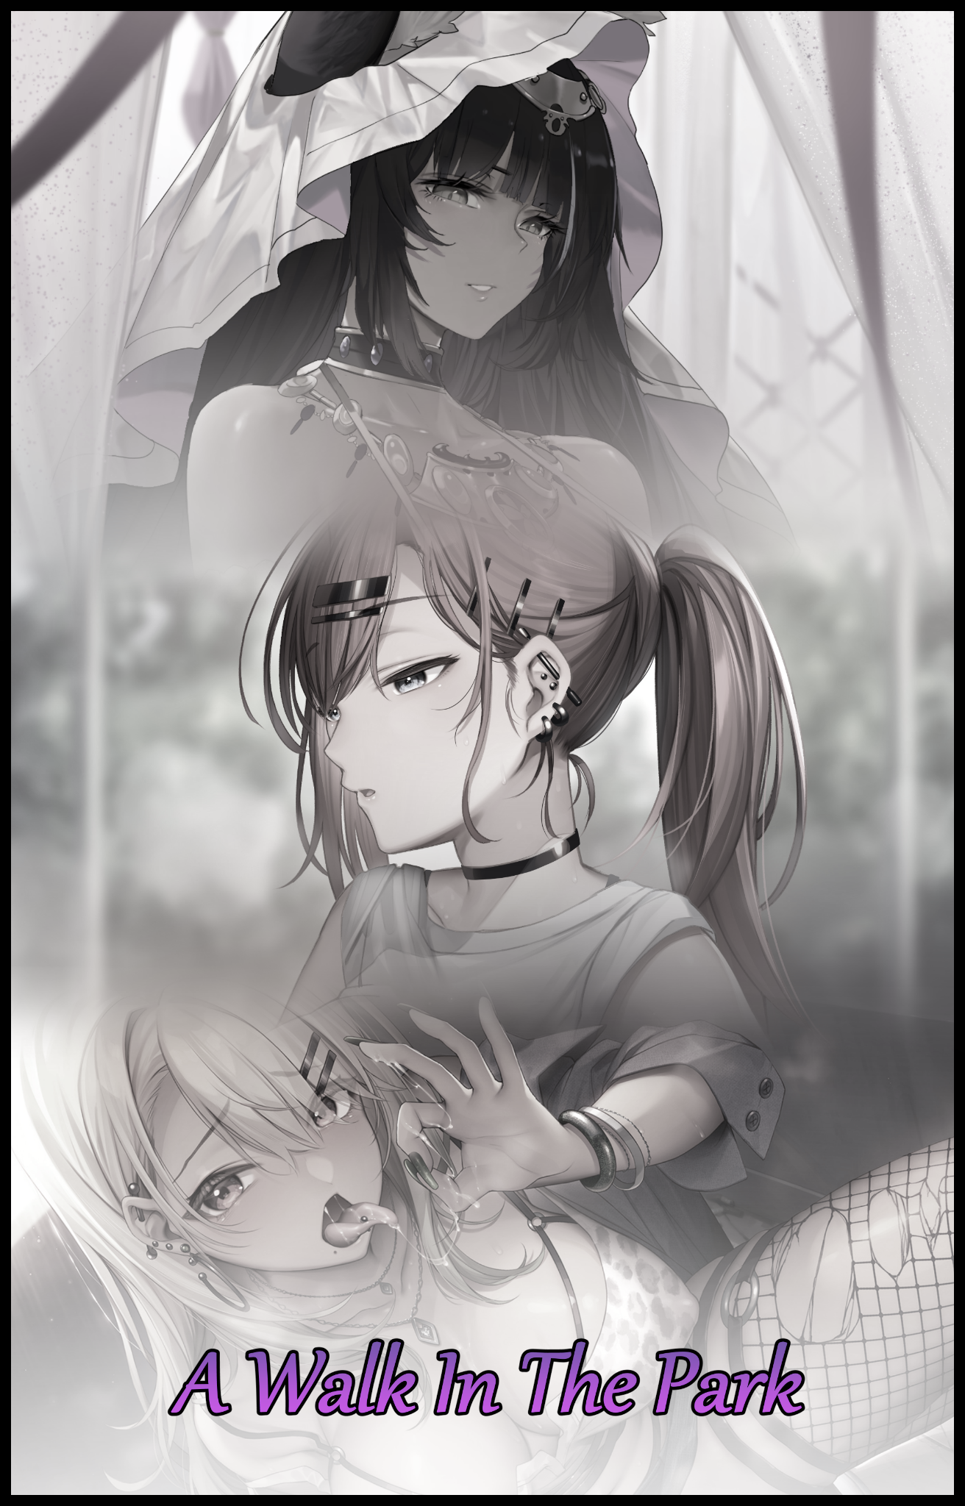

In a quiet central city park, there lurked a certain individual whose appearance belied a horrible reputation. One that had a massive bounty hovering over their head worth more than five times the amount it would take to build a boozy millionaire’s private retreat. A titanic sum the likes of which had never before been seen in the history of man and one that had only continued to grow in size with the continued failure to see the outlaw's punishment through at the hands of the global court.

But to amass such infamy, the crimes committed would have had to be on equal magnitude. Terrorism, massive loss of life and other crimes against humanity on an unthinkable scale. Plotted and executed through a network maybe. Headed by a mastermind who had evaded capture for so long thanks to wit and the fact that they would never operate directly. Hence the authorities inability to track them down and bring his reign of terror to an end…that was what most people had immediately assumed of this mystery fugitive when reports of his bounty and ongoing activity made headlines across the world. But the truth was far more complex and, in a way, simple than one might think.

A solo act. That was what made the fugitive incredibly hard to track and pin down among other things. It was bad enough that they didn't have any associates to betray their identity or other such juicy secrets. But when initial reports were compiled and made about their misdeeds. It left the first responders over at the police stumped and quizzical. Unable to take what they were reading seriously until the seemingly superpowered criminal's sights came to rest on them.

Many forms of entertainment media had explored the idea of the Evil Superman; a demihuman with the power to end or reign over the Earth and its helpless human populace as they went on a power drunk crime spree. Knowing full well that nothing could stop them until the introduction of kryptonite or an element-X of some form that would put them down once and for all…or in some instances, fail entirely. Ending off on a sour note. A doomed outcome the inhabitants of the real world seemed to be headed towards with the emergence of the Warper. A nickname the global community had colloquially come to an agreement on after viewing their handiwork for the first time once the scientific community had overcome their initial disbelief after being asked to work on investigating how the human body could be altered in such a way that defied all established conventions and sciences. Left with no choice but to substantiate their government's claims to the people that the Warper was indeed; a supervillain. One who didn't seem to be in it for monetary gain or global infamy, but because they reveled in it like a perverse addiction of sorts, transforming people against their will into shadows of their former selves for the fun of it through a means not yet understood by those in pursuit of the Warper's ever lengthening trail.

Like their namesake implied, the Warper's signature was left in the form of their target being afflicted with an irrevocable change that seemed to vary wildly from a case to case basis. Random outcomes, random targets…and the worst part was the further implications of the fugitive somehow being able to mess with the fabric of reality itself as a part of the process to transform their victims. Requiring the toil of various teams in the creation of a series of hypothetical 'rules' in an effort to try and pinpoint a viable weakness they could use to track down and apprehend the elusive supervillain for good. Possible energy signatures left at the scene of the crime where victims had been found, pouring through CCTV surveillance footage to weed out artifacts or other such glitches moments before and after the infamous 'Blip' that occurred so fast, the description of the victim sucking in a breath of air before carbon dioxide would leave a different set of nostrils was terrifying fitting…

So many plans were tried and failed, conjured from crackpot ideas and theory crafting with no real basis to go off of. All while the Warper would continue to add to their list of victims. Changing people like it was going out of style while the majority of the public would remain more or less ignorant to the threat posed by their actions thanks to the aforementioned effect his abilities had on reality. Masking the fates of what must've been thousands of victims who had the misfortune of going unobserved at the time of their change resulting in their former lives as a whole being replaced entirely with the world reacting as if nothing was wrong. The only concrete finding that ultimately resulted in nothing more than alerting the world to the Warper's existence and the bounty on their head. A growing sum that would never be collected considering how no one even knew what the face behind the villainous mask even looked like. Nor would they ever get the chance to once the day was up, for the nefarious villain had something big in mind for when the sun would next crest below the horizon.

But there was still plenty of time left until the midday sun would reach that point. So until it did, the Warper couldn't think of a better way to pass the time than to pick out some 'lucky' individuals amongst the rather quiet weekend crowd meandering through the spacious park to feel the winds of change. Pulling out a small handheld device of a sort that looked like a cross between an old fashioned cell phone and a remote to operate a car lock; the secret to their success and the true bearer of the fugitive's title. Readying it beneath an encompassing sleeve with a thumb over the singular red tinted button that made up a sizeable portion of the device as the unsuspecting Warper takes the first of many steps in a slow walk beneath lush greenery and a scenic backdrop made up of rolling hills, well kempt shrubs and a shimmering pond.

Nothing but the people mattered to the villain as they trudged down the cobblestone walkway without so much as a single twist of the neck. A shadowy gaze, focused on what laid ahead instead of the park's faux natural beauty while a lax posture radiates serene calm. Masking the roiling mass of dark thoughts and sinful urges brewing away within a decrepit mind as shifty eyes scanned their surroundings. Darting to and fro on the lookout for suitable candidates with which to ply the trade with…and as a small cuboid building tucked away beneath a cluster of trees comes into view, the shifting figure sliding in past the entrance pique's the Warper's interest. Turning to face the outdoor bathroom with a wry smile on their face at the devilishly simple idea that comes to mind as the hooded figure comes to rest on a nearby bench. Pulling out the device in full with the button already depressed, watching as the screen fills with a series of three dots blinking in repetition before a wall of text blinks into existence. Disregarding most of it to filter out the noise with a seasoned precision until only the necessities remained. And what the Warper saw was enough to make the wry grin splitting their lips widen into a menacing smile…

A decadent, two-bit lowlife. Single and without any family left who'd care enough to bat an eye towards whatever happened to him. A brief but adequate description for the obvious drunk who had stumbled into the bathroom with a not so subtle wobble to his gait. A wastrel of a soul with the name of Felix Mendels and a perfect catalyst to serve as the opening event leading up to the promised hour. Setting things into motion as the cackling Warper's hovering thumb descends upon the device once more, pressing down on it with scarlet irises devoid of conscience already locked on to Felix's position behind the toilet's outer wall. Envisioning the perfect scenario for his latest plaything as the scrappy tiles that made up the cheap walls and floors expected of a public restroom takes shape within the depths of a twisted headcase. Adding a dab of grime on the stalls. Rusty metal pipes and the stench of a suffocated toilet that had seen many a visitor without much maintenance to complete the lovely environment Felix had been forced to step into if he didn't want to crap his pants while taking a chance elsewhere in the hopes of a cleaner toilet to use. And the fact that he hadn't needed to wipe the seats before use was enough of an assurance for him to settle in somewhat despite the rank atmosphere of the claustrophobic stall he was currently nestled in.

Cursing under his breath while withdrawing a lighter and cigarettes from his breast pocket in the hopes of making this miserable experience go along faster, the thug, with the stinging onset of a migraine dulling his senses in addition to an alcohol soaked system would barely be able register the tickle of lengthening hair brushing against the nape of his neck. A neck that steadily tightens inward in a strange manner that could be seen spreading across Felix's wide frame. Pinching in around the waistline while the arms of a brawler melted away into markedly weakened manipulators. A reduction in stature, triggered without prior warning and occuring at such a rapid pace that by the time the lighter's flame had managed to ignite the tip of the cigarette held between thinning digits, a noticeable khaki hued tan had already replaced the former waxen beige of the gangbanger's toughened exterior.

Although 'toughened' might be stretching things a bit now that the coarse texture and wiry strands of body hair had all been cleansed and painted over. Showing off a glossy sheen that only served to bring emphasis to the subtle hints of tender meat and lean bone pressing up against Felix's compacted figure. Losing whole centimeters in height while a wide, imposing wall of muscle and fat gleaned from a rampant drinking addiction had become a far flung memory in the face of the petite, lanky figure that had subsumed his core. Replacing steroid fueled lumps that were an affront to bodybuilders the world over with gentle cushions of appealing fat while obese pockets vanished altogether. A startling change that had not spared the clothes that wreathed said rippling mass as the lifeless fabric undergoes its own change; creeping up Felix's body like a rising curtain to expose a tummy that had been reduced into a comfy cushion of roiling fat formed from repurposed abdominals while baggy sleeves fell away to show off slender wrists adorned with golden bangles and silver chain bracelets. Clinking together once the vestigial remnants of a cheap, knock-off luxury watch comes apart to form the real deal. A sharp sound that snaps Felix out of his tobacco induced stupor as clawed fingers ending off in artificially lengthened shells painted a toxic green falls away from the front of his face. Just in time to avoid drooping, side swept bangs coming down to frame it alongside curling extensions and silky locks of dirty blonde. A new color that, like his shiny 'wet' skin, had grown over from the root itself. Overwriting dark brunette to give him quite the trashy look. Especially once a flimsy, leopard print singlet finishes its growth and separation from the amorphous blob to settle over a chest that had lost its chiseled hardiness for a soft, enticing look that better suits a slender torso with curves in all the right places. And while the condensed mass of fabrics, lace and other such materials finish splitting off and morphing into three distinct sections including the aforementioned article of clothing. The initial onslaught of seemingly random and unpredictable physical deformations steadily begin to look more systematic once an abused spine corrects itself, snapping inward near the base of the pelvis to take on a more provocative posture that emphasizes a swollen chest swelling to fruition while a blocky rump down below squishes against the seat. Forceful, aggressive changes that would continue to be ignored by Felix who seemed to be more occupied by the pretty refractions of afternoon sunlight streaming in from the windows above bouncing off the jewelry slung around his wrists without a care in the world for the excessive muscle he had prided himself in being wiped clean down to the last layer in a body that was no longer his own…

Questions about where on Earth he had even gotten these brand spanking new accessories would float around inside a rapidly emptying mind while the remnants of a raggedy business suit that had seen much use finalizes itself as a baggy purple crop top. Popping open the front to give the burgeoning growth of a healthy pair of milk laden teats some air to breathe as they surge forward. Two perky melons pulled forth from wasted pectorals as hairy brown nubs shiver before spasming like panicked worms. Shaking off the last unsightly bits of burlesque manhood while taking on a rosy pink glow, hardening in unrestrained arousal once dormant glands and stimulated nerves flare to life across Felix's sweaty body. Bringing a heightened sense of awareness to how feminine he was in comparison to the hard-boiled brute he had walked in as. A futile effort by a waning mind that didn't do much to make him notice how girlish his own demeanor had become; sitting with alluring legs crossed over the other, suffocating a receding weiner sliding into a freshly carved opening oozing pale nectar where wrinkled sacs once laid. Plump thighs of cocoa goodness bereft of ugly bulk, meshing like freshly roasted marshmallows once shredded fishnets derived from ruined pant legs secured themselves around their jiggly girth. Firm calves swinging gently in the air that taper off into waifish feet clad in sneakers instead of ugly boots…

Pearly lashes flutter in response to the ticklish sensation of something cold and hard linking itself around a dainty little neck. Averting the gaze of a foxy pair of eyes cleansed of heavy bags atop rosy cheeks to stare at the gemstone nestled atop a heaving set of tits. Tanned skin painted with subtle maroon highlights as blood pressure rises in response to the titillating sting of piercings embedding themselves all throughout her body. Shivering in alien delight as invisible hands fill soft earlobes with gaudy studs, gasping in a high pitched voice against the insertion of cold metal into a warm belly button, ending off with a primal sound forcing its way out of a saliva soaked throat before a flailing tongue molds the intangible vibration into the unadulterated moan of a shameless minx. Laced with ecstasy, dripping with wanton lust and burning with sonorous vocals befitting the young woman that had replaced the oblivious gangster in the men's toilet. Ending the emasculation of one Felix Mendels with the branding of a broken heart tattoo searing itself into the pudgy meat of the newly molded skank's left thigh just inches away from an exposed snatch barely hidden beneath the woefully short hem of a leather miniskirt. Seeding her loins with a brief moment of searing pain that evokes a vulgarity out of equally depraved lips as the blonde spasms in perverse delight, spoken with all the sensual grace expected of a whore. Burning that identity into a brain that could no longer process complex thoughts and unimportant memories besides the raunchy images that had flooded it ever since amber eyes had come to rest on the necklace she remembered her father…no, her daddy giving her during…childhood? No, no, that wasn't it, it had been a gift for her hard work out on the streets…yes, that sounded right…sounded good.

And once more shattered memories aligned themselves into the distorted vision prepared for her by the inescapable influence working on her like a sculptor would a slab of wet putty, all Vivian could do was coo in vapid delight once the full force of freshly sown desires and wants comes crashing down against her psyche. Erasing everything in relation to the useless thug whose ego was far too big for his own good. Freed from the Warper's influence once the leathery straps of a cupless bra and racy G-string finishes encasing her tenderized body. Squeezing into breast meat with enough force to dislodge a heavy left breast from its flimsy covering while an unrelenting snake worms its way between voluminous ass cheeks before digging into Vivian's pussy. Rubbing against a defeated pecker nestled atop a juicy pair of fattened lips and moistened folds, stimulating nerves to swell into a swollen clitoris in tandem with a second jet of shimmering fluids being ejected from a puckered hole and into the toilet bowl below. An orgasmic release that sends a wild mane of blonde hair highlighted with ivy green flying as Vivian's head cranes backward, screaming her joy for all to hear as her undulating vagina crowns itself with a smooth bush of brunette pubes. Finalizing her place in the world just in time for the stall door to open and the wasted cigarette in her hand to fall to the floor.

The cubicle around a sweaty Vivian had become even more roughed up than it had been previously. Littered with used condoms while glory holes had been carved into the walls on either side. Igniting vision after vision in the street walker's inept brain as she takes the man who had walked in on her inside the stall. Shutting the door behind him while an overeager hand slinks inside his pants to caress his oversized meat. Excitement burning strong within soulless eyes while estrogen and other feel good hormones flooded her needy body in anticipation for what was about to happen as Vivian mounts the toilet seat like a podium. Balancing herself expertly on the rim as if she had done this many times before. An undeniable fact considering how everyone with dealings in the seedier aspects of the city's nightlife bore memories of Vivian for the voracious slut she was just like her body remembered; knowing where to pinch, pull and lick with a single glance of a man's weiner after sampling the all the cock there was to fill her mouth, pussy and ass with. From the small, adorable ones she found just right to play with using her pinky to the large, veiny specimens she loved to feel knocking against the back of her throat. Bonus points if the stud was daring enough to wrap his hands around her head like she was nothing more than a doll to be used…and as the aromatic stench of a man's rod wafts into her nostrils, Vivian knew exactly what to do with her client as he slips her the fee before closing in, ready to do the deed much to the chagrin of their singular audience. Who had already dusted their pants off before continuing on their stroll down the path. Paying little mind to the small crowd of men that had gathered around the toilet. Masking the faint moans and grunts of a 'young couple' going at it within the depths of the concrete structure.

Giving form to Vivian had been a great opening to the afternoon's events, but the joy extracted from the deed soon leaves the Warper's insatiable appetite wanting for more. Reaching beyond the scum of the Earth to try something they'd never done before, at least, within recent memory. With a little…scratch that, a lot of the raunchy flair their work usually came bundled with. And with a little time spent wandering the park while ignoring multiple notifications from the device, the fugitive's eyes would come to rest on an athletic man speeding by on a late afternoon run. Marking him as the next hit with a quick swipe and a successful beep. Coming to rest against a nearby lamppost, waiting for the next time the blissfully ignorant soul would pass them by as someone else altogether. A fate Johnathan Jorgen would not be able to outrun even with all the speed he could muster once the Warper's insidious influence catches up to him. Phasing through skin and flesh to touch his very being, triggering a series of changes that would again, go unnoticed to most of the park including Johnathan while bounding legs kept his momentum going strong. Even as they began to throb and contort, retaining their remarkable length but losing the precious thing he had earned through years of strenuous training and endurance as each step ends with a subtle decrease in speed. Too small for the naked eye to notice but accrued at a rate fast enough to leave the athlete struggling to keep up the pace he had come to set for himself as a standard. Not when the bulk of his quads had all but vanished like smoke in the wind.

But the adamant athlete would not let it slow him down anymore than it already had. Fighting back the urge to slow down to a jog through sheer strength of will. Keeping the momentum by making up for lost distance traveled per step with a simple increase to the amount of steps he took. Turning the steady beat of sneakers slamming against the pavement into a rising crescendo of heavy footfalls. A commendable effort that would prove insufficient in the long run as the changes wracking Johnathan's body continue to spread, leaving their mark in the form of a slender pair of legs that looked more like they belonged to a gravure model rather than a rising star athlete. A rather slow change in comparison to what had befallen the forgotten thug being taken in the men's bathroom by a second client right about now. Knowledge Johnathan wrinkles his nose against as he sprints by the popular 'attraction'. Wondering when the authorities were ever going to crack down on the solicitation of sexual favors going on in broad daylight ever since that skank had decided to use the building as her love nest.

Sensing and accommodating for their victim's adamantine will, the unseen force changes its tactic. Applying an added strain on Johnathan's mind in an effort to go after the foundations. Seeking to alter the root while keeping that pesky determination of his in a hijacking that would see said will speeding up the metamorphosis instead of hampering it.

Allegiances and ideologies were the first to go. Forgetting about a crush he didn't yet know was already engaged to another while a stern outlook for a useless roommate who he had to share a dormitory space with in university ebbs and distorts into an incoherent mess. Forgetting why he had even despised the oaf in the first place as knowledge of the man's bad habits and irksome hobbies that contrasted his own were immediately lost to him. Leaving a void to be filled with realistic fabrications that would in turn, supplant hatred and negativity with earnest desires and bubbly warmth. Soothing a troubled heart and mind that had accepted the corrupt slice of mental information, slotted in to replace the chunk scooped out of it without notice. An act that weakens the structure as a whole once synapses flare in response to the change. Taking to a figurative knee once Johnathan's mind comes under full assault. Allowing for the changes to his physical form to resume unabated and at an enhanced speed. Working in tandem with a failing mental state while his pace soon stabilizes into a steady sprint instead of the maddened dash the athlete had been desperate to maintain a moment ago.

Instead of the memories that told him all he needed to know about why his roommate was a deadbeat asshole who couldn't be trusted. New experiences in a markedly divorced university life far from his own would say otherwise; filling Johnathan in on a hidden side to the unexpectedly suave man he had never seen before as conveyed through quiet moments spent during their first day together in the bunk. He should've felt even more disgusted by the obvious quips and pick up lines being sent his way by a detestable bastard like Isaac…and yet, it all felt so…distant and new at the same time. Finding less and less of a reason to hate and more things to like about him the more Johnathan loses himself in what was obviously a facade from the view of a girl that had yet to be born. Ensnared by the life-like vision of his roommate from two years ago, tracing over features like that spiky mop of hair and those dark, brooding eyes he loved to feel staring at him all the time…because with a figure like hers, who wouldn't?

A passing, inconspicuous thought like that would simply be the first of many fatal hits dished out against Johnathan's waning sense of self. A blow to his identity that gives way for the reshaping of flesh to resume in earnest as a lanky figure pinches in at the center, bestowing undulating waves to an overall silhouette that had begun to edge closer and closer to femininity with the emergence of a cushioned stomach flanked by meaty handholds; wide hips that would aid in the birthing of many a children as the necessary organs manifest within the athlete's morphing body. Adding weight and heft that aids in the formation of an adorable rump as unremarkable cheeks fill with fat and mass. Sagging just enough to form a rotund curve demarking the point where slappable cheeks ended and meaty thighs began. Panting in arousal as his mind continues to dwell on the visions of an as of yet nameless young lady's first encounter with love, speeding by awkward conversations and dates to the point where things had grown enough for her to allow Isaac a feel for her sensual form without complaint. Experiencing that life-changing moment in a solidifying past where the mischievous man had given her ass a good squeeze while they were on the way to class. Replicating the intense arousal Johnathan had to deal with afterwards for the entirety of the lesson in silent suffering as his testicles in the present empty themselves before splitting apart down the middle. A morbid display of flesh and skin moving in unnatural ways to the whims of an inhuman force. Flexing and smoothening out into blankets of tender skin and hypersensitized flesh. All contained and hidden away within the shrinking bulge of tightening running pants as it shifts itself into marginally smaller boxer shorts held up by handlebars of lovely beige that had replaced a Caucasian tan. Leaving the athlete unrecognizable as he sprints past the halfway point toward the finishing line. Although the masculine form of address could no longer apply to Johnathan at this point. Not when the pecker he had found some pride in had been left in a sorry state as nothing more than a pink nub of collective nerves. Shivering as newly formed internal muscles pull it into place beneath a blanket of moist skin. Signing off on the completion of a fat, juicy vulva tucked away between long curvy legs that could no longer bound and leap great distances. A worrying fact that would've left Johnathan screaming in denial besides the equally harrowing loss of her manhood…that is of course, if she even remembered having those traits and abilities in the first place…

But with how thorough the mental scrubbing was and her indulgence in them after her ability to deny them had been crushed. The rest was simple work for the Warper's influence to finish up on as bubbling masses of congealed flesh derived from repurposed muscle and miscellaneous tissue gently grow out into a pair of perky tits. Not incredibly large funbags by any means but still enough to leave any man satisfied should they find themselves lucky enough to wind up in bed with the European redhead, whose demeanor had gone from hardcore athlete to attention seeking beauty. Reducing her already sluggish sprint to a slow jog now that the reason and drive to continue had evaporated from her pretty little head. Doing so not to build up more muscle or endurance for a marathon but rather, to lose any excess weight she might've gained over the week. One of many deviations from a fading set of memories belonging to another life; recalling the moments of impromptu finger banging she had been subject to whenever her lover felt the need to busy his hands instead of isolated lunches and studying all on his own as an icky man that wasn't Isaac. Or the immense joy she felt when Isaac had reciprocated her confession with hours of sloppy kissing and messy dick sucking preceding an even longer session of heated lovemaking to mark the loss of her virginity. Unable to stop herself from moaning mid run as her innards, now molded after the phallus of the man she once despised, clenches in need. Soaking her boxers with a liberal squirt of vaginal juices…
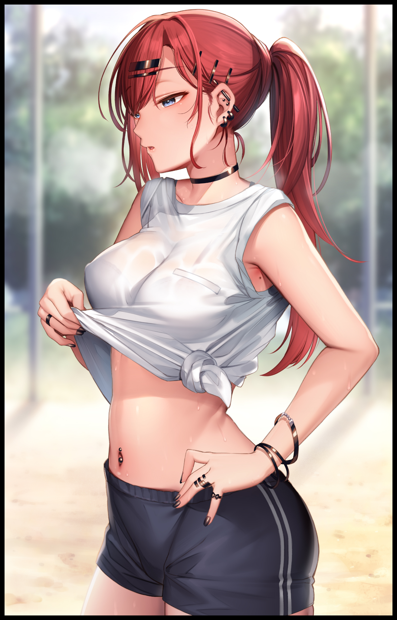
And as a tight leather choker snaps itself around her neck, the emergence of a new, foxy persona finishes its usurpation of Johnathan, or rather, what little remained of the former athlete's soul. Perverting it into that of a daring minx who wouldn't be afraid to show off a gratuitous amount of skin to the public eye as demonstrated by the use of boxers so tight the outlines of her pussy were clear for all to see while an altered singlet she had tied most of its length into a knot above her navel exposes the eye-catching curve of her back and the majority of her navel. A habit seeded and grown by Isaac's encouragement over the three years they had been together now that would embroil her in many scuffles with the obnoxiously righteous oafs that littered the streets. Preaching moral nonsense Aine Byrne could care less about. Asserting faith in an identity that serves to cement Johnathan's fate as Isaac's significant other in stone. Never looking back on that sickening old life of hers as brooding accessories of ebony steel begin to dot her figure. Piercings on certain portions of her body, wristlets to draw the eye toward her fair digits, ear studs and hair clips contrasting against a flourishing head of crimson strands tied into a long, wavy ponytail, decorated rings of intricate design to go with trimmed shells of polished night. Most of it, bought with her own money earned from posting lewds and nudes online for the horny masses to throw dough her way while others, like the choker and even a womb tattoo hidden just out of sight above her well oiled snatch being gifts from her dearest Isaac. Coming to a sweaty stop right outside the toilet, the crowd lingering around the entrance as large as it always was. Eager for their turn to do the fabled whore lying in wait for them inside no doubt. She had spoken to the woman before, and what she remembered seeing her do brings to mind a few things Aife could replicate with her boyfriend tonight once he was back from working that side gig of in the privacy of their dorm, putting a seedy smile on her beautiful face as half lidded eyes of steely azure narrowed into a dreamy stare at the thought of it all. Humming the tune of her favorite song with that husky voice of her’s while sashaying her way out of the park. None the wiser to the ‘performance’ she was putting on for the Warper in her midst as the lecherous gaze of the shrouded individual lingers over Aife's swaying ass…shrinking into the distance as the foreign maiden leaves for home. Turning the Warper's attention skyward as red eyes match the crimson glow of fading sunlight beyond a canvas of red and blue coalescing into one harsh tone; the afternoon's imminent end and evening's dawn.

But before they could enact their great plan. A loud voice shouts for them to turn around, breaking the park's serene atmosphere and causing heads to turn their way as what few people remained nearby became spectators to the sight of a police officer turning his gun on a suspicious figure. Oblivious to the damning reputation possessed by ‘him’ as they watch the man comply. Turning slowly with arms raised up high…before they draw inward to pull the hood off of their heads, freeing a silken mop of raven black hair that cascades down and around the woman's shoulders and back in a wild, animalistic curtain. Unveiling the Warper's identity to be that of a woman. With deathly pale skin contrasted against bright red irises burning with an insidious fire as they come to rest on the officer who had thought himself capable of apprehending the supervillain without a fight.


Emotions were like a double edged sword; for they could hold one back from doing what must be done for whatever cause they might serve. Just as easily as it could empower them to do the unthinkable, putting the mission before personal feelings got in the way to muddy things up. A dilemma the Warper herself knew full well about after everything she had done and seen over the many lives she had lived ever since coming into possession of the otherworldly device that had enabled her to become the world's most feared individual ever to exist. And as long as she held claim to the immense power nestled literally in the palm of her hands, she would make certain that the world would never forget her reign of terror. Not even bothering with the unfortunate officer's personal information as her thumb descends upon the remote's button once more. Sending the crowd dispersing into a panicked mob as they realized what they were seeing. Leaving the policeman to his fate as a concentrated miasma of the remote's energy ensnares the frozen man, a gathering of energy so thick and vile that the people who weren't fast enough to clear out were caught in the transmogrifying maelstrom that continues to expand. Joining in the officer's fate as bodies shifted and melted like moistened clay while the ground they stand on ripples into a flat plane of polished marble instead of rolling hills and artificial grass. Their clothes meshing together to form a uniform mesh that splits apart into unusual shapes. Solidifying into ornate jewelry and revealing raiments while far more unusual changes strike their pulsating bodies. Coaxing what looked to be a bundle of tails out the back of bloating derrieres while fleshy ears melted away into nothingness before vulpine extrusions pop out the top of rejuvenated scalps. Twitching as nerves connect while fine fur that matches midnight purple hair grows to cover the newly grown organs. Doing so with the flurry of tails that had grown to full size behind each victim of the encapsulated masses once their respective mutations reach a peak. Removing all signs of individuality from the dozen or so humans trapped by the Warper, smiling a toothy smile as she watches the rippling humanoids darken. Gaining an exotic tinge to their lovely hides just in time for a lewd ensemble to gather around their increasingly voluptuous forms as fat and tender flesh surges all over. Encouraging massive mammaries tipped with dull brown nipples to bloom while a sensual figure perfect for swinging and dancing to the sinful beats of dark music settles into place. Bountiful bodies of fox women decorated in jingling ornaments, transparent veils and scandalous underwear. Finalizing their rebirth into the world as the Warper's very own personal harem of Egyptian-themed Kitsune dressed in titillating dancer's garb without a care in the world for how exposing it was. Expending a bounty of power gathered over a millenia's worth of temporal resets to shape the very Earth itself along with those who walked its surface to whatever the villainess desired, like for instance; twelve or so Egyptian demihuman sisters with a shared mind to service their Mistress~ Men, women, righteous folk or the debased, all would feel her touch whether they liked it or not, just like all the others she had 'turned' without society's notice.

It had taken so long, so many resets…walking the same, boring old Earth filled with equally boring people she must've altered a thousand times over now. All in a bid to gather the required energy needed for her grand plan to succeed with each soul she would alter, resetting time by 'Warping' herself back in time soon after reaching a ripe old age back during a first loop filled with disgusting moral choices and decision making that had cost her much.

But as the Warper walks up toward the Kitsune that had been the oversized heroic wannabe minutes ago, none of that mattered to her anymore as an outstretched hand reaches past the veil barely concealing her dancer's vagina from view. Pinching the needy fox woman's clitoris while relishing in the strong, aromatic scent of lavender wafting off of her convulsing tails. Her ears taking in the sound of a deep, enchanting voice she couldn't wait to hear sing the high notes for her before releasing her grip on the Kitsune’s privates, beckoning for her to follow as the rest of her siblings fall in line. Moving with the grace expected of women of their caliber, paying no need to the formation of a cathedral-esque bedchamber building itself from thin air as the expanding sphere consumes the park before continuing its spread unabated…

With her dream of sleeping with fluffy tails and beautiful Egyptian women accomplished, the Warper would savor her reward for a job well done. All while the rest of the world would slowly reshape itself around her and her foxy harem. Never to be the same again…

THE END

Image 1 & 2 by Nanafuton : https://www.pixiv.net/en/users/72613636

Image 3 by Dishwasher1910 : https://www.pixiv.net/en/users/13408193

