RED ROPED
COMMISSION STORY
BY CHALDEACHANGE
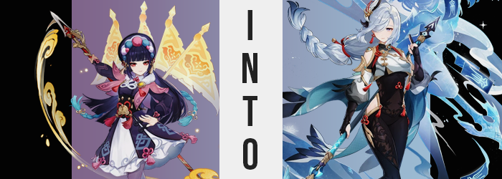

It was rare to find Yun Jin in Liyue’s mountains.

Well, perhaps it wasn’t as rare as one might expect. She was a famous opera performer in Liyue Harbor, and so she certainly wasn’t the type of young woman whose image might have meshed with scaling mountains. At least to those who didn’t know her on a personal level. But Yun Jin was very much the outdoorsy type – fitting, perhaps, for a holder of a Geo Vision.

But when she took long trips through the countryside it often was with intent. No one just ‘went for a stroll’ through the rolling mountains of the nation unless they had an ultimate goal in doing so. For her it was often a case of seeking inspiration. If she was to put on greater shows and tell grander stories in her position then she naturally always had to be on the lookout for new materials.

New locations, new sights, new people, new experiences; these could all aid a creative mind if tapped into, and Yun Jin was keen on utilizing each and every thing at her disposal to constantly put on the best shows of her life. So typically, if anyone caught her roaming through the wilds, she would often offer that as an explanation. Even if she sometimes did go on trips to train with her spear in secret. Not a hobby quite fit for a performer but one she still treasured, nonetheless.

A lady had to be able to take care of herself, after all.

This outing was a rare case of an instance where the young woman wasn’t out and about for either reason, however. In fact she had traveled far deeper into the mountains than she usually did, and she wasn’t doing so as aimlessly as was often the case. She had come out into the mountainside on an invitation for once. “Hm… She said it should be around here, correct?” She had recently made a pretty interesting friend. An amazing one, in fact.


Shenhe. A human woman that had been raised by the Adepti. An unheard of scenario, but one Yun Jin had confirmed through her own experiences. Shenhe was a woman cursed by fate, a woman who had weathered horrors but found the strength to keep going – along with now possessing a place where she truly belonged. But tragic backstory aside, the two had become fast friends through it all. And so Shenhe had eventually invited the opera singer out for a visit.

If… you could call it that? “Why did she have to choose a random cave? I’m practically doomed to get lost…” Since Shenhe lived primarily with one of the Adepti, Cloud Retainer, visiting her at her real home was something of a no-go apparently. And so Shenhe had ultimately suggested that Yun Jin visit her secondary home, a cave she used in a neighboring mountain when she was out late.

It had been something of a hassle to find, but eventually she managed to find the location. Once inside it was difficult to deny that it was likely Shenhe’s abode. Supplies were limited but there were clear signs that a person had been living there. Unless animals set up a bed and were hoarding little gizmos that could have only been pieced together by Cloud Retainer’s inventing… talons.

“Shenhe? Are you here? Did she perhaps step out? Hm… I’m sure if I wait for her she’ll come back.” Yun Jin was later than she had said she’d be, but she couldn’t have properly timed such a long trip. It was Shenhe who had given her an estimation of how long said trip should have taken, but in retrospect? Maybe the woman with long legs and freakish stamina who also happened to live in the mountains wasn’t the best one to ask how long it would take to trek through said mountains.

And so the dark-haired woman resolved to get comfortable. There wasn’t a lot in the cave, but Shenhe being something of a minimalist didn’t surprise her in the slightest. Aside from the bed and the gadgets there were some spare clothes around and some utensils for cooking. But there wasn’t much the visitor could do with these to amuse herself. It was then, after moving slightly on the bed’s top, that she noticed something underneath. With a little tug she pulled them out. “These are…?”

Held in Yun Jin’s hands were a set of red ropes. She recognized them of course, how could she not? They were the very same set that Shenhe incorporated into her outfit. Supposedly they helped repress the curse that she had the displeasure of being bound by and under no circumstances was she supposed to remove them. Yun Jin had always assumed the limitations weren’t that strict though. How could she bathe with them on? Albeit briefly, Shenhe must have had moments where she didn’t wear them.

And did this imply she kept spares? “I suppose it wouldn’t be odd that Cloud Retainer would prepare multiple sets…” And Shenhe likely kept some in this cave in case of an emergency. Just as the Geo Vision holder was about to put the ropes back where she found them though, something odd happened. Those ropes slithered as if they were snakes and wrapped around her shoulders and back, binding the woman in the very same way they bound Shenhe.

“E-Erm!? Down, ropes?” Yun Jun naturally didn’t know how to react to this change of circumstances. The force of the ropes fastening themselves to her body had sent her torso flying back on the bed but she then ultimately managed to regain her composure and stand up so that she’d have an easier time attempting to pull them off. They were just ropes. Whether or not they’d gained a life of their own to bind her or not didn’t change that she should have been able to easily remove them.

Or so she’d believed, and yet it didn’t seem to matter how much force she applied. Even though it should have been as simple as rolling and pulling them off of her shoulders, they just wouldn’t budge whatsoever. “Hey now! Get off of me! Shenhe will think something odd if she sees me wearing her clothes!” And that was something she really didn’t want to happen. Doubly so since she believe she had been beginning to develop a crush on the tall, white-haired woman.

It almost felt a touch funny that the opera singer had pictured Shenhe’s hair with such fixation in that moment, as for reasons she didn’t quite understand her own hair began to develop strands of the very same, snow white color. It began with only a few strands that were dyed and oddly appeared to grow about five inches longer than her hair normally was, though the very tips in the back remained black. Yet one by one, then ten by ten, and fifty by fifty; the rest was dyed snow white as well.

Still struggling to remove the ropes, it wasn’t until bangs lengthened and swooshed over her right eye that Yun Jin finally came to the realization. “My hair? Why is it this color? It’s almost like…” She blushed. “Shenhe’s…?” It wasn’t a matter of it being almost like Shenhe’s hair. From the color to the length, to the thick white bush in her loins, it was all identical to how Cloud Retainer’s tallest daughter wore her hair in both color and style.

“Could it be that the ropes are doing something? Shenhe’s hair turned white when her curse was sealed so is this a side effect of the ropes attaching to me?” The logic felt somewhat sound but there was still a big hole in this theory. If it could explain changing her hair color, could it possibly explain the change in her hair’s length? It didn’t and couldn’t explain that much, and in the end more and more evidence had begun to mount to make it even more difficult to comprehend.

The cavern had been plenty small already. Even though Yun Jin was a mere 5’0”, she felt like the roof was relatively low. It must have been just barely tall enough for its resident to stand up straight inside… and that was a theory ripe for the testing. Literally so. “Um…?” A number of sensations struck her at once. One: the tights that hugged her waist were being tugged down. Two: the bed she had just been sitting on gradually appeared to be lower. Three: her skirt was lifting off her hips and her arms were pushing out of her gown’s sleeves. “Could I be getting taller?”

It felt like such an idiotic thing to ask in retrospect. She had shot up so that she was just an inch lower than the cavern ceiling – placing her at around 5’8” which was a significant jump. Her tailored opera gown appeared child-sized on her new frame. A frame that was, undeniable, the same height as Shenhe’s now. But what it wasn’t was the same in curvature and bulk.

This was corrected in the least urgent place nearly immediately. Yun Jin was attempting to grapple with how her height jump had messed with her sense of balance only to find herself stuck readjusting further as the front of her dress – namely around her chest – became tighter and fuller still. “It couldn’t be… are my breasts…?” Had she not been alone she wouldn’t have commented on it aloud, but she had done so for good reason.

Her pair had been perky and full for her original height, but now that she was taller her tits had seemed a little smaller versus that height. No longer, for the magic of the ropes that bound her inflated her tits two cup sizes. It meant that her dress was tight. Too tight! Her breasts were pushing into her ribcage and making it harder to breathe! “Ugh!” If she didn’t do something then she could have been in real danger, which was why in a panic she gripped the neck of her dress with both hands and pulled.

RIIIIIIIIIIIIIIIIIIP!

Until her hands did something that no one with regular strength should have been able to do. She tore her dress right off of her like her body had been wearing only paper and throwing it onto the floor in a panic, leaving her naked aside from the red ropes, as well as her panties and lowered tights. She blushed furiously as enlarged breasts bounced out, nipples puffier than she recalled. But their size… Much like her hair and her height, they seemed reminiscent of the exorcist she had come into the mountains to visit.

And her body seemed so toned? When had her arms swelled to be so buff? Stronger pecs must have been contributing to the size of her bust.

“Am I becoming Shenhe!?” Yun Jin had finally hit the nail on the head, but this realization burned her cheeks brighter. Did that mean she was looking at the tits of the woman she was interested in? Sure, they were on her chest, but—! “What now!?” That thought had to be scrapped for the time being. Her knees buckled in towards each other despite legs somehow being farther apart. She could feel that the strap of her panties was on its last legs, too – all because her hips had swung roughly four inches wider.

It was a substantial enhancement and a preparatory one. Her thighs and ass ballooned not even seconds later. Regarding the former? Plush, fattier tissue swept over (now) muscular thighs, coating them in a gentle layer befitting of a naturally attractive woman. What didn’t thicken her thighs to close the gap between them instead crept into her rump, pushing cheeks into a heart shape that finally snapped her panties. “Enough.” Contrary to her usual personality, she then coldly spoke an end to her patience when it came to her clothing and tore her tights off with the same strength.

In a motion that involved bending over to jut her big ass into the air.

“That… wasn’t me? Did I say that? Hm…” Oh no. She could Shenhe both in the sound of her deepened voice and in the blunt way she spoke. She felt a little lethargic all of a sudden. Awkward, distant. Her extroverted nature was being sapped away and something rather alien and reserved was shaping in its place. “Can I even sing with this voice? No.” Yun Jin couldn’t even remember how to sing. Core memories remained, but she was struggling to remember even things that had been common sense to her prior.

She was the spitting image of Shenhe in demeanor, but she was merely almost there when it came to appearances. In fact it briefly seemed as if someone had edited Yun Jin’s face onto Shenhe’s body. At least until her reddish pink eyes were tinted silver and narrowed. Her expression decreasingly emotive while it lengthened in shape, presenting her with a porcelain-colored oval that sported thick, pouty lips and a defined nose. A picturesque beauty that was different from Yun Jin’s in its maturity, suggesting that she was closer to her early thirties than Yun Jin, who had been in her mid-twenties. The face that Yun Jin had fallen in love with.

Even though it was now her face.

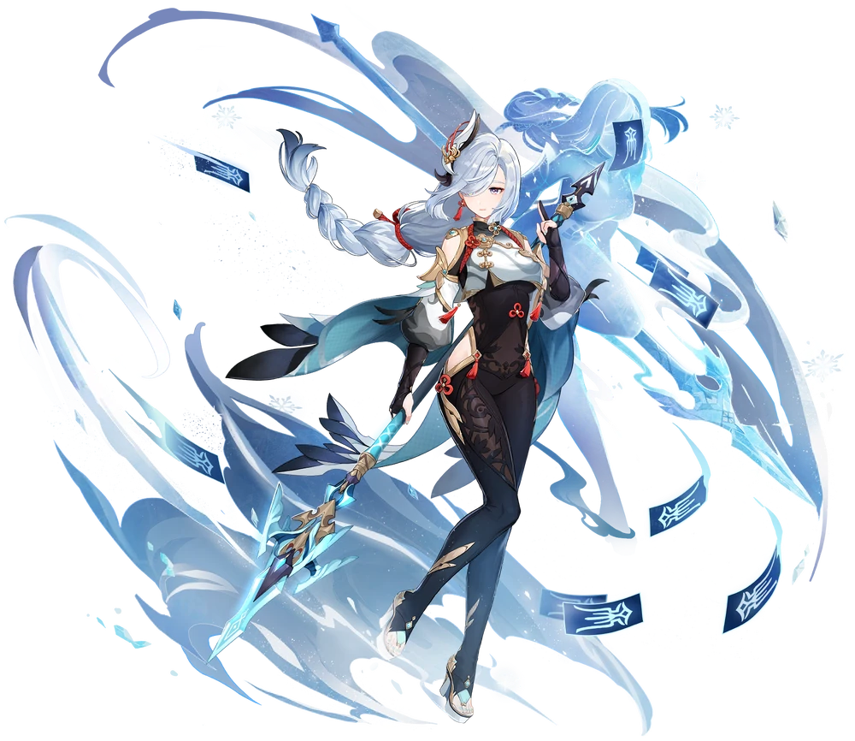
“…” The silver-haired woman that stood alone in the cave did not immediately provide further commentary on the situation she now found herself in. It was alarming. There was no denying that. After all, she had just become Shenhe – or at least a very convincing copy of her. She didn’t possess Shenhe’s memories but that didn’t change the fact that she was acting just like her. Even her wants and needs were what you’d expect from the superhuman human. That included possessing her freakish strength.

But Shenhe’s personality was far more reserved than most people’s, much less Yun Jin’s. She could process what had happened to her as ‘unusual’ and ‘alarming’, but showing these emotions was anything but a simple feat. At best she could manage to utter a simple “Hm…” as her mind did the rest, attempting to figure out how she should handle this. Shenhe’s lack of social sense probably wouldn’t help things in that regard.

“Should I wait for the other Shenhe to get back? But what if she tried to fight me?” Understanding Shenhe’s personality now – because it was her own personality – the possibility that the original, upon seeing a fake, might try to kill her didn’t feel that farfetched. Should she escape into the mountains? To Liyue Harbor? Somehow that felt like she would just be delaying the inevitable if anything. Eventually she wordlessly nodded to herself. She had decided to remain.

But in the meantime? “Clothes.” Yun Jin’s dress still unfortunately remained in tatters on the cavern floor and Shenhe’s buff, tall body was naked aside from the red ropes. It was a good thing then that the real Shenhe kept a change of clothes in the cavern. It was just a matter of putting them on, and she did so as if she had done it a million times. While dressing herself she considered her other options. Mortals usually talked things out, right? She should try that.

…Even though she had been a regular mortal before anyways.

She may have had more experience with human society deep down as Yun Jin, but all of that experience was worthless now. Shenhe’s ego was much too strong and forced her to act as a clueless introvert might when the topic of social situations came up. “No matter what I shouldn’t try to kill her.” That probably should have been common sense, right?

