TOO DUMB TO RULE
BIWEEKLY STORY #95
BY CHALDEACHANGE
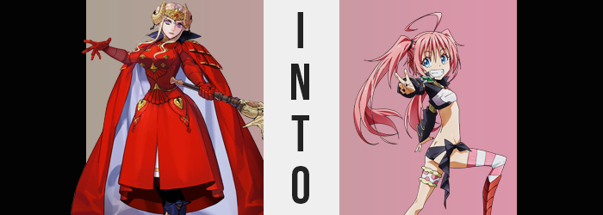

It was certainly a difficult time for Fodlan. The continent had been plunged into war over the sake of its future, with factions warring both against and alongside the Church of Seiros that had governed it for so long. This war had begun at the behest of the Adrestian Empire almost five years ago, and so much had been sacrificed during that time. Still, its emperor, Edelgard von Hresvelg, had showed no regrets (even though she most certainly had them) nor intention of bringing the war to a halt until her goals had been accomplished.

Because of this, she had become a centerpiece of developing strategies by the other kingdoms. If Edelgard was removed, by their logic, then this war would quickly come to an end. Cutting the head off of the snake, so to speak. But she wasn’t a woman that was so easily killed. The security around her out of combat was incredible what with how she was holed up in Garreg Mach, and on the battlefield? She was a nigh untouchable warrior, just as talented as she was fearsome.

And so if she was to be disposed of, it would have to be a plan that didn’t involve killing her outright. But that was a difficult pill to swallow in itself, because if blades and magic could not reach her, there was only really one thing left to do. That was turning to the dark arts. Curses that could not properly be controlled by mere mortals. At best they could hope to dispose of her, but those wishes might not manifest in the way they had hoped. Nonetheless, it was all that a certain faction of the Church had by this juncture, and so they placed all of their hopes behind it…

Of course, the target of this attempted curse? Well, she had no idea that she was being targeted by anything of the nature. Having something of an alliance with Those Who Slither in the Dark had come with some benefits, even if Edelgard did not believe in their methods. She had been gifted a special charm that was meant to ward off curses from potential foes, seeing as they could be cast from anywhere in the world so long as the feelings associated with their use were strong enough.
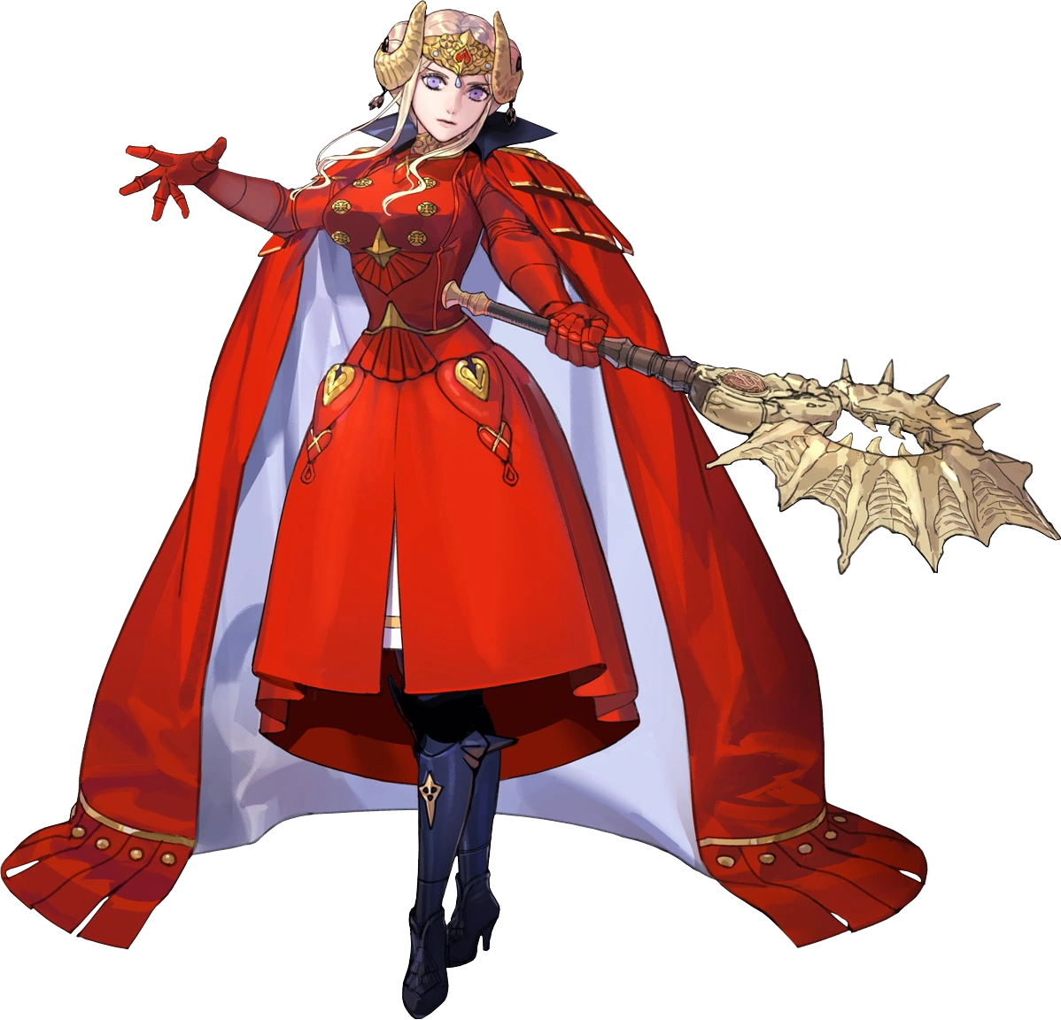
As she rested in her chambers though, she was unaware of some damage that this charm had sustained in a recent battle. Since she always kept it in a pocket within the clothes she wore under her armor, she didn’t always have it in a place where she could perceive it visually. And so with her day done, she was simply trying to relax with a book she had borrowed from Garreg Mach’s library, snuggled up in a chair.

It was supposed to be a peaceful evening, and yet evidently her detractors had sought to disturb that peace in the most unthinkable way possible. It had all begun with a shudder that had wracked her body. One that she had initially dismissed as a chill, and yet… “Hm…?” Just as the emperor couldn’t shake that chill, she also couldn’t shake the feeling that something was wrong. That prompted her to put down her book. “Something isn’t right.” But what?

Edelgard stood, wondering if doing so might give her some perspective. It didn’t, not really, but in her defense it wasn’t really her fault. If a curse led to someone noticing and calling for help, then it wouldn’t truly have been that effective, would it? No, there were stopgaps laced within its composition so that she was left oblivious enough to not seek support in what would be a very trying time.

Though the earliest signs weren’t so easily observed to begin with, seeing at they took place in and around the point of her body through which the emperor could perceive things anyways. In fact, it was the eyes themselves that showed signs of altercation. Midst their mauves emerged speckles of a greenish blue that quickly spread like a wave, ultimately dominating over and then obliterating the previous color. Even then, tweaks were likewise done to the corners of her eyes so that they were bigger, more expressive, and in a way? Almost a little more childlike.

That was a trend that bled into the rest of the woman’s face from her eyes. The skin across her complexion softened and was robbed of any blemishes, while cheeks swelled just a bit pudgier and her nose smaller and much more button shaped. In many ways, she no longer resembled Edelgard von Hresvelg whatsoever. She looked more like a young girl. One that was completely detached from the emperor she was supposed to be.

Meanwhile, the woman midst a transformation felt uncharacteristically restless. Edelgard was good at being patient and still, yet now? She was tapping both her foot and her hand. “What is wrong with me?” She could tell that something was awry, but it was getting much more difficult to focus on that fact. Her mind kept wandering, which played into her physical restlessness as well.

All while a much more fun color had found its way into Edelgard’s hair. While it had once been brown, only to lose it due to the experiments she had suffered through by Those Who Slither in the Dark… Well, it wasn’t the brown that returned in place of the white. Instead it was a bright and vibrant pastel pink that was more in line with the hair of Hilda Valentine Goneril’s.

It also lengthened, quickly undoing the buns at the side of her head so that it could spill out behind her. It tumbled far down her back behind her, all while bangs both lengthened and became a little messier – tickling the peaks of her eyes but not falling past them. Atop her head one strand grew much longer than the rest, spiraling into an eccentric ahoge. In a way, the new color and style really helped… helped make her more like a child, that is.

“Mmm…” The impatience that Edelgard was displaying had become much more apparent, with her foot tapping very quickly against the floorboards now. She was swinging her arms about without much of a reason to. “What was I worried about again?” All it took was the time between her groan and her statement for her voice to jump a plethora of octaves. It made much more sense coming from a face with thin lips and younger features.

And the rest of her would eventually come to corroborate the idea that the woman was young. For example, the front of her crimson jacket didn’t seem quite as pronounced as it had been moments before. This wasn’t for no good reason though, but because the woman’s bosom was not quite as ample as it had been before. The meat of her bosom lessened, and her nipples shrunk alongside them, ultimately leaving her bust as little more than a slight protrusion from her chest.

And in kind, so too did her rear end. Edelgard’s rump caved in on itself, plump and mature cheeks ultimately turning much more lackluster… which translated to her thighs as well. In the end she had become much scrawnier, with even her waistline sucking in until it was extraordinarily thin. This looked super bizarre considering her height, but fortunately her clothing concealed this fact.

“Whoa!?” It wasn’t even a long term issue anyways. She threw out her hands because of a great imbalance that had struck her – or at least that was how she’d perceived it. But the truth of the matter was that her stature had begun to regress, her height quickly dropping down to around 4’10”. This meant she was practically swallowed by her armored dress, which was too elaborately done up to just fall apart piece by piece.

The damage was done by this juncture. Effectively, the emperor of the Adrestian Empire was no more. Instead there was what appeared to be a child occupying her outfit. Not that it fit. “These clothes are reaaaally stuffy!” And even the girl herself had taken notice of that fact. Pulling her arms in as much as she could, a sudden explosion of what appeared to be energy shredded everything she was wearing. Except the pink haired girl? Underneath, she’d somehow spawned a different outfit altogether.


Much of her skin was exposed, from all of her torso sans her chest, to the peak of her butt crack and her thighs. Why she elected to only wear what looked like a pair of black underwear tied to the side around her hips, or why she only had a pink and white striped thigh high on one leg, or why her chest and arms were the only things wrapped – was all one big mystery, really. This choice of fashion didn’t speak much sense, but then again? Nothing about Milim Nava did.

“Um… Am I supposed to be the queen or something? Ahahaha! I’ll be the best queen in the world!” Case in point: while some vague memories of her past life did linger, it was evident that she wasn’t handling them with any level of maturity. There was no way in the world that this girl could competently run a country – not by a long shot. To begin with she didn’t really have the attention span. She was already throwing some priceless artifacts around, after all. “I’m boooored.” Was there even anything interesting in this room?

Of course there was also the problem that no one in this empire would acknowledge a random girl as their emperor. At least not without a little show of power. Which, despite her appearance? Milim most certainly had.

