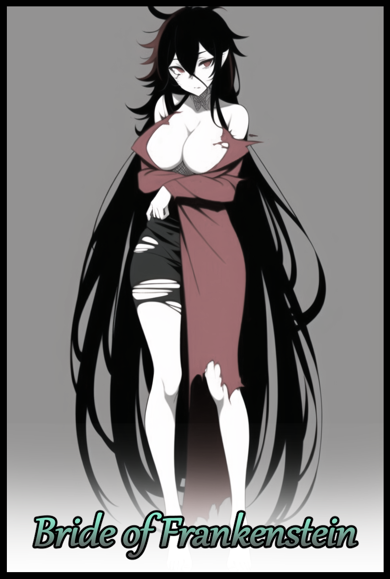

Darkness. Unfathomable darkness that just wouldn't go away no matter how many times he tried to blink his heavy eyes. Or at least, he thought he was, not for sure when he couldn't even make out the bridge of his nose…

Every now and then, he could see faint pulses, flashes of multicolored lights far into the depths of this isolatory void at a distance unknown to him. They would flash for a brief moment or leave sparkles that trail off without direction for a few seconds before fading, but the light show was the only thing keeping his mind busy and focused, trying not to panic in this already dire predicament.

But maybe this was all just some lucid dream? A terrible nightmare gleaned from the atrocious driving skills of his friend he'd made the mistake of handing the wheels over to when they had left a highschool reunion party thoroughly wasted and not quite fit to drive. But lacking hindsight and with their minds thoroughly addled by drink, they would still hit the road.

The last thing he remembered clearly before awakening in this subconscious realm was vandalizing good songs with their terrible singing voices before the lights went out, figuratively speaking…but that got him thinking about terrible stuff, like the possibility of a traffic accident occurring…had they crashed the car? This void, some form of purgatory for souls of the blind and stupid before judgement? If so, where was his friend? So many questions with no clear answer.

Still though, there was hope in the fact that he *didn't* know what was going on. He *could* still be stuck in a dream, sort of like sleep paralysis but without the demons under the bed! An accident? No way…probably…

For now though, at least there were pretty lights to keep himself occupied with, counting the particles like sheep to pass the time…strange how he hadn't yet devolved into a full blown panic attack by now. One would think being trapped in complete darkness would trigger a fit of uncontrollable fright. But he still felt no urgency, no thumping ache in his chest spurring him on to find a way out…almost as if there was something, either this place or an external force, keeping him calm and sedated.

Either that, or he'd drunk so much alcohol to the point where his brain couldn't even formulate a dream, keeping him trapped in the void as punishment for willingly imbibing so much poison. Even if he didn't have much to live for. No girlfriend, no family members who'd give a rat's ass about where he was working another dead end job…the reminder would've soured him greatly if he could feel a thing.

Unbeknownst to him however, the fate that awaited him in the waking world would be one far more abstract and impossible than the aforementioned fates he'd previously skimmed through…

-

Victor Hoffenstein, an eccentric amongst eccentrics. For years he had lived in the city as a well known engineer, respected and adorned for his ability to repair anything thrown his way. From simple handheld devices to complex engines used in airplanes, Victor knew them all like the back of his hand, their inner workings, what faults they could possibly be ailed by. His services were vital to the community, for an affordable sum that varied depending on what he was asked to look at in his workshop trailer, many sought out the engineer for whatever problem with electronics they might have had.

Until one day, Victor would vanish without saying a word to anyone. Leaving nothing but memory to mark his presence in the world. Many had assumed he was finally off to make a better life for himself since they felt like a man of his talents would be wasted here; confined to a city with no path left to climb higher. And then there were the few who would utter soft spoken rumors about the man being lured into the pitfalls of love after citing glimpses of Victor paying particular attention to a strange woman from abroad, eloping into the night to be with her once his spark for her had grown into a flame, a love far greater than his devotion to the city and its people.

Whatever the case though, no one would ever hear of Victor Hoffman ever again. Although his mark had been made, it, like everything else, would fade overtime. Whether disdain or favor, the people's feelings about the genius engineer's disappearance would likewise vanish with their memory of him. Turning him into something of a local myth, spoken of as something of a rumor rather than a flesh and blood person that once lived there as weeks turned to months…until eventually, fifty or so years would pass since Victor's disappearance.

With nothing left to track him down and extended family likewise stumped, all efforts to locate the runaway engineer had ceased a long time ago, forsaking Victor when even his trailer had dropped off the grid. If he didn't want to be found, then so be it they thought. They each had their own lives to live, and by the time they managed to find him, they were certain that dusty bones would be all that remained…

And they were right to an extent. Because half a decade could do many things to a man of Victor's age. Whatever he hoped to achieve, whether the rumors were true, had surely gone to the grave with him…except that wasn't quite the case, for Victor Hoffman was still very much alive and well, except not in the way most people would define the term.

If moving around, talking and working complex machinery counted for being alive, then Victor hadn't kicked the bucket, continuing a new line of work he had undertaken at the behest of someone important in his life, turning into an obsession of sorts for him as the years went by. A long, unrelenting passage that wore him down in many ways without anyone to speak to, constantly working day and night without rest…because in his new state of being, rest simply could not apply to one who felt no need for it. A body that would never tire, never truly die…yet was all the more fragile for it…

If the tale of Frankenstein's Monster sounded familiar, then one didn't need to think much about how Victor Hoffman could still be alive after close to a millennia had already passed. Except in this case, Victor was both Frankenstein and his Monster at the same time; using his genius intellect and affinity with machinery to create a procedure that involved inflicting upon himself the greatest pain known to the human body, lasting hours as he performed the equivalent of a high risk surgery on himself before tossing a metaphorical coin in a gamble to see if he would live through the final step; a point blank shot of lighting as he laid strapped down in the observatory on an apparatus that would turn the unfortunate soul on it into a living lightning conductor, primed to receive the immense energies of Earth's natural storms through a searing bolt of light far hotter than the sun itself.

But he survived, won the coin toss. And now he 'lived' as a ghoul of his former self. Retaining all of his mental faculties alongside his appearance as an American man in his late thirties, albeit with an unnatural greenish gray tint all over his body, criss crossed with scars and stitches that were testament to the hellish procedure he had survived. Just like the final product he was putting together out of the…'fresh material' delivered right to his doorstep at the foot of the mountainous forest he'd been using as his hideout ever since becoming a reclusive hermit to be with the love of his life in what once was their home.

Victor was once satisfied with being here all on his own, respecting the memory of his wife after she, unfortunately, had been the first to go. But as time always did, it wore him down, ate away at his mind, made him do things he normally wouldn't. Until he would find himself committed to searching for a way to revive the dead. It sounded ridiculous, desperate even. But with nothing else to do, a sizable forest home all to himself and a longing to share it with his wife again, Victor just had to try.

Before he could see his wife however, he needed to tend to himself first. Because what was the point of bringing her back if he wouldn't be there for her? Or what if the research and time needed to create the necessary infrastructure and technology far exceeds that of his own life? He needed assurance, a guarantee that this miracle creation of his would work. He didn't doubt his ability to create this hypothetical miracle worker. He doubted the efficacy of it.

But years later, his doubts would be put to rest in the form of his new and improved body; the first and only successful product to have walked in and out of the madman's contraption he had installed in their spacious attic. That was when new problems arose, something he could never truly solve without resorting to drastic measures his conscience would plague him to no end over if he were to commit to it. True, he desperately wanted to bring his wife back from the other side, but that didn't mean he was willing to resort to using live human subjects to test on…not like that was even a possibility considering how far out and away he was from society at large.

So he'd resigned himself to working on the bare minimum, using the same techniques he'd developed to rejuvenate his lover's exhumed body, pouring over the other reference books and records left behind in the study stemming from his significant other's extensive dabbling in sciences related to the human form, a surprise he would only find after he'd hit a dead end in the initial research before coming across the abundance of data stowed away in that dusty old study of theirs, as if whoever hid them there wanted to forget. And from what he read, he understood the reason…

Time crawled onward, but with little success and an unwillingness to desecrate the body of his wife, Victor was going nowhere, unsure of what to do next until one fine evening where a loud explosive bang pierces the silent night, rousing him from his work to look outward beyond the endless row of trees to spot a small plume of smoke and the eerie orange glow of a fire…an accident?

Initially, he'd been hesitant to set foot outside to offer aid to the survivors (if any) in fear of their reaction to his…less than appealing physical appearance. Unless they mistook him for a Halloweener all the way out here in the wilderness, they'd most likely freak and run, or worse yet, assault him.

But it was the temptation of another possibility that finally drove him to step outside, medical bag in hand in case there were people in need…an airtight body bag in the other if his morbid hopes proved true…

Victor didn't need to be a doctor to see there was no hope for survival upon sighting the ruined wreck of a mangled car, hitting a tree so hard the entire chassis had bifurcated down the middle with ugly cracks and tortured metal…and then he saw the bodies…as grim as it was, Victor had hoped that maybe he could find someone else to talk to, ask about the outside world once he'd helped them…but there was nothing to be said from a lifeless husk that hadn't gone cold yet…but it was the latter that instilled a modicum of hope inside of his electrical heart as he salvages what he can before gathering up the bodies of the two joyriders reeking of alcohol and thick iron, making a quick escape in case there were other people nearby.

Leaving the salvage aside for later, Victor's immediate assessment of the cadavers wasn't too promising. One was nearly unusable as a vessel considering the terrible condition of his head while the other…well, both of them…were men. He'd gotten out unscathed, but with a smashed chest that had instantly blown apart his internals…this was going to be a tricky fix.

That is, *if* Victor wasn't a pseudo mad scientist who'd been using unethical research for grand purposes. And in all his time working on this project, Victor had gleaned two inventions that were offshoots of the main branch. One, the aforementioned 'Rejuvenator' capable of restoring the dead to a moderately acceptable level he'd refined over the years so as to leave minimal scarring and patchwork evidence. And the second, mainly the fruit of his wife's family records, was something not too dissimilar to gene splicing. Thanks to the added benefit of restoring their bodies so early after their untimely demise, the bodies had retained their functions as if they were alive. But their brains, unfortunately, seemed locked down in a comatose state, barely alive in the conscious sense of the word…at least, for one of them.

The man whose head was in irreparable condition was more akin to a lobotomite…but maybe he could still be 'saved' after the next steps were taken towards Victor's goal.

By taking genetic material from his wife to concoct a highly volatile brew and implanting it into the two more or less restored bodies, something Victor had only done on animals to observe the creation of chimeran creatures. He was treated to a sight he'd never thought possible, and like any good man of science would, had documented it for future study. Bioscan readings, internal records, cameral recordings. All of it was safely stored away once he was done witnessing the bodies of the two men slowly shift and reshape where they laid on cold metal bedding. It was a strange, mesmerizing sight to behold as he watched the two strangers transform, gaining features familiar only to him.

The supple breasts he remembered fondling when they made love despite his wife's infertility growing forth from their barren chests. The gorgeous visage he watched waste away to cancer restored in its prime by subsuming the rugged faces of both men. Pronounced curves and tantalizing indents came together to form a bodacious, hourglass figure bestowed upon the pair, and lastly, the erasure of their now useless members as Victor looks on with particular interest at what was arguably the most drastic alteration; taking in the sight of plump labia forming from repurposed ball sacks while excess flesh peels apart to form the moist folds and flaps of a woman's flower, connecting to a functional baby chamber now nestled nicely below a firm, yet tubby navel.

Explosive hair growth aside, Victor almost had to stop himself from reaching out to caress the sleeping faces of the newly revived and feminized men, they weren't her…at least, not yet. He wouldn't know until he put them through the final steps to ensure they would be as everlasting as he was before ensuring their mental states were corrected. To know that he could finally be reunited with his Maria in both body and mind…

Even though the two comatose women were clinically brain dead, Victor held doubts in his heart once again as he worked on them, applying the same surgery he'd performed on himself all while wondering if anything would remain in their mind after he was done…and the moral ramifications of such an act…technically they'd already died…what would Maria say if she suddenly wondered why she was alive again, only to realize her body was once someone else's? Would she reject it? Call him a monster, even though he technically already was one? He didn't know…nor did he bother to think about it any further, not when he had already come this far after years of not a single step being made. By the night's end, he was resolute in having Maria by his side once more. He couldn't stop, not when he was already so close to the end.

Without anything proper to dress them in, Victor had simply left their old clothes on before strapping the more or less identical Maria clones into the machine he'd used twice before, once on himself and another on his wife's old body, one that couldn't be revived due to the prolonged time since burial and exhumation. But this time, he was certain it would…he'd been given a chance, and no way was he going to let it slide.

But this third procedure would be different, very much so. By introducing a special version of the brew derived from Maria's brain into the dulled brains of the two women, this would be his last attempt. If it failed, then he would be left with nothing. But, if they won the coin toss just like he had…then it would all be worth it.

A quick, painless jab through the forehead, ensuring their restraints were tied down, and soon enough, the machine was ready, whirring if life with bolts of static electricity leaping from surface to surface, summoning a small, concentrated storm right above the hole in the structure in preparation to deliver the singular bolt of energy needed to jolt them back 'alive' as well as transforming them even further, ascending to a place between life and death where they would never truly either away.

Cranking the lever that controlled the rusted gate preventing the elements from breaching his lab, all Victor had to do from this point on, was hold his breath and pray, as ridiculous as it sounded, for the best, doing his all to witness the moment of his wife's resurrection without blinking, even as the white hot streak of lightning and it's explosive bang bathes the entire lab in blinding light…

-

Eighty nine…that was the latest count on the number of strange lights he'd seen since coming to in the void, still no closer to waking up. At this point, he was starting to fear he really had been caught up in an accident.

*'Damn it Drew…had to go and let you of all people drive us home…'*

Despite the clear anger in his tone, the remark had been one of frustration, because he knew he was also partially to blame for their current predicament…that is, if his friend really was stuck in a similar void not too different from his. And if this really was just a bad dream. Time couldn't be expected to flow right in someone's head after all, he could spend what felt like years inside this place and awaken with no a minute having passed in the real world.

But there was something else that had occurred not too long ago, it sounded like a faint voice, muddled and unclear, but it was definitely the voice of a man. Once that had come to pass however, even more oddities would start to emerge all around the still immobilized man, unable to twist his head around to glimpse the origin of another voice separate from that of the previous, disembodied voice from above. This one clearly belonged to a woman, but her words sounded incoherent, as if she too was confused and, unlike his unnatural state of calm, afraid. It should've creeped him out, but in some strange way, it felt…soothing, urging him to try and move, to get closer to the source and comfort it…not like he could even if he wanted to.

The occurrences didn't just stop at the auditory and visual limits though, because something about himself was starting to feel off, like a creeping sense of alienation towards his own body as new 'feelings' emerged all across his phantom figure. A weight, especially heavy in his pectorals tugging on his shoulders. An icy tingling spreading across bare skin. The unmistakable tickle of unkempt hair against the nape of his neck and down beyond a strangely arched spine…and the blubbery thighs that usually rubbed together thanks to his beer gut no longer felt the same as a cool breeze slips freely between the parted meat curtains…oblivious to the sensation of invisible hands massaging his pecker back inside of a tight, pink slit between toned legs far too curvy to be a man's.

But that was precisely why he felt so weirded out. After all this time as an unfeeling sprite on the verge of fading, it was the sensations he could feel after being mute to it all for so long that had him on edge. In fact, his vision was starting to clear up, making out the small narrow bridge of his nose and a messy fringe in front of his eyes, instilling hope that he might soon be waking up, freed from this suffocating place as more of his bodily functions and senses are restored. Until the stranger's voice pipes up again, clearer this time. Clear enough for him to realize that it hadn't been coming from behind as it questions its surroundings once more.

It was coming from *inside* his head as strange as it sounded. And as his senses are restored to him, the strong emotions emanating from the second presence begins to bleed into him as well, taking on her fear, her confusion…and what he could only presume were her memories. As if something had triggered in an effort to fuse them together, melding his mind with Maria's without notice as the veil of darkness gradually lifts away to reveal a startling sight related to his body, missing the fact that he suddenly knew the name of the stranger and how all this new information was beginning to make his own memories a confusing blunder to navigate and distinguish from the arguably stronger set pouring its way into his brain like an unstoppable flow of magma.

He knew his name was supposed to be Kevin, the name given to him in a family of three including himself. But this Maria character’s decorated past was far stronger than his own, it wasn't as if he was forgetting his old life, but the feeling of it was akin to being burdened by additional baggage in the form of Maria's life. Everything, from the shame of her forefather's doings to the love she held for her husband was starting to become a part of Kevin, integrating themselves easily into his young, vulnerable mind. In the short span of a few seconds, over fourty years worth of memories had been added to his insignificant twenty four. More than enough to ease the foreign reception to her new, curvaceous figure and how…'sensual' she looked as the darkness obscuring her fades completely, revealing the body of Maria completely under Kevin's control, her voice that had once rang loud and clear in the back of her mind seemingly silenced after the deluge of memories as if her worries had been placated…or maybe she knew something else Kevin didn't…

He should've been outraged, or at the very least confused as to why she suddenly had the body of a young woman. But whatever had kept her calm and neutered to stimuli had returned once again, preventing her from feeling the slightest hint of panic or worry even as she hefts a heavy breast in one hand while the other traces over wide hips and an undulating tummy…this wasn't her body, sure. But whatever else that brain blast from earlier had done besides inserting new memories of a different life was making Kevin feel right at home in her feminine form. On the bright side of things, at least she could move again.

But that had her thinking about what was going on now that it was clear this was anything but a dream. Maria's memories had been too real, everything, from her childhood all the way up to her last moments spent with someone called Victor. It was like a brief glimpse into someone else's mind…and although she didn't look alot like her, the body she possessed right now could easily pass her off as a close relative of Maria. All of that combined with her inability to feel a lick of emotion, and her worries about a car accident, the events of the get together party and the state of Drew was completely brushed to the side.

Before she could try and move a step forward, the sharp, unmistakable sound of crystalline cracking fills the void, drawing Kevin's eyes toward a bright source of light gleaming through the criss-crossing lines of an immense fissure where the flickering orbs once danced across, tearing open larger and wider cracks as more sounds accompanied it's growth; the steady booming of thunder, rushing air like being in a subway car speeding through subterranean tunnels, the pinging sounds of old machinery being pushed to their limits and even though it was vague, she could hear a familiar voice beckoning her toward the light, making out faint pleas vocalized by the earnest tone of a man stricken with a longing to see his loved one again…to see *her* again…

She was confused beyond measure, but there was nothing left here for Kevin to glean answers from…if she wanted to know more, the state of her actual body, the situation regarding Drew…and what was going on…there was only one step for her to take, and that was through the glowing white portal that had opened for her to walk through.

*'Please…just tell me this is all just a really bad dream…'*

No matter how much she hoped it was however, a part of her knew this was all very much real, balling a hand into a fist over her bosom in anticipation for who she already knew awaited her on the other side from the bevy of information given to her brief encounter with the vestiges of Maria…

-

The smoke was thick and the exceptional charge delivered by the lightning had been intense, enough for it blow out the protective glass barriers shielding the main chamber currently occupied by the twins, forcing Victor to shield his eyes from the barrage of broken glass and the intense whip of wind blasting out towards him, stunning the ghoulish scientist before panic takes precedence over hope, hobbling to his feet before sprinting towards the smoking chamber, biting back disgust from the stench of acrid sizzling burning strong from something inside the small circular room.

But the sight that awaited him had an immediate effect in quelling his fears as his worried eyes met the crimson gaze of Maria, staring groggily at him as she laid strapped to the table, chest visibly rising and falling with activity, soft lips struggling to draw breath, slender limbs twitching as new life flows its way through her once lifeless body. Except the faint beige of her skin had been replaced by the same greenish gray coloration matching his own. Lending credence to the fact that she was a corpse brought back to life, a fusion of two souls made one with the irony being she looked more alive in deathly slumber than she did now as a revived individual implanted with strange technologies that would keep her alive until the Earth's end by Victor's side…

Frankenstein was reunited with his bride, but whether or not she would accept herself as much as him in their new existence was something else altogether, something Victor wanted to find out as he frees 'Maria' from her restraints, coaxing her into a seated position carefully, stopping whenever her emotionless face seemed to stiffen and wince in discomfort. He wasn't sure who was at the helm, his wife? Or the person who had become her doppelganger? But that distrust didn't seem to matter in the midst of the excitement he was feeling. After so long, the sight of his wife moving on her own before him was enough to make Victor want to forget those worries, but he knew a hollow shell could never be his wife.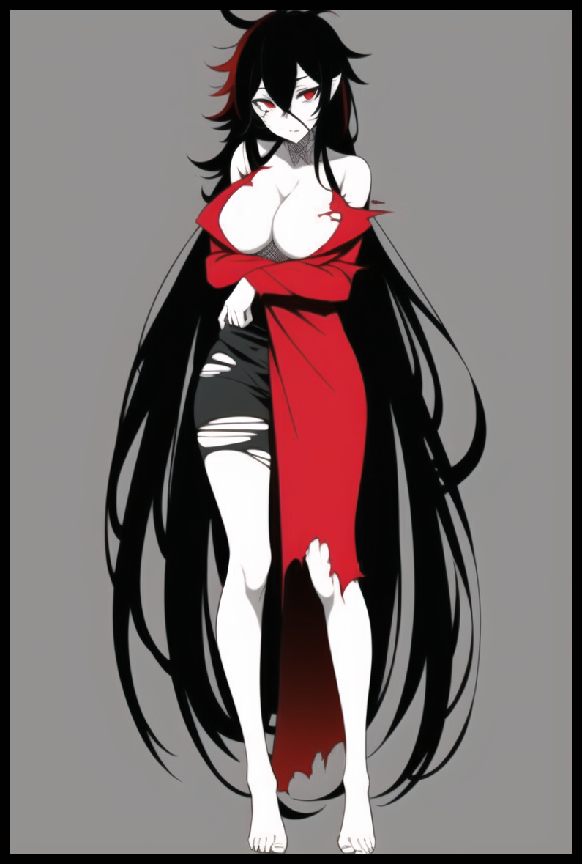

**"V…Vic…tor…?"**

Stiffening up at the sound of Maria's croaking voice, Victor almost had to stop himself from doubling back at the sight of Maria's dull red irises focusing on him, clearly able to see and recognize him for who he was despite how emotionless her expression was.

**"Someone…else…t-there was…someone else I…was with…"**

**"Someone…else?"**

At that point, his hopes were slightly dulled by the weird question his wife was asking, turning his neck toward the table where the other subject had been lying on; not awake, but she was breathing. Whether or not the machine had worked in reviving her brain however, he wouldn’t know, at least not until he got to examine her.

But at this point he was beginning to doubt Maria had returned, giving her room to slip off of the table in what remained of her old clothes hanging off of her body.

**"He uh…she I mean…I might need to look further into her condition but…she's alive…for the most part…how about you? You said…my name…but are you Maria?"**

Clearing her throat with a ragged cough while hugging her flayed top in an effeminate manner so her breasts remained contained, 'Maria' turns her focus back toward Kevin, cocking her head to the side with a faint look on confusion on her stiff face, making it hard to tell how she was feeling. If she was mad, then it wasn't obvious. If she was even aware of her gender being inverted alongside her body having been aged up into that of a motherly lady, then Victor was oblivious to it. Making it awkward to carry his first conversation in decades with someone who resembled his wife in appearance alone.

**"I…D-Don't really know…I remember I…died…you were there by my side…but I also re…remember being a man…Kevin…I'm definitely Kevin…but I also feel like Maria…whenever I…I look at you…what d-did you…to yourse-ergh…"**

**"Maria! Easy there…you're not fit to be walking on your own right now…look, I know you're probably confused right now, but…you need rest…trust me, I've felt this before…c'mon, slow steps now, and up we go."**

Hoisting the arm of his revived wife around his shoulders, Victor carefully lifts her up into a bridal carry before stalking out of the cage, headed for the bedroom he had been careful not to touch, keeping it in pristine condition unlike the rest of the place in memory of his one and only. Someone he'd never truly see ever again…it seemed that even with the advancement of heretical sciences gleaned from terrible crimes against humanity, the soul, once claimed by the afterlife, could never be revived in the same fashion it once lived by, just like the woman in his arms.

He had no more resources left to continue this line of work, and he'd been at it for years…a signal for him to hang up lab coat and move on maybe.

But what if…that didn't need to be the case? He could keep her around as a companion to fill this dreary place with life if this 'Kevin' person agreed to it. And if her companion somehow came out alright…the more the merrier…wishful thinking he couldn’t help but indulge in as he continued on his way to put his wife to bed before thinking about the next steps to take moving forward.

Kevin, on the other hand, was dealing with her own tumultuous feelings on the matter. Compared to the void, waking up only to be assaulted by what smelt like badly burned meat and the unmistakable weight of a terrible hangover was hell. She could barely focus her blurry vision on the cold, industrial setting she found herself in instead of the cramped interior of her car, numb to the sensation of her jiggly body being freed of its restraints by the man she’d heard speaking in her mind…and he was…well, strange. To say the least.

His skin was covered in stitches and the various discolored regions made his body look like a patchwork ensemble of body parts taken from different people. All he needed was a giant nail through the side of his skull, and he would look fit the appearance of Frankenstein’s monster…except his frightening appearance didn’t rouse fear in her heart, instead, she felt oddly concerned for him, taking note of the way his brow was furrowed in worry. The deep eyebags he wore on his face suggesting a lack of proper rest. His tense posture from how rigid his shoulders were…all things someone close to Victor would know, someone like the person whose memories she'd inherited as her own, acting against Kevin's uncertainty to try and reassure her husband…it was hard to hold back, not when she still felt drunk out of her mind.

Shortly after that however, a brief moment of clarity allowed her to speak as herself, wasting no time in asking after Drew, relaxing somewhat after hearing that he, or if Victor was to be believed; she, was safe. But that smidgen of good news wasn't enough. There were so much more she wanted to ask the *stupidly, handsome bastard* who made her a woman…but the alcohol wasn’t helping things, and before she could finish clarifying her stuttered statement mixed in with yet more concern from Maria’s imprint bleeding into her mind again, Kevin had collapsed midway through taking her first, shaky steps toward him.

She was exhausted beyond belief, and even though she was aware of her body, her mind wasn’t quite ready to witness the brief glimpse of deathly gray skin and patchwork stitches that riddled her mature figure. The dream had indeed been real, and the body she'd grown up in had been replaced by Maria's. She loved boobs as much as any other man, but the possibility that she would sport a pair of her own never once came to mind.

Even stranger still, being a woman didn't seem to irk Kevin as much as she thought it would, even when she allowed herself to be hoisted into Victor's grasp, her body's reaction…was far from adverse if the tingle in her heart alongside a warm sensation in her tummy was evidence enough to the opposite which made about of sense to her, considering how she couldn't help thinking of herself as Victor's wife, squirming uncontrollably in his arms at the idea of what they could do…if she were to accept her womanhood of course.

*'No! I'm…still a man on…the inside!'*

Vehemently denying her body's yearning for Victor despite the undeniable feelings of affection for him she just couldn’t seem to shrug off, Kevin's struggle inevitably sends her back into the realm of the unconscious, falling asleep while en route to an uncertain future, stemming from an unsurprising drunken joyride gone wrong leading to a chance encounter with a reclusive Frankenstein living far out beyond the city’s limits…all while the third, forgotten soul continues her beauty sleep undisturbed in her restraints…blissfully ignorant to the mess she had gotten Kevin and herself into…

To Be Continued