**“G-Good Evening Master…H-How would you like to be served tonight? Whatever you w-want, this little bunny can get it for you! *P*…*Pyon~*”**



The face of the bashful maiden flares red upon the utterance of the cutesy catchphrase that falls in line with the lascivious uniform strapped to her bodacious body; a shimmering raven blue leotard with a flimsy pair of form-fitting cups to mask the bare minimum while leaving plenty of boobage on show, displaying the swollen mounds of sensitive teats through suffocating spandex with plentiful cutouts giving the man in front of her plenty to satisfy his eyes with. Making the demure bunny squirm in apparent discomfort from being leered at, her movements oddly contrasted against her feelings as pillowy legs unflinchingly part to reveal the sight of a tightly clenched cameltoe down between undulating thighs collared by the bite of rubbery leggings. Tucking a lock of hair behind adorable ears before planting her free arm inches away from a cushioned derriere to complete the look of a hesitant yet provocative minx, her figure contrasting nicely against the dark depths of a baggy jacket hanging over supple shoulders. A display that leaves the loner at the poker table completely entranced, dull enough to miss the sight of another passing bunny girl slipping a little present into his forgotten drink, fizzling for a second before vanishing just as addled hands wrap around them before bringing the cold glass up to mottled lips. giving the eye candy an acknowledging nod of the head and a wry smile as he does so. **“No worries dear, I’ve already…got my drink right here…run along now, but give that ass of yours a good shake yeah? That’s all I’ll need before the…before the big one…”**

Sliding off the table after a meek little nod, all the girl could do was sigh in shame and embarrassment while feeling a eyes hanging off her posh rear, walking with an unintentional sway to her step thanks to how wide her hips were, and when taken in tandem with a sensual thigh gap, it was impossible to walk without. Resulting in many more lecherous gazes latching on to her pretty little body, biting her lower lip in silent frustration with her head held low while she makes her way back toward the bartender’s booth in the hopes of blending in. Hiding from the world and the shame of distracting unwitting customers for her colleagues to drug with addling hallucinogens, a shame she needed to shoulder if she wanted to free herself from the burden of being forced to work in this devilish casino after falling prey to the same machination she had aided in moments before…

Born as one ***Aidan Schmidt***, the playboy bunny hadn’t always been the soft spoken beauty bearing slight hints of tomboy flavor in her short cut hair, styled with a dash of maddened curls at the tips. Obnoxiously loud and confident to a fault, the man she once used to be had been a self-professed gambler, a cumbersome addict who had been to all the major gambling dens country wide and drained them dry…save for a new one that had recently opened in his home city of all places. A posh establishment with a heavy emphasis on bunny girls bearing unique characters of their own known simply as ***The Rabbit’s Foot***, an ironic name considering its very nature as a casino.

It was here where Aidan would finally meet his match. Game after game would be played without a win. Bets were placed and lost. The man was hemorrhaging money like no one’s business, eating through all he had on him...not like that seemed to stop Aidan when the spirit to win it had possessed him, continuing to play and gamble, accruing so much debt to a point where not even the exorbitant winnings of his short lived glory days could dig him out of it. Ending with an unceremonious loss after a gratuitous offer by the manager to either win his freedom or be forced to work off every single cent he owed.

Except The Rabbit’s Foot would not see him employed as a guard, a barkeep or server. Instead, the unusual manager had subjected him to a forced injection, pumping Aidan’s system with a secret formula of hers that wasted no time in bringing the panicked man to a feverish boil, sweating profusely while cramping muscles and cracking bones were remodeled in seconds under the influence of the serum. Growing a pair of hefty milkers to call his own while a gaunt silhouette snaps and reforms into a soft and pleasant one lined with curves aplenty, leaving no trace of the arrogant gambler by the time a pained visage mellows out into the boyish face of a bona fide babe from the feeling of his pecker inverting itself into the hallowed halls of a female’s snatch, reaching down too late between slick legs with a dainty hand to paw at air and a sensitive nub, her fate as ***Alisa The Tech-Bunny***. Tomboy hacker (in an imaginary resume of course) and the casino’s newest girl sealed for the foreseeable future as wide eyes turned to her new overseers, not in anger but fear and unwillingness. Finding her hotheaded flair and abrasive tendencies quelled and restrained against her will the more she got used to her new body. Put to work not even a full day after her instantaneous transition to the other side of the metaphorical fence dividing man and woman. Enduring the same treatment men like her old self would subject other girls to without a care in the world; squealing in a shameful voice whenever a stray hand dips to cop a feel of her sensitive ass, moaning under a sharp breath upon the rare occurrence of an accidental brush stimulating her newly grown flower…and all she could do was either ignore it, or wave it off with a smile on her face. Because to harm the customer in any way meant damage to her pay check that would go to paying off her debt, and Alisa wanted dearly to get out of this accursed casino sooner rather than later. Knowing she had no way out after the display of power her new manager had put on for her. Because if The Rabbit’s Foot had stealthy aficionados and femme fatale bunny girls under their employ alongside a serum that could turn men into helpless girls with amped up pleasure centers, Alisa feared to see what other toys they had under the table.

By the time a month had passed, Alisa had barely eaten into her debt with the measly earnings she had worked for. Earning stifling remarks from those she had served but unwavering praise from those who found her meek persona a delight to witness. Like the man she knew would soon be losing games left and right after imbibing the tainted drink. And if he were to continue wasting dollars like she had…it was probably safe to assume that she would soon be getting a junior colleague to work with. Something that mattered little to her in comparison to a growing number of other major issues that were starting to cause her a crisis of identity…issues like the fact that her movements were already starting to become more feminine…*more sensual*…beneath her notice as it was second nature just like all the things she’d been taught. Like sitting down whenever she needed to go to the toilet or dabbing a tissue over her snatch to clean up after herself. Heck, even those were nothing in comparison to the recent emergence of undesirable thoughts surfacing inside of her mind while on the job.

Alisa could recall the disgust for her fellow man whenever she was forced to interact with vile, grabby customers who treated her like the eye candy she was. The discomfort from living like a girl…but a month in, and that disgust was starting to give way for silent adoration and submission; finding herself staring at the exceptionally handsome clientele while approaching them more often to ask for drinks and the like. Inadvertently painting them as targets to be drugged much like she had on her first day at The Rabbit’s Foot. But any more of this, and Alisa was starting to become fearful of what this place, this body and all it entailed, would do to her by the time her debt was repaid…if it ever could be in the first place.

In the meantime however, the nauseous bunny would deviate from her path, moving away from the bar and towards the toilets instead with a less than subtle shade of crimson to her cheeks and a dampening of the region between her legs. Intent on ridding herself of the lingering image of that stupidly *handsome* gambler from before, the only way she knew how after an accidental slip of the hand while putting on her tampon last week had opened her mind and body to the glorious release that awaited her at the end of it…

THE END

***Katrina Rodriguez*** had been one of the greatest minds of her generation. A headstrong woman of science boasting an impressive repertoire of feats in the scientific community whose habits and personality had been molded strongly by her late mother, a like individual who wasn’t afraid to challenge barriers and break convention if it meant getting one step closer to whatever goals they might have in mind. And in Katrina’s never ending quest, that willpower would be critical in her current mission; hoping to be able to tap the weave of space-time itself, enabling travel across alternate universes and different time periods. A titanic goal that predictably, would require an equivalent amount of time to achieve. Time Katrina knew she didn’t have.

Age, illness, accidents…there were many many things that could intervene and cut her time on Earth short. Something she wouldn’t mind happening ***after*** her life’s goal was achieved. An improbable outcome that wouldn’t change no matter how hard she wished it to be…unless of course, a gander was taken and corners were cut…a hazardous path to take with anything involving matters of world changing sciences no one in their right mind would be willing to play around with so carelessly. But Katrina was not like anyone else, at least in her eyes. She had already accomplished so much, and with far less care than what she was putting into this project, surely things would turn out the same once again…

Unfortunately for Katrina however, the blessings of Lady Luck were finite. Quick to abandon those under its protection without a second notice as if in warning to never take those fleeting moments in life for granted. And for the hasty woman who could not see reason in her relentless pursuit of knowledge and the self-fulfilling bliss of achieving the impossible, that fact would remain hidden from short sighted eyes until it was too late to take a step back. At a point where her magnum opus had already taken shape before her very eyes; an unassuming arch composed of a snow white metal shell containing complex mechanisms and advanced electronics that held the power to bestow upon Katrina, the ability to traverse the world around her like never before, to see the past, future and alternative of everything in existence through an accompanying set of contact lenses linked to the bulky device built into the back of her personal van. Primed and ready for a joyride through town, excited to give her ultimate creation a go as Katrina speeds off into the quiet streets of the dusty town somewhere in Mexico she called home. Narrowly avoiding accidents wherever she went when her eyes saw constantly changing states of her surroundings. Swapping between desolate ruins and futuristic, alien environs among other things, all with a single thought…It was all going so swimmingly well and all without a hitch. Leaving Katrina in a state of cloud nine that necessitated she stop the van and get a breath of fresh air. And that was when her eyes would unknowingly chance upon the object of her downfall after hopping out the driver’s seat.

Coming to a stop out near the back of a mechanic’s garage, strewn with random bits and baubles, a haphazardly tossed full body mirror leaned up against a signpost near the road would reflect Katrina’s self back at her. Except she wasn’t looking at herself, not as she was now, but rather; a flat image taken from the past, back when she had still been a hopeful dreamer in highschool. Piquing the scientist’s curiosity as her thoughts begin to cycle back further through the past, and then the present. Watching her clone shift and change in the cracked glass as if someone were playing a record reel of her entire life, a seemingly harmless process that takes a sudden turn for the worst the instant the naive woman thinks of what her ‘other self’ might look like, allowing dastardly fate to choose for her the side she would never get the chance to regret knowing of. Sealing her fate the moment distant eyes register a sight only she was privy to. An obscene image the rest of the world would soon come to familiarize themselves with once a strange wind begins to swirl, centralized around the still form of Katrina Rodriguez as the casually dressed scientist starts to shift in accordance to the whims of temporal change. A buzzing mind, helpless to resist as tingling synapses open the way for altered memories and new preferences to creep inside and swarm over her very being.

For every crack to line her psyche, a part of her physical being would conform to fill them as if a blip in reality had occurred, leaving portions of the scientist’s body irreparably changed; sporting a shade of darker, sunkissed skin far more radiant than before. And then came her limbs, retaining their build but filled with layers of toned meat and plush fat, making them perfect handholds, pleasing to the eyes. Sensual shifts that made sense in the context of seedier memories that told of a decadent life, led by the vulgar reflection steadily taking form where Katrina once stood as eyes sapped of intelligence slim into provocative slits housing wanton pearls. Framing the bridge of a sleek nose set atop a pouty pair of lips finishing their growth into perverted cushions. Erasing the visage of the intellectual once neatly trimmed hair tumbles down the alluring mask that had overtaken it, a side swept fringe and lengthy locks pouring over the perfectly sculpted fakes of a pornstar and a smooth, supple spine to support a body that was no longer Katrina’s. Not when an airy giggle escapes her mouth instead of a horrified gasp upon being greeted by the arousing sensation of her virgin vagina sagging into a well oiled canal, a vanished hymen popped by a phantom phallus as her innards shift and pulsate around it’s intangible girth. Wetting herself with unabashed glee as a lean vulva becomes fat and juicy, crowned with a newly grown bush of unkempt pubes and dripping in anticipation to make real the debauched imagery floating around inside a devastated head stripped of everything that made Katrina the woman she was. Sighing in ecstatic bliss as her pussy shivers upon the swift exit of the thing that had instilled within her loins decades of use and experience from many a faceless stud. And as a new set of bling pops into existence over thin wrists, a softened tummy and a delicate neck. The scientist’s ruination would complete itself just in time for the owner of the garage to catch sight of and call out to her, shaking the dazed whore out of her confused stupor as she turns to look at the hunky man waving at her to come inside. Seemingly oblivious to the revealing raiments of a shameless hooker adorning her tight, curvaceous figure in place of an old set of modest clothing as she heads his way with a pronounced sway to fertile hips and a jiggle to bubbly ass cheeks that, like the faux bosom jutting out the front of a lithe torso, had been tarnished with a thin layer of silicone.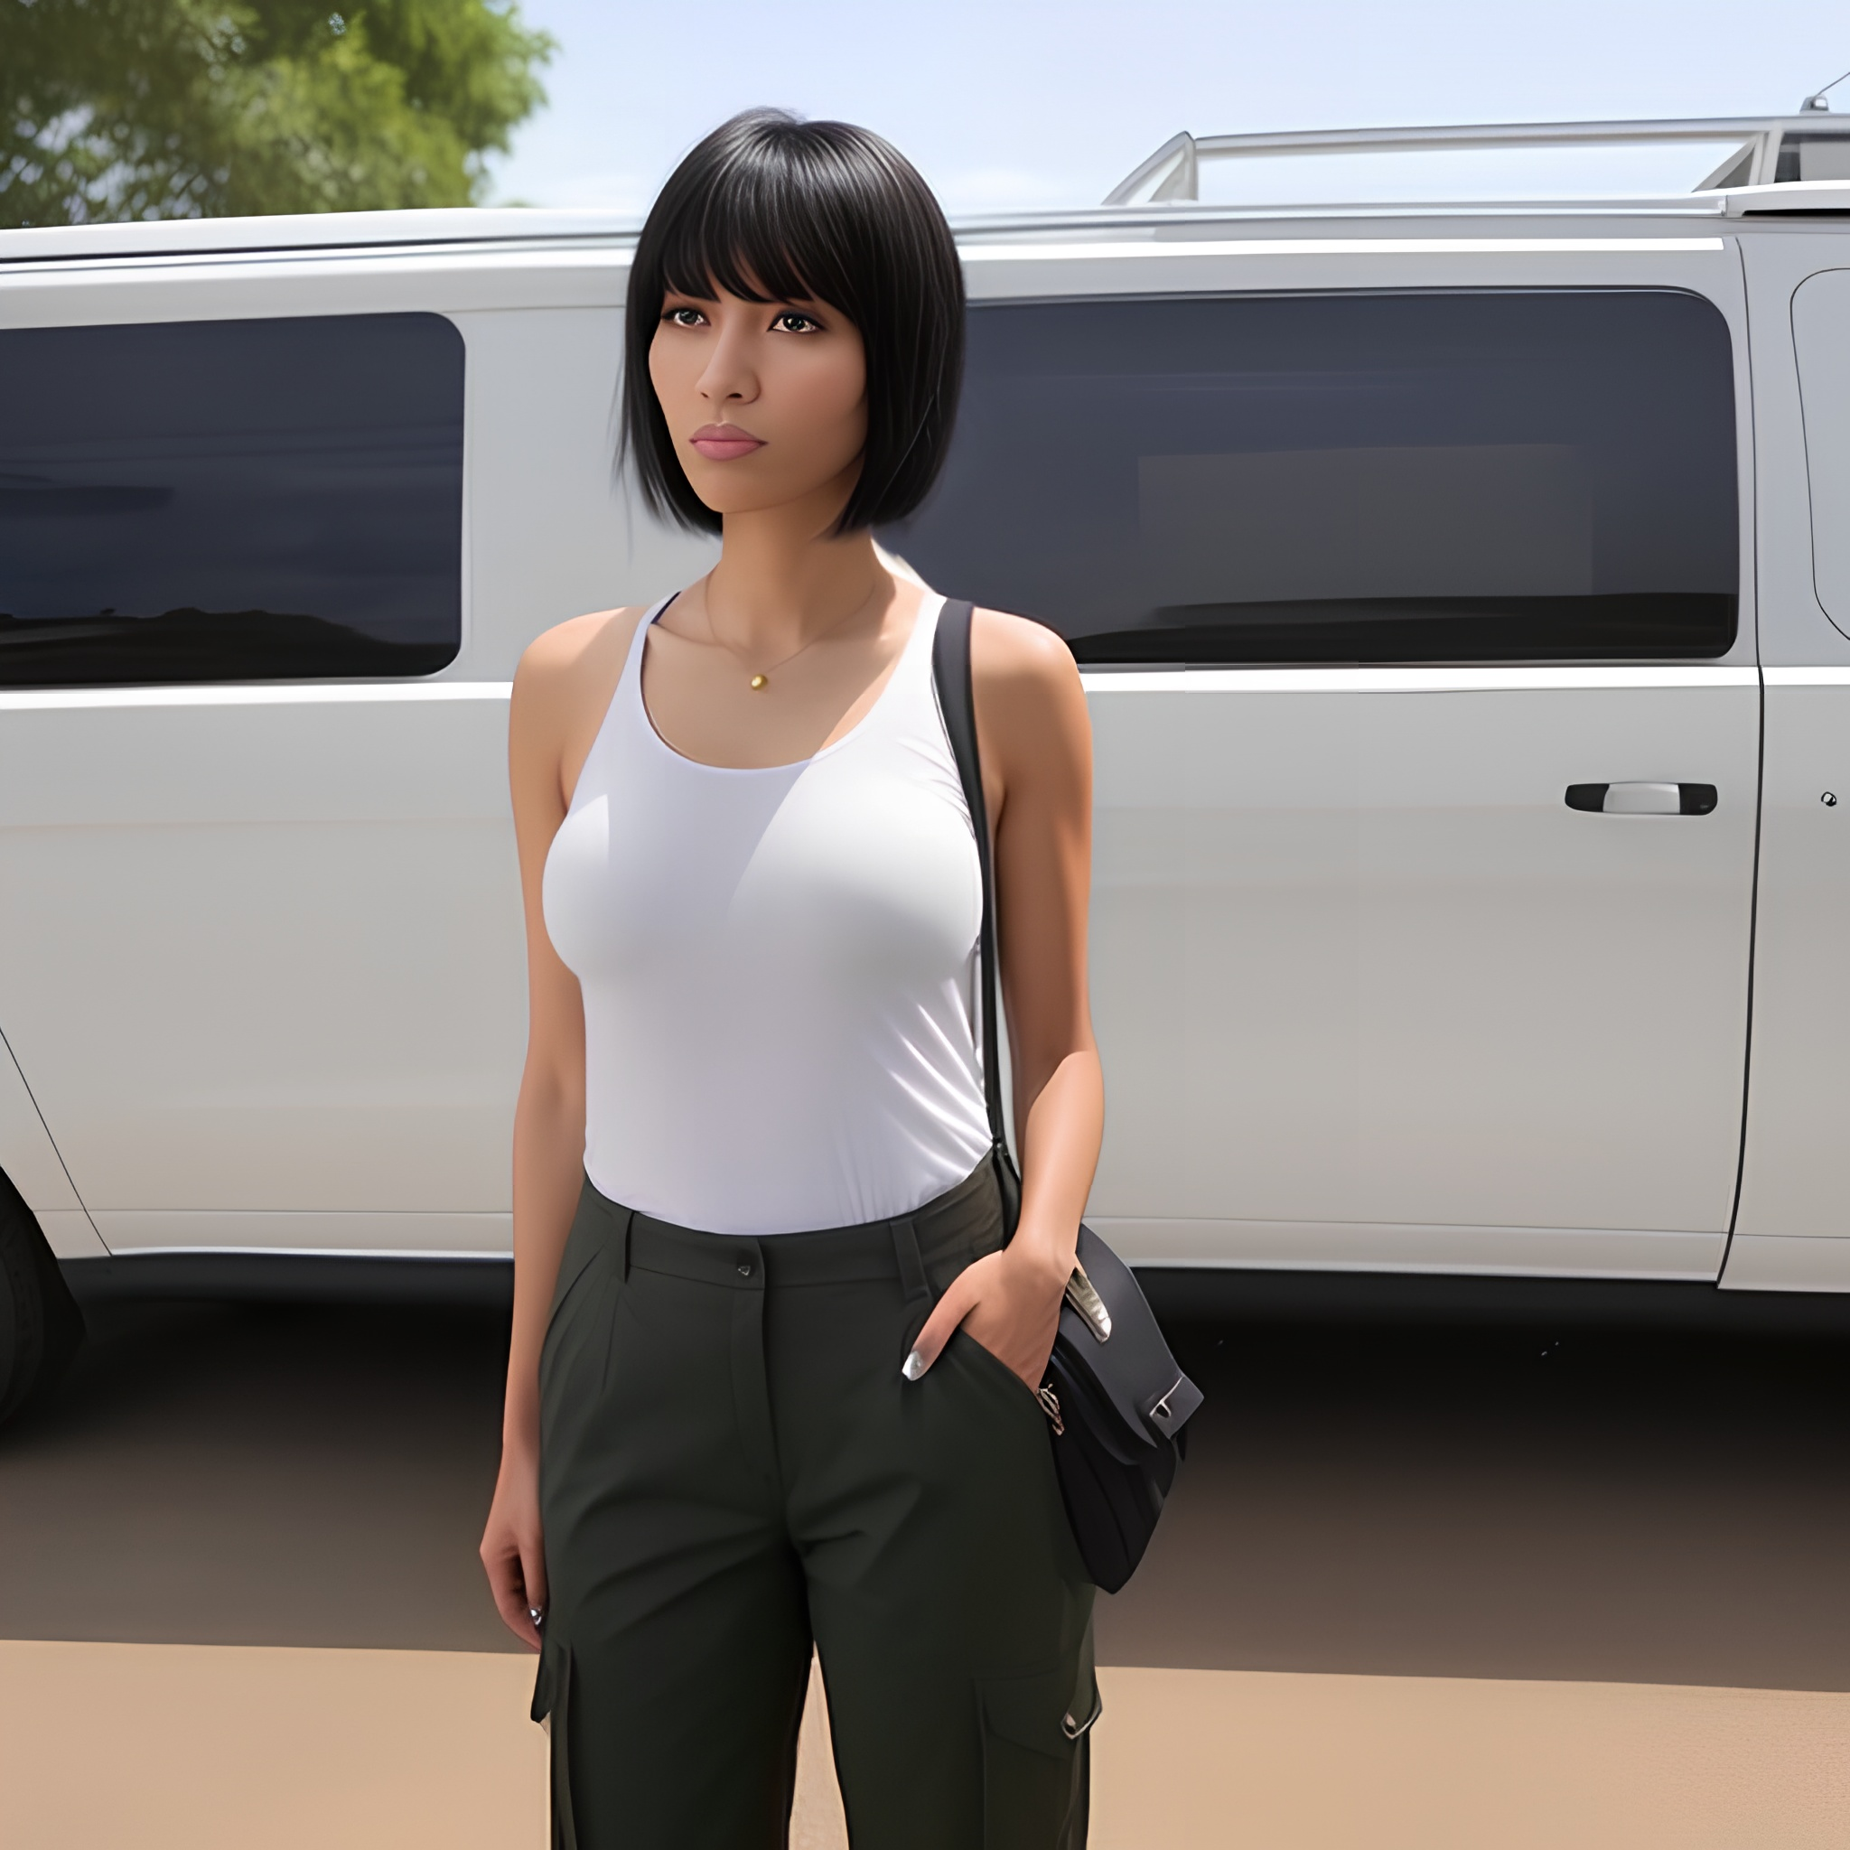

What felt like minutes had in reality, been only the briefest of moments. A split second flash that had left Katrina Rodriguez forever changed. Eradicating a stern yet loving childhood with a mother whose face and habits she no longer remembered and the sequential events that came after to make her the avid yet careless scientist. Instead, all ***Kayla*** remembered was a stiff life on the streets after a hopeless time in school that barely went anywhere, working the only job she knew how to once her deadbeat father had decided to leave as her coming of age present after doing nothing but feeding her scraps for years. Without an education, the scum of the Earth as her mentors and a graduation from some cheap highschool in the form of an expulsion, Kayla had been influenced early on, groomed into becoming just another one of the trashy street walkers lining the streets of the dusty town. Selling herself to anyone with a dick between their legs and the money to afford her, and after what her Papis had done to ‘augment’ her body, Kayla had a reputation for being one of the most expensive pieces of ass to share a bed with…or a wall in some alleyway…or wherever else her clientele wanted to do her in. Licking her lips as her current customer, a familiar face she had come to know after repeat visits, leads her into one such destination; a dark room by the side of the main garage, lined with all manner of toys she couldn’t wait to plug her orifices with…after this grease monkey had finished pumping her barren womb full of his essence. There was just nothing like it; walking around after being taken by a real man, her dribbling loins sealed by a dildo pressing against her panties, keeping all that cum locked inside of her throbbing belly. It had been enough for her to climax right then and there, earning a sly remark from the man as he peels away her underwear, leaving Kayla trembling in excitement atop the sheets as a bulky index finger slips into her vag with a wet ***‘shlick’*** as folds part while a titillating ***‘ahn~’*** spurs him on…

In her haste to complete the device by a reduction of a few dozen decades of work involving supplemental technology deemed irrelevant to the former genius. Katrina had failed to take into account the separation between worlds; between what she knew to be herself, and her myriad variants, young, old, alternate. A breach that had enabled Kayla-Katrina to inadvertently cross the boundaries between their worlds and ‘infect’ the observer, who had just so happened to be watching right when the slut had been putting on regular contacts…a major conflict that had led to the utter absorption and dissolution of Katrina until all that remained was Kayla; a Katrina whose horrid father had won the custody dispute instead of her mother, leading to the birth of the town’s newest lay and the vanishing of everything in relation with Katrina Rodriguez. Her inventions and the benefits they had, even her home had become a vacant rental flat, with her equipment van outside becoming a rundown vehicle emptied of core components and the machine that had caused this mess in the first place, never to be created again now that it’s maker had been rendered a vapid bimbo singing praise to her man in the form of raunchy vocalizations as he thrusts like a bucking beast, sending the full length of member into the sweat soaked woman just the way she liked it. No one would ever remember bat an eye towards Katrina’s disappearance, not when there was Kayla to enjoy in her stead.

She had taken a major risk and failed, hoping for fame and recognition the likes of which she already had…instead, all that scattered praise around the globe would be concentrated in the confines of her hometown; manifested as the one all the men would turn their heads to in unbridled lust while girls seethed in envious rage. A reputation Kayla would relish in forevermore, a dark love she would never take for granted as long as she lived…

THE END

**Overstepping Boundaries**

Images generated by Pornpen : <https://pornpen.ai>

**The Rabbit’s Foot Casino**

Image 1 by Loki : <https://www.pixiv.net/en/users/371157>